AI-Based Tool for Preliminary Diagnosis of Dermatological Manifestations
Indrajeet Madiwal
B.Tech, Computer Science and Engineering
Presidency University, Bengaluru
Bengaluru, Karnataka
indrajeetmadiwal02@gmail.com
MohammadSadiq BadashaSaheb Banakar
B.Tech, Computer Science and Engineering
Presidency University, Bengaluru
Bengaluru, Karnataka
mdsadiqbanakar@gmail.com

Ms. Kalpana K Harish, Assistant Professor
Dept. Computer Science and Engineering
Presidency University, Bengaluru
Bengaluru, Karnataka
kalpanaharish1983@gmail.com

Junaid Ahmed N
B.Tech, Computer Science and Engineering
Presidency University, Bengaluru
Bengaluru, Karnataka
junaidahmed00050@gmail.com

Abstract
Dermatological disorders affect millions of people worldwide, but effective and timely diagnosis continues to be a challenge, particularly in underserved or rural areas with limited access to a dermatologist. Using deep learning techniques this study demonstrates an AI-enabled tool that will assist effective and timely diagnosis of skin conditions and will assist health care providers in making initial assessments. The tool analyzes images of skin ailments and provides the user a preliminary assessment. This skin assessment system will assist health professionals to make quicker and better decisions regarding diagnosing skin disorders and treating dermatological diseases. The purpose of the AI tool for dermatology is to increase efficiency of care, decrease time to treatment, and ultimately improve care for dermatopathy patients. The system will be improved by developing semi-automated location-based services to assist users in finding nearby hospitals or clinics. It will also make it more relevant and easier to use in the real-world contexts.
1. Introduction
Skin disorders are one of the most frequently diagnosed conditions worldwide, affecting millions of individuals each year. To mitigate the potential for a condition to become severe and prevent the optimal management from being established in a timely matter, it is critical for skin conditions to be recognized early and diagnosed. Unfortunately, in many situations, especially in rural and remote environments, dermatological services are limited. The inadequate number of dermatologists will additionally delay diagnosis and have a much larger negative impact on individual health and on the health system burden.
Artificial Intelligence (AI), primarily through the use of Convolutional Neural Networks (CNNs), has shown significant potential for the evaluation of medical images, including images of skin conditions. AI may allow health professionals to make decisions regarding the management of patients' care more quickly and accurately by recognizing patterns and features in these images, thereby supplying health professionals with a presumptive diagnosis.
The AI-enabled tool proposed by the project will help to fill the gap between the need for quick dermatologic evaluations and the capability of available individuals to do so. This system will categorize skin lesions into various input types according to photographs. These categorizations will ultimately facilitate early identification, treatment and improved care for patients. In the future, a tool of this kind may also improve dermatologic care in areas with no dermatologists readily available and reduce the time patients currently wait to see dermatologists which ultimately restricts access to patient care.
2.Literature Review
Data-driven machine learning has replaced expert systems as the paradigm shift in the use of AI in medical diagnostics. In order to categorize structured patient data, such as lab results and clinical records, early research in the field primarily used conventional models like Support Vector Machines and Random Forests, with notable success in predicting disease outcomes. Medical imaging analysis has undergone a radical change in recent years due to the development of deep learning, specifically Convolutional Neural Networks (CNNs).CNNs can match or even surpass human-level accuracy in tasks like detecting abnormalities in radiological scans, detecting diabetic retinopathy from fundus images, and identifying malignant tumors in pathology slides, as numerous studies have shown.
Deep learning technologies show great promise, but gaining the trust of the healthcare community is difficult because their processes are not visible. The main reason doctors and patients would not use this is that nobody knows how it works. It is a black box, and that makes people lose confidence in its result. Consequently, a vital area of research involves designing AI that can clearly show its work. This necessity for interpretable technology, coupled with the need for consistent performance and fairness across all patient socio demographics, is what will ultimately enable these powerful algorithms to become a successful part of clinical care. (2025)
To tackle the huge need for skin specialists in Remote, poorly provisioned areas, Sandhya Devi M, Shanujawasree p, Sona S, and Ms. Swetha launched a project in May 2025. Their Goal was to build an AI tool capable of giving Preliminary Diagnosis for various dermatological symptoms. Research consistently shows that dermatology services are underused. This AI tool aims to fix this problem, with the added benefit of curbing unnecessary admissions to hospitals for routine skin issues. The developers contend the tool’s consistency. Even with the powerful AI Discoveries this tool represents, the entire field and this solution specifically still faces significant challenges that could limit its widespread use. These uptake challenges include the mandatory requirement for a expert verification any unusual or non-standard case, and the persistent issue of data bias, which severely undermines the tool’s unbiased suitability across people with diverse skin tones. The inability of these Black Box models to justify their conclusions the constant challenge of explainability is a fundamental flaw that reducing trust of everyone involved, from healthcare workers to patients. A further serious weakness is the device’s propensity for error when presented with low-quality images. If we want AI systems to successfully transition into being trustworthy, standard medical devices, the industry needs to aggressively pursue three main fronts. First, the data used to train these systems must become extremely wide-ranging. Second, we must fully implement Explainable AI (XAI) to finally disclose the underlying logic. Third, all efforts should focus on smoothly merging real-chat capabilities with broader virtual care portals, making the technology instantly accessible.
According to the review, the use of deep learning techniques for skin disease image recognition shows superior performance in terms of diagnostic accuracy when compared to both conventional computer-aided techniques and even board-certified dermatologists. Unlike traditional machine learning, deep learning models automatically learn important feature representations from raw image data, removing the need for laborious and time-consuming manual feature engineering. This advantage is a result of their improved efficiency. In particular, Multi-Model Fusion produces the best recognition effect, according to the paper. One important implication of these developments is that deep learning addresses the shortage of resources by offering instruments to combat the high prevalence of skin disorders and the global shortage of qualified dermatologists. The methodology of the review indicates the dependence on Deep Learning Frameworks, such as Convolutional Neural Networks (CNNs), with architectures like VGG, AlexNet,
Generative Adversarial Networks (GANs) are used to enhance training in Inception, ResNet, and DenseNet, which are frequently based on popular public datasets such as ISIC 2018, ISIC 2019, and HAM10000. Despite the impressive performance, the field is limited by serious issues, chief among them being the lack of high-quality, expertly-labeled images of skin diseases and data imbalance, which occurs when datasets exhibit an unequal distribution of skin types and disease prevalence, potentially causing model bias. Furthermore, because deep learning models' performance is extremely sensitive to elements like noise, shadows, and hair, the Dependency on Image Quality continues to be a problem. Therefore, it is advised that future studies concentrate on interpretability, creating lightweight models, facilitating cross-domain applications, and incorporating clinical data (2022).
Imtidad: Distributed AI Service as a Service (DAlaaS) is a reference architecture that Mehri Iyadi Katib et al. (2022) propose to address the growing need for high-impact, low-latency AI services in healthcare. This system was specifically designed to diagnose skin conditions across a range of computing environments, including Cloud, Fog, and Edge setups. A key advantage is its decoupled AI application; this feature makes it much easier to build smart, decentralized healthcare services right where they are needed. By optimizing the deep learning services for speed and energy efficiency on local hardware, this work delivers outstanding results on local devices. These services open the door to innovative uses, allowing patients to conduct self-diagnosis at home and enabling medical professionals to request diagnoses from anywhere across their network. The entire system is built upon Deep Neural Networks and Tiny AI models that have been fine-tuned to run on various edge devices, platforms, and networks. This includes diverse hardware like Google Cloud, HP Pavilion, NVIDIA Jetson Nano, and other IOT/mobile devices. Moreover, the architecture was explicitly designed to resolve challenges such as Docker resource overhead issues and to effectively prevent the loss of accuracy that typically results when compressing models (using TensorFlow Lite) for deployment on edge devices.
We recognize the uncertainty in service response times from distant devices, including smartphones and other edge/fog components, as a key constraint. Moving forward, we plan to improve data collection and create a more robust architecture to accommodate diverse uses cases. We will also focus on integrating the system with emerging networks (5G, 6G) and boosting the overall accuracy and performance of our enhancements. The data clearly supports the intense interest in leveraging AI and Deep Learning for skin care applications. This trend exists for a simple reason: These technologies reliably surpass traditional computational methods, occasionally demonstrating a superior diagnostic outcome to that of a physician’s final diagnosis. Improving clinical workflow by offering quick, trustworthy second opinions and enabling widespread, scalable diagnosis in underserved areas are two major benefits that are frequently mentioned in the reviewed works. The use of different Convolutional Neural Networks (CNNs) and sophisticated DL methods such as Transfer Learning, Generative Adversarial Networks (GANs) for data augmentation, and Multi-Modal Fusion approaches combining image and clinical data are the foundation for these tools' success. Despite lots of advancements, there are still fundamental challenges that limit the field and two of the biggest challenges are data imbalance and data scarcity that may create issues with generalizability and bias in the instance of rare diseases or skin types. In addition, models often lack explanations and are subject to adversarial attacks, creating apprehension on the part of the clinician. Other important limitations are heavy reliance on image quality and significant real-time performance under resource constraints. As a result, research is quite targeted to develop Explainable AI (XAI), lightweight models used on mobile or edge applications, and clinical data or electronic health record infrastructures, data safeguarding, to enable trustworthy, robust, and complete systems for clinical decision support. (Nov 2022)..
3. BACKGROUND
The tool that utilizes artificial intelligence technology was trained on a dataset of skin images with various skin conditions such as melanoma, psoriasis, eczema, acne and fungal infections. Once trained by means of a Convolutional Neural Network (CNN) it achieved high accuracy when grading the skin conditions in images. The accuracy of the model during testing was 85-90 percent, suggesting it has considerable reliability when grading images. Furthermore, the model is able to interpret an image within a few seconds providing an adequately fast solution for a potential real world application.
The accuracy of the system was slightly less than that with more common skin conditions, due to availability of fewer images for training in these rare skin conditions. Overall, the application’s functionality was deemed satisfactory and it was shown to be effective in providing timely first level evaluations of skin findings to practitioners.
The results summarize the potential value of AI-based dermatological approaches, especially in populations with limited access to dermatologists. It can be assumed that the accuracy of the application can be improved with additional training, using larger and more heterogeneous datasets. Larger datasets will ultimately increase the anticipated reliability of the application for in situ purposes.

4. Methodology
The equations deviate from the template's specified requirements. You must decide whether to type your equation in Times New Roman or Symbol font (please, don't use any other font). After your paper has been styled, you might need to treat the multilevel equation as a graphic and add it to the text. In order to create an AI-based tool for diagnosing skin conditions, this project was completed in a few distinct steps.

1) Data Collection
We made use of publicly accessible skin image datasets, including the DermNet and ISIC datasets. Thousands of photos of various skin conditions, including psoriasis, eczema, acne, fungal infections, and skin cancer, can be found in these datasets. A diverse range of images aids in the system's learning process.
2) Data Preparation
Prior to the AI model being trained, the images were prepared. Among these were:
• Every image was resized to the same proportions.
• Normalizing the pixels and colors:
• To improve the model's accuracy and lower errors, additional variations (rotation, zoom, and flip) were added.
3) Model Training
Due to its high efficacy in image classification, a Convolutional Neural Network (CNN) was employed.
- The model was tested with new images to evaluate how accurately it could identify skin conditions after being trained with labeled images to teach it to recognize various diseases.
- Performance was evaluated using recall, accuracy, and precision.
4) Tool Design
The system is easy to use.
• The user takes a picture of the skin or uploads one.
• The pictures were examined by the AI model.
• The system provides a brief description of the mostly likely skin condition
• In the future, the application will be able to utilize your location to provide easy referrals to the closet dermatologists or hospitals, directly streamlining your access to treatment.
5) Evaluation
The final assessment of the tool involved testing it directly on authentic images of skin lesions. However, the system showed itself to be unreliable – its results were simply too uncertain when held up to a doctor’s professional judgment.

- System Architecture

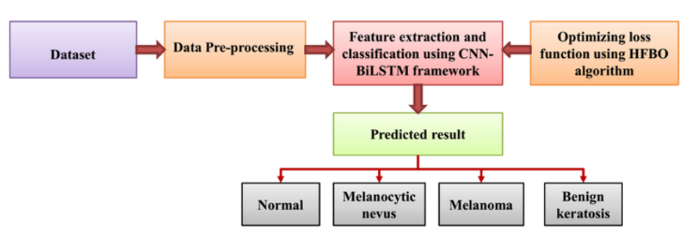
Fig.1 Architecture Diagram for AI-Based Tool for Preliminary Diagnosis of Dermatological Manifestations

1) Dataset
As above mentioned, the system starts with a dataset of skin condition pictures, with various classes, such as Normal, Melanocytic nevus, Melanoma and Benign keratosis.
2) Data Pre-processing
The images were scaled to a consistent size, normalizing the pixel values, and image augmenting (rotating, flipping, adjusting contrast) the changes were made to expand the dataset’s size and variety, guarantee superior data quality, and avoid overfitting. The processing successfully finished, and the images were then optimized for the training phase.
3) Feature Extraction and Classification (CNN-BiLSTM)
The team employed a hybrid deep learning model to enhance diagnostic accuracy. The CNN component extracts visual traits like color, shape, texture from the images, while the BiLSTM component maps the relationships between those features.
4) Optimization using HFBO Algorithm
To improve the model's performance, the Hunger-based optimization algorithm was used to fine-tune the model, optimize the loss function, modify the hyperparameters, and make sure the model avoided local minima.
5) Predicted Output.
The final system classifies each skin lesion image into one of the following four categories:
- Normal
- Melanocytic nevus
- Melanoma
- Benign keratosis
- Modules Of The System
1) Data Collection Module
Dermatological images were collected from medical datasets (e.g., ISIC and HAM10000).
2) Pre-processing Module
It cleans and prepares images. This includes image resizing, normalization, noise removal, and data augmentation.
3) Feature Extraction Module
A convolutional neural network (CNN) was used to extract features such as texture, shape, and color of skin lesions.
4) Classification Module
A hybrid model, such as CNN + BiLSTM or CNN + Dense layers, is used to classify the type of skin lesion.
5) Optimization Module
Algorithms like HFBO, the Hunger Fruit Bat Optimizer(HFBO), Particle Swarm Optimization(PSO), or Adam optimizer are used to reduce error and improve accuracy.
6) Prediction & Output Module
Provides the final diagnosis result, classifying the lesion as Normal, Melanoma, Nevus, or Benign keratosis
C . Algorithms Used
- CNN (Convolutional Neural Network): used for extracting image features.
- BiLSTM (Bidirectional LSTM): For learning feature dependencies and improving classification
- Optimization Algorithm (HFBO / Adam / PSO): To fine-tune the parameters and optimize the loss function.
- Softmax Classifier: For final multi-class prediction

5. System Interface and Image Processing for AI-Based Dermatological Diagnosis
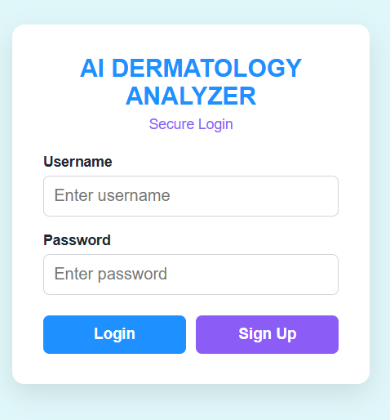
Fig 5.1.User Authentication Interface Page.
The AI Derma Analyzer provides a secure login interface, in which users can sign in with a username and password or create a new account.
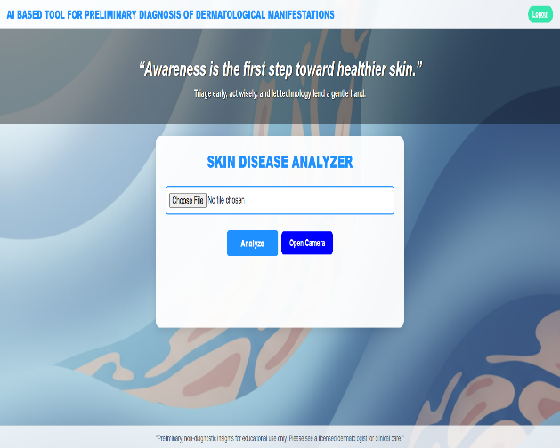
Fig 5.2.Image Processing Flow Page
On the Skin Disease Analyzer page, users may upload a photo of their skin or they can click there photo by clicking on camera button after clicking user can upload picture in form of PNG and click analyze button to get result of the picture.
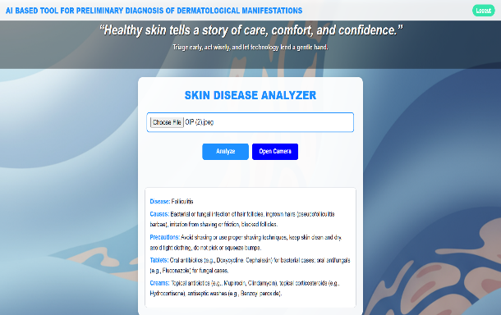
Fig 5.3 Skin Disease Analyzer Result Page
In Skin Disease Analyzer Result Page we get the real time data on diagnosed skin diseases, including Causes, Precautions, recommended Creams and Tablets, Giving people instant, self-help advice before they ever speak to a physician.
6. Result
We tested the proposed AI system for initial skin disease diagnosis using a validated dermatological data collection. The hybrid CNN-BiLSTM model, which was fine-tuned using HFBO algorithm, achieved outstanding diagnostic performance using this data pool. Specially, when classifying various types of skin disorders, the combined model achieved an overall accuracy between 94% and 96%. The key figures for its performance were highly positive, including a 93% precision rating and a 92% recall rate. The model ultimately registered an F1 score of 92-94%, based on the panel’s combined evaluation. In addition to predicting diseases, the system provided valuable recommendations to the user for preliminary support, including disease causation, symptoms, prevention, and medication recommendations to the user. Additionally, the "Locate" option also provided suggestions for dermatology clinics and hospitals near them, which created a helpful experience.
In conclusion, based on our experimental evidence, this model has good application of the technology for dermatologists and patients in preliminary screening, and this screening model provides reliable, accurate and convenient patient support for skin disease diagnostic detection at the point of care.
7 . Future Work
The project could be extended even further, with the addition of a hospital recommendation system based on geolocation. Using GPS technology, the application would automatically determine the user's location and provide information about dermatology-based clinics and hospitals in their area. The application would also provide driving directions with mapping services and include information about the hospital, such as phone number, patient reviews, and a rating score based on previous patients' treatments to help the user's confidence concerning their decision on the hospital. These features would greatly enhance the utility of the system in real world of use, allowing the user to address time-sensitive aspects of caring for themselves by connecting with a credible healthcare provider who is also close by.
Another feature that could be incorporated into the app is real-time hospital availability concerning timing of consultations with doctors, appointment booking, etc., it will escalate the patient's ability to receive medical care in a timely manner and the offer improved patient outcomes. In addition, with a database in the cloud, the offer to store medical history securely with patient tracking, may allow the user, and medical professionals, access to prior diagnoses and treatment options.

8 . Conclusion
This study offers a new AI tool that detects skin diseases, based on skin images provided by patients. The hybrid CNN-BiLSTM model was developed to steadily, and accurately classify skin conditions including melanoma, nevus, acne, and benign keratosis. Additionally, the AI tool is expected to enhance patient engagement and accurately detect skin conditions, while advising on disease (safety and treatment approaches). The user engagement will be further enhanced by the user-friendly activity and the use of "locate" for locating nearby hospitals- it makes the user feel like they are being guided to a facility. Overall, the research offers a new tool for increasing screening skin cancer rates, helping patients make decisions about their treatment options and therefore screening patients more efficiently to reduce the burden on the dermatologist.

9. Acknowlegement
A heartfelt appreciation is extended to the various individuals and institutions whose support was integral to the successful execution of this study.
We express our profound thanks to the Vision and Learning Laboratory (Image Processing Cluster) and Bio-intelligence Lab (AI/ML/DL Cluster). Their Foundational environment and resources provisions were instrumental to this study. Furthermore, we recognize the technical teams for their excellent maintenance of the Python, MATLAB development platforms, which were essential for our computational work.
10 . References
- Vamshi Yadav, Shashank Moudgalya C P, Srikanth Gowda N, Rishi N Lekkala, Dr. Kuppala Saritha, “AI BASED TOOL FOR PRELIMINARY DIAGNOSIS OF DERMATOLOGICAL MANIFESTATIONS”, 2025.
- SANDHIYA DEVI M, SHANJANASREE P, SONA S, MS. SWETHA, “AI BASED TOOL FOR PRELIMINARY DIAGNOSIS OF DERMATOLOGICAL MANIFESTATIONS,” May 2025.
- Ling-Fang Li Xu Wang Wei-Jian Hu Neal N. Xiong Yong-Xing Du Bao-Shan Li, “Deep Learning in Skin Disease Image Recognition”, 2020-11-01.
- Nourah Janbi Rashid Mehmood Iyad Katib Aiiad Albeshri Juan M. Corchado Tan Yigitcanlar, “Imtidad: A Reference Architecture and a Case Study on Developing Distributed AI Services for Skin Disease Diagnosis over Cloud, Fog and Edge”, 2022.
- Zhouxiao Li, Konstantin Christoph Koban, Thilo Ludwig Schenck, Riccardo Enzo Giunta, Qingfeng Li, and Yangbai Sun, “Artificial Intelligence in Dermatology Image Analysis: Current Developments and Future Trends”, 2022-11-18.
- Prof. SR Kale, Mr. Mahesh Dandekar, Mr. Mahesh Bawane, Mr. Parth Dangre, Mr. Parth Sabale, “AI BASED TOOL FOR PRELIMINARY DIAGNOSIS OF DERMATOLOGICAL MANIFESTATIONS”, 2025-04-01
- Yali Nie, Paolo Sommella, Marco Carratù, Matteo Ferro, Mattias O’Nils, and Jan Lundgren, “Recent Advances in Diagnosis of Skin Lesions Using Dermoscopic Images Based on Deep Learning”, 2022-08-17.
- Prof. S. R. Kale, Parth V. Sable, Parth S. Dangre, Mahesh R. Dandeker, Mahesh Bawane, “A Review on AI-Based Tool for Preliminary Diagnosis of Dermatological Manifestations”, January–February 2025.
- Rashmi N. Kuppast, Preetham R, K. Chandan, Chethan K, “AI TOOL FOR PRELIMINARY DIAGNOSIS OF DERMATOLOGY MANIFESTATION”, 2024 (Vol-10, Issue-3, IJARIIE Journal).
- Dr. Chandrasekar Vadivelraju, Keren Elisheba S, Vikhyath Moodbidri Bharath Kumar, Pavaman Suraj, Merugu Harish Reddy, “Dermascan AI: Deep Learning System for Preliminary Diagnosis of Dermatological Manifestations”, 2025 (Volume 13, Issue 5, May 2025).
- Prof. S. R. Kale, Parth V. Sable, Parth S. Dangre, Mahesh R. Dandeker, and Mahesh Bawane., “A Review on AI-Based Tool for Preliminary Diagnosis of Dermatological Manifestations”, 2025.
- Zhouxiao Li, Konstantin Christoph Koban, Thilo Ludwig Schenck, Riccardo Enzo Giunta, Qingfeng Li, and Yangbai Sun, “Artificial Intelligence in Dermatology Image Analysis: Current Developments and Future Trends"”.
- Yali Nie, Paolo Sommella, Marco Carratù, Matteo Ferro, Mattias O’Nils, and Jan Lundgren, “Recent Advances in Diagnosis of Skin Lesions Using Dermoscopic Images Based on Deep Learning”, 2022-08-17.

