**题目要求：**

**利用PLY实现的Python程序的解析**

**本次学习的语法是函数语句，需要注意的是本次使用的语法做了一些改进，不是纯粹的python2语法。**

**需要结合上次课四则运算的解析程序**

1. **示例程序位于example4/**

**（2）需要进行解析的文件为快速排序quick_sort.py**

**（3）解析结果以语法树的形式呈现**

**quick_sort.py文件内容如下：**

**def quick_sort(array, left, right):**

**if(left >= right){**

**return**

**}**

**low = left**

**high = right**

**key = array[low]**

**while(left < right){**

**while(left < right and array[right] > key){**

**right -= 1**

**}**

**array[left] = array[right]**

**while(left < right and array[left] <= key){**

**left += 1**

**}**

**array[right] = array[left]**

**}**

**array[right] = key**

**quick_sort(array, low, left - 1)**

**quick_sort(array, left + 1, high)**

**a=[1,2,4,3,6,5,7,3]**

**quick_sort(a,0,len(a)-1)**

**print(a)**

**程序说明：**

1. 打开main.py文件，确保source中的所有代码在同一目录下
2. 确保已经安装了PLY库
3. 运行main.py文件
4. 对quick_sort.py文件中的程序段进行解析，结果以语法树的形式展现，并展示print的结果以及所有变量的最终值字典，解析结果如下(图片太长，直接放文字)：

+ [PROGRAM]

+ [STATEMENTS]

+ [STATEMENTS]

+ [STATEMENTS]

+ [STATEMENTS]

+ [STATEMENTS]

+ [STATEMENT]

+ [FUNCTION]

+ quick_sort

+ [SENTENCE]

+ [WORD]

+ array

+ ,

+ [SENTENCE]

+ [WORD]

+ left

+ ,

+ [SENTENCE]

+ [WORD]

+ right

+ [STATEMENTS]

+ [STATEMENTS]

+ [STATEMENTS]

+ [STATEMENTS]

+ [STATEMENTS]

+ [STATEMENTS]

+ [STATEMENTS]

+ [STATEMENTS]

+ [STATEMENTS]

+ [STATEMENTS]

+ [STATEMENT]

+ [IF]

+ [CONDITION]

+ left

+ >

+ =

+ right

+ [STATEMENTS]

+ [STATEMENT]

+ [RETURN]

+ return

+ [STATEMENT]

+ [OPERATION]

+ low

+ =

+ [EXPR]

+ [TERM]

+ [FACTOR]

+ left

+ [STATEMENT]

+ [OPERATION]

+ high

+ =

+ [EXPR]

+ [TERM]

+ [FACTOR]

+ right

+ [STATEMENT]

+ [OPERATION]

+ key

+ =

+ [EXPR]

+ array

+ [

+ [FACTOR]

+ low

+ ]

+ [STATEMENT]

+ [WHILE]

+ [CONDITION]

+ left

+ <

+ right

+ [STATEMENTS]

+ [STATEMENTS]

+ [STATEMENTS]

+ [STATEMENTS]

+ [STATEMENT]

+ [WHILE]

+ [CONDITION_COMPLEX1]

+ left

+ right

+ array

+ [FACTOR]

+ right

+ key

+ [STATEMENTS]

+ [STATEMENT]

+ [OPERATION]

+ right

+ -

+ [STATEMENT]

+ [MODIFICATION]

+ array

+ [FACTOR]

+ left

+ array

+ [FACTOR]

+ right

+ [STATEMENT]

+ [WHILE]

+ [CONDITION_COMPLEX2]

+ left

+ right

+ array

+ [FACTOR]

+ left

+ key

+ [STATEMENTS]

+ [STATEMENT]

+ [OPERATION]

+ left

+ +

+ [STATEMENT]

+ [MODIFICATION]

+ array

+ [FACTOR]

+ right

+ array

+ [FACTOR]

+ left

+ [STATEMENT]

+ [MODIFICATION]

+ array

+ [FACTOR]

+ right

+ key

+ [STATEMENT]

+ [OPERATION]

+ x

+ =

+ [EXPR]

+ [EXPR]

+ [TERM]

+ [FACTOR]

+ left

+ -

+ [TERM]

+ [FACTOR]

+ 1

+ [STATEMENT]

+ [OPERATION]

+ y

+ =

+ [EXPR]

+ [EXPR]

+ [TERM]

+ [FACTOR]

+ left

+ +

+ [TERM]

+ [FACTOR]

+ 1

+ [STATEMENT]

+ [RUNFUNCTION]

+ quick_sort

+ [SENTENCE]

+ [WORD]

+ array

+ ,

+ [SENTENCE]

+ [WORD]

+ low

+ ,

+ [SENTENCE]

+ [WORD]

+ x

+ [STATEMENT]

+ [RUNFUNCTION]

+ quick_sort

+ [SENTENCE]

+ [WORD]

+ array

+ ,

+ [SENTENCE]

+ [WORD]

+ y

+ ,

+ [SENTENCE]

+ [WORD]

+ high

+ [STATEMENT]

+ [ASSIGNMENT]

+ a

+ =

+ [

+ [SENTENCE]

+ [WORD]

+ 1

+ ,

+ [SENTENCE]

+ [WORD]

+ 2

+ ,

+ [SENTENCE]

+ [WORD]

+ 4

+ ,

+ [SENTENCE]

+ [WORD]

+ 3

+ ,

+ [SENTENCE]

+ [WORD]

+ 6

+ ,

+ [SENTENCE]

+ [WORD]

+ 5

+ ,

+ [SENTENCE]

+ [WORD]

+ 3

+ ,

+ [SENTENCE]

+ [WORD]

+ 7

+ ]

+ [STATEMENT]

+ [OPERATION]

+ b

+ =

+ [EXPR]

+ [EXPR]

+ len(

+ [TERM]

+ [FACTOR]

+ a

+ )

+ -

+ [TERM]

+ [FACTOR]

+ 1

+ [STATEMENT]

+ [RUNFUNCTION]

+ quick_sort

+ [SENTENCE]

+ [WORD]

+ a

+ ,

+ [SENTENCE]

+ [WORD]

+ 0

+ ,

+ [SENTENCE]

+ [WORD]

+ b

+ [STATEMENT]

+ [PRINT]

+ print

+ (

+ [SENTENCE]

+ [WORD]

+ a

+ )

程序的print结果以及对应的最后v_table内容如下：



1. 对Lexer程序定义的token规则的解释

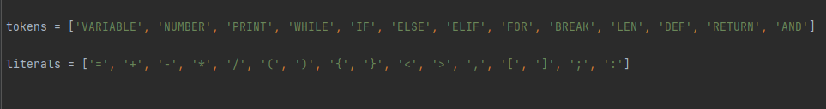

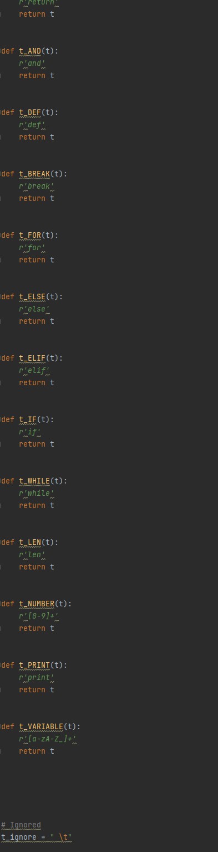

不难发现，这次的token里面多了一些新的关键字，比如说and，return，def。其余和上次的实验保持一致。值得注意的是这些新加入的关键字的优先级都是更高的，要写在变量那些关键字的上面。

1. Yacc语法规则的设计

设计的语法规则展开后如下所示：

Grammar  
  
Rule 0 S' -> program  
Rule 1 program -> statements  
Rule 2 statements -> statements statement  
Rule 3 statements -> statement  
Rule 4 statement -> assignment  
Rule 5 statement -> operation  
Rule 6 statement -> print  
Rule 7 statement -> modification  
Rule 8 statement -> iF  
Rule 9 statement -> whilE  
Rule 10 statement -> for  
Rule 11 statement -> break  
Rule 12 statement -> return  
Rule 13 statement -> function  
Rule 14 statement -> runfunction  
Rule 15 break -> BREAK statements  
Rule 16 break -> BREAK  
Rule 17 return -> RETURN  
Rule 18 for -> FOR ( operation ; condition ; operation ) { statements }  
Rule 19 condition -> VARIABLE > VARIABLE  
Rule 20 condition -> VARIABLE < VARIABLE  
Rule 21 condition -> VARIABLE > NUMBER  
Rule 22 condition -> VARIABLE < NUMBER  
Rule 23 condition -> VARIABLE < = VARIABLE  
Rule 24 condition -> VARIABLE > = VARIABLE  
Rule 25 condition -> VARIABLE [ factor ] > VARIABLE  
Rule 26 condition -> VARIABLE [ factor ] < VARIABLE  
Rule 27 condition -> VARIABLE < VARIABLE AND VARIABLE [ factor ] > VARIABLE  
Rule 28 condition -> VARIABLE < VARIABLE AND VARIABLE [ factor ] < = VARIABLE  
Rule 29 iF -> IF ( condition ) { statements }  
Rule 30 iF -> IF ( condition ) { statements } ELIF ( condition ) { statements } ELSE { statements }  
Rule 31 whilE -> WHILE ( condition ) { statements }  
Rule 32 assignment -> VARIABLE = NUMBER  
Rule 33 assignment -> VARIABLE = [ sentence ]  
Rule 34 modification -> VARIABLE [ factor ] = VARIABLE [ factor ]  
Rule 35 modification -> VARIABLE [ factor ] = VARIABLE  
Rule 36 operation -> VARIABLE = expression  
Rule 37 operation -> VARIABLE + +  
Rule 38 operation -> VARIABLE - -  
Rule 39 expression -> expression + term  
Rule 40 expression -> expression - term  
Rule 41 expression -> term  
Rule 42 expression -> VARIABLE [ factor ]  
Rule 43 expression -> LEN ( term )  
Rule 44 term -> term * factor  
Rule 45 term -> term / factor  
Rule 46 term -> term / / factor  
Rule 47 term -> factor  
Rule 48 factor -> VARIABLE  
Rule 49 factor -> ( expression )  
Rule 50 factor -> NUMBER  
Rule 51 print -> PRINT ( sentence )  
Rule 52 sentence -> word , sentence  
Rule 53 sentence -> word  
Rule 54 word -> NUMBER  
Rule 55 word -> VARIABLE  
Rule 56 function -> DEF VARIABLE ( sentence ) { statements }  
Rule 57 runfunction -> VARIABLE ( sentence )

1. Translation的关键部分逻辑设计
2. 函数FUNCTION



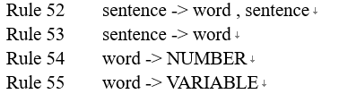

规则在这，可以发现sentence最终可以归约到多个变量上去。

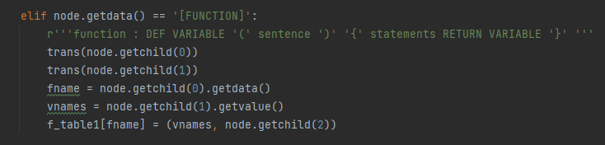

先翻译下头两个结点，也就是变量名和形参sentence。再获取函数名和自变量数组（这个数组具体的值传递方式在sentence部分规定好了），把内容存到放函数的table去即可。

1. 执行函数RUNFUNCTION

规则如下



对应到translation的代码：

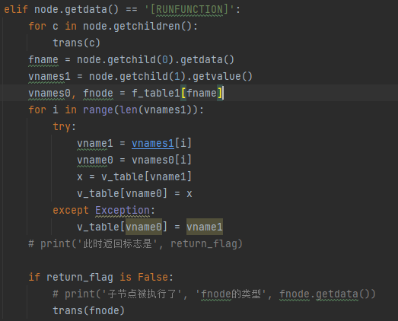

先把函数名取出来，然后找到输入函数的实参名数组，从f_table里面取出形参数组和待执行的子结点，把实参赋值给形参，如果此时函数并没有执行返回语句，那么就Translate子结点。

1. 关于return的信号怎么层层传递回statements去，让函数停止运行。

Return的规则：



首先设置一个return_flag用于表示此时是否return了，如果return了那么该值为True，否则为False。然后设置一个变量用于统计从函数执行的那一层层层返回到应该继续往下执行的那一层statements中间一共几层（自底向上），这个工作在statements自顶向下递归的时候统计完成。然后就不停地向上break掉循环，直到计数器count可以整除该变量，那么就停止break，正常循环，重置count，并把return_flag重新设置为False。

代码：

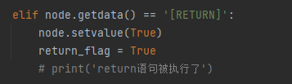

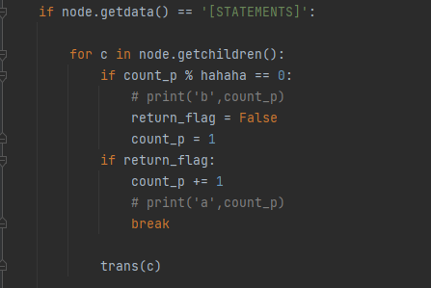

（其中hahaha即为统计向下递归层数的变量）