AE Bra Promotion Enhancements Scope Estimate
This Scope/Estimate Document (S/ED) supplies the following information about the project:
- Outline of Program Features and Goals
- High-Level Technology Requirements
- Level-of-Effort Estimates

The Brierley Technology team created this S/ED based on information supplied by the client about the project. Due to the uncertainties inherent in any complex technology project, the estimations of effort have a variance of +/- 25%. Additionally, the level of effort figures are based on the project team’s understanding of the requirements at the time this document was created. Should the scope or requirements change at any point after approval of this document, the Brierley Technology team may deem it necessary to update this document, re-calibrate the level-of-effort calculations according to the requirements changes, and initiate a second round of client approval prior to proceeding with the next steps of the project.

Objectives & Business Needs
- AE currently runs a promotion where AEREWARD$ members can earn a coupon for a free bra after purchasing 4 qualifying bras.
- Qualifying bras are determined by the following business rules: An item from a specific list of Classes (provided by AE) AND where the final selling price is > $.01.
- The promotion currently runs on a monthly basis, where each month members that have qualified for one or more free bras are included in a file that is sent to the coupon fulfillment vendor. The vendor then mails the qualifiers a coupon to redeem in store or online for a free bra.
- There is currently no limit on the number of free bra coupons a member can earn so long as they continue purchasing qualifying bras.
- AE is considering various updates to this promotion for 2011 including:
  - Bi-weekly fulfillment with hold period - Fulfilling the coupons on a bi-weekly basis with a 2 week hold period between qualifying for a bra and going in a fulfillment file for a free bra coupon.
  - Yearly Bra Counter Reset & Bras Mailed Detail – Resetting the bra counts for all members to 0 at the beginning of each calendar year and breaking out the bras mailed during the current year from bras mailed over the lifetime of the program
  - Buy 5, Get 1 Free - Promotion changes from Buy 4 Qualifying Bras, Get 1 Free to Buy 5 Qualifying Bras, Get 1 free

Assumptions, Dependencies, & Responsibilities
Below is a list of project conditions outside the scope of Brierley technology’s control on which the viability of this project is based. Each of these factors must be present/true to ensure a successful implementation.

- This estimate is based on our current understanding of the project requirements. Any differences between this document and actual requirements must be noted and accounted for, and may have an impact on the delivery date of the project.

- Each enhancement will be scoped separately and an LOE will be provided for each functionality change. AE may choose to implement all of the items detailed in this document or only select to implement a specific function. In the event that all of the new functionalities defined below are implemented, there are some requirements that overlap and those are called out in this document.

- Existing business rules for identifying qualifying bra purchases and returns in member transactions will not be changed for this project:
- A bra qualifies for the promotion if it is from the list of qualifying classes provided by AE and is identified in the TLOG as a ‘purchase’ (using item type =1).
- The bra balance is deducted for bras from the qualifying class list and the item is identified as a return in the TLOG (using item type > 1).
- A free bra redemption is recognized as a bra with an item level reason code matching any bra reason code identified in the reason code calendar that has a purchase price between $0.00 and $0.01 (inclusive) and is from the qualifying class list.
- Employees are not eligible for the bra promotion.
- Unmailable accounts are excluded from fulfillment files.

- While the updates defined in this document will help further reduce the risk of members abusing the program, these changes will not eliminate the possibility of a member abusing the bra program by purchasing enough bras to earn coupons, receiving those coupons, and then returning all of the bras originally purchased. This risk exists today and is not eliminated with the updates outlined in this document.

- There are data elements pertaining to the bra promotion that are exchanged between ae.com and the Brierley web service; however ae.com is not displaying these values on the public website at the present time. It is likely that the values currently exchanged will need to be modified should all of the functionalities outlined in this document be implemented in production, as they may no longer be appropriate to display on the public website. Any such changes to the bra promotion values sent over the web service to ae.com are not included in this effort and will be addressed at a later time – most likely when ae.com is ready to begin displaying bra promotional data on the website.

- In order to execute the fulfillment process bi-monthly, a new reason code calendar must be provided from AE with reason codes, earn dates, pull dates, in-home dates, and all other associated information for each time the fulfillment process is expected to run (doubling the current amount received in the reason code calendar). It is assumed that this calendar will be provided from AE within an agreed upon timeframe prior to project implementation of the bi-monthly fulfillment process.

High-level Requirements

Buy 5 Bras, Get 1 Free

R1. Update the bra promotion rules from ‘Buy 4 Bras, Get 1 Free’ to ‘Buy 5 Bras, Get 1 Free’.
R.1.1 Update the bra promotion processing code so that a member does not qualifying for a free bra until they have purchased 5 qualifying bras instead of 4.
R1.2 Update the count for ‘Current Free Bras Earned’ to be based on 5 qualifying bras purchased instead of 4. This field is currently displayed and/or sent in multiple places throughout the loyalty program, so ensure that it’s updated in all applicable areas:
- Admin Tool
- CheetahMail Weekly File Feed
- Web Service – GetAccountSummary (currentbrasearned)
R1.3 Update the Terms & Conditions page with new copy for promotion update.

LEVEL-OF-EFFORT OVERVIEW
Project Phases | BA / PM  (Business Analyst) | Development | Infrastructure  (Network Engineer) | DBS  (ETL Manager or Reporting Manager) | TOTAL
Requirements Gathering / Documenting | 3 |  |  |  | 3
Development |  | 12 |  |  | 12
QA Testing | 6 | 7 |  |  | 13
UAT | 3 | 4 |  |  | 4
Production Push | 1 | 1 | 1 |  | 3
Total Level-of-Effort |  |  |  |  | 35

Bi-Weekly Fulfillment with Hold Period

R2. Update the monthly bra promotion fulfillment process to run on a bi-weekly basis while incorporating a two-week holding period between a member earning a certificate (aka the free bra coupon) and inclusion in the fulfillment file. Currently the fulfillment process runs once a month and includes any member that has qualified for a free bra since the last fulfillment process was run. A snapshot is taken at the time the fulfillment process is executed that sums the number of qualifying bra purchases and divides that value by 4 to determine how many certificates each qualifying member has earned. This count, along with the member detail, is included in the fulfillment file that is forwarded on to the print vendor that will ultimately mail the coupons to the member.

This process would change so that a member is not included in the fulfillment file until a minimum of 2 weeks has passed since the qualifying purchase was made that earned the certificate. This changes the fulfillment process from taking a ‘snapshot’ at the time the fulfillment file is created to a process where certificates are treated individually based on their associated earn date. The bra fulfillment process would work as follows:

R2.1 The monthly fulfillment process will run on the 1st and 15th of each month, continuing to provide a file of qualifying members and their associated data in the existing file layout format.

R2.2 Load a new reason code calendar containing bra promotion detail for a bi-weekly fulfillment process.
R2.2.1 Modify the job that imports the reason code calendar to look for an ‘Event/Program’ description of ‘Free Bra%’ where the description can be anything so long as it starts with the exact text ‘Free Bra’.

R2.3 Brierley must begin tracking the details for the qualifying transaction that earns the member eligibility for a free bra certificate; including the transaction date on the qualifying transaction.

R2.4 Once a member qualifies for a free bra, the system triggers a holding period where the member is excluded from inclusion in the fulfillment file for that certificate for a minimum of 2 weeks from the qualifying transaction date plus any additional days until the next fulfillment process runs.

R2.4.1 Any qualifying transaction with a transaction date from the 1-15th of the month is eligible to be included in the fulfillment file created on the 1st day of the following month.

R2.4.2 Any qualifying transaction with a transaction date from the 16th through the end of the month is eligible to be included in the fulfillment file created on the 15th day of the following month.

R2.4.3 It is understood that the length of the hold period will vary from member to member based on their qualifying transaction date.
Example:
- Member A qualifies for a free bra on 01/02 (slated for the 02/01 fulfillment file.)
- Member B qualifies for a free bra on 01/14 (also slated for the 02/01 fulfillment file.)
- Member A has a hold period of 29 days, where Member B has a hold period of only 17 days.

R2.5 During that hold period, the system will watch for a return transaction to be received that would prevent the member from qualifying for the free bra.

R2.6 If no return is received, the member is included in the next fulfillment file based on the qualifying transaction date as defined in R1.4.

R2.7 If a qualifying bra return transaction is received, even if it is on the last day before the fulfillment process runs, the member’s ‘Current Qualifying Bras Purchased’ count is decremented and they potentially no longer qualify to be included in the file if that count goes below 5 qualifying bras.

R2.8 If a member qualifies for more than 1 free bra with multiple hold periods, each pending certificate earned must be maintained separately so that returns can deduct from the appropriate certificate.

R2.8.1 If a member is scheduled to be included in multiple fulfillment files and a return transaction is received that deducts the balance such that they no longer qualify for one of the certificates earned, the most recent certificate earned will be eliminated first.

R2.8.2 If the return transaction contains multiple bras returned or if multiple bra return transactions are received, the ‘Current Bras Purchased’ balance is deducted per the normal business rules and could potentially prevent the member from earning multiple certificates. Certificates are deducted by the most recent earned first and working back to the earliest earned certificate that has not yet been fulfilled.

R2.8.3 If a single transaction contains both purchases and returns for qualifying bras, the purchases will be processed first and increment the balance, then the returns will be processed and decrement the balance. This helps to ensure the returns impact the balance.
Example:
- Member has a ‘Current Bras Purchased’ balance = 2
- Transaction is received for the member that contains 3 bra returns and 2 bra purchases.
- If the returns were processed first, only 2 could be deducted since the balance would hit 0. Thus the member would end up with a balance of 2 after the purchases were processed.
- When the purchases are processed first, the member’s balance is incremented to 4, then after the returns are processed, it is decremented to 1.

R2.8.4 If a single transaction contains an equal number of bra purchases and returns (an exchange), the bra balance and associated fulfillment dates will not be impacted.
Example
- Member has a ‘Current Bras Purchased’ balance = 5, with one free certificate earned
- Expected Fulfillment Date is 05/01.
- On 4/17, and exchange transaction is received for the member contain 1 bra purchase and 1 bra return.
- The member’s bra balance remains at 5, and the expected fulfillment date remains at 05/01

R2.9 Modify the bra promotion section of the Admin Tool to display the expected fulfillment date and associated count for each free bra earned in the format ‘<count> ON <mm/dd/yyyy>’ where <count> is the number of certificates earned for the fulfillment period and <mm/dd/yyyy> is the date of fulfillment. See below for example:

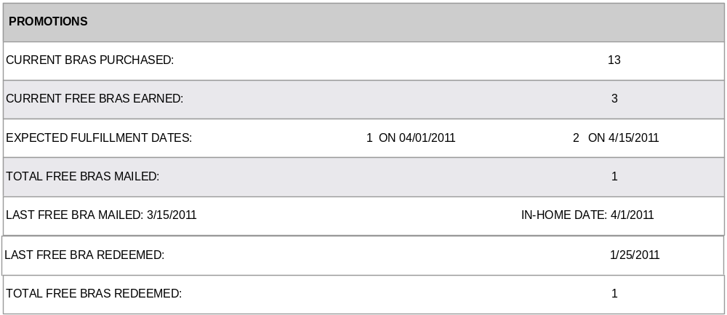
R2.9.1 There should only be 2 fulfillment dates displayed at any given time since the fulfillment process runs bi-monthly.

R2.9.2 If a member only has free bras earned for one fulfillment date, only display 1 column of data. See below for example:

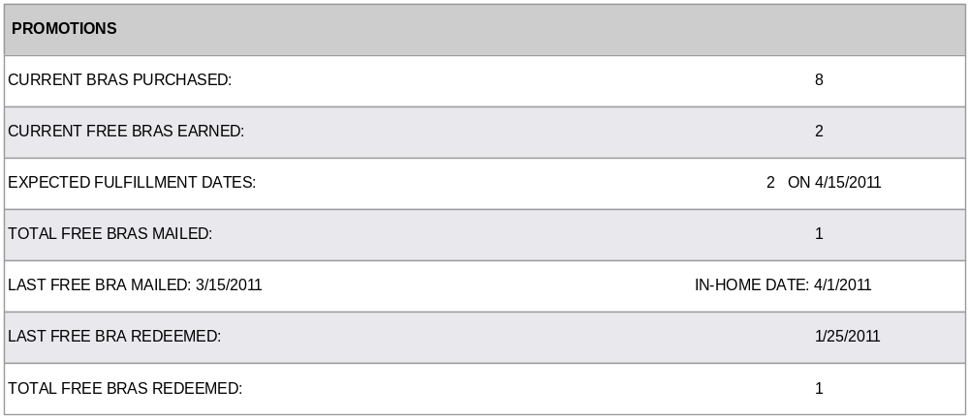

R2.9.3 If no free bras have been earned, the default is to display an empty field:

Unmailable Accounts and Employee Accounts

Unmailable Accounts
R2.10 Members with accounts in ‘Unmailable’ status are still eligible to accrue bras toward the Buy 5, Get 1 Free promotion, however, they will be excluded from all fulfillment files until their address is changed to ‘Mailable’ status. During the time their account is ‘Unmailable’, the system shall handle the account in the following manner:

R2.10.1 The ‘Current Bras Purchased’ balance shall continue to increment/decrement as qualifying bras are purchased and returned.

R2.10.2 The ‘Current Free Bras Earned’ value shall always display 0, regardless of the ‘Current Bras Purchase’ balance. This signifies that the member will not receive any free bra certificates.

R2.10.3 The ‘Expected Fulfillment Dates’ field should also display empty, further clarifying that no certificates will be mailed to the member.

R2.11 Immediately upon updating an ‘Unmailable’ account to ‘Mailable’ address status, the Promotion section should be updated in the following manner:

R2.11.1 The ‘Current Bras Purchased’ balance shall continue to display the current bra balance.

R2.11.2 The ‘Current Free Bras Earned’ value shall be updated to display the number of free bras earned per the current business rules of ‘Current Bras Purchased’ balance divided by 5 (rounded down).

R2.11.3 The ‘Expected Fulfillment Dates’ field should be populated based on the following rules:

R2.1.3.1 If the ‘Expected Fulfillment Date’ for any free bras earned (based on their earn date) is greater than the current system date, display the ‘Expected Fulfillment Date’ value based on the current business rules.

R2.1.3.2 If the ‘Expected Fulfillment Date’ for any free bras earned (based on their earn date) is less than the current system date, meaning the fulfillment date has already passed, display the next scheduled fulfillment date.

Example: Member earns a free bra with a qualifying transaction on 04/02, which would have been fulfilled on 05/01, but the address is ‘Unmailable’. On 06/14, the address is updated to ‘Mailable’ status. Since the fulfillment date associated with the earned certificate is in the past, the system will display the next scheduled fulfillment date of 06/15.

Employee Accounts
R2.12 Members with accounts flagged as ‘Current Employee’ shall continue to be excluded from bra fulfillment files and their bra purchases will not increment or decrement their bra counters. However, since member accounts can move in and out of Current Employee status from quarter to quarter, there will be scenarios where non employees have bra purchases that have not yet been fulfilled, and then their account is changed to employee status. When this occurs, the system shall display the Promotions detail in the following manner:

R2.12.1 The ‘Current Bras Purchased’ balance shall no longer increment while the account is in ‘Current Employee’ status. The balance prior to the status update shall continue to display.

R2.12.2 The ‘Current Free Bras Earned’ value shall always display 0, regardless of the ‘Current Bras Purchase’ balance. This signifies that the employee will not receive any free bra certificates.

R2.12.3 The ‘Expected Fulfillment Dates’ field should also display empty, further clarifying that no certificates will be mailed to the employee.

R2.13 Immediately upon updating a ‘Current Employee’ to ‘Previous Employee’ status (currently part of the Quarterly Rewards process), the Promotion section should be updated in the following manner:

R2.13.1 The ‘Current Bras Purchased’ balance shall continue to display the current bra balance.

R2.13.2 The ‘Current Free Bras Earned’ value shall be updated to display the number of free bras earned per the current business rules of ‘Current Bras Purchased’ balance divided by 5 (rounded down).

R2.13.3 The ‘Expected Fulfillment Dates’ field should be populated based on the following rules:

R2.13.1.1 If the ‘Expected Fulfillment Date’ for any free bras earned (based on their earn date) is greater than the current system date, display the ‘Expected Fulfillment Date’ value based on the current business rules.

R2.13.1.2 If the ‘Expected Fulfillment Date’ for any free bras earned (based on their earn date) is less than the current system date, meaning the fulfillment date has already passed, display the next scheduled fulfillment date.

Get Points Requests
R2.14 Members have the ability to submit a request for Point credit for purchases made any time during the current quarter. In the event such a request is received, the transaction is found, and the transaction is credited to the member, the system must also check if the transaction contains a qualifying bra purchase or return.

R2.14.1 If the transaction submitted in the Get Points request contains no qualifying bra items, no further action is needed.

R2.14.2 If the transaction does contain a qualifying bra item, the system should follow the regular business rules for determining if the transaction will impact the bra balance and adjust it accordingly.

R2.14.3 The transaction must also be checked for a free bra redemption and update the redemption values on the bra counter accordingly (Last Free Bra Redeemed, Total Free Bras Redeemed)

R2.14.4 If the transaction contains enough qualifying bra purchases to earn the member a free bra certificate, the system shall display the ‘Expected Fulfillment Date’ based on the following rules:

R2.14.1.1 If the ‘Expected Fulfillment Date’ for any free bras earned (based on their earn date) is greater than the current system date, display the ‘Expected Fulfillment Date’ value based on the current business rules.

R2.14.1.2 If the ‘Expected Fulfillment Date’ for any free bras earned (based on their earn date) is less than the current system date, meaning the fulfillment date has already passed, display the next scheduled fulfillment date.

R2.14.4 If the transaction submitted in the Get Points request has a transaction date in a different quarter, it will be ignored and the bra purchase/return/redemption will not be recognized. This follows the existing business rule that Get Points requests are only eligible for purchases occurring during the current quarter.

R2.15 Each time the bi-weekly fulfillment process runs, the system must check for any bra certificates that are eligible for fulfillment that have not yet been fulfilled and have passed the two week hold period. The process shall include those certificates in the fulfillment file. This will capture certificates earned for Unmailable > Mailable accounts, Employee – Non Employee accounts, and Get Points requests.
R2.16 Update the Terms & Conditions page with new copy for promotion update.
Overlapping Requirements:

R2.17 In the event the bra data counts are reset at the beginning of each calendar year as described below in R2, any bra returns received during the month of January will not impact the certificates earned for the January fulfillment dates. The bras earned for fulfillment in January can only be impacted if returns are received prior to the data reset.

Bra Promotion with Bi-Weekly Fulfillment and Hold Period - User Scenarios
The following scenarios outline how the system should handle the bra promotion and fulfillment of certificates using a bi-weekly fulfillment process with the 2 week hold period.

Scenario 1 – Standard free bra qualification and fulfillment
- Member qualifies for a free bra coupon for a transaction that occurs on 10/20.
- Member’s ‘Current Bras Purchased’ count is 5.
- Fulfillment process runs on 11/1; member is excluded because she hasn’t met the 2 week holding period.
- Member makes no additional bra purchases during hold period.
- Member is included with one certificate earned in the 11/15 fulfillment file.

Scenario 2 – Free bra qualification with return during hold period that prevents fulfillment
- Member qualifies for a free bra coupon for a transaction that occurs on 10/20.
- Member’s ‘Current Bras Purchased’ count is 5.
- Fulfillment process runs on 11/1; member is excluded because she hasn’t met the 2 week holding period.
- Member returns 2 bras on 11/3; her ‘Current Bras Purchased’ count is now 3 so she no longer qualifies for the fulfillment process on 11/15.

Scenario 3 – Free bra qualification with return during hold period that does not prevent fulfillment
- Member qualifies for a free bra coupon for a transaction that occurs on 10/20.
- Member’s ‘Current Bras Purchased’ count is 6.
- Fulfillment process runs on 11/1; member is excluded because she hasn’t met the 2 week holding period.
- Member returns a bra on 11/3; her ‘Current Bras Purchased’ count is now 5.
- Member is included with one certificate earned in the 11/15 fulfillment file.
- Member’s ‘Current Bras Purchased’ count is 0.

Scenario 4 – Multiple bras earned during the same holding period
- Member qualifies for a free bra coupon for a transaction that occurs on 10/20.
- Member’s ‘Current Bras Purchased’ count is 5.
- Member qualifies for a second free bra coupon for a transaction that occurs on 10/21.
- Member’s ‘Current Bras Purchased’ count is 10.
- Fulfillment process runs on 11/1; member is excluded because she hasn’t met the 2 week holding period.
- Member makes no additional bra purchases during hold period.
- Member is included with two certificates earned in the 11/15 fulfillment file.
- Member’s ‘Current Bras Purchased’ count is 0.

Scenario 5 – Multiple bras earned during different hold periods
- Member qualifies for a free bra coupon for a transaction that occurs on 10/20.
- Member’s ‘Current Bras Purchased’ count is 5.
- Member qualifies for a second free bra coupon for a transaction that occurs on 11/1.
- Member’s ‘Current Bras Purchased’ count is 11.
- Fulfillment process runs on 11/1; member is excluded because she hasn’t met the 2 week holding period.
- Member is included with one certificate earned in the 11/15 fulfillment file.
- Member’s ‘Current Bras Purchased’ count is 6.
- Member is included with one certificate earned in the 12/1 fulfillment file.
- Member’s ‘Current Bras Purchased’ count is 1.

Scenario 6 – Return and new purchase during holding period
- Member qualifies for a free bra coupon for a transaction that occurs on 10/20.
- Member’s ‘Current Bras Purchased’ count is 6.
- Fulfillment process runs on 11/1; member is excluded because she hasn’t met the 2 week holding period.
- Member returns a bra on 11/3; her ‘Current Bras Purchased’ count is now 3, so now she no longer qualifies for the fulfillment process on 11/15.
- Member purchases two qualifying bras on 11/10.
- Member’s ‘Current Bras Purchased’ count is incremented to 5.
- Member is excluded from the 11/15 run because she hasn’t met the 2 week minimum hold period from the most recent qualifying transaction (11/10).
- Member is included with one certificate earned in the 12/1 fulfillment file.
- Member’s ‘Current Bras Purchased’ count is 0.

Scenario 7 – Exchange during holding period
- Member qualifies for a free bra coupon for a transaction that occurs on 10/20.
- Member’s ‘Current Bras Purchased’ count is 5.
- Fulfillment process runs on 11/1; member is excluded because she hasn’t met the 2 week holding period.
- Member exchanges a bra on 11/3 (different size, color, etc)
- Member’s ‘Current Bras Purchased’ count is decremented to 4, but then incremented back to 5 as the return and new purchase are processed.
- Member is included with one certificate in the 1/15 fulfillment file.
- Member’s ‘Current Bras Purchased’ count is 0.

Scenario 8 – Employee transaction during hold period
- Non-employee member qualifies for a free bra coupon for a transaction that occurs on 5/20.
- Member’s ‘Current Bras Purchased’ count is 5.
- Fulfillment process runs on 6/1; member is excluded because she hasn’t met the 2 week holding period.
- On 6/10, a transaction is received that sets the member to employee status.
- Although all of the qualifying bras were purchased while the member was a non-employee, she is excluded from the 6/15 fulfillment file because she is now set to employee status. Any additional bras purchased during employee status window do not increment the count per the current business rules.
- Member’s ‘Current Bras Purchased’ count remains at 5, but with employee status.
- When quarterly rewards is run on 7/1, employee status is removed and member is included in the 7/15 fulfillment file with 1 certificate earned.

Scenario 9 – Multiple coupons during same hold period with return
- Member qualifies for a free bra coupon for a transaction that occurs on 10/20, scheduled for the 11/15 fulfillment file.
- Member’s ‘Current Bras Purchased’ count is 5.
- Member qualifies for additional free bra for a transaction that occurs on 10/30, scheduled for the 11/15 fulfillment file.
- Member’s ‘Current Bras Purchased’ count is 10.
- Fulfillment process runs on 11/1, they are excluded because they haven’t met the 2 week holding period for either bra purchase.
- Member returns 1 bra on 11/14.
- Member’s ‘Current Bras Purchased’ count is 9.
- Member is included in 11/15 fulfillment file with only 1 bra certificate earned.
- Member’s ‘Current Bras Purchased’ count is 4.

Scenario 10 – Multiple coupons during different hold periods with return
- Member qualifies for a free bra coupon for a transaction that occurs on 10/10, scheduled for the 11/1 fulfillment file.
- Member’s ‘Current Bras Purchased’ count is 5.
- Member qualifies for additional free bra for a transaction that occurs on 10/20, scheduled for the 11/15 fulfillment file.
- Member’s ‘Current Bras Purchased’ count is 10.
- Member returns a bra on 10/31.
- Member’s ‘Current Bras Purchased’ count is 9.
- Return deducts from most recent earned certificate (10/20).
- Fulfillment process runs on 11/1, and member is included with 1 certificate earned for the 10/10 qualifying transaction.
- Member’s ‘Current Bras Purchased’ count is 4.
- Member is excluded from 11/15 fulfillment file due to the return on 10/31.

Scenario 11 – Multiple coupons earned with multiple bras returned in 1 transaction
- Member qualifies for a free bra coupon for a transaction that occurs on 10/10, scheduled for the 11/1 fulfillment file.
- Member’s ‘Current Bras Purchased’ count is 5.
- Member qualifies for additional free bra for a transaction that occurs on 10/20, scheduled for the 11/15 fulfillment file.
- Member’s Current Bras Purchased’ count is 10.
- Member returns 6 bras on 10/31.
- Member’s ‘Current Bras Purchased’ count is 4.
- Fulfillment process runs on 11/1, and member is excluded due to returns on 10/31.
- Fulfillment process runs on 11/15, and member is excluded due to returns on 10/31.

Scenario 12 – Multiple coupons earned with multiple bras returned in multiple transactions
- Member qualifies for a free bra coupon for a transaction that occurs on 10/10, scheduled for the 11/1 fulfillment file.
- Member’s ‘Current Bras Purchased’ count is 5.
- Member qualifies for additional free bra for a transaction that occurs on 10/20, scheduled for the 11/15 fulfillment file.
- Member’s ‘Current Bras Purchased’ count is 10.
- Member returns 4 bras on 10/30.
- Member’s ‘Current Bras Purchased’ count is 6, and member is still scheduled to be included in the 11/1 fulfillment file.
- Member returns 2 bras on 10/31.
- Member’s ‘Current Bras Purchased’ count is 4.
- Fulfillment process runs on 11/1, and member is excluded due to returns on 10/31.
- Fulfillment process runs on 11/15, and member excluded due to returns on 10/30.

Scenario 13 – Return after hold period
- Member qualifies for a free bra coupon for a transaction that occurs on 10/10.
- Member’s ‘Current Bras Purchased’ count is 5.
- Fulfillment process runs on 10/15; member is excluded because she hasn’t met the 2 week holding period.
- Fulfillment process runs on 11/1, member is included with 1 certificate.
- Member’s ‘Current Bras Purchased’ count is 0.
- Member returns a bra on 11/3.
- Bra counter is not impacted since current bra count is 0 and can’t go below 0.
- Note: this scenario exists per the current business rules today – no process change.

Scenario 14 – Accounts merged during hold period
- Account A qualifies for a free bra coupon for a transaction that occurs on 10/14, scheduled for the 11/1 fulfillment file.
- Member A’s ‘Current Bras Purchased’ count is 5.
- Account B qualifies for a free bra coupon for a transaction that occurs on 10/17, scheduled for the 11/15 fulfillment file.
- Member B’s ‘Current Bras Purchased’ count is 6.
- Account A & Account B are merged on 10/30.
- Member’s new ‘Current Bras Purchased’ count after the merge is 11.
- Member is included in 11/1 fulfillment file with 1 certificate for the 10/14 transaction.
- Member’s ‘Current Bras Purchased’ count is 6.
- Member is included in 11/15 fulfillment file with 1 certificate for the 10/17 transaction.
- Member’s ‘Current Bras Purchased’ count is 1.

Overlapping Requirements:

Scenario 15 – Return after yearly bra data reset
Member qualifies for a free bra coupon for a transaction that occurs on 12/20, scheduled for the 1/15 fulfillment file.
- Member’s ‘Current Bras Purchased’ count is 5.
- Bra data reset occurs on 1/1.
- Member’s ‘Current Bras Purchased’ count is 0.
- Fulfillment process runs on 1/1; member is excluded because she hasn’t met the 2 week holding period
- Member returns a bra on 1/5.
- Bra counter is not impacted since ‘Current Bras Purchased’ count is 0 and can’t go below 0.
- Fulfillment process runs on 1/15 and member is included with one certificate for the 12/20 transaction. Return on 1/5 does not negatively impact the member for this time period.

LEVEL-OF-EFFORT OVERVIEW
Project Phases | BA / PM  (Business Analyst) | Development | Infrastructure  (Network Engineer) | DBS  (ETL Manager or Reporting Manager) | TOTAL
Requirements Gathering / Documenting | 10 |  |  |  | 10
Development |  | 30 |  |  | 30
QA Testing | 10 | 15 |  |  | 25
UAT | 8 | 10 | 1 |  | 18
Production Push | 1 | 1 | 1 |  | 3
Total Level-of-Effort |  |  |  |  | 86

Yearly Bra Counter Reset & Bras Mailed Detail

R2 Create a process that will reset specific values for the bra promotion to 0 at the beginning of each calendar year for all members, and break out the ‘Total Bras Mailed’ value on a lifetime and current year basis.

R2.1 Reset the following values at the beginning of each calendar year, after the fulfillment process has been successfully executed:

- Current Bras Purchased
- Current Free Bras Earned
- Total Free Bras Mailed - Current Year

R2.1.1 The following values will NOT reset to 0 each year:
- Total Free Bras Mailed – Lifetime
- Last Free Bra Mailed
- In-Home Date
- Last Free Bra Redeemed
- Total Free Bras Redeemed

R2.1.2 The member will forfeit any qualifying bras accumulated at the end of the year that were not converted to free bra coupons.

R2.1.3 Bra coupons sent in the fulfillment files in January will count toward the current year even though the bra purchases that qualified for those coupons were made during the previous calendar year. This ensures the count for ‘Total Bras Mailed – Current Year’ clearly depicts the count that were physically mailed during the existing calendar year.

R2.2 Update the Bra Promotion section of the Admin Tool:

R2.2.1 Update the existing label ‘Total Free Bras Mailed:’ to state ‘Total Free Bras Mailed – Lifetime:’. This value will continue to display the total number of certificates the member has earned and been mailed via the promotion fulfillment file over their lifetime in the program.
* Note - This count will remain the value sent in the GetAccountSummary web service call for ‘freebrasmailed’ and the value sent for ‘Total Bras Mailed’ in the weekly feed to CheetahMail.

R2.2.2 Add a new label between ‘Current Free Bras Earned:’ and ‘Total Free Bras Mailed – Lifetime:’ called
‘Total Free Bras Mailed – Current Year:’

R2.2.3 For the new value ‘Total Free Bras Mailed - Current Year’, display the number of certificates the member has earned that have already been sent in the monthly promotion fulfillment files for the current calendar year only. See below for example:

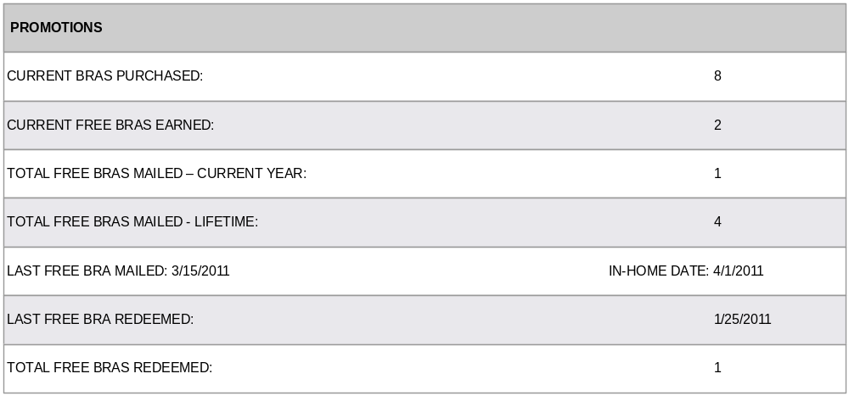
R2.3 Update the Terms & Conditions page with new copy for promotion update.

LEVEL-OF-EFFORT OVERVIEW
Project Phases | BA / PM  (Business Analyst) | Development | Infrastructure  (Network Engineer) | DBS  (ETL Manager or Reporting Manager) | TOTAL
Requirements Gathering / Documenting | 7 |  |  |  | 7
Development |  | 15 |  |  | 15
QA Testing | 8 | 8 |  |  | 16
UAT | 6 | 10 | 1 |  | 17
Production Push | 1 | 1 | 1 |  | 3
Total Level-of-Effort |  |  |  |  | 58

Overlapping Requirements:

Note: If all requirements listed above are approved for implementation including the two week hold period and Total Mailed breakout, the Promotions section of the Admin Tool will look as follows (with sample data populated):

Assume current date = 3/20/2011. Member has made enough purchases to earn multiple free bras, fulfilling on different dates:
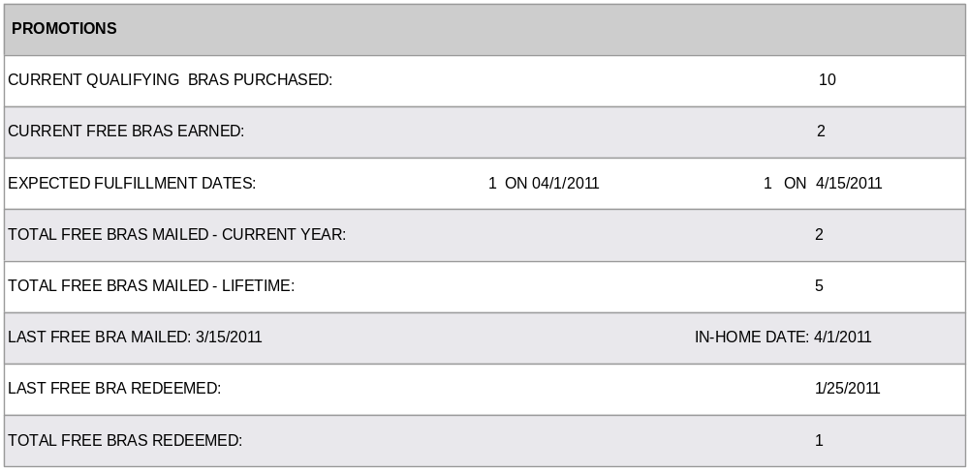

Fulfillment process runs on 4/1 and ‘Current Bras Purchased’ and ‘Current Free Bras Earned’ values are decremented. ‘Total Free Bras Mailed – Current Year’ and ‘Total Free Bras Mailed – Lifetime’ are incremented. Member is still scheduled for fulfillment of 1 additional free bra on 4/15.
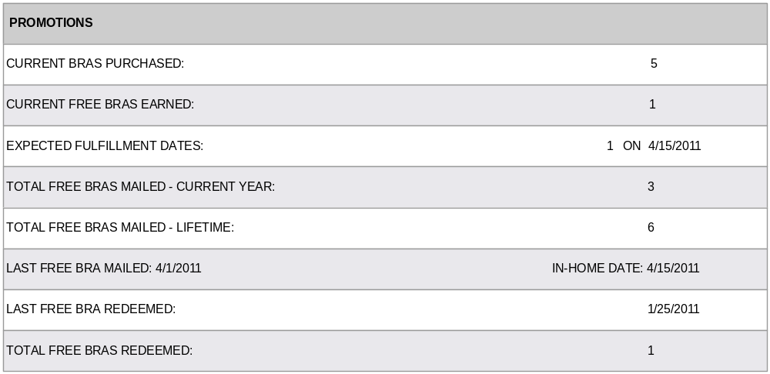

After 4/15 fulfillment, ‘Current Bras Purchased’ and ‘Current Free Bras Earned’ values are decremented. ‘Total Free Bras Mailed – Current Year’ and ‘Total Free Bras Mailed – Lifetime’ are incremented.
