Program artiFISHal File Descriptions

Inputs
Inputs.xls - Excel spreadsheet used to input data
tab SimLake - inputs for lake shape
tab SimFish - inputs for fish population
tab Sample - inputs for down-looking acoustics and midwater trawls

R scripts
*.r - text files with R program commands
SimulateFish.r - create a simulated population of fish in an artificial lake
SampleFish.r - sample simulated population of fish with down-looking acoustics (cross-lake, west-to-east) and midwater trawls (west-to-east)

Outputs
*.pdf - graphical output from R program
Diagnostics-lake#.pdf - diagnostic plots of fish population
Survey-lake#-run#.pdf - diagnostic plots of acoustics and midwater trawl sampling
*.csv - comma delimited file, used to output data from R program
ACTargets-lake#-run#.csv - individual acoustic targets
ACSummaryIL-lake#-run#.csv - summary of acoustic targets by interval (I) and layer (L)
ACSummaryI-lake#-run#.csv - summary of acoustic targets by interval (I)
MTRCatch-lake#-run#.csv - individual fish captured in midwater trawl
truth-lake#.csv - number and biomass of true population of fish in lake
*.Rdata - collection of R objects
fish-lake#.Rdata - true population of fish in lake, one row per fish
inputs-lake#.Rdata - collection of R objects that are used in multiple R scripts
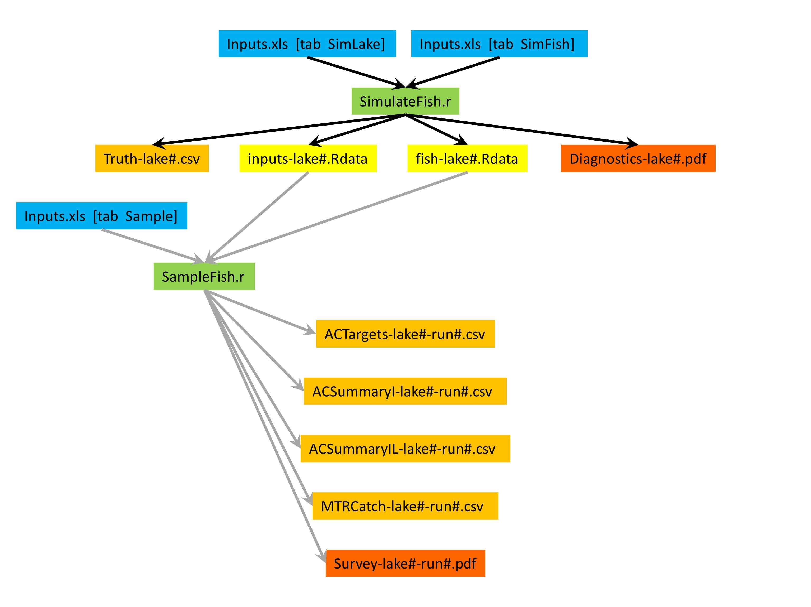

Flowchart showing relationship among inputs (blue), scripts (green), and outputs (orange, yellow, and red). Follow the black arrows (top) to create a fish population in a lake, the gray arrows to survey the lake with down-looking acoustics and midwater trawls.

################################################################################################
### artiFISHal ###
### U.S. Geological Survey (USGS) Computer Program "artiFISHal" version 2014-04 ###
### Written by Jean V. Adams, USGS - Great Lakes Science Center, Ann Arbor, Michigan, USA ###
### Use of this program was first described by Jean V. Adams in a publication by ###
### Yule et al. (2013) in the Canadian Journal of Fisheries and Aquatic Sciences ###
### Written in programming language R (R Core Team, 2013, www.R-project.org), ###
### version 3.0.1 (2013-05-16) ###
### Run on a PC with Intel(R) Core(TM)2 Duo CPU P8600 @ 2.40 GHz processor, 8.00 GB RAM, ###
### and Microsoft Windows 7 Enterprise operating system 2009 Service Pack 1 ###
### Source code is available from Jean V. Adams, jvadams@usgs.gov ###
################################################################################################

################################################################################################
### artiFISHal ###
### Disclaimer: ###
### Although this program has been used by the USGS, no warranty, expressed or implied, is ###
### made by the USGS or the United States Government as to the accuracy and functioning of ###
### the program and related program material nor shall the fact of distribution constitute ###
### any such warranty, and no responsibility is assumed by the USGS in connection therewith. ###
################################################################################################

