General R Markdown Template

For Word Documents

Jean V. Adams

1 Mar 2015

This is an R Markdown template for creating a Word document. To use these styles in other Word documents created by R Markdown, use reference_docx: WordRMDTemplateGeneral.docx For more details, see [R Markdown](http://rmarkdown.rstudio.com).

# Header fonts

# Header 1

## Header 2

### Header 3

#### Header 4

##### Header 5

Header 6

# Lists

Unordered List:

* This item
* That item
  + A that subitem
  + Another that subitem

Ordered List:

1. Item 1
2. Item 2
3. Item 3
   1. Item 3a
   2. Item 3b

# Tables

You can create tables using simple source code (Table 1) or using the knitr function kable (Table 2).

**Table 1.** First few rows of mtcars using simple source code.

mpg cyl disp hp drat wt qsec vs am gear carb  
Mazda RX4 21.0 6 160 110 3.90 2.620 16.46 0 1 4 4  
Mazda RX4 Wag 21.0 6 160 110 3.90 2.875 17.02 0 1 4 4  
Datsun 710 22.8 4 108 93 3.85 2.320 18.61 1 1 4 1  
Hornet 4 Drive 21.4 6 258 110 3.08 3.215 19.44 1 0 3 1  
Hornet Sportabout 18.7 8 360 175 3.15 3.440 17.02 0 0 3 2  
Valiant 18.1 6 225 105 2.76 3.460 20.22 1 0 3 1

**Table 1.** First few rows of mtcars using kable.

|  |  |  |  |  |  |  |  |  |  |  |  |
| --- | --- | --- | --- | --- | --- | --- | --- | --- | --- | --- | --- |
|  | mpg | cyl | disp | hp | drat | wt | qsec | vs | am | gear | carb |
| Mazda RX4 | 21.0 | 6 | 160 | 110 | 3.90 | 2.620 | 16.46 | 0 | 1 | 4 | 4 |
| Mazda RX4 Wag | 21.0 | 6 | 160 | 110 | 3.90 | 2.875 | 17.02 | 0 | 1 | 4 | 4 |
| Datsun 710 | 22.8 | 4 | 108 | 93 | 3.85 | 2.320 | 18.61 | 1 | 1 | 4 | 1 |
| Hornet 4 Drive | 21.4 | 6 | 258 | 110 | 3.08 | 3.215 | 19.44 | 1 | 0 | 3 | 1 |
| Hornet Sportabout | 18.7 | 8 | 360 | 175 | 3.15 | 3.440 | 17.02 | 0 | 0 | 3 | 2 |
| Valiant | 18.1 | 6 | 225 | 105 | 2.76 | 3.460 | 20.22 | 1 | 0 | 3 | 1 |

# Figures

You can embed figures, too (Figure 1).

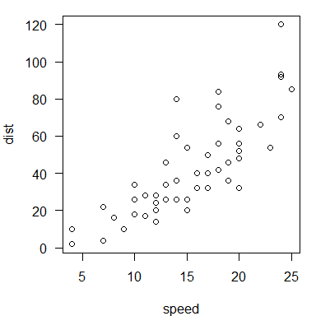

**Figure 1.** Simple plot of cars, default size.

# Miscellany

Inline equation: $A=π*r^{2}$

Displayed equation:

$$A=π*r^{2}$$

superscript2

subscriptij

~~strikethrough~~

Horizontal rule:

Block quote for a long piece of indented text. When you click the **Knit** button a document will be generated that includes both content as well as the output of any embedded R code chunks within the document.