Jack Barry

11/8/2016

AI homework 5

1. I ran the k-means algorithm on two images with different dominant color schemes to see the effects that it would have on the clustering of colors dependent on the number of colors defined in the code. I did trials with 64, 10, 5, and 2 colors. Some of the results can be seen below. The interesting part of this experiment is that the colors that are dominant in the original image come to replace the colors the are less dominant. This is apparent in the image immediately below. I have blue eyes but when I limit the number of colors that can we use to render the image my eyes appear to be a light brown or blondish colors like my hair, my hair is also noticeably more brown as all the colors converge to a combination of my skin and hair colors and the white backdrop. It is also interesting to note that with the experiment on the first image the code took much longer to run. I suspect it is because that image was a much higher quality being a headshot rather than a selfie taken from my phone on Halloween like that second image. In regards to the second image the same clustering around dominant colors is noticed as it moves toward light and dark shades of black and white with some brown tint. After experimenting on pictures containing my face I wanted to see what would happen to an image without a face and a more evenly distributed color scheme so I ran the code on a rainbow picture. The results were interesting but to be expected, the colors clustered around a compromised middle group for the representation of a shade of color. The results are pictured below. The rainbow converges to a brown shade when the number of colors is limited to 1, which we learn as children is was happens when you take all the rainbow colors of paint and mix them together.

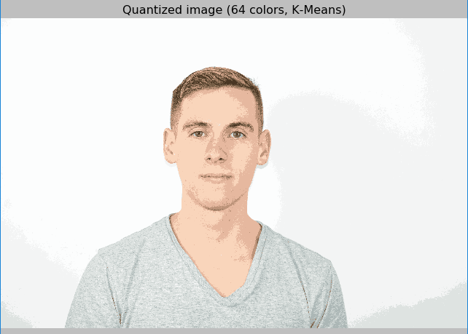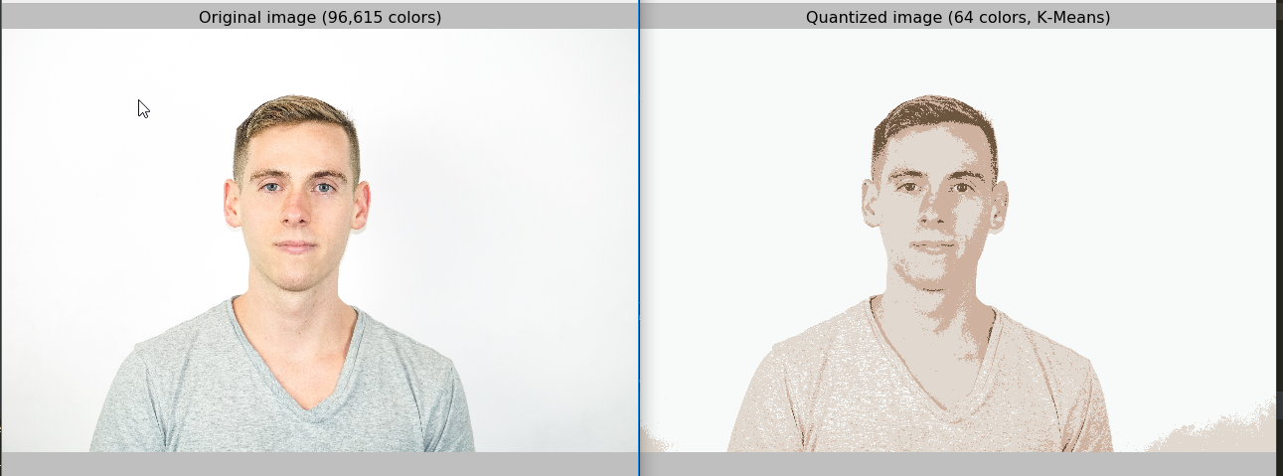





1. After running MLP with 1000 samples the following results were reached

Neurons 1, eta 0.1. Testing set CV score: -6.569748

Neurons 3, eta 0.7. Testing set CV score: -4.529462

Neurons 23, eta 0.2. Testing set CV score: -4.511360

Neurons 37, eta 0.2. Testing set CV score: -3.571403

Iteration 1, loss = 2.95433499

Iteration 2, loss = 0.51924785

Iteration 3, loss = 0.24700023

Iteration 4, loss = 0.17098925

Iteration 5, loss = 0.08531583

Iteration 6, loss = 0.06462834

Iteration 7, loss = 0.06285819

Iteration 8, loss = 0.05853279

Iteration 9, loss = 0.03355900

Iteration 10, loss = 0.02242580

Iteration 11, loss = 0.01852370

Iteration 12, loss = 0.01697422

Iteration 13, loss = 0.01314419

Iteration 14, loss = 0.01162239

Iteration 15, loss = 0.01158739

Iteration 16, loss = 0.01056230

Iteration 17, loss = 0.01148044

Iteration 18, loss = 0.01180852

Iteration 19, loss = 0.01030580

Iteration 20, loss = 0.01026301

Iteration 21, loss = 0.01065703

Iteration 22, loss = 0.01186907

Training loss did not improve more than tol=0.000100 for two consecutive epochs. Stopping.

Training set score: 0.876439

Testing set score: 0.874371

Neurons 1, eta 0.1. Testing set CV score: -52.538799

Neurons 1, eta 0.2. Testing set CV score: -28.376350

Neurons 1, eta 0.3. Testing set CV score: -20.798974

Neurons 1, eta 0.5. Testing set CV score: -16.216934

Neurons 1, eta 0.6. Testing set CV score: -14.039907

Neurons 1, eta 0.9. Testing set CV score: -11.431661

Neurons 2, eta 0.1. Testing set CV score: -10.707360

Neurons 3, eta 0.5. Testing set CV score: -9.033829

Neurons 23, eta 0.3. Testing set CV score: -7.075958

Neurons 25, eta 0.2. Testing set CV score: -5.820201

Neurons 37, eta 0.2. Testing set CV score: -3.982872

Neurons 96, eta 0.1. Testing set CV score: -3.896675

Iteration 1, loss = 1.48016275

Iteration 2, loss = 0.41232125

Iteration 3, loss = 0.15397569

Iteration 4, loss = 0.10565967

Iteration 5, loss = 0.07412626

Iteration 6, loss = 0.05153479

Iteration 7, loss = 0.04162751

Iteration 8, loss = 0.02639700

Iteration 9, loss = 0.02063785

Iteration 10, loss = 0.02070784

Iteration 11, loss = 0.01761135

Iteration 12, loss = 0.01392871

Iteration 13, loss = 0.01269225

Iteration 14, loss = 0.01120862

Iteration 15, loss = 0.01045273

Iteration 16, loss = 0.01037838

Iteration 17, loss = 0.00986997

Iteration 18, loss = 0.01065520

Iteration 19, loss = 0.01172710

Iteration 20, loss = 0.00893691

Iteration 21, loss = 0.00938176

Iteration 22, loss = 0.00971290

Iteration 23, loss = 0.00919122

Training loss did not improve more than tol=0.000100 for two consecutive epochs. Stopping.

Training set score: 0.907571

Testing set score: 0.904722