COMPILER DESIGN LAB REPORT

Date: 04 Jan 2025
Name: Jeevandeep LN Shettigar
Registration No: 220905016
Section: C - I
Roll No: 5

Lab Title: Lab 1 – Basic File Handling

Question 1:
Write a C program to count number of lines and characters in a file.

Solution:

#include<stdio.h>
#include<stdlib.h>

int main(int argc, char **argv) {
if(argc <= 1) {
printf("ERROR - Insufficient arguements passed to program\n");
return 0;
}
FILE *fp1;
char c = '\0';
int charCount = 0;
int lineCount = 0;

fp1 = fopen(argv[1], "r+");
if(fp1 == NULL) {
printf("ERROR - supplied file %s doesnt exist\n", argv[1]);
}
c = fgetc(fp1);
while(c != EOF) {
charCount += (c != '\n' && c != '\t'); //dont count new line and tab spaces
if(c == '\n')
lineCount++;
c = fgetc(fp1);
}
lineCount += charCount > 0; //if empty file then 0 lines, else add 1 to account for lack of a new line symbol before 1st line
printf("Line Count = %d\nChar Count = %d\n", lineCount, charCount);
return 0;
}

Sample I/0:
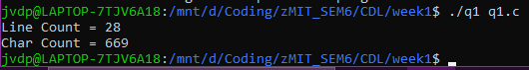

Question 2:
Write a C program to reverse the contents of a file and store it in another file. Also display the size of the file.

Solution:

#include<stdio.h>
#include<stdlib.h>

int main(int argc, char **argv) {
if(argc <= 2) {
printf("ERROR - Insufficient arguements passed to program\n");
return 0;
}
FILE *fp1, *fp2;
char c = '\0';
int curPos = 0;

fp1 = fopen(argv[1], "r+");
if(fp1 == NULL) {
printf("ERROR - supplied file %s doesnt exist\n", argv[1]);
}
fp2 = fopen(argv[2], "w+");

fseek(fp1, 1, SEEK_END); //go past EOF to avoid overflow in case of empty file
curPos = ftell(fp1); //use separate var to track current position to handle overflow once operation finishes
printf("File size: %d bytes\n", curPos - 1);
if(curPos == 1) {
fclose(fp1);
fclose(fp2);
return 0;
}
while(curPos >= 2) {
fseek(fp1, -2, SEEK_CUR); //since we start 2 pos after last char, if non-empty file
c = fgetc(fp1);
fputc(c, fp2); //increments current pos by 1, hence we decrement by 2 above
curPos--;
}
fclose(fp1);
fclose(fp2);
return 0;
}

Sample I/O:
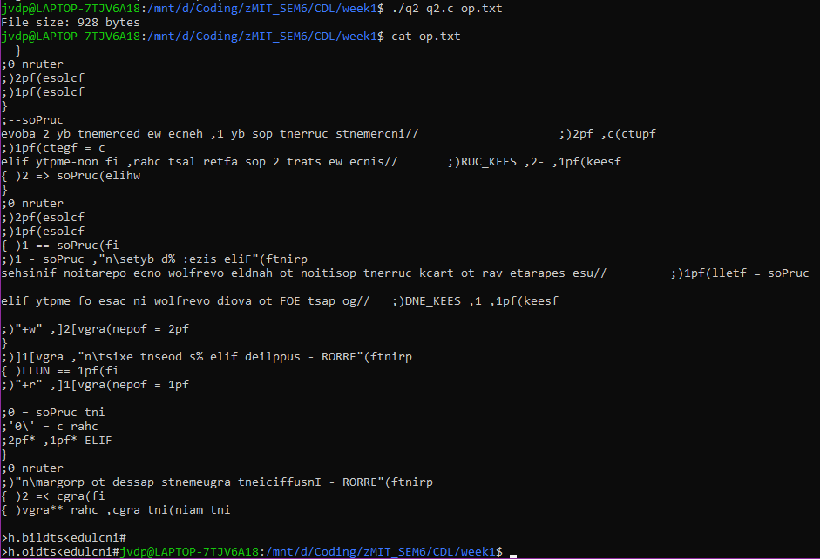

Question 3:
Write a C program to alternatively merge the lines of two file contents into another file.

Solution:

#include<stdio.h>
#include<stdlib.h>

int main(int argc, char **argv) {
if(argc <= 3) {
printf("ERROR - Insufficient arguements passed to program\n");
return 0;
}
FILE *fp1, *fp2, *fp3;
char c1 = 'a';
char c2 = 'a';
int done1 = 0;
int done2 = 0;

fp1 = fopen(argv[1], "r+");
if(fp1 == NULL) {
printf("ERROR - supplied file %s doesnt exist\n", argv[1]);
}
fp2 = fopen(argv[2], "r+");
if(fp1 == NULL) {
printf("ERROR - supplied file %s doesnt exist\n", argv[2]);
}
fp3 = fopen(argv[3], "w+");

while(c1 != EOF || c2 != EOF) {
if(c1 != EOF)
c1 = fgetc(fp1);
if(c2 != EOF)
c2 = fgetc(fp2);
while(c1 != EOF && c1 != '\n') {
fputc(c1, fp3);
c1 = fgetc(fp1);
}
fputc('\n', fp3);
while(c2 != EOF && c2 != '\n') {
fputc(c2, fp3);
c2 = fgetc(fp2);
}
fputc('\n', fp3);
}
fclose(fp1);
fclose(fp2);
fclose(fp3);
return 0;
}

Sample I/O:
