WEB PROGRAMMING LAB – HOME ASSIGNMENT 1

Question:

Solution:
- <article>
  - It is used to represent a self-contained piece of content that can be independently distributed or reused. Typically, it is used for content that makes sense on its own, such as blog posts, news articles, forum posts, or any other type of standalone content that could be syndicated or shared.
  - Example:
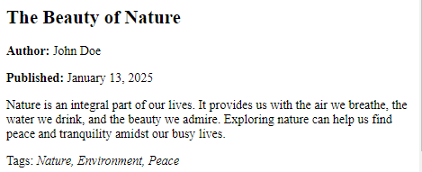
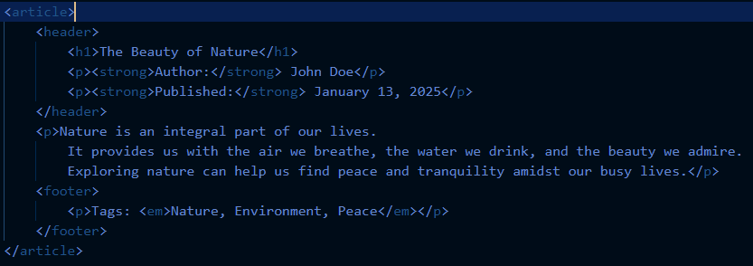
- <aside>
  - It is used to represent content that is tangentially related to the content around it, often placed as a sidebar or an additional section that can provide supplementary information. It is typically used for content that is not essential to the main flow of the document but still relevant to the surrounding content.
  - Example:
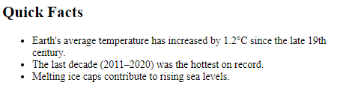
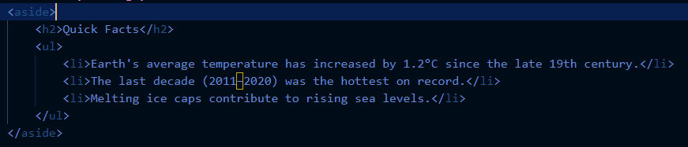
- <audio>
  - It is used to embed audio content in a webpage, such as music, sound effects, or voice recordings. It allows you to add audio without relying on external plugins (like Flash) and provides a standardized way to control playback, volume, and other audio-related settings.
  - Example:
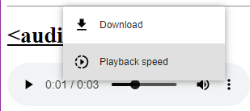 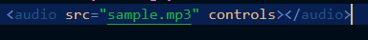
- <canvas>
  - It is used to draw graphics on the fly via JavaScript. It is a powerful feature for rendering 2D shapes, images, animations, and even complex visualizations directly on a webpage. The <canvas> element itself is a blank area on the page, and its contents are drawn programmatically using JavaScript.
  - Example:
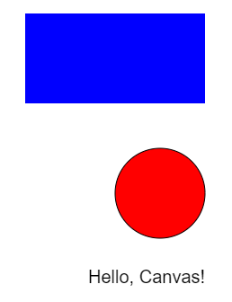 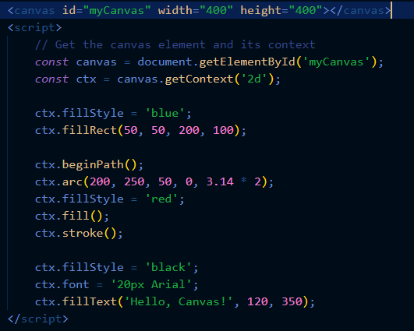
- <command>
  - It is used to define a command button that can be activated by the user. It represents a command the user can invoke, such as an action button (e.g., a "Save" or "Delete" button), and is typically used within user interfaces where actions are expected.
This tag is deprecated.
- <datalist>
  - It is used to provide a list of predefined options for an <input> element. It is typically used with <input> fields to offer a list of suggestions or autocomplete options, helping the user fill in the input more easily by selecting from the list.
  - Example:
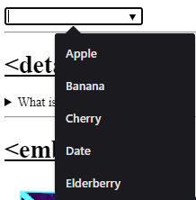 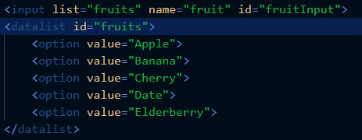
- <details>
  - It is used to create a disclosure widget from which the user can view or hide additional content. It is often used for creating interactive sections where the content is initially hidden, but can be revealed when the user clicks on the widget (usually the summary). The <details> tag enhances the user experience by keeping the page clean and organized while providing optional content that users can access when needed.
  - Example:
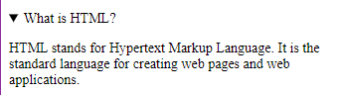 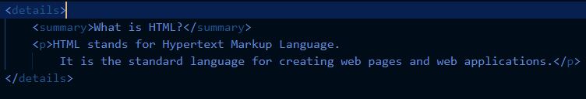
- <embed>
  - It is used to embed external content, such as multimedia (audio, video, or interactive elements), applications, or other resources like PDFs or Flash files, into a webpage. It acts as a container for embedded media or resources, allowing you to integrate non-HTML content directly into your page without the need for external plugins (other than the browser's native support for the embedded resource).
  - Example:
 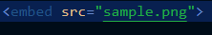
- <figure>
  - It is used to group and display media content along with its caption. It is typically used for images, illustrations, diagrams, charts, or other media that need to be referenced or explained, and it can be paired with the <figcaption> tag to provide a caption or description for the content. This helps to provide semantic structure to the webpage and improves accessibility.
  - Example:
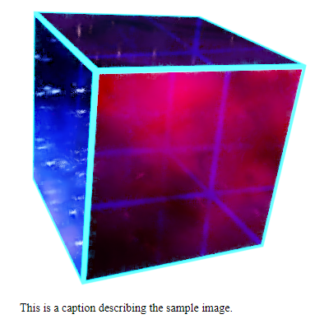 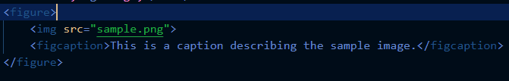
- <footer>
  - It is used to define the footer section of a webpage or a specific section within the page. It typically contains information about the author, copyright details, navigation links, or related content that appears at the bottom of the page. The <footer> element is semantically meaningful, indicating that the content inside is related to the footer or concluding section of the page.
  - Example:
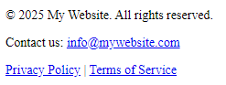 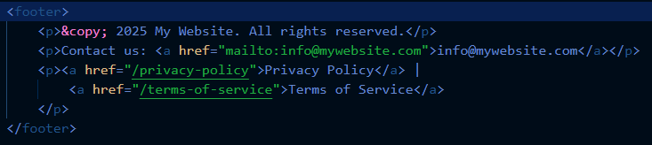
- <header>
  - It is used to define a header section for a webpage or a specific section of content (such as an article, section, or div). It typically contains introductory content or navigational elements like the site’s logo, navigation links, headings, and other elements that introduce or summarize the content of the page or section.
- <hgroup>
  - It is used to group multiple <h1> to <h6> heading elements together to create a shared header for a section or document. It was intended to provide a way to combine headings that form a single logical unit. For example, if you had a main heading and a subheading, you could use <hgroup> to group them together semantically.
- <nav>
  - It is used to define a navigation section in a webpage. It groups together links that help users navigate through the site or application, typically in the form of menus or other links for navigation. The <nav> tag is semantic, meaning it clearly indicates to both users and search engines that the enclosed content is intended for navigation purposes.
  - Example:
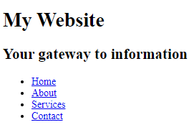 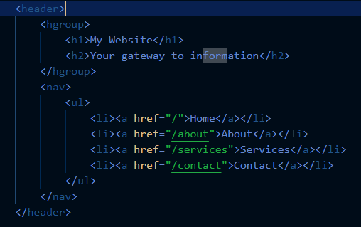
- <keygen>
  - It is used to create a key-pair generator for forms. It allowed users to generate a public and private key pair, which was primarily used for secure authentication processes, like client-side SSL certificates or encrypted communication. The <keygen> tag was part of HTML5 and was designed to be a simple mechanism for creating cryptographic keys without requiring external software.
  - This tag is deprecated.
- <mark>
  - It is used to highlight or emphasize a portion of text, typically to indicate a search result or something that is of particular importance. The content inside a <mark> element is typically displayed with a yellow background by default, making it visually stand out from the surrounding text
  - Example:
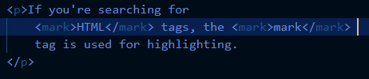
- <meter>
  - It is used to represent a scalar measurement within a known range or a gauge. It is typically used to show a value within a predefined range, such as progress, performance, or status. It can visually represent things like disk usage, temperature, or progress toward a goal, similar to a progress bar but for different types of measurements.
  - Example:
 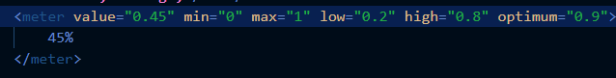
- <output>
  - It is used to display the result of a calculation or a script, typically within a form. It is particularly useful for showing dynamic results, such as those from user interactions with form controls or JavaScript calculations.
  - Example:
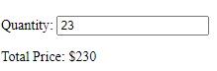
  - 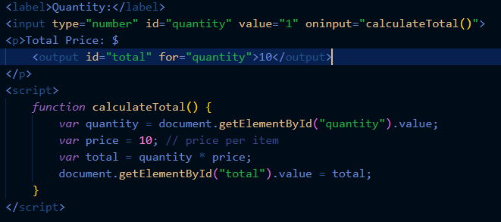
- <progress>
  - It is used to visually display the progress of a task or operation. It provides a bar that fills proportionally to the completion status, making it ideal for showing tasks like downloads, uploads, data processing, or any measurable activity.
  - Example:
- <ruby>
  - It used to display ruby annotations, which are small text annotations that provide pronunciation, meaning, or other information about characters, words, or phrases. It is primarily used in East Asian typography, such as Japanese or Chinese, to show the pronunciation of characters (called furigana in Japanese or pinyin in Chinese).
  - Example:
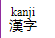
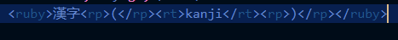
- <section>
  - It is used to define a thematic grouping of content within a webpage. It represents a distinct section of a document, typically with its own heading, and is used to structure content logically for better organization, accessibility, and SEO.
  - Example:
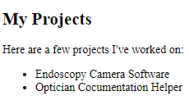
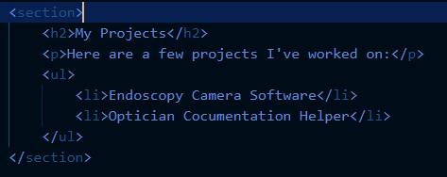
- <time>
  - It is used to represent a specific point in time, a duration, or both. It provides semantic meaning to dates, times, or durations, making the content machine-readable (e.g., for search engines or assistive technologies).
  - Example:
- <video>
  - It is used to embed video content on a webpage. It allows you to include videos with or without controls and provides options for autoplay, looping, captions, and more.
  - Example:
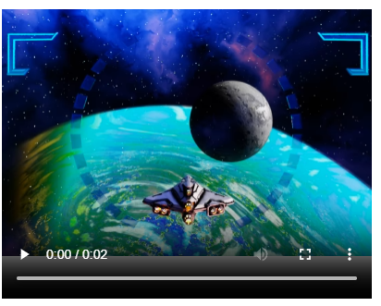
- <wbr>
  - It stands for Word Break Opportunity. It is used to specify where the browser may optionally break a long word or URL for better text wrapping. This tag is particularly useful when dealing with content like long URLs, file paths, or lengthy words that might otherwise overflow their container.
  - Example:
