1. Login to console and launch instance.
2. Select Red hat enterprise 64 bit.

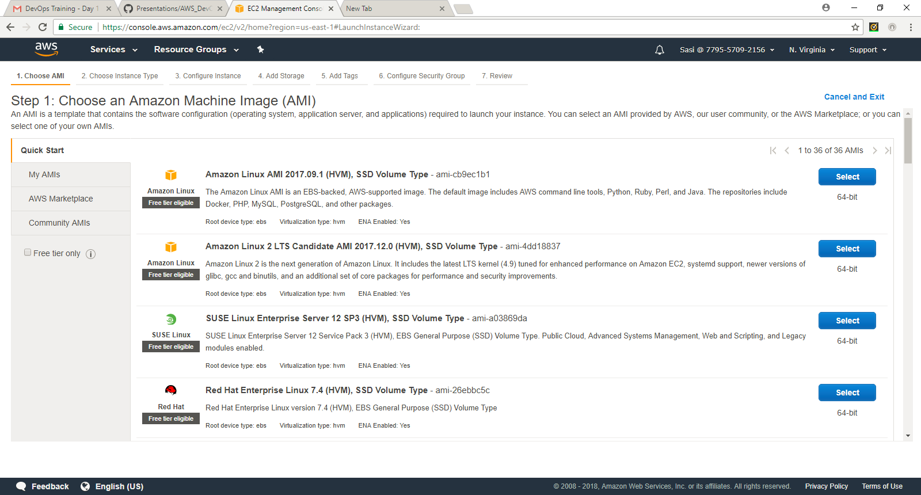

1. Choose type t2.micro and proceed with next step

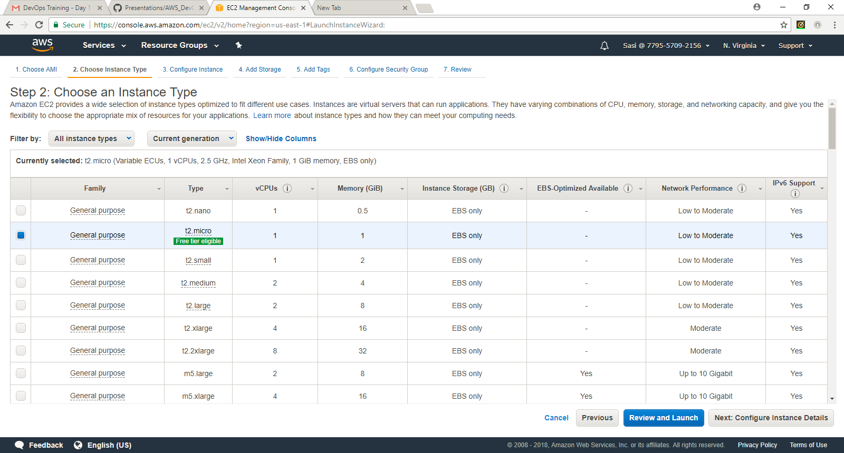

1. Leave them as default for this exercise and proceed with next step

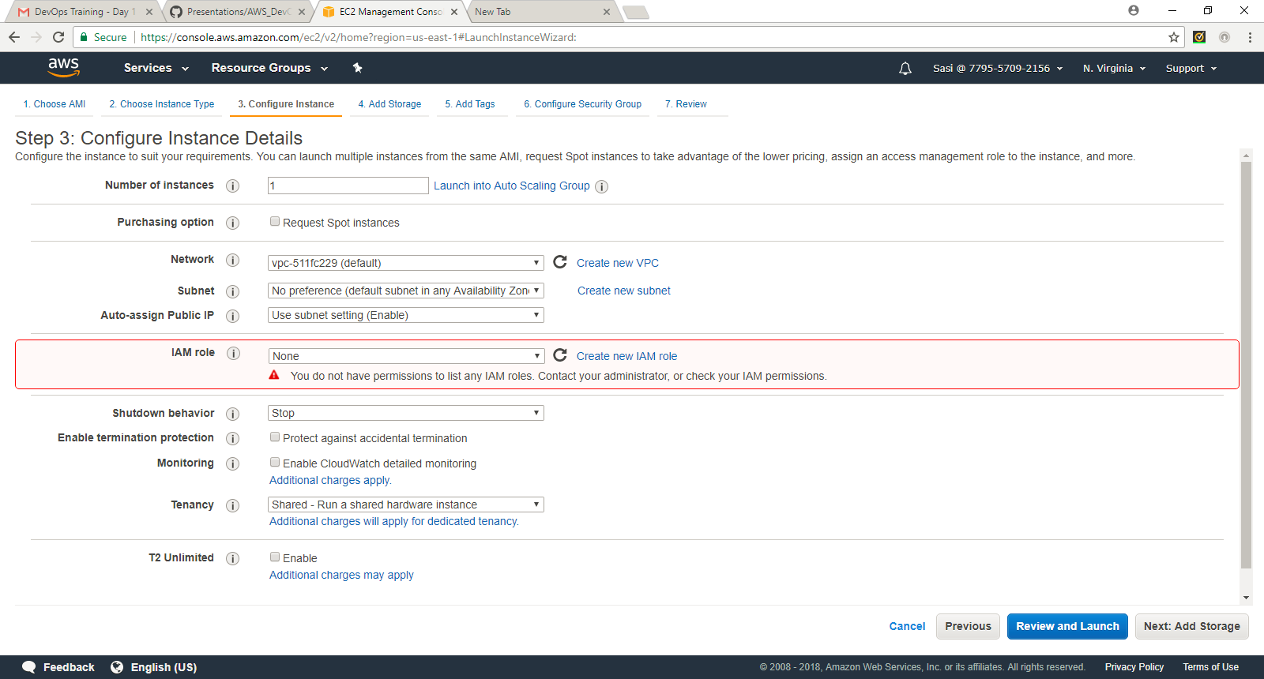

1. Add new Volume (EBS) – I have added 10 GB and continue to add tags

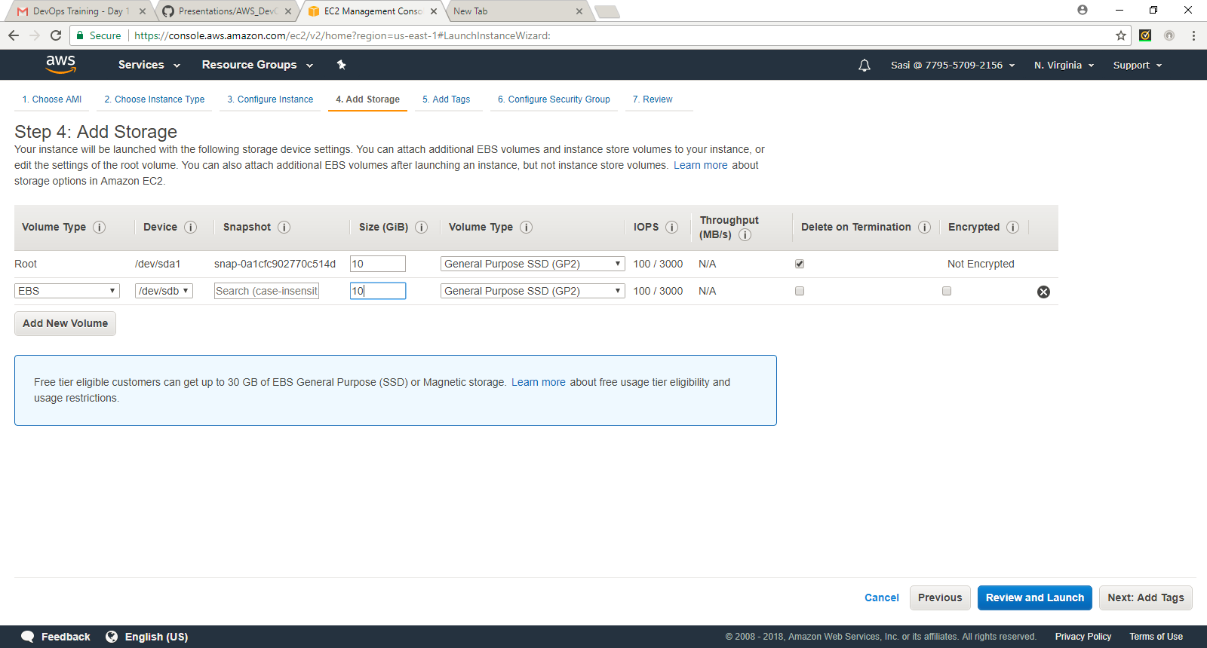

1. ADD Tags

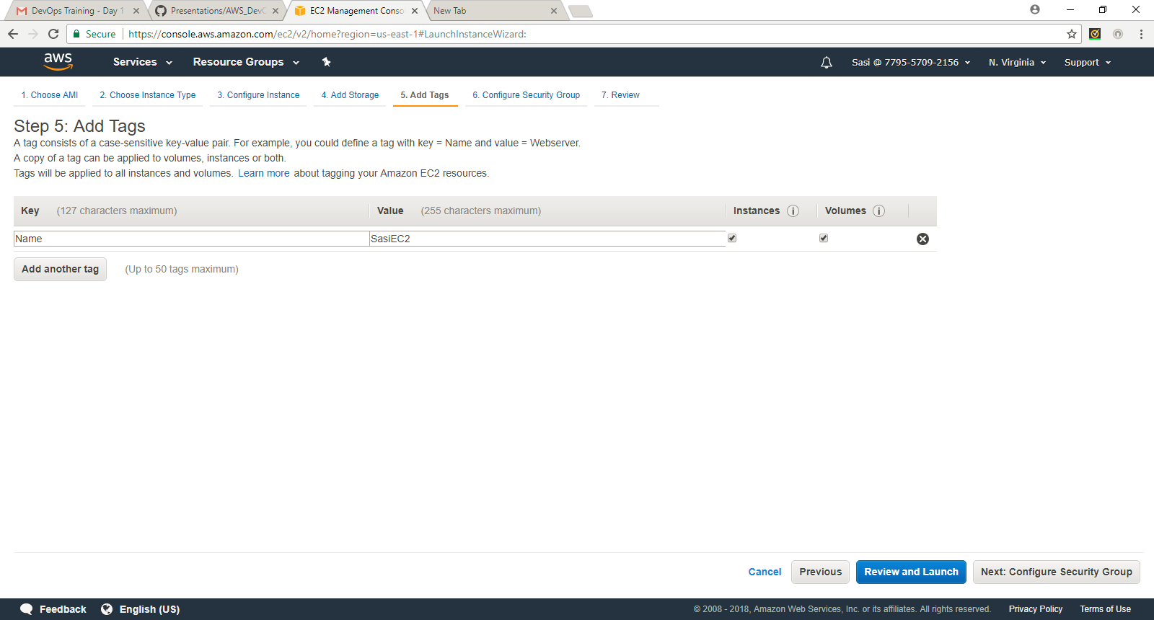

7: Add security groups: for this exercise ensure SSH is included.

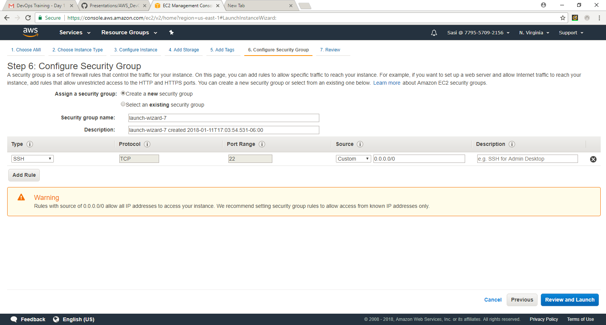

1. Review and Launch:

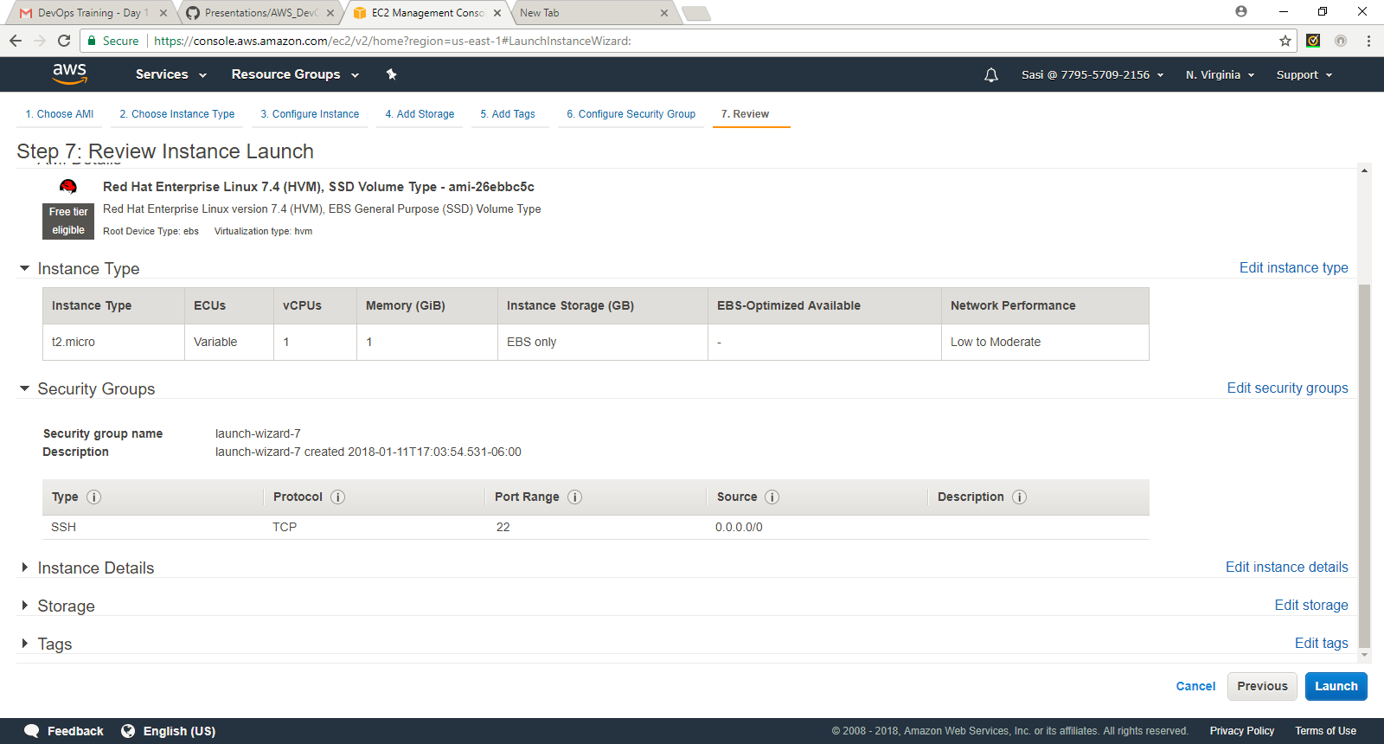

1. Launch: create and download a new key pair, without key pair you will not be able to access the VM created.

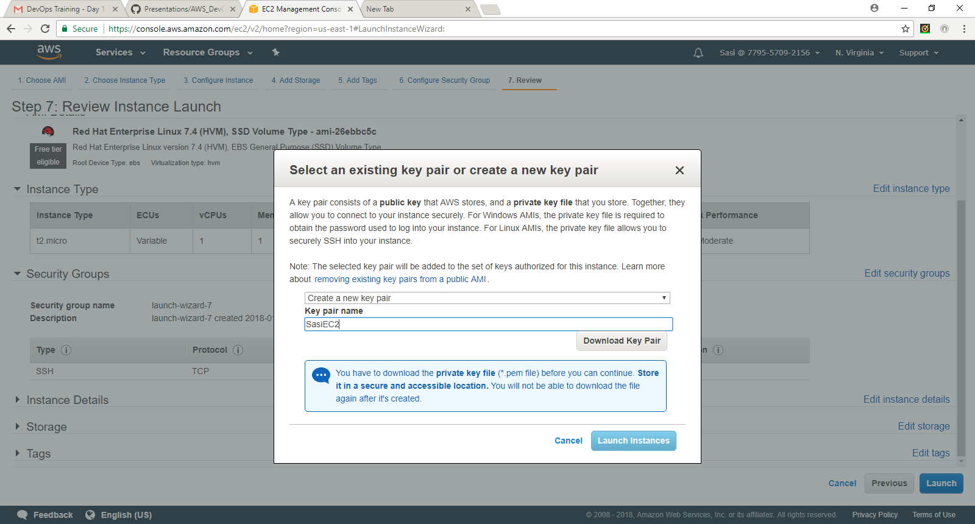

Launch instances:

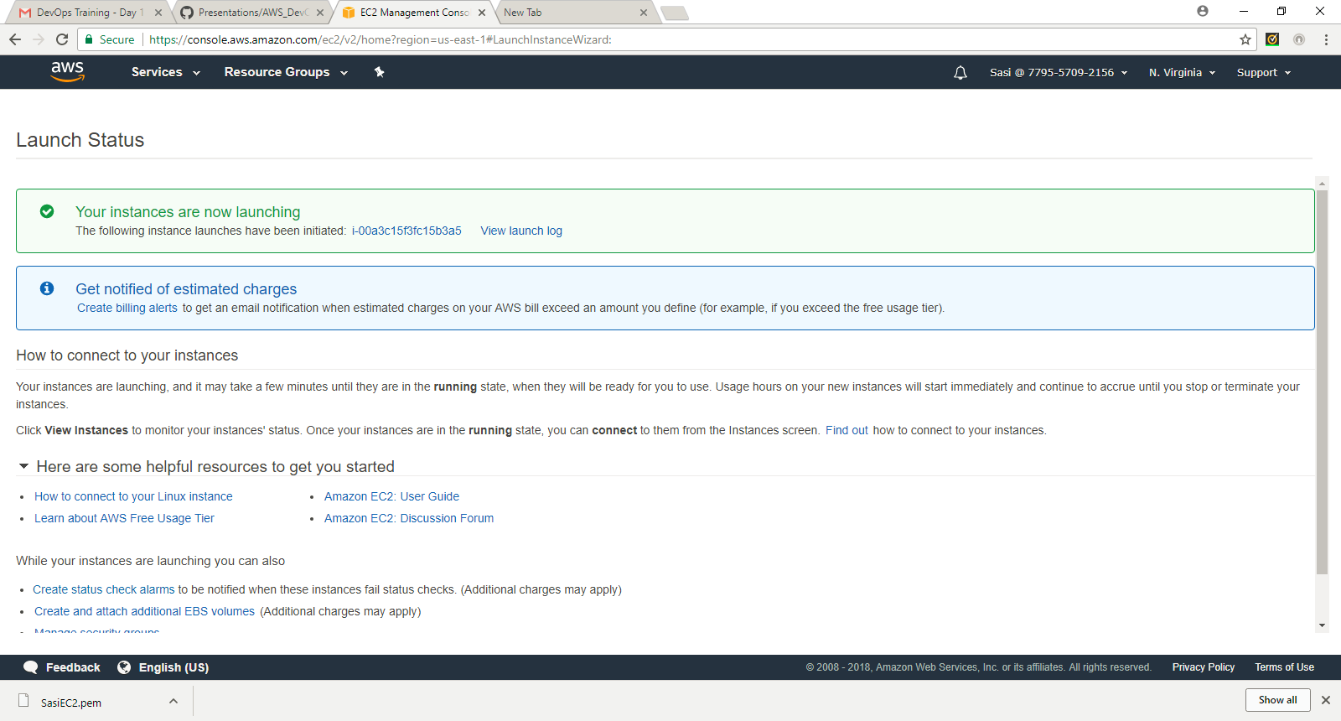

1. Load the .pem file in putty generator and save private key as .ppk file.

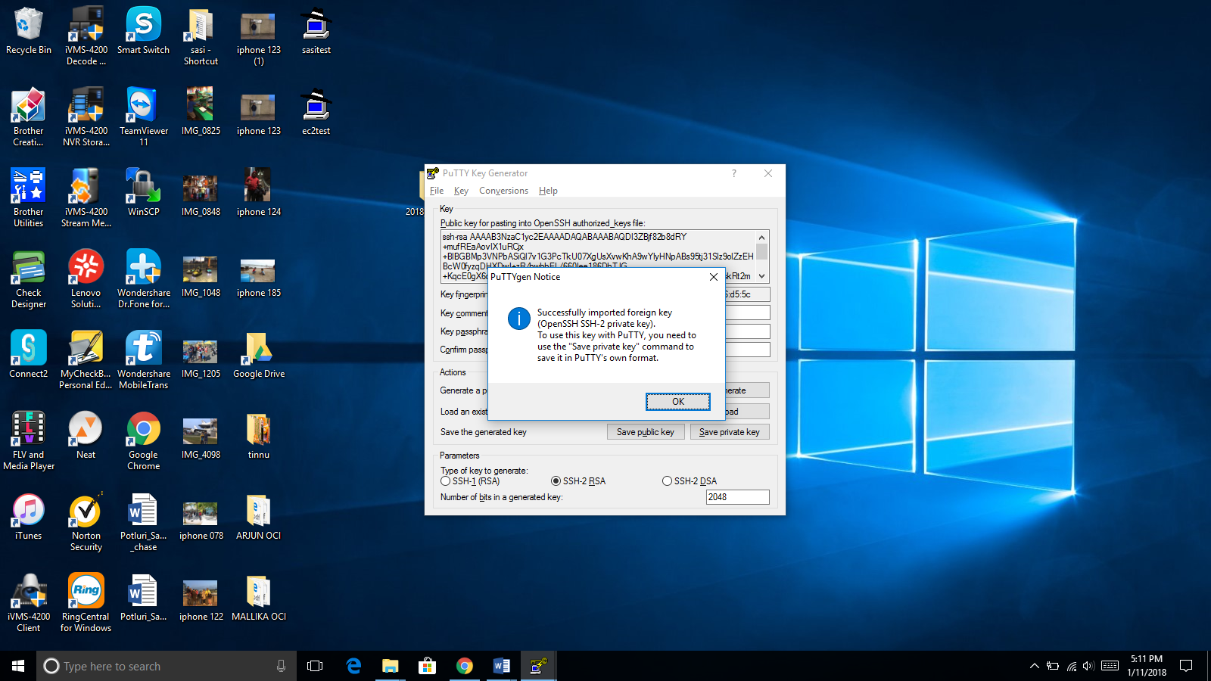

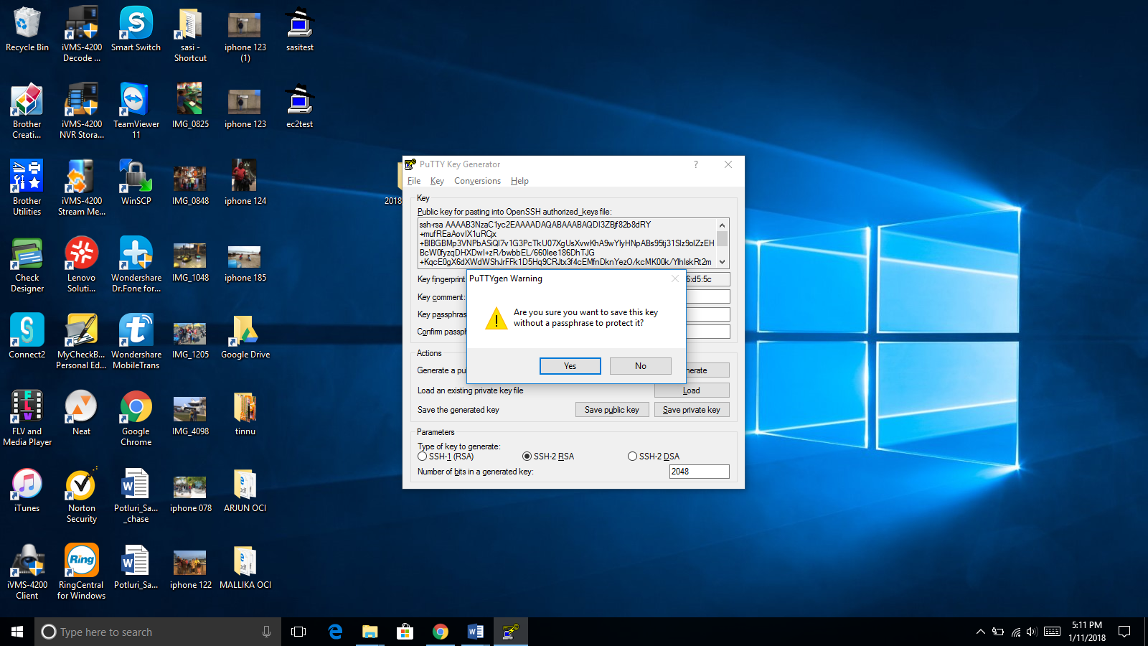

1. Open Putty and SSH with ec2-user@PublicDNS or ec2-user @Public IP (from EC2 console).

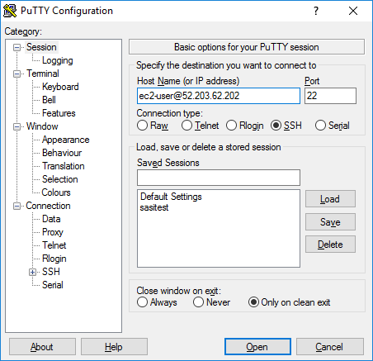

1. Open SSH/Auth and browse the .ppk file and open. (Connected to Linux VM through Putty)

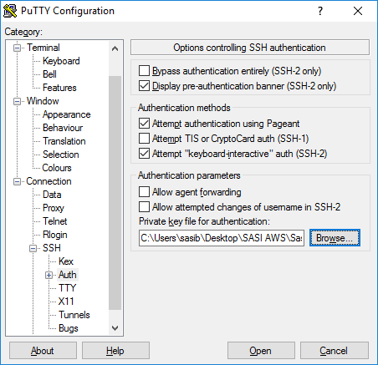

1. Connected to Vm through Putty

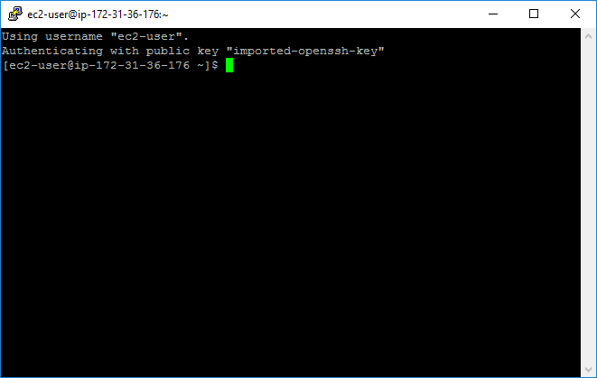

1. Switched to root user.

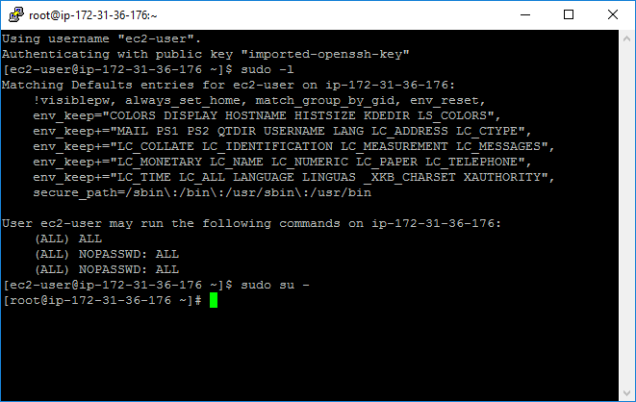

1. Stopped the VM(SasiEC2)