Exercise:

1. VPC Creation
2. Private subnet with Route Table
3. Internet Gateway
4. Public Subnet with Route Table
5. Public Security Group
6. Private Security Group
7. Elastic IP
8. NAT Gateway
9. Ec2 Instance

**VPC Creation**

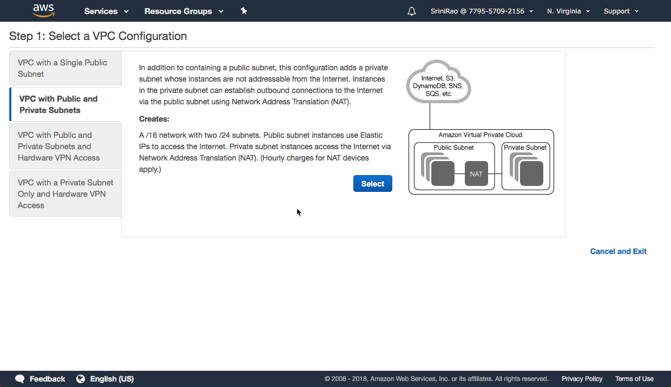

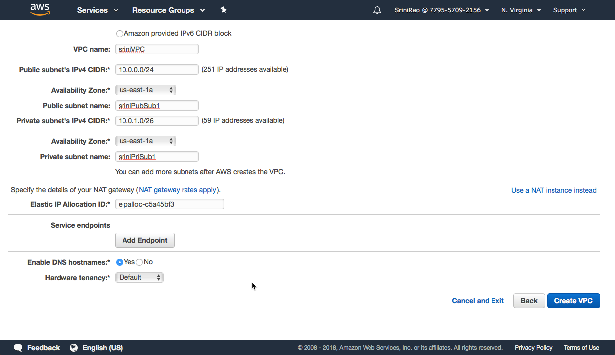

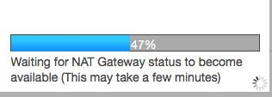

**Public Subnet & Route Table**

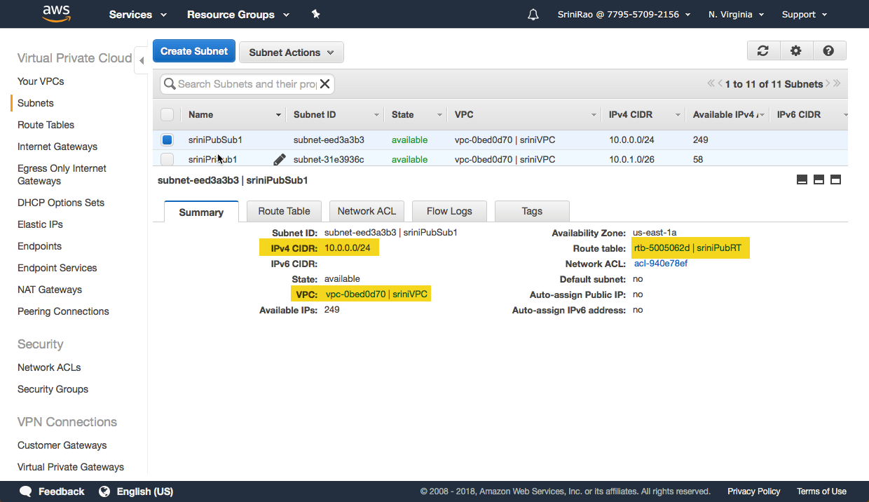

* Configure Internet Gateway on Public Subnet Route table to connect Internet

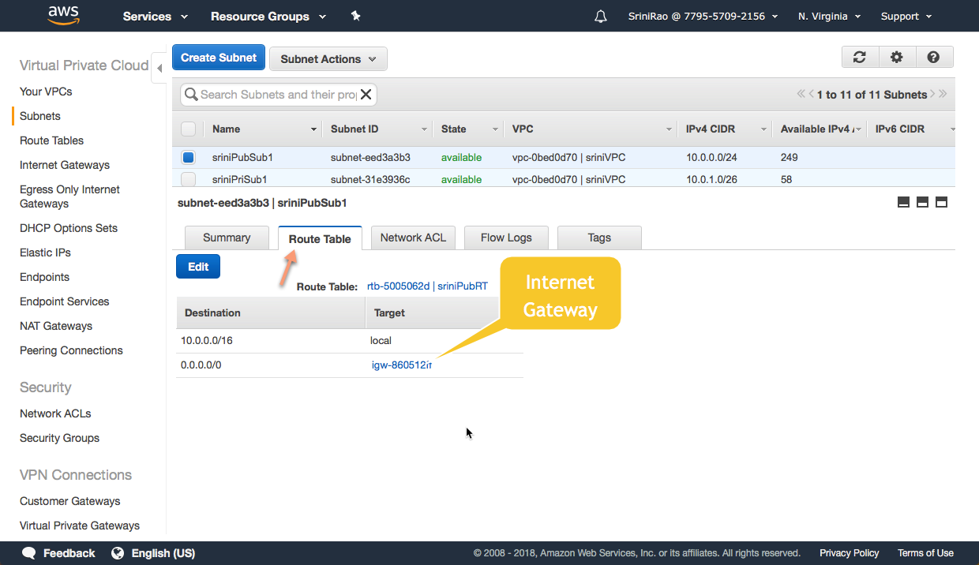

**Internet Gateway**

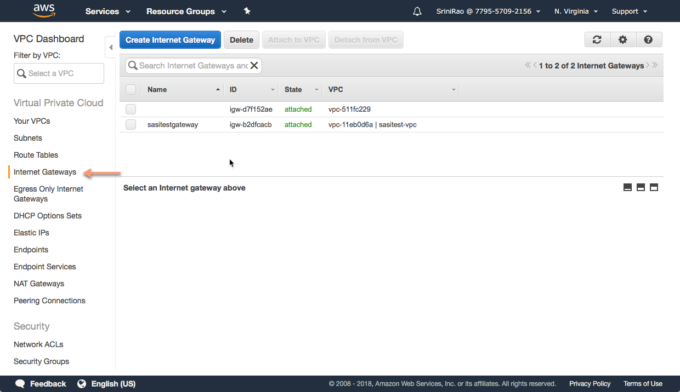

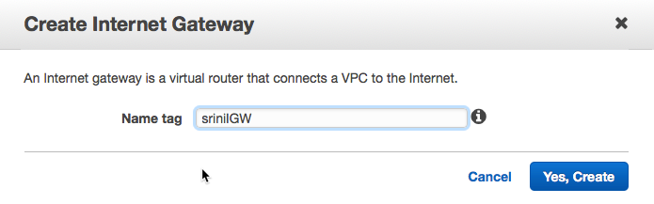

**Private Subnet & Route Table**

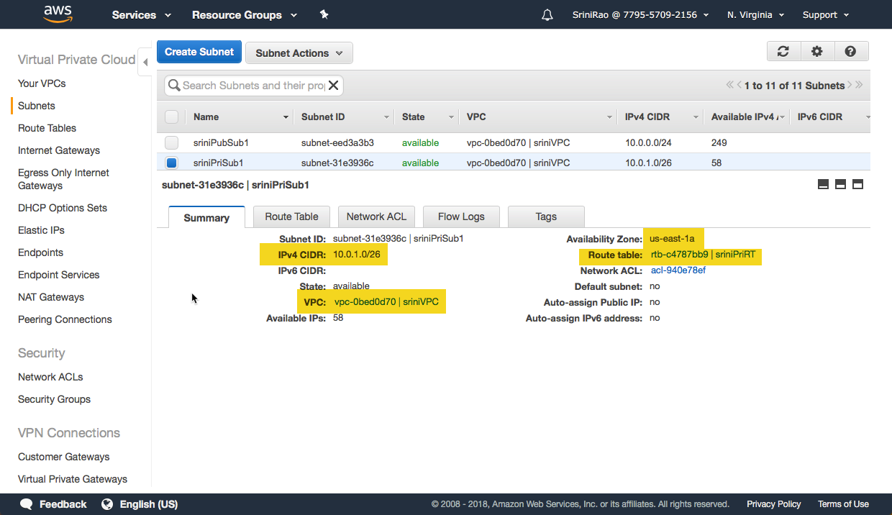

* Configure NAT Gateway : where it converts private IP to public IP using Elastic IP address

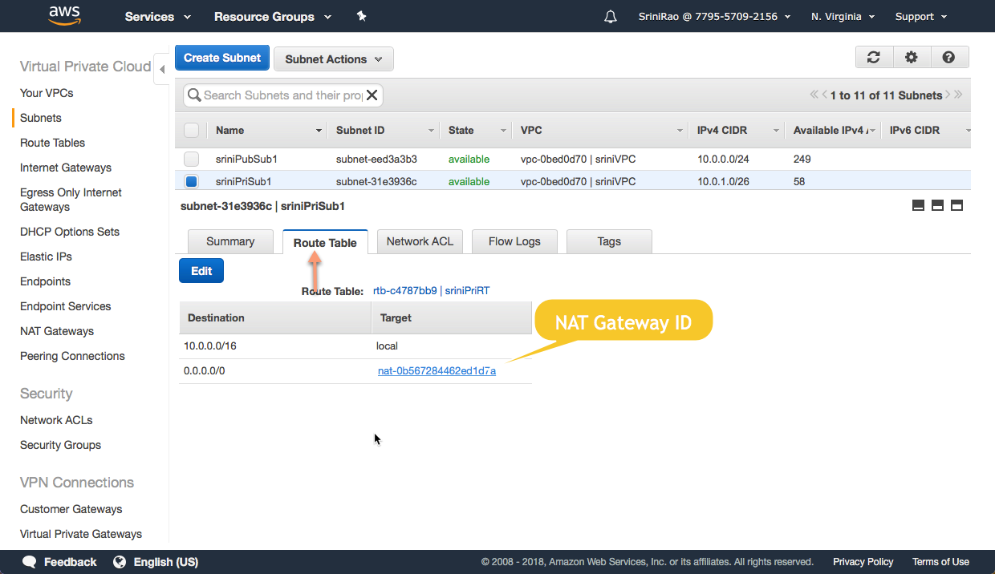

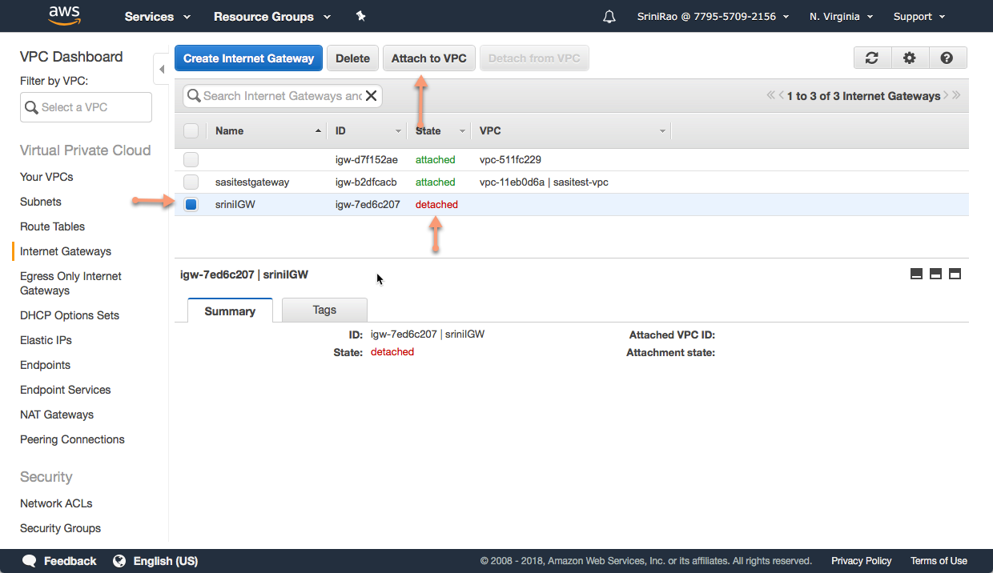

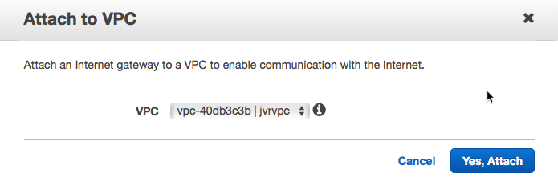

**Public Security Group:**

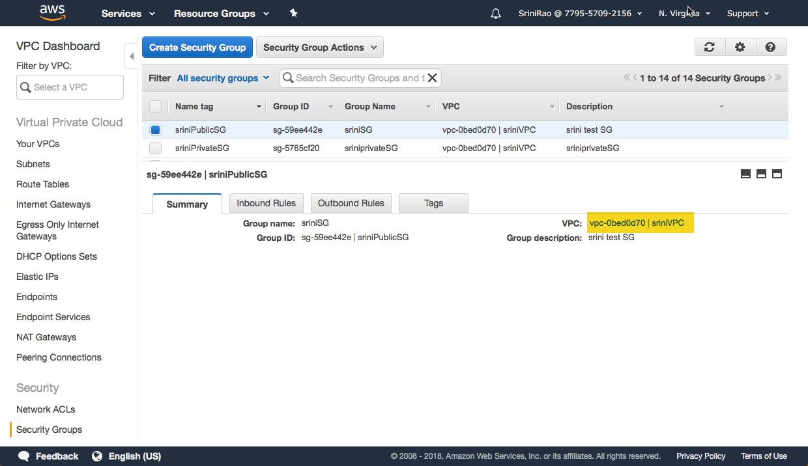

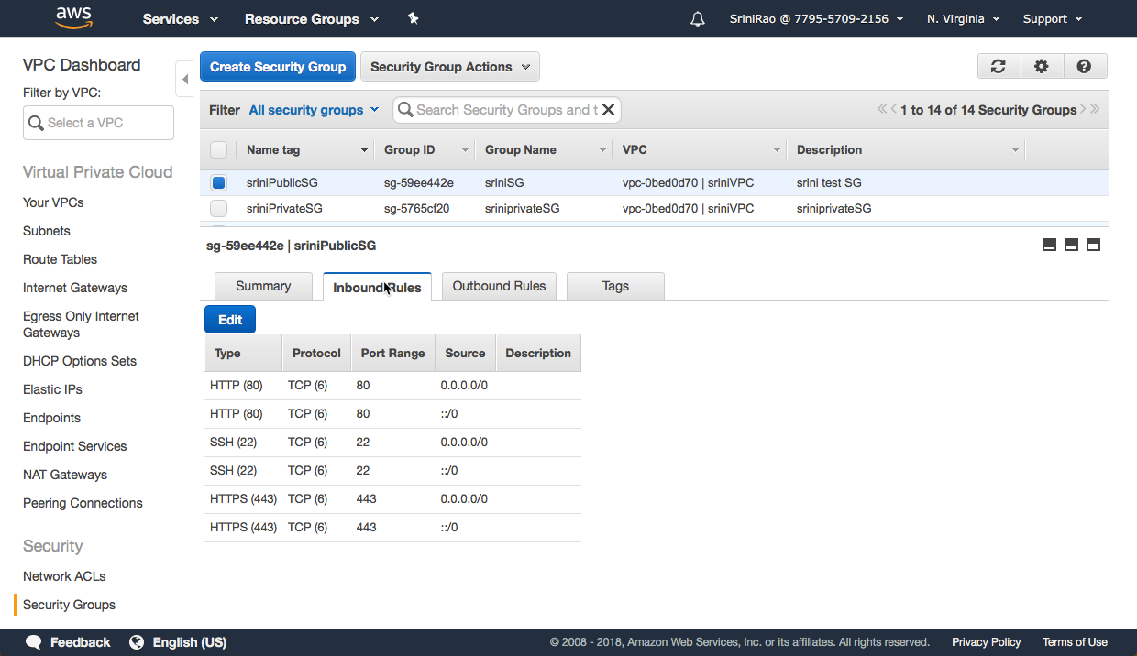

**Private Security Group:**

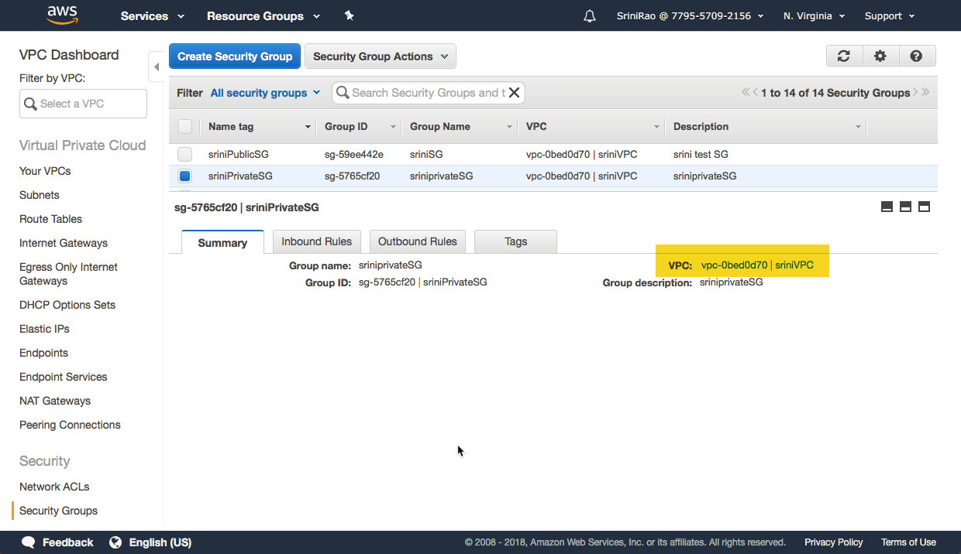

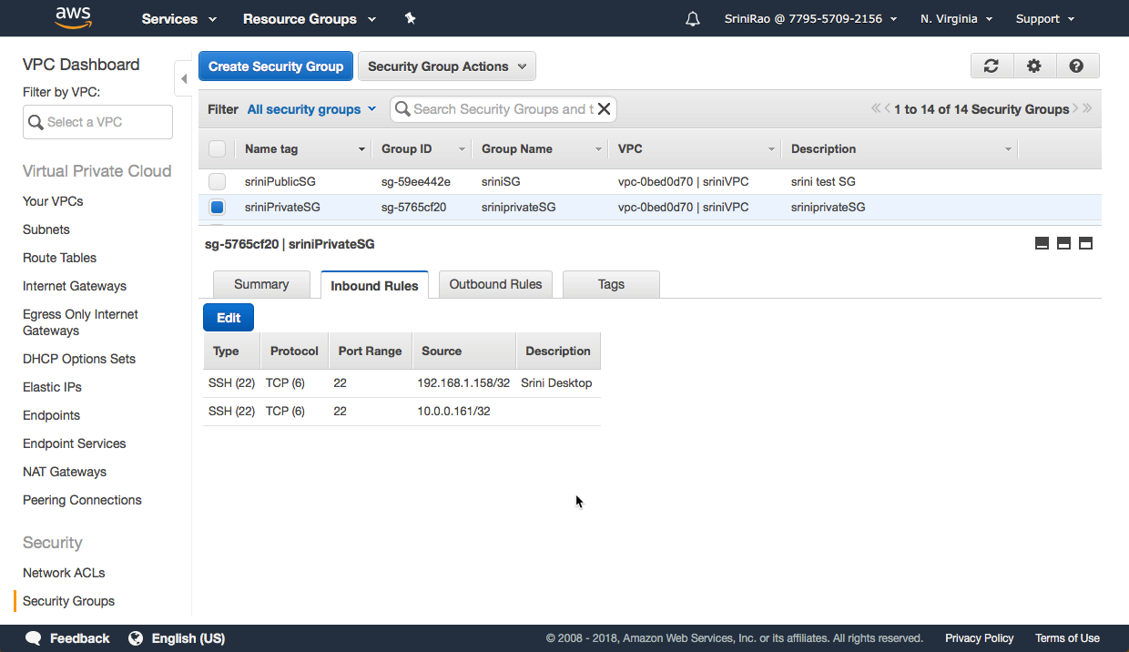

**Elastic IPS:**

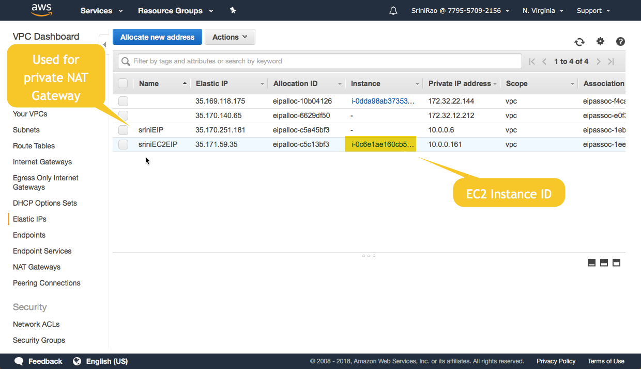

**NAT Gateway**

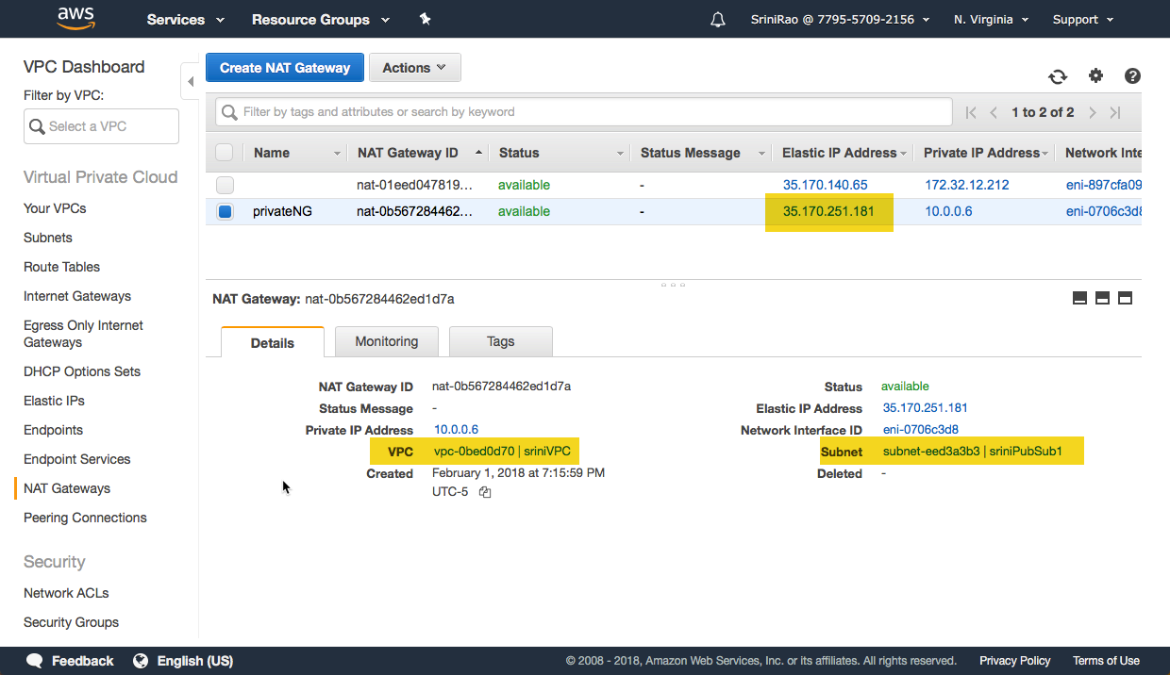

**Ec2 Instance**

