Task:

**Git**:

1. Setting up an account in GitHub.com

2. Create a GitHub Repository.

3. Upload Example WAR Files to the Repository - Extract Example WAR Files from the email below

GitHub: GitHub is a web-based version control repository. It offers source code management functionality, as well as adding its own features.

**1**

**Go to the**[**GitHub sign up page.**](https://github.com/signup/free) This page is used to sign you up for a free GitHub plan.

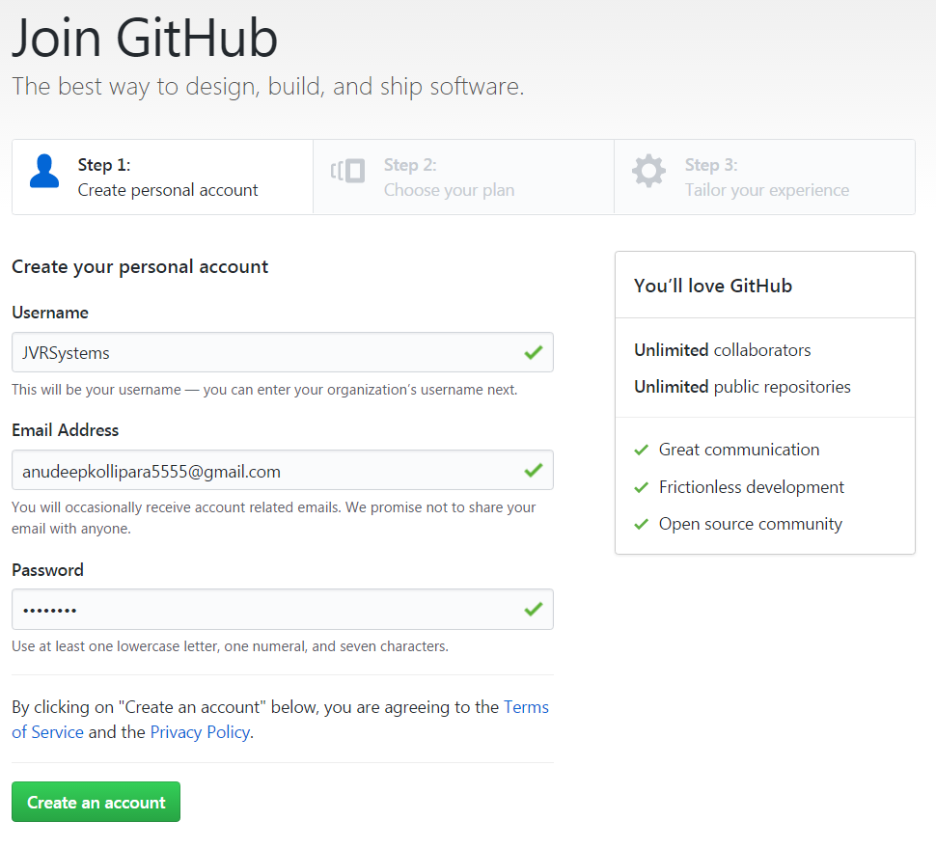

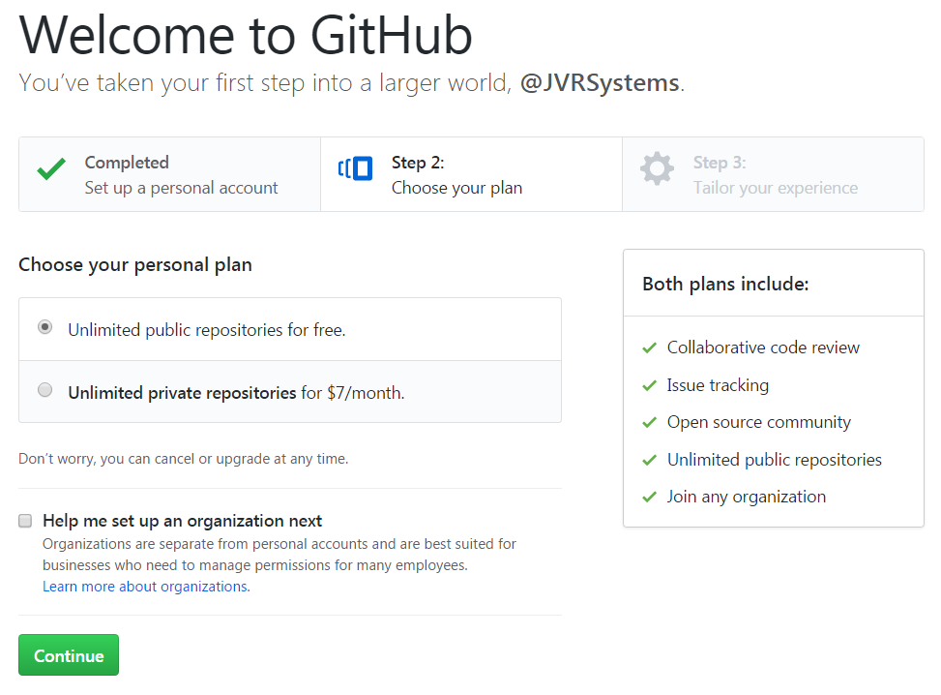



**2**

**Create a new Repository**

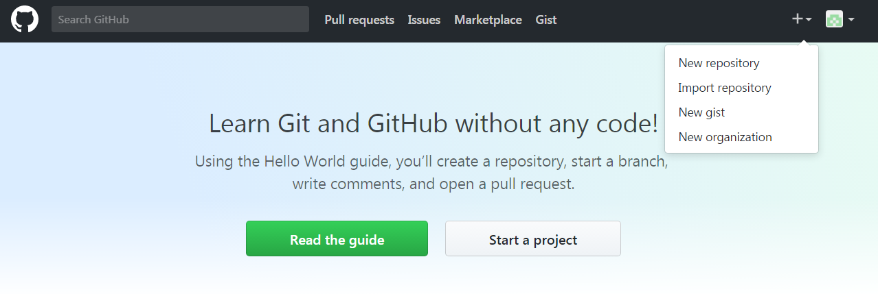

Name the Repository

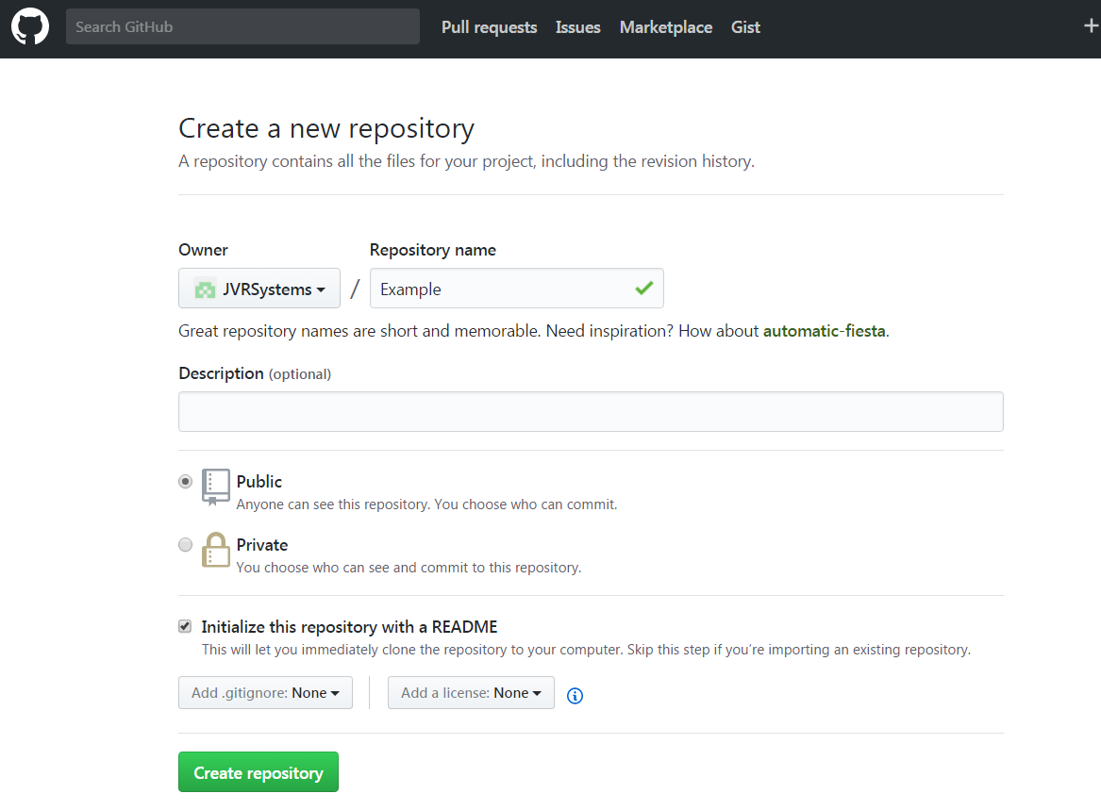

**3**

**Extract and Upload Example WAR files to the new Repository**

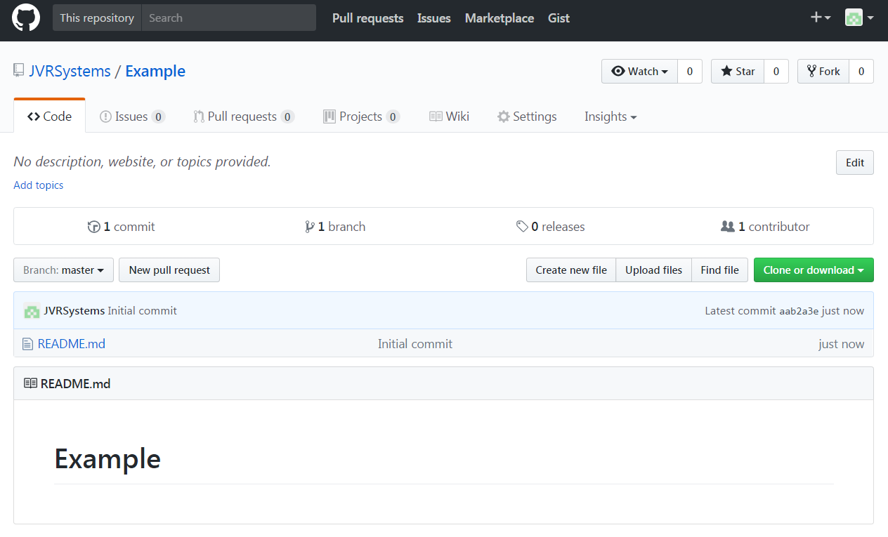

**Drag and Drop the files**

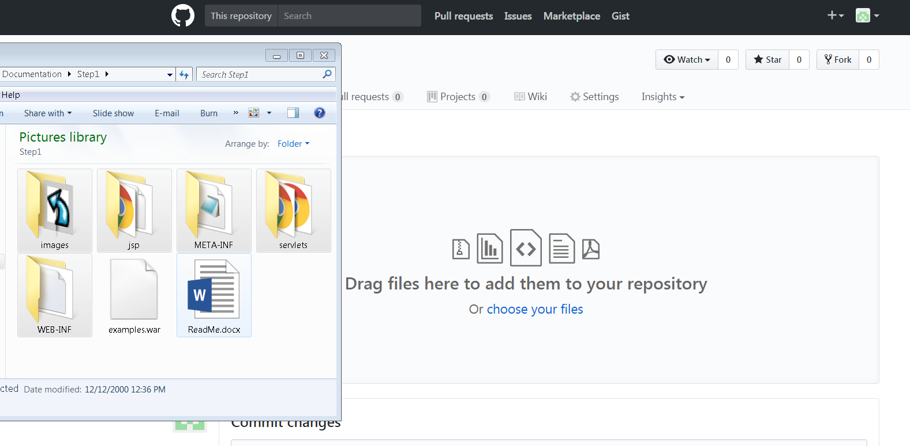

**After importing files Commit Changes**

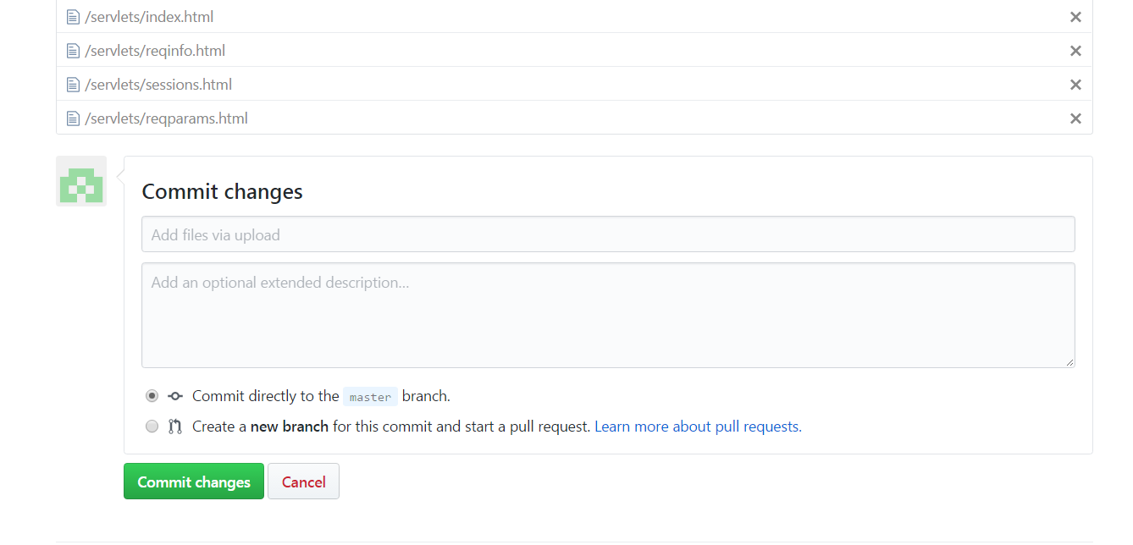

**Clone the Repository using SSH or HTTPS link(s)**

USE HTTPS: <https://github.com/JVRSystems/Example.git>

USE SSH: **git@github.com:JVRSystems/Example.git**

