Day 4

Git and GitHub Exercise.

To Install Git into local

Download the Git from

<https://git-scm.com/download/win>

installed Git into local PC

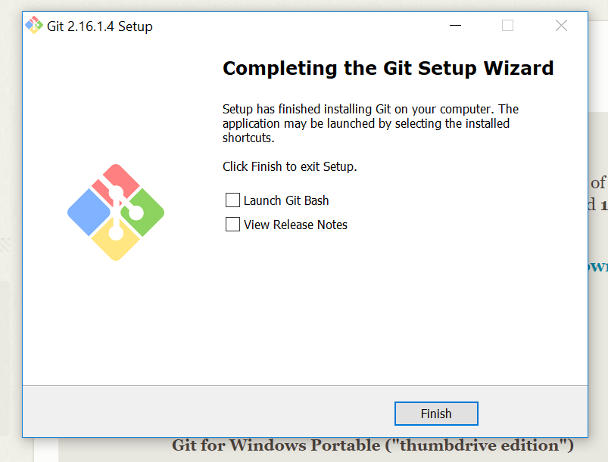

Open the Git bash

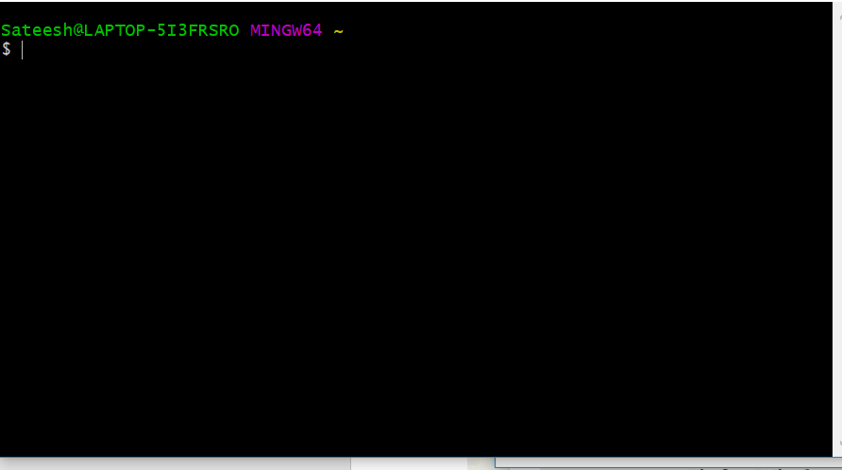

Create GitHuB account

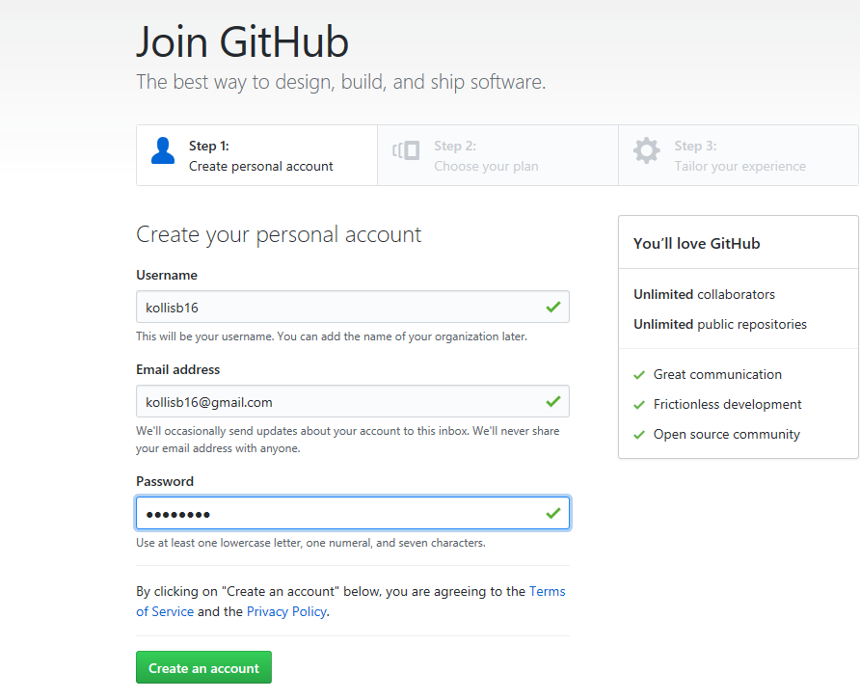

Create new repository

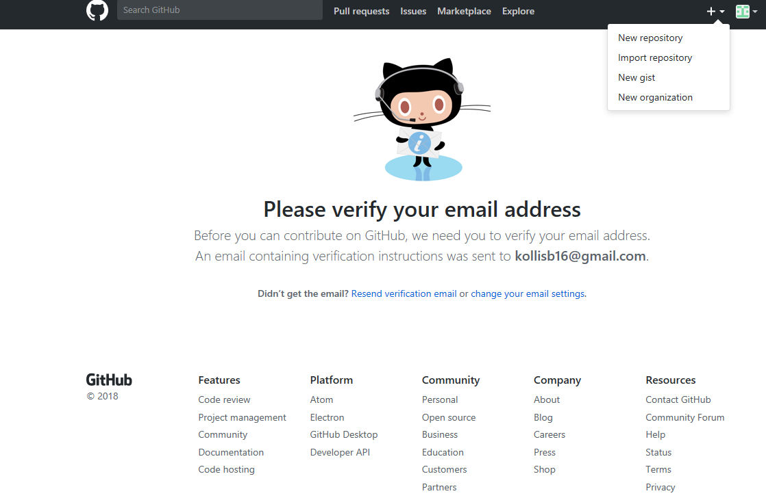

Set the name of repository

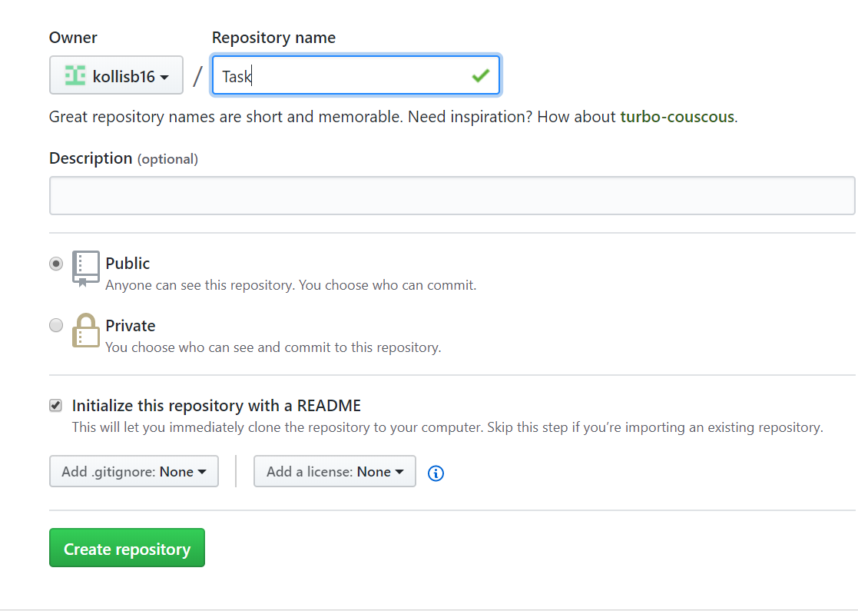

Drag and Drop the files

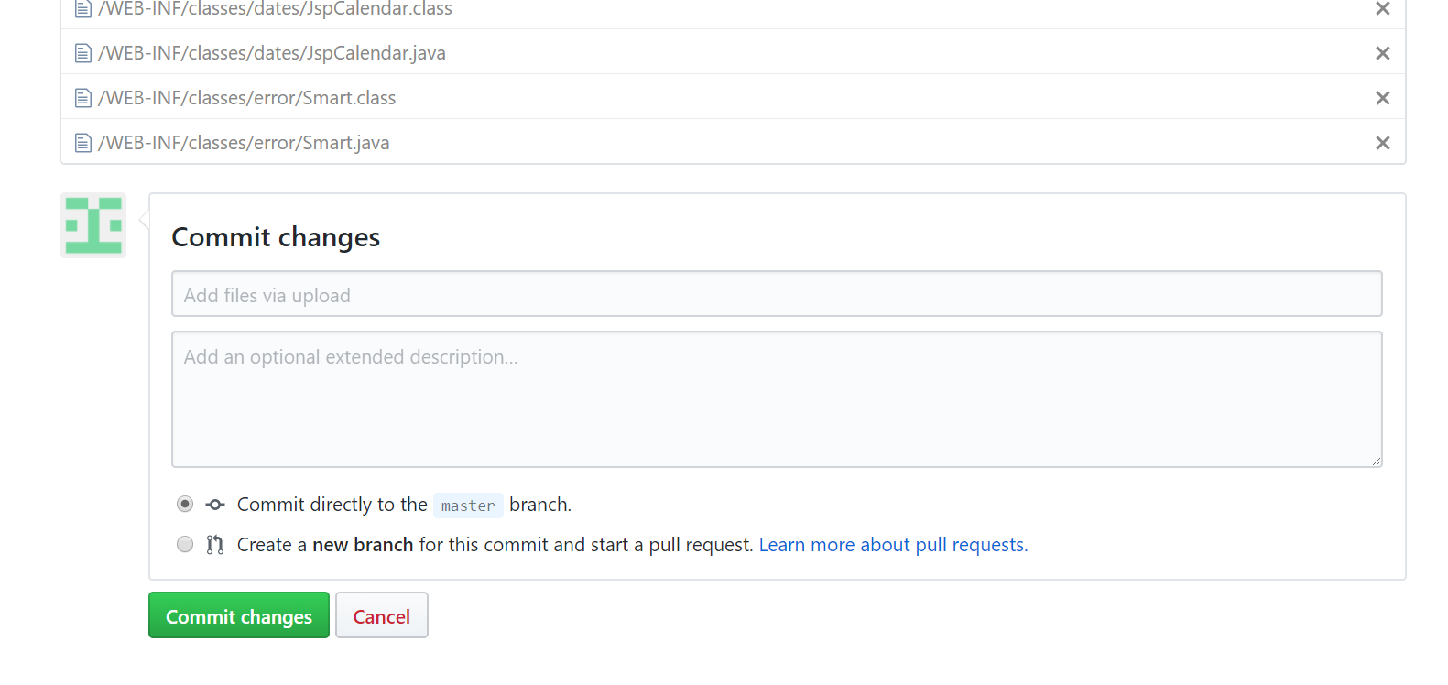

Clone the repository

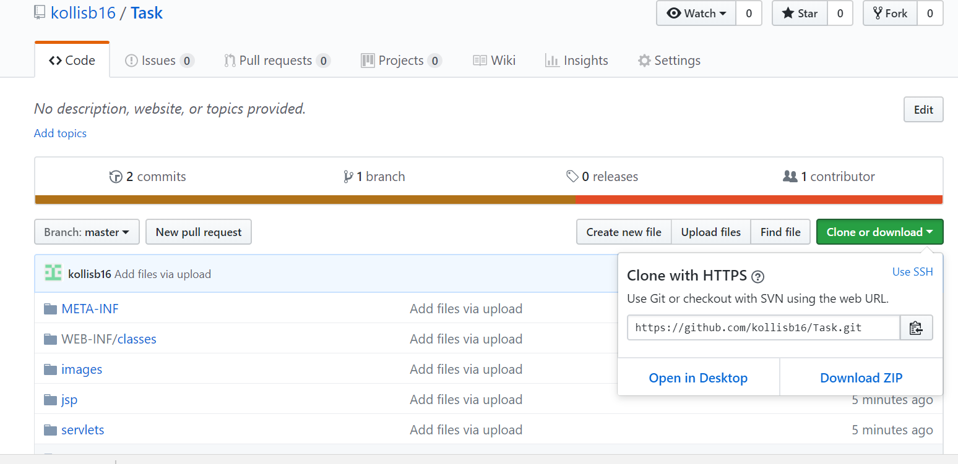

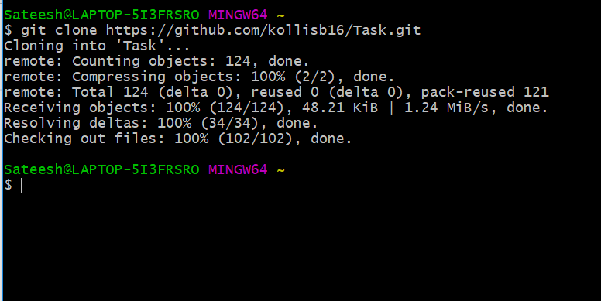

To check the status

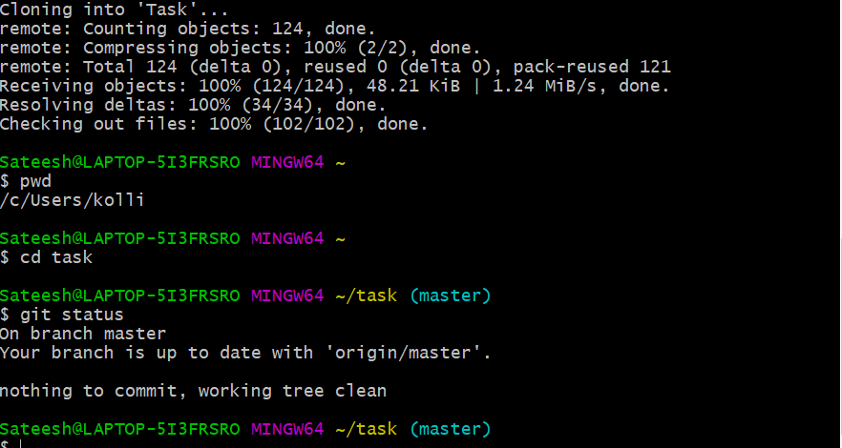

Copy the new file into Task directory

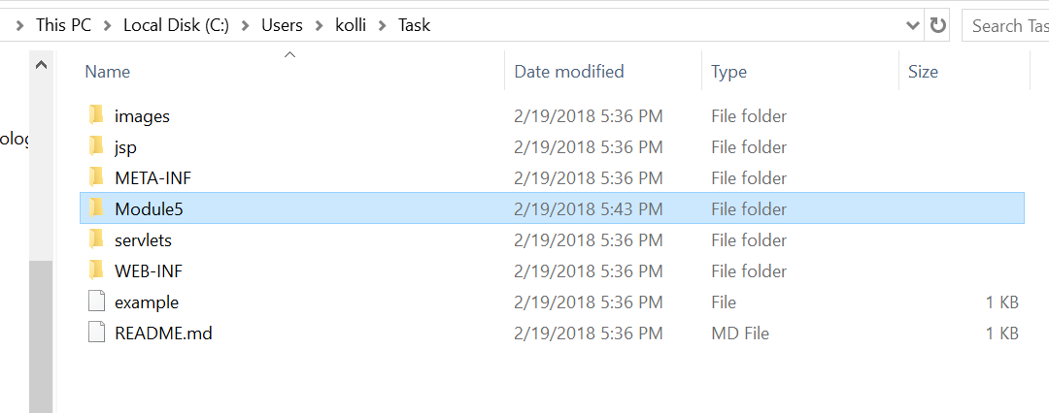

Untracked files in the working directory can’t be staged as below

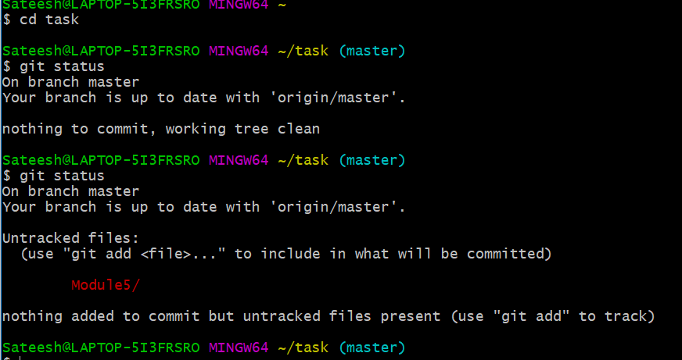

For tracking use the command Add as below

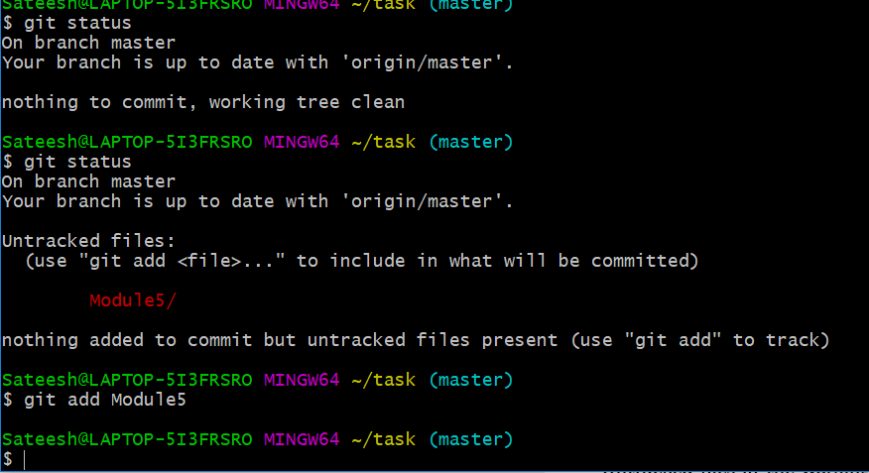

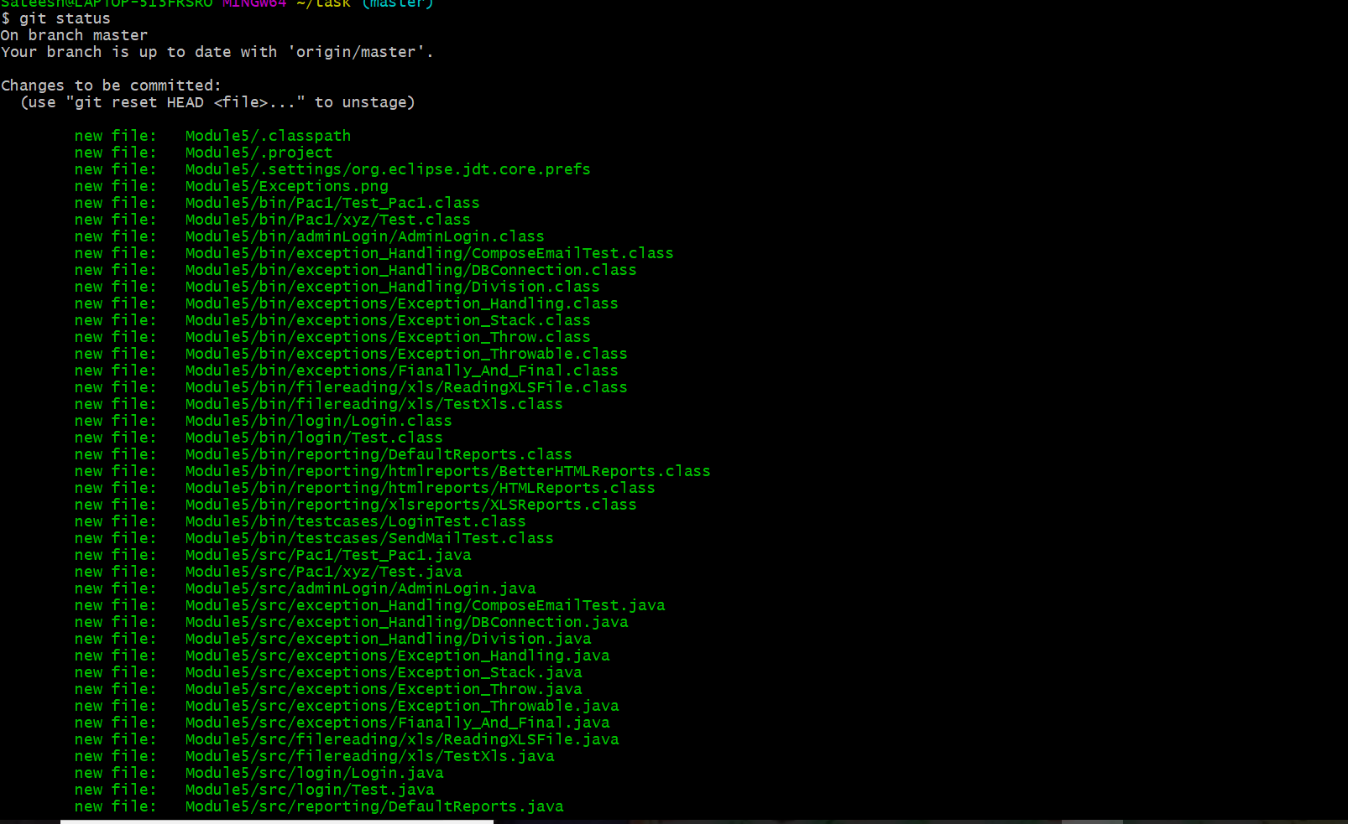

Adding the latest changes to local repository

Before commit we need to set the user name or email id for commits

As below



Hit the commit command for latest changes to local repository

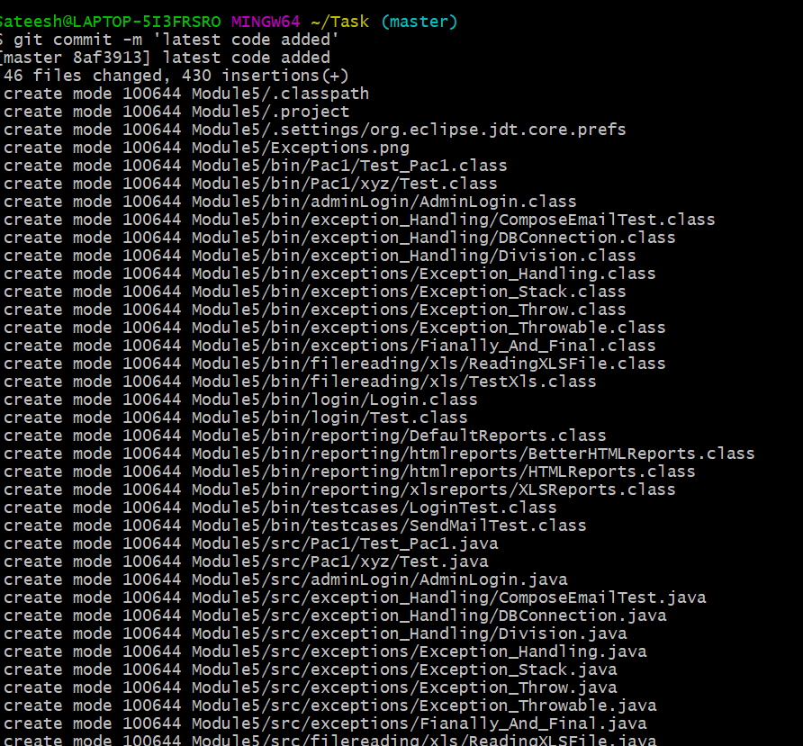

Rename the file name from Module5 to Module 5.1

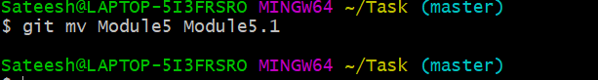

Log:

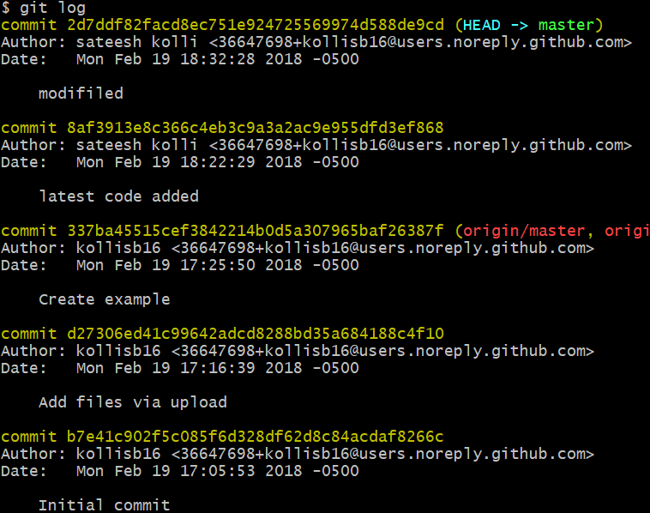

Push the changes from local to remote repository

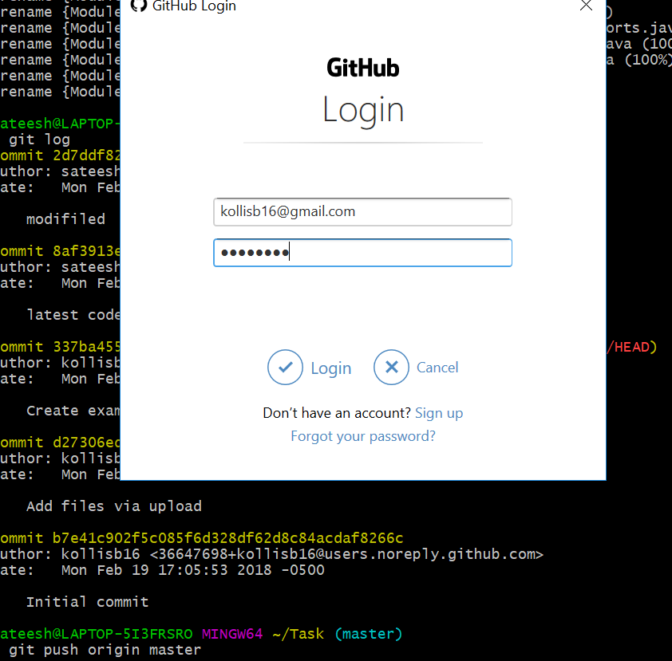

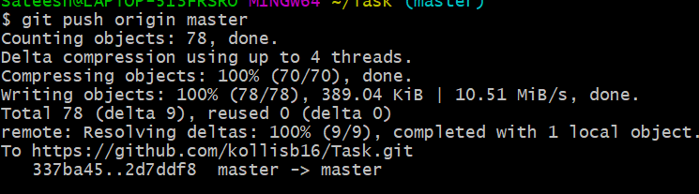

Branching:

