[Panduga @ 7795-5709-2156 Ohio](https://us-east-2.console.aws.amazon.com/ec2/v2/home?region=us-east-2)

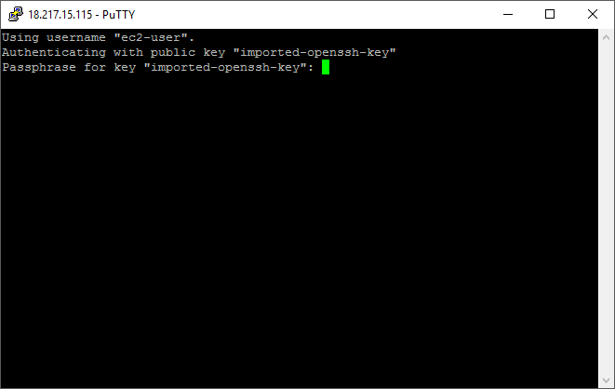

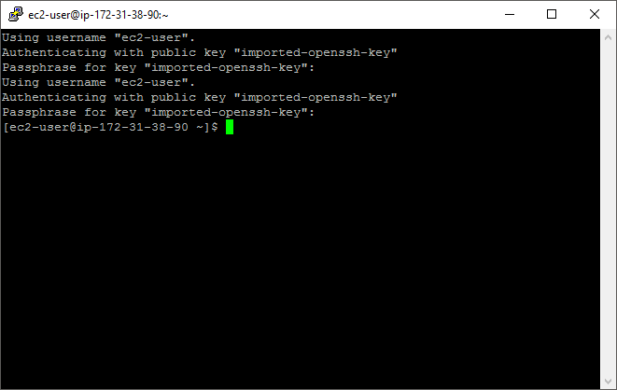

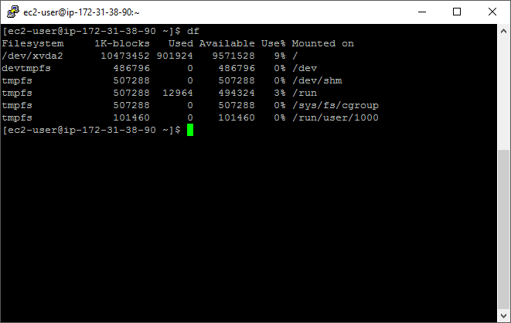

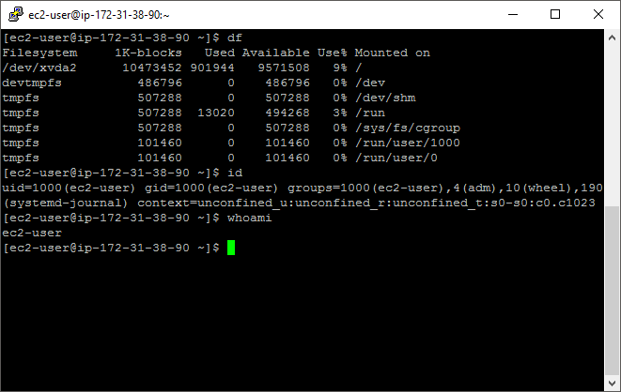

**Key Pair**

**.pem to private .ppk file**

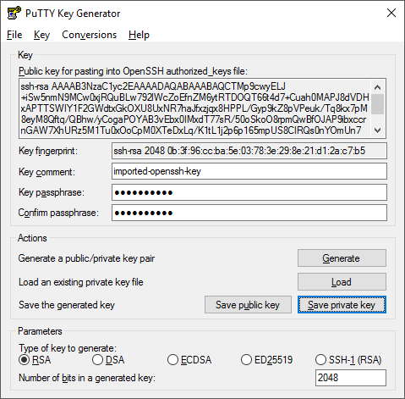

Public DNS ec2-18-217-15-115.us-east-2.compute.amazonaws.com

IPv4 Public IP 18.217.15.115

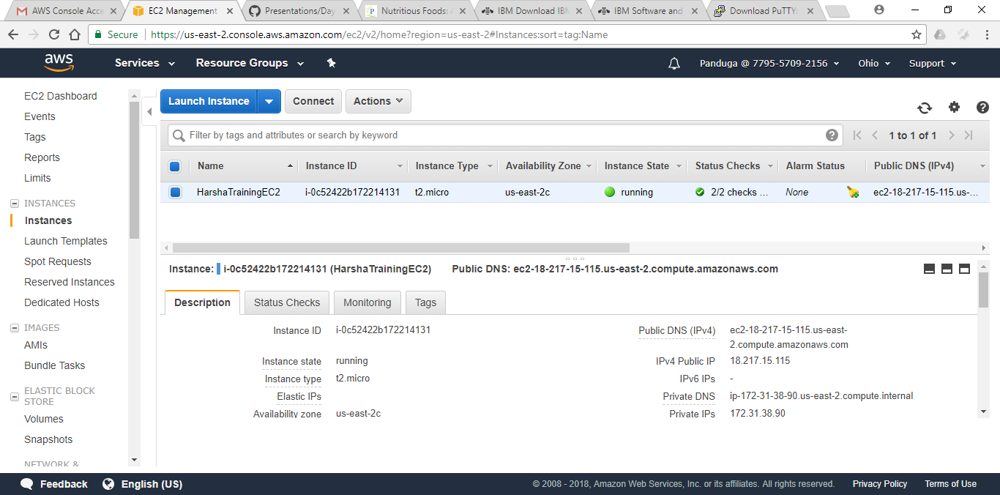

**EC2 instance name** – HarshaTrainingEC2 under user Panduga@7795-5709-2156

