1.

<!DOCTYPE html>

<html>

<body>

<h1>Numbers</h1>

<p style="color:Tomato;">1</p>

<p style="color:Orange;">2</p>

<p style="color:Gray;">3</p>

<p style="color:SlateBlue;">4</p>

<p style="color:DodgerBlue;">5</p>

<p style="color:Red;">6</p>

<p style="color:Black;">7</p>

<p style="color:Blue;">8</p>

<p style="color:Violet;">9</p>

<p style="color:MediumSeaGreen;">10</p>

</body>

</html>

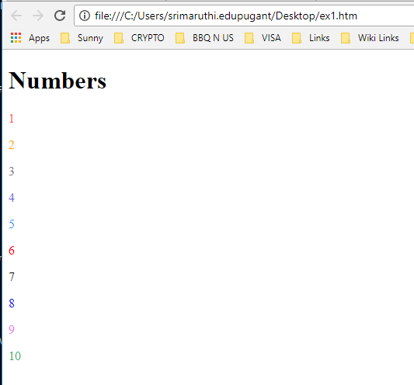

2.

<!DOCTYPE html>

<html>

<body>

<h1>Unalphabetized list</h1>

<p>James<sub>1</sub></p><br>

<p>John<sub>2</sub></p><br>

<p>Peter<sub>3</sub></p><br>

<p>Sunny<sub>4</sub></p><br>

<p>Johnson<sub>5</sub></p><br>

<p>Mike<sub>6</sub></p><br>

<p>Micheal<sub>7</sub></p><br>

<p>Dave<sub>8</sub></p><br>

<p>Megh<sub>9</sub></p><br>

<p>Rina<sub>10</sub></p><br>

<h1>Alpabetized list</h1>

<p>Dave<sub>1</sub></p><br>

<p>James<sub>2</sub></p><br>

<p>John<sub>3</sub></p><br>

<p>Johnson<sub>4</sub></p><br>

<p>Megh<sub>5</sub></p><br>

<p>Michael<sub>6</sub></p><br>

<p>Mike<sub>7</sub></p><br>

<p>Peter<sub>8</sub></p><br>

<p>Rina<sub>9</sub></p><br>

<p>Sunny<sub>10</sub></p><br>

</body>

</html>

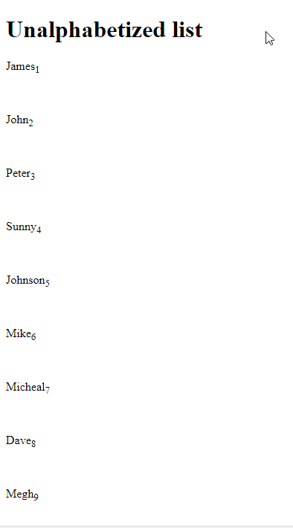

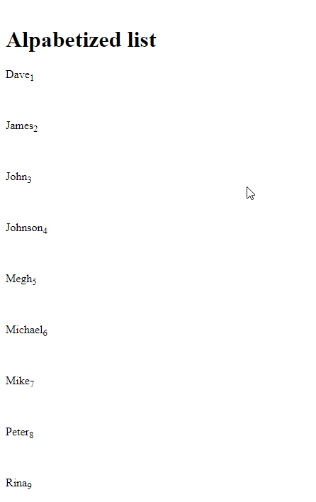

3.

<!DOCTYPE html>

<html>

<body>

<h2 id="top">Top of page!</h2>

<a href="#bottom">Go to Bottom</a>

<h1>Unalphabetized list</h1>

<p>James<sub>1</sub></p><br>

<p>John<sub>2</sub></p><br>

<p>Peter<sub>3</sub></p><br>

<p>Sunny<sub>4</sub></p><br>

<p>Johnson<sub>5</sub></p><br>

<p>Mike<sub>6</sub></p><br>

<p>Micheal<sub>7</sub></p><br>

<p>Dave<sub>8</sub></p><br>

<p>Megh<sub>9</sub></p><br>

<p>Rina<sub>10</sub></p><br>

<h1>Alpabetized list</h1>

<p>Dave<sub>1</sub></p><br>

<p>James<sub>2</sub></p><br>

<p>John<sub>3</sub></p><br>

<p>Johnson<sub>4</sub></p><br>

<p>Megh<sub>5</sub></p><br>

<p>Michael<sub>6</sub></p><br>

<p>Mike<sub>7</sub></p><br>

<p>Peter<sub>8</sub></p><br>

<p>Rina<sub>9</sub></p><br>

<p>Sunny<sub>10</sub></p><br>

<h2 id="bottom">Bottom of page!</h2>

<a href="#top">Go to top</a>

</body>

</html>

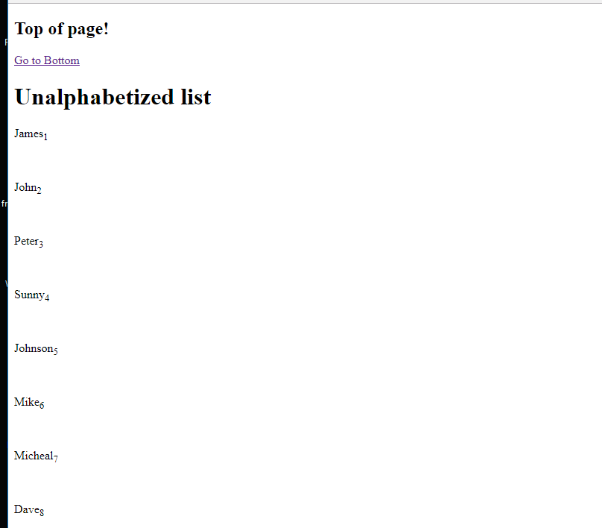

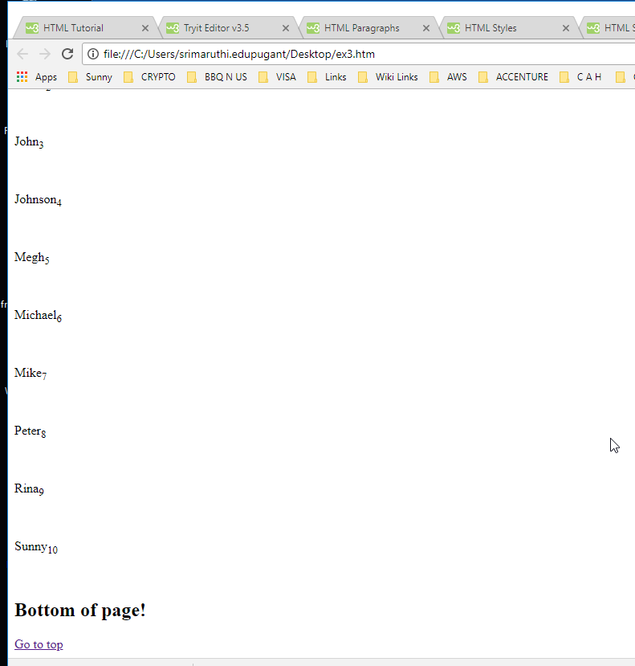

4.

<!DOCTYPE html>

<html>

<body>

<h2>Image Links</h2>

<p>Click on the image for google search</p>

<a href="https://www.google.com">

<img src="giphy.gif" alt="Google Search">

</a>

</body>

</html>

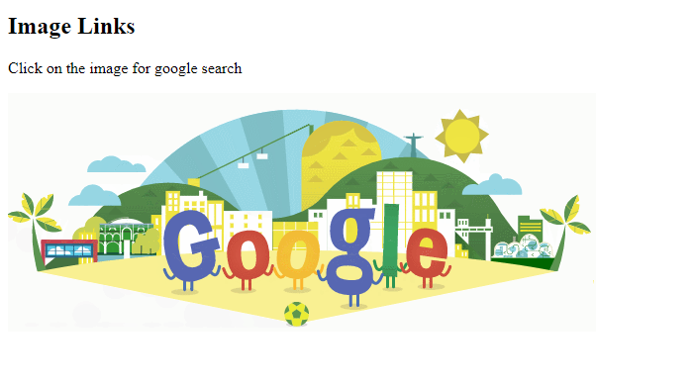

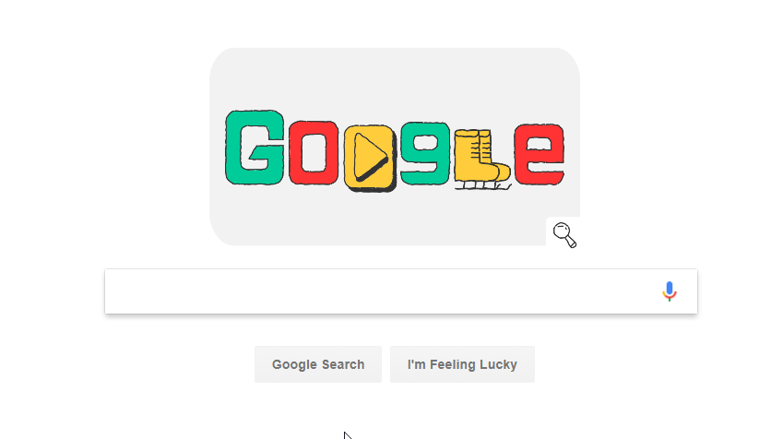

5.

<!DOCTYPE html>

<html>

<body>

<form>

Enter the name:<br>

<input type="text" name="name" value="zcy">

<br>

Enter the address:<br>

<input type="textarea" name="address" value="xdcxdcxcxvxv">

<br><br>

<input type="submit" value="Submit">

</form>

</body>

</html>

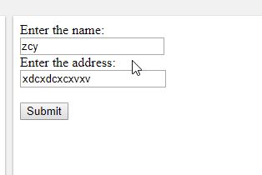

6.

<!DOCTYPE html>

<html>

<body>

<form>

<table style="width:100%">

<tr>

<td>First Name</td>

<td>

<input type="text" name="firstname"

</td>

</tr>

<tr>

<td>Last Name</td>

<td>

<input type="text" name="lastname"

</td>

</tr>

<tr>

<td>Address</td>

<td>

<input type="text" name="address"

</td>

</tr>

<tr>

<td>City</td>

<td>

<input type="text" name="city"

</td>

</tr>

<tr>

<td>State</td>

<td>

<input type="text" name="state"

</td>

</tr>

<tr>

<td>Zipcode</td>

<td>

<input type="text" name="zipcode"

</td>

</tr>

</table>

<input type="submit" value="Submit">

</form>

</body>

</html>

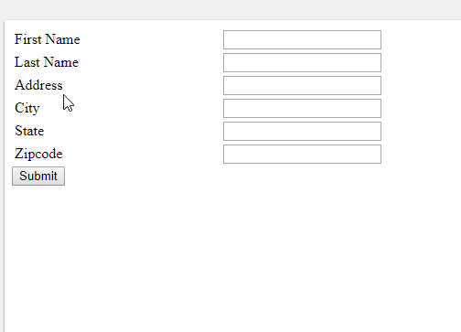

7.

<!DOCTYPE html>

<html>

<head>

<style>

table, th, td {

border: 1px solid black;

}

</style>

</head>

<body>

<table>

<col width="50">

<col width="500">

<col width="100">

<tr>

<th>col 1</th>

<th>col 2</th>

<th>col 3</th>

</tr>

<tr height="50">

<td>row 1</td>

<td>row 1</td>

<td>row 1</td>

</tr>

<tr height="50">

<td>row 2</td>

<td>row 2</td>

<td>row 2</td>

<tr height="500">

<td>row 3</td>

<td>row 3</td>

<td>row 3</td>

<tr height="50">

<td>row 4</td>

<td>row 4</td>

<td>row 4</td>

</table>

</body>

</html>

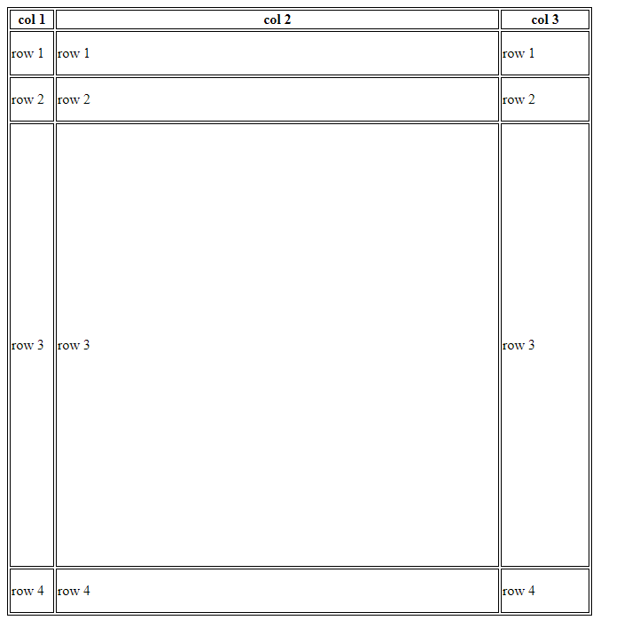

8.

<!DOCTYPE html>

<html>

<head>

<style>

img {

float: left

}

</style>

</head>

<body>

<p><img src="fruits-for-juicing.jpg" alt="Fruits" style="width:170px;height:170px;">

In botany, a fruit is the seed-bearing structure in flowering plants (also known as angiosperms) formed from the ovary after flowering.

Fruits are the means by which angiosperms disseminate seeds. Edible fruits, in particular, have propagated with the movements of humans and animals in a symbiotic relationship as a means for seed dispersal and nutrition; in fact, humans and many animals have become dependent on fruits as a source of food.[1] Accordingly, fruits account for a substantial fraction of the world's agricultural output, and some (such as the apple and the pomegranate) have acquired extensive cultural and symbolic meanings.

In common language usage, "fruit" normally means the fleshy seed-associated structures of a plant that are sweet or sour, and edible in the raw state, such as apples, bananas, grapes, lemons, oranges, and strawberries. On the other hand, in botanical usage, "fruit" includes many structures that are not commonly called "fruits", such as bean pods, corn kernels, tomatoes, and wheat grains.[2][3] The section of a fungus that produces spores is also called a fruiting body.[4]

</p>

</body>

</html>

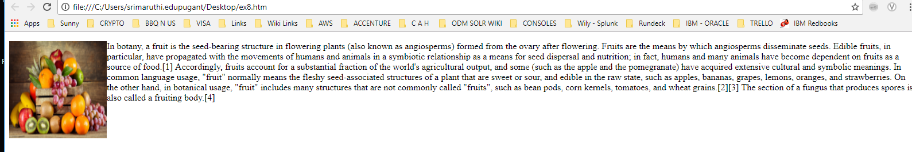

10.

<!DOCTYPE html>

<html>

<body>

<p>

<span style="color:blue">.NET Framework (pronounced dot net)</span>.NET Framework (pronounced dot net) is a software framework developed by Microsoft that runs primarily on Microsoft Windows. It includes a large class library named Framework Class Library (FCL) and provides language interoperability (each language can use code written in other languages) across several programming languages. <span style="color:red">Programs written for .NET Framework execute in a software environment (in contrast to a hardware environment) named Common Language Runtime (CLR), an application virtual machine that provides services such as security, memory management, and exception handling.</span> <span style="color:violet">(As such, computer code written using .NET Framework is called "managed code".) FCL and CLR together constitute .NET Framework</span>

</p>

</body>

</html>

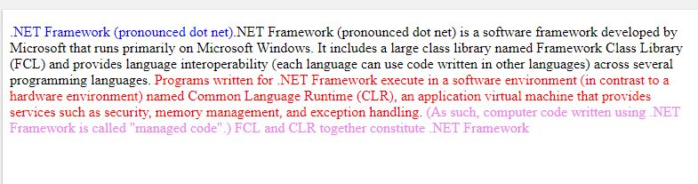

11.

<!DOCTYPE html>

<html>

<head>

<style>

p.one {

border-style: dotted;

border-color: blue;

padding: 25px 50px 75px;

border-radius: 5px

}

p.two {

border-style: dashed;

border-color: red;

padding: 25px 50px 75px;

border-radius: 10px;

}

p.three {

border-style: solid;

border-color: green;

padding: 25px 50px 75px;

border-radius: 1px;

text-align: center;

font-size:20px;

}

</style>

</head>

<body>

<div>

<p class="one">OUTSIDE DIV.</p>

<div>

<p class="two">MIDDLE DIV.</p>

<div>

<p class="three">INNER DIV.</p>

</div>

</div>

</div>

</body>

</html>

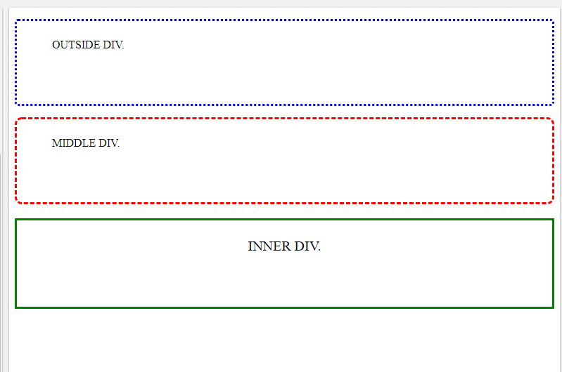

12.

<!DOCTYPE html>

<html>

<body>

<p>

<span style="color:blue">.NET Framework (pronounced dot net)</span>.NET Framework (pronounced dot net) is a software framework developed by Microsoft that runs primarily on Microsoft Windows. It includes a large class library named Framework Class Library (FCL) and provides language interoperability (each language can use code written in other languages) across several programming languages. <span style="color:red">Programs written for .NET Framework execute in a <p style="font-family:courier;">software environment (in contrast to a hardware environment) named Common Language Runtime (CLR),</p> an application virtual machine that provides services such as security, memory management, and exception handling.</span> <span style="color:violet">(As such, computer code written using .NET Framework is called "managed code".) FCL and CLR together constitute .NET Framework</span>

</p>

</body>

</html>

