**Project Title: ProConnect**

**Team Members – (Group – 7) :**

Vamsi Alapaty - 18230326

Pavan Kumar Jonnadula - 16324822

Sri Nikhitha Boddapati - 16322565

Sukumar Bodapati – 16326105

**Introduction:**

As part of this project, we are developing a centralized application of Canvas, Handshake, umsystem and Microsoft team which will save the time and convenient for the user since all the applications are available in a single application.

**Background/Related work:**

For developing this, we have analyzed all the applications functionalities.

**Define your proposed idea:**

For the students at UMKC, we have different applications like canvas for course work, Handshake for job opportunities, umsystem for personal and financial information and teams for texting. It is very difficult to navigate through the different application and login into them. It consumes lot of time. Instead, if we have a single application where all the features are available, user can easily navigate through the pages in the application which save a lot of time and accessibility will be good.

**Methodology/Approach:**

In the project application that we are developing, the user needs to login once. Then user can see the modules and he can select based upon his requirement like if he want to access the course work, he can click on the course work module when all his course work schedule will be available.

**Features:**

The following are the features that we are developing in this application:

From **CANVAS** we are implementing:

* Dashboard
* Announcements
* Syllabus
* Modules / Assignments
* Grade

From **HANDSHAKE** we are implementing:

* Jobs finder
* Events

From **UMSYSTEM** we are implementing:

* Courses Offered
* UMKC Alerts/Notifications (if time permits)
* Personal Information
* Financial Account

From **Success Network** and **Microsoft Teams** (if time permits) we are implementing:

* Faculty and Staff
* Official chatting feature among Roos.

**Modules & Work Sharing:**

We developed a front end for this project as part of increment 2:

1.Developed a home page which has navigation bar of home, login, modules.

2.Developed login page to login into the application

3.When user clicks on the modules, it opens a new page which contains all the details about the coursework.

Vamsi Alapaty & Pavan Kumar Jonnadula – Implementing the Umsystem module & Canvas module Sukumar Bodapati & Sri Nikhitha Boddapati – Success network module , Handshake module and documentation

**Technologies required**:

Angular, GitHub, node.js, MongoDB, VS Code.

**GitHub Link:**<https://github.com/JVSPAVAN/WebMobile-2022Spring/tree/main/Project>

**Blockages:**

Since we have developed only front end, we are not having any issue’s as of now. When we develop the backend application, we may face issues.

**Wireframes:**

**Home Page:**

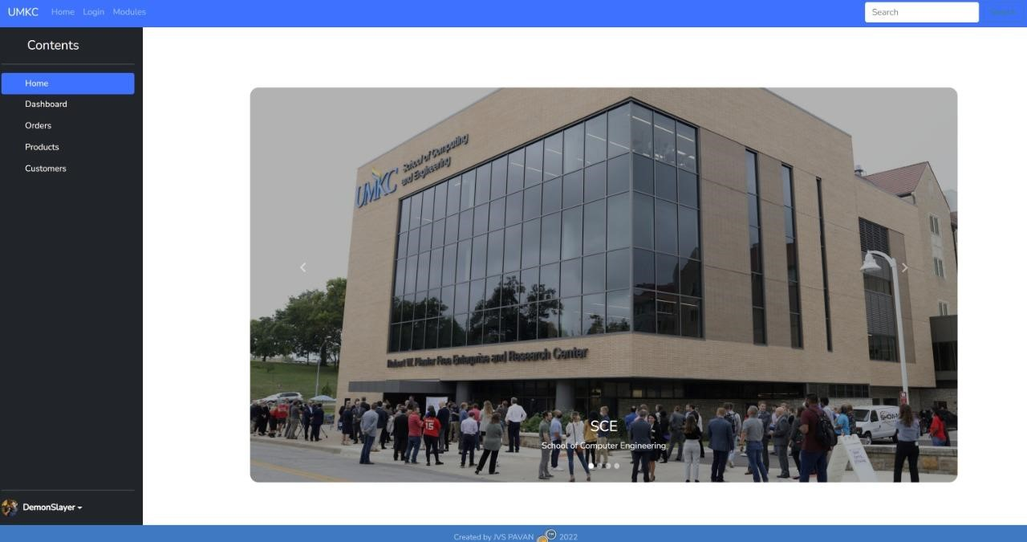

**Login Page:**

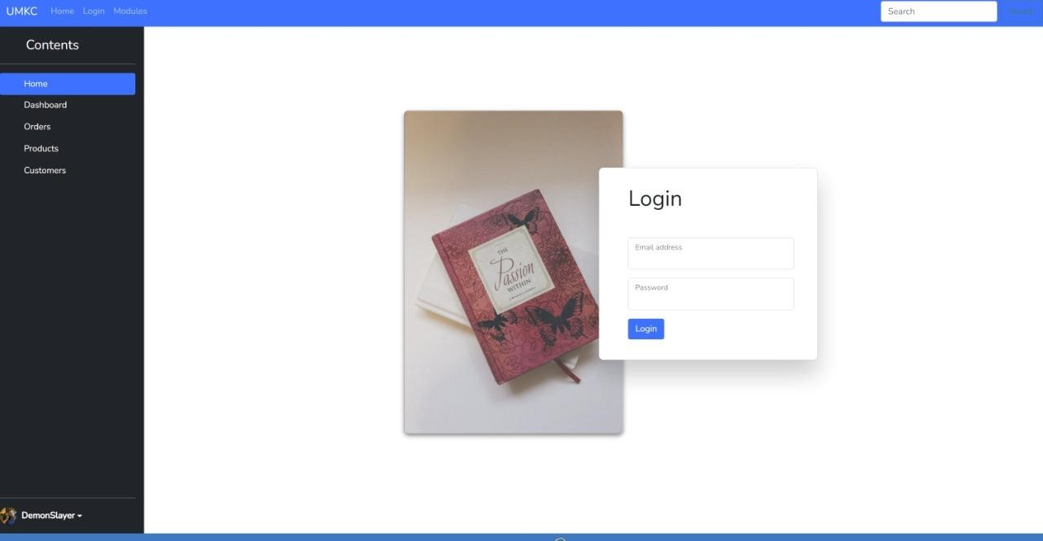

**Modules:**

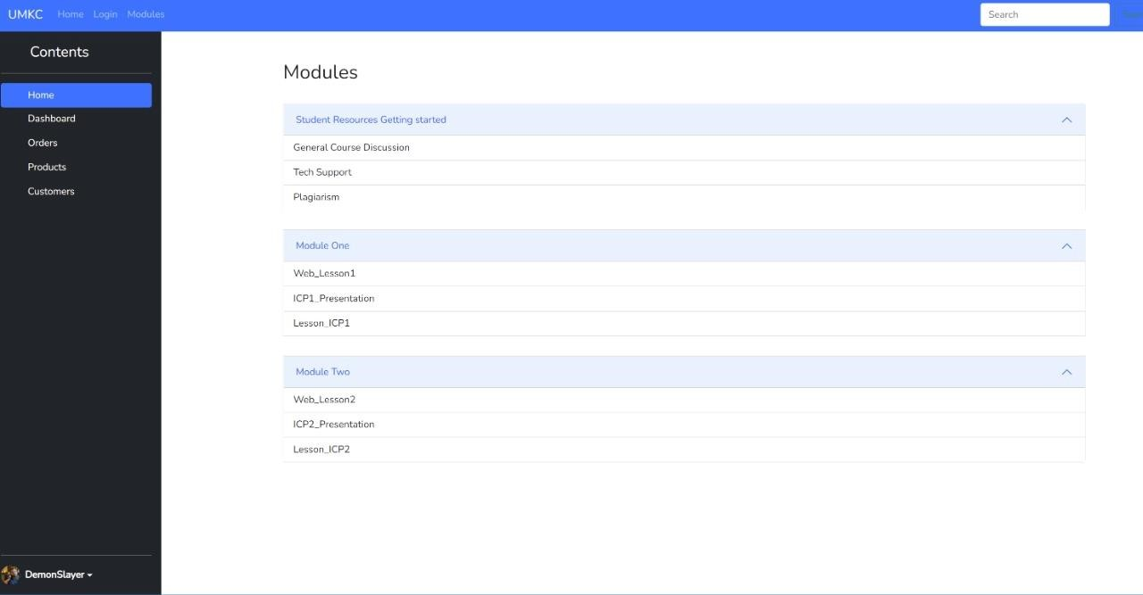

**References:**

Various component ideas, such as umsystem, canvas, success network, and handshake, can be found on the current UMKC official sites.