**Exercise 3**

**Question 1: What is the status code and phrase returned from the server to the client browser?**

The status code returned was 200 and the phrase was “OK”

**Question 2: When was the HTML file that the browser is retrieving last modified at the server? Does the response also contain a DATE header? How are these two fields different?**

The HTML file was last modified on the 23rd of September 2003 at 05:29:00 GMT.

The response also contains a “Date” header and the date contained in that header is 23rd of September 2003 at 05:29:50 GMT.

These two fields are different as the “Last Modified” field represents the time when the page was last changed in the origin server however the “Date” field is the time when the message was retrieved from the server.

**Question 3: Is the connection established between the browser and the server persistent or non-persistent? How can you infer this?**

The connection established between the browser and the server is persistent and can be inferred from the “Keep Alive” header.

**Question 4: How many bytes of content are being returned to the browser?**

73 bytes of content are being returned to the browser, indicated in the “File Data’ field.

**Question 5: What is the data contained inside the HTTP response packet?**

<html>\n

Congratulations. You've downloaded the file lab2-1.html!

</html>\n

**Exercise 4**

**Question 1: Inspect the contents of the first HTTP GET request from the browser to the server. Do you see an “IF-MODIFIED-SINCE” line in the HTTP GET?**

No, there is no “If-Modified-Since” line in the first HTTP GET.

**Question 2: Does the response indicate the last time that the requested file was modified?**

Yes, the response to the GET request does indicate the last time that the requested file was modified.

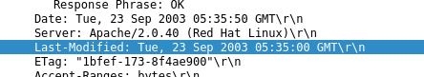

**Question 3: Now inspect the contents of the second HTTP GET request from the browser to the server. Do you see an “IF-MODIFIED-SINCE:” and “IF-NONE-MATCH” lines in the HTTP GET? If so, what information is contained in these header lines?**

Yes, there is an “If-Modified-Since” and “If-None-Match” field in the HTTP GET header.



The “If-Modified-Since” field contains the date of when the content within that HTTP request was last modified.

The “If-None-Match” field contains a E-Tag of that specific content field from the origin server.

**Question 4: What is the HTTP status code and phrase returned from the server in response to this second HTTP GET? Did the server explicitly return the contents of the file? Explain.**

The HTTP status code and phrase returned from the server in was “304 Not Modified”

No, the server did not explicitly return the contents of the file as from the status suggests the contents of the file has not changed and so there is no need to resend the contents.

**Question 5: What is the value of the Etag field in the 2nd response message and how it is used? Has this value changed since the 1 stresponse message was received?**

The value of the “ETag” field is “1bfef-173-8f4ae900”

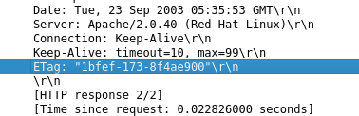

The “ETag” field is similar to a hash key where when sent to the origin server, it compares the HTTP GET’s “If-Modified-Since” date and the “Last-Modified” date in the origin server to determine whether that specific ETag’s content has been modified. The server then responds accordingly to the result of that comparison e.g. If it has not been modified, no field content is sent in response. If the content has been modified, the field content is sent.

This value has not changed since the 1st response message was received as it is requesting the same content and so it would have the same ETag.

**Exercise 5**

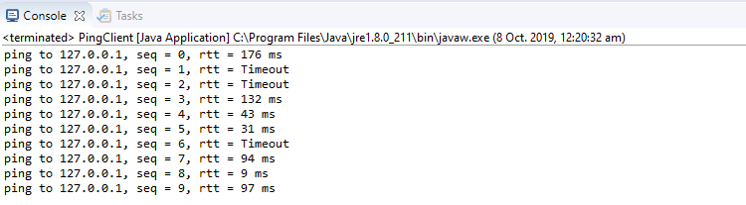

**Minimum –** 9 ms  
**Maximum** – 176 ms   
**Average** – 83.14 ms