

Business Template

Subject areas
Logo / Image

Contents
Business Description 3
1.1 the Benefits of implementing a database. Project Vision 3
2 Model description 3
2.1 Definitions & Acronyms 3
2.2 Logical Scheme 3
2.3 Objects 3

Business Description

the Benefits of implementing a database. Project Vision
- How will the database solve the problems listed in the description?
The database stores information about vehicles, customers, trips, pricing, maintenance, payments, and ratings in one consistent structure. It records trip details and vehicle status changes, while separate pricing rules allow rates to depend on vehicle type, duration, and distance.
- How will it ensure data integrity, consistency, and traceability?
Primary keys uniquely identify records, and foreign keys ensure that related records refer to existing entities. Unique constraints and check constraints prevent duplicate vehicle types and invalid values, such as negative costs or invalid time intervals.
- How does the model store the history of changes?
VehicleStatusHistory stores vehicle status changes with timestamps, while ServiceRecord keeps maintenance and inspection records. New history records should be inserted rather than overwriting previous ones. Effective dates in PricingRule help explain which rates applied during a particular period.
P.S. Historical information is preserved only if the application inserts new history records instead of overwriting previous ones. The current schema supports this approach, but does not itself prevent existing history records from being updated or deleted.
- How does the structure allow the system to scale without major redesign?
Separate tables allow new vehicles, customers, employees, trips, and pricing rules to be added without redesigning the entire model. Storing vehicle types and pricing rules separately also reduces unnecessary duplication.
- Which constraints and checks have been added to keep data correct as volume grows?
The model uses primary keys, foreign keys, NOT NULL, and UNIQUE constraints, along with checks for valid vehicle statuses, non-negative costs and distances, correct timestamp ordering, valid pricing periods, and rating scores within the assumed range of 1–5.

Model description

Definitions & Acronyms
- Vehicle: A car available for use through the car-sharing service, identified by its unique VIN.
- VIN (Vehicle Identification Number): A unique identifier assigned to a vehicle.
- Customer: A person who uses the car-sharing service and can make trips.
- Trip: A journey made by a customer using a vehicle. It records the start and end times, distance, cost, and pricing rule used.
- Vehicle status history: A record of a vehicle's status at a particular time, allowing previous status changes to be retained.
- Vehicle type: A category used to group vehicles, such as Economy or Premium.
- Pricing rule: The rates applied to a vehicle type, including the price per minute and per kilometre, and the period during which the rule is effective.
- Service record: A record of maintenance or inspection performed on a vehicle by an employee.
- Payment: A record of a payment associated with a trip.
- Rating: Customer feedback associated with a trip. In this model, a trip can have at most one rating.
- PK (Primary Key): A column or set of columns that uniquely identifies a record in a table.
- FK (Foreign Key): A column or set of columns that references a key in another table and establishes a relationship between records.
- 3NF (Third Normal Form): A normalization level in which non-key attributes depend on the key, the whole key, and nothing but the key.
Design assumptions:
- Vehicle assignment information is recorded in VehicleStatusHistory through AssignedCustomerID. This is a simplified approach and does not represent a complete reservation lifecycle.
- The rating scale is assumed to be from 1 to 5 because the business description does not specify a scale. The rating scale is assumed to be from 1 to 5 because the business description does not specify a scale.

Logical Scheme
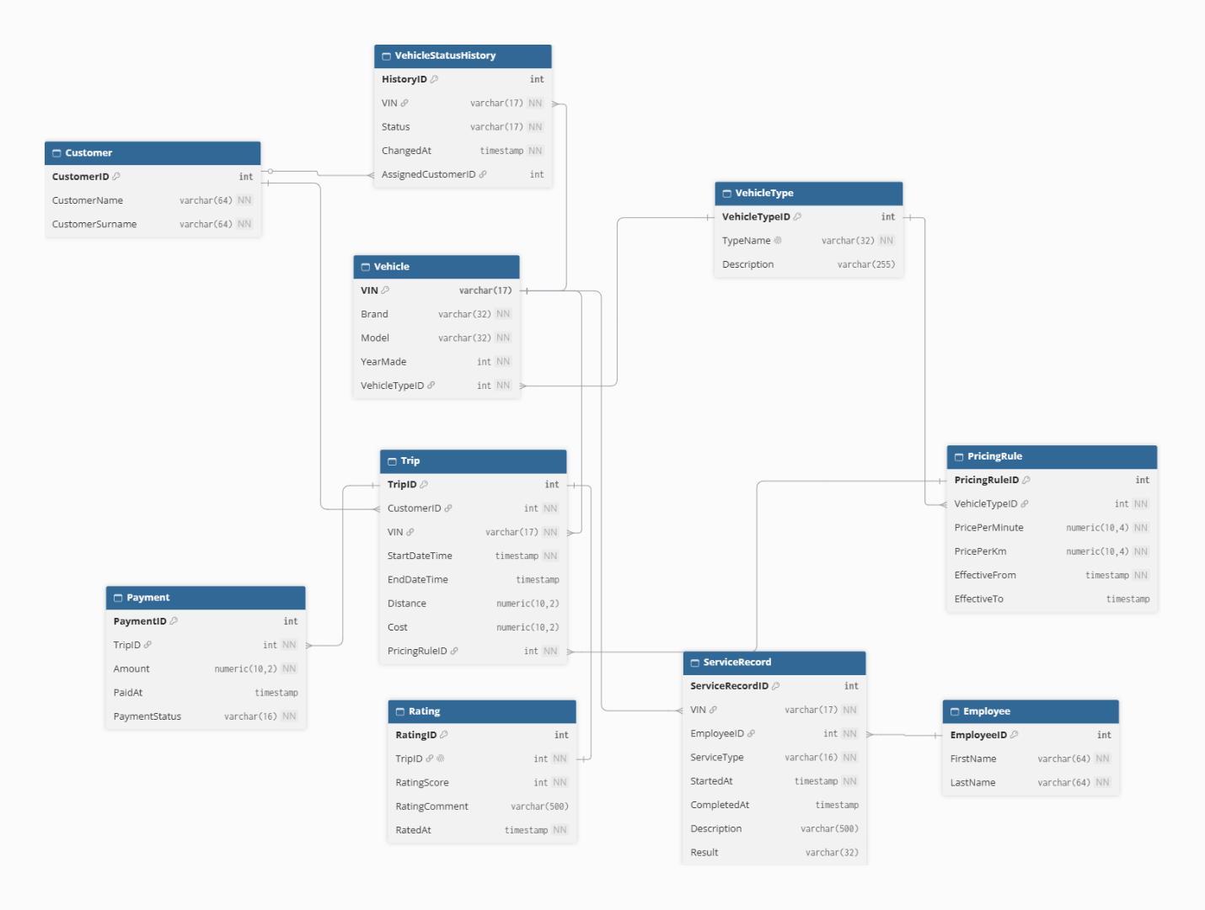

- Most difficult modeling decision: One of the main decisions was how to represent vehicle status changes and preserve historical information. The VehicleStatusHistory table stores a vehicle's status and the time of the change, rather than relying only on its current status. Another decision was to use Trip to connect customers and vehicles, because one customer can take many trips and one vehicle can be used by many customers over time. The ServiceRecord table combines maintenance and inspections, distinguished by the ServiceType field.Provide examples of potential data anomalies that your design prevents. Explain which constraints or structure elements prevent them.
- Data anomalies prevented: Primary keys uniquely identify records, while foreign keys prevent relationships to records that do not exist. For example, a trip cannot refer to a nonexistent customer or vehicle. The unique constraint on VehicleType.TypeName prevents duplicate vehicle-type names, and the unique constraint on Rating.TripID ensures that a trip has at most one rating. Check constraints reject invalid values, such as negative trip distances or costs, rating scores outside the assumed 1–5 range, unsupported vehicle statuses, and completion times earlier than their corresponding start times.
- Scalability: The model separates vehicles, customers, vehicle types, employees, trips, and other business concepts into separate tables. New vehicles, customers, employees, trips, and pricing rules can be added without changing the overall table structure. Storing vehicle types and pricing rules separately also avoids repeating the same type descriptions and pricing information for every vehicle or trip.
- Possible changes if requirements expand: The current model represents customer assignment through VehicleStatusHistory and AssignedCustomerID, which is a simplified approach. If the service needs to manage reservation dates, cancellations, and reservation history in more detail, a separate Reservation table would be appropriate. Other possible extensions include supporting multiple ratings per trip, additional payment details, or more complex pricing rules.
Small but important note: the historical information is preserved only if the application inserts new history records instead of overwriting previous ones. Similarly, the current schema does not prevent overlapping effective periods for pricing rules; that could be addressed if the business requires it.

Objects

Example: VehicleType

Table description:

The VehicleType table stores the categories used to classify vehicles, such as Economy and Premium. It is stored separately from Vehicle because several vehicles can belong to the same category, and storing the category name and description once avoids unnecessary duplication. VehicleTypeID is the primary key because it provides a stable, unique identifier for each category. A composite key is unnecessary because each category can be identified by a single ID. The TypeName field is also unique, preventing duplicate category names.
The table is designed to satisfy Third Normal Form (3NF). Each record represents one vehicle type, and the non-key attributes, TypeName and Description, describe that type. There are no partial dependencies because the primary key consists of a single column. There are no transitive dependencies between non-key attributes in the intended design. The foreign-key relationships are defined in the Vehicle and PricingRule tables through VehicleTypeID: one vehicle type can be associated with multiple vehicles and multiple pricing rules. This separation allows category descriptions and pricing rules to be managed without repeating vehicle-type information for every vehicle.

Table Name | Field name | Field Description | Data Type
VehicleType | VehicleTypeID | Unique identifier, PK | INT
VehicleType | Name of vehicle category | unique | VARCHAR(32)
VehicleType | Description of the category |  | VARCHAR(255)

Example with data:

VehicleTypeID | TypeName | Description
1 | Economy | Economical vehicles for everyday trips
2 | Premium | Higher-class vehicles

