**Introduction**

With the development of IoT(Internet of Things), cloud and data science, mobile ads has becoming a more and more powerful industry. Different from traditional ads we have seen on TV or other medias, mobile ads display on phones, tablets and other mobiles devices in various kinds, such as pictures, texts, video, html5 and links. Combined with cloud and data, mobile ads can target ads customer more concisely and instantly at anywhere and anytime.

 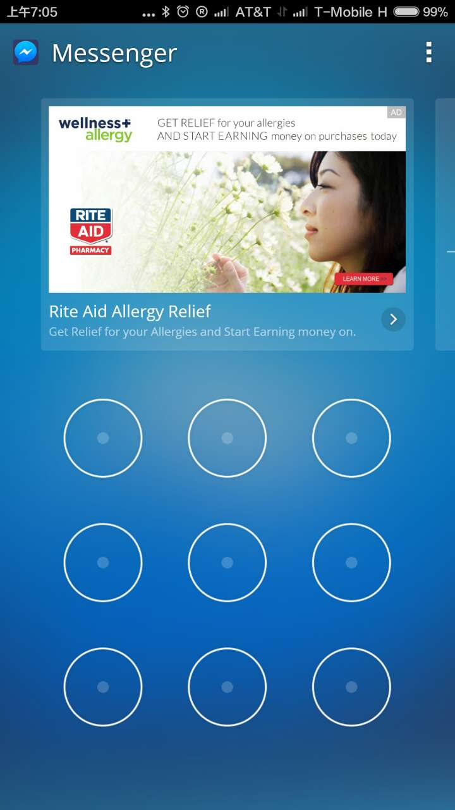 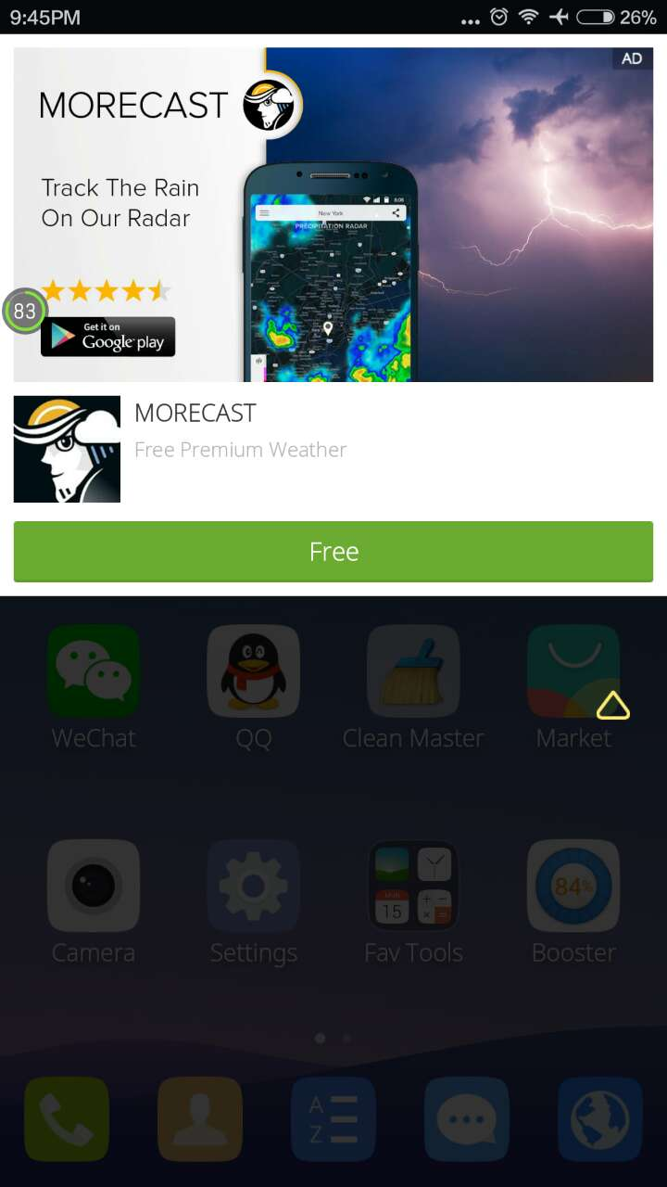

Figure 1 Mobile Ads Samples

As reported, mobile ads industry is a hundred billion level business. In 2016, the mobile and internet spending will be over $100 billion and more than 50% will be digital ad spending. Especially in China and other developing countries,, accordingly the leading advertisers are also changing to devote to mobile ads market. Even in developed countries, there are still growing customers in mobile devices[1].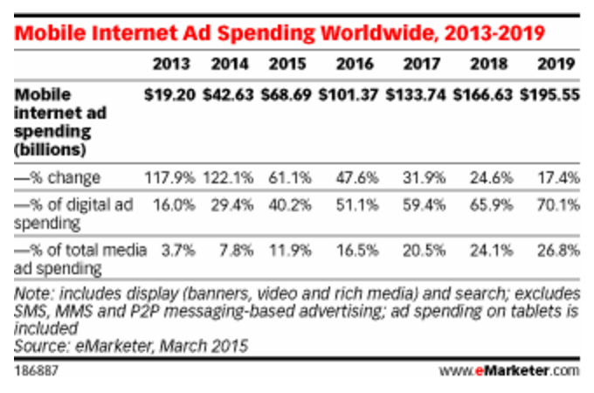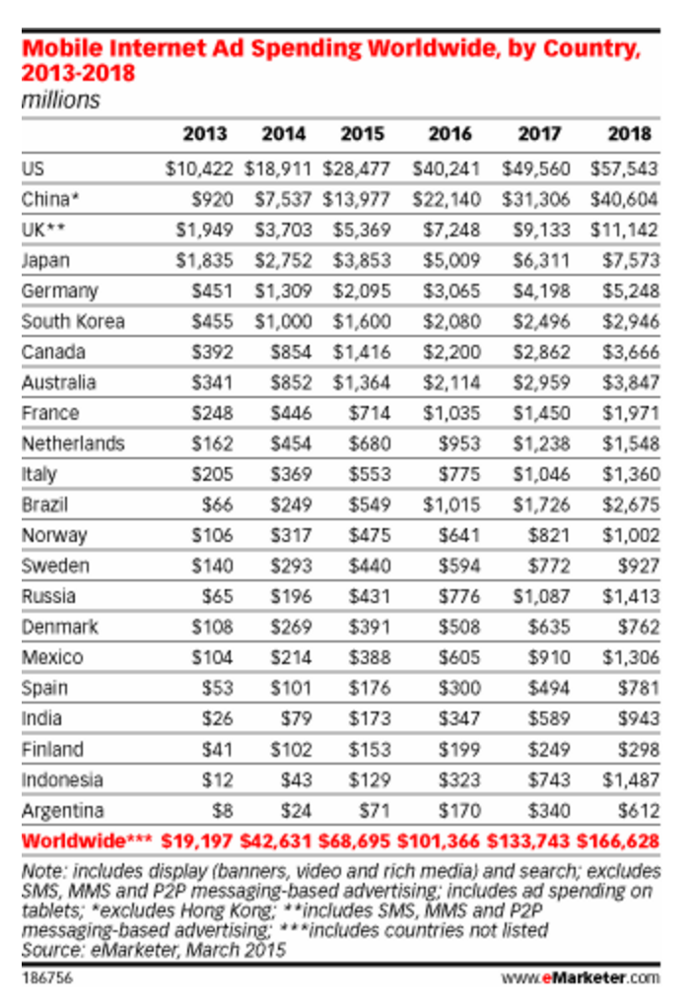

Figure 2 Mobile Ads Market Statistics

**Motivation**

Traditional advertising formats on mobile devices suffer from poor click through rates and are considered to be invasive and non-intuitive for the end user. At present, industry experts are advocating a new advertising format called Native Ads. However, there isn’t sufficient metric to validate the effectiveness of this new advertising format. Since native ads require significant effort by the developer to incorporate the ads in their apps, a quick comparison of the efficacy of this format will assuage the fear of the smaller app studios.

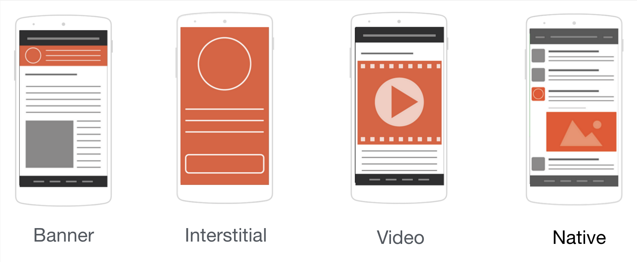

Figure 3 Ad Formats

The above figure shows all the available ad formats for mobile devices. Although banner ad formats have been extremely popular among mobile app developers (publishers), it is not able to get enough users to click on them. So, banner ads tend to have lower performance. In order to boost the monetization efforts of mobile app developers, the mobile ad industry has been experimenting with various other ad formats like ‘Interstitial’ format, ‘Video’ format and the most new entrant is the ‘Native’ ad format. Although Interstitial ads have high performance and garner more impressions, it comes at the cost of being extremely intrusive and poor UX design. On the other hand, Video ads have shown great promise with the ability to gain high engagement while delivering an immersive full screen experience. However, video ads have delivered this mostly for game apps. Finally, Native ads has emerged as a new trend pioneered by Facebook and has delivered on its promise of high performance while not disrupting the user experience.

Below, you will find the anatomy of a Native ad. The primary elements are the small icon, title, description, big picture (or video), call to action button. By using either one or more or all these five elements, the app developer can configure the layout of an ad to fit perfectly with their existing app user interface. This way, the app can deliver ads without disrupting the user experience.

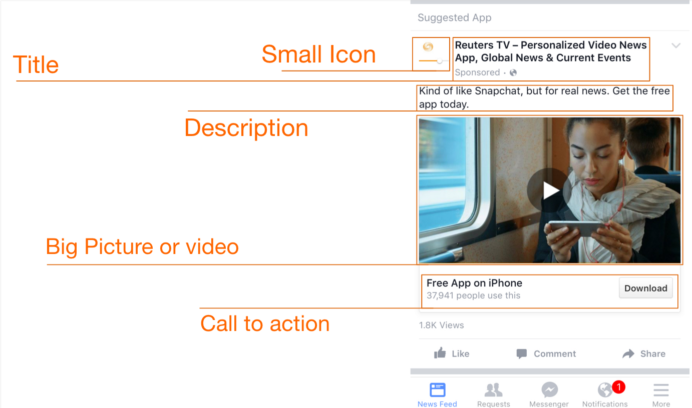

Figure 4 Anatomy of Native Ad