**What the GIF**

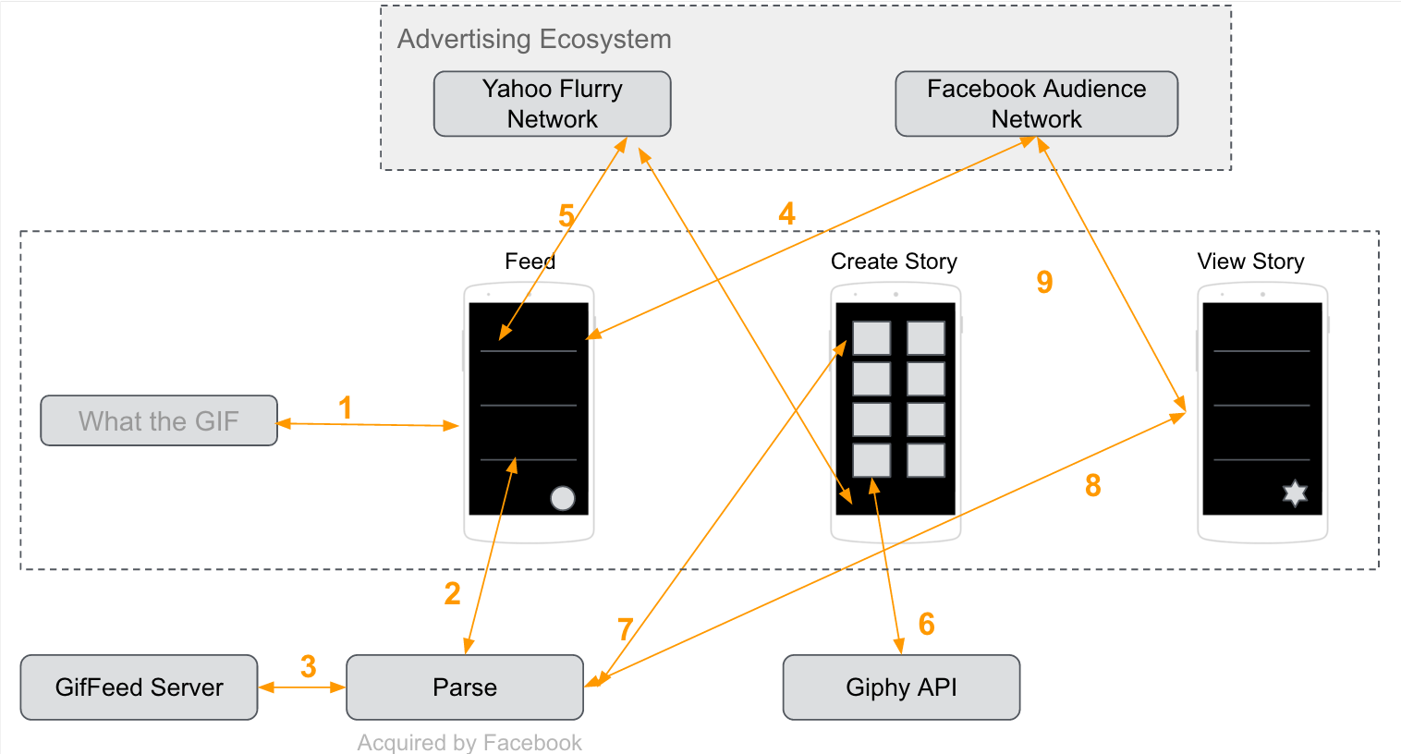

Figure 8 System Design

The above figure shows the system design for ‘What the GIF’ app. The core layers of the system are the ‘Advertiser Ecosystem’, the Android mobile app and the ‘Web Services’.

Advertiser Ecosystem: The Advertiser ecosystem consists of the various advertising network used by the android application to fetch advertisements to display within the application. We have used two advertising networks to help serve ads within the app. First, Facebook Audience Network is an advertising network introduced by Facebook to serve mobile ads to app publishers. They have a mature Facebook SDK to help developers integrate the ads within their individual apps. Using their SDK, we fetched both banner ads and native ads to be displayed within the What the GIF app. Second, Yahoo Flurry Network is an advertising network by Yahoo to serve ads within mobile applications. They also have a SDK to help developers integrate the ads within the application. Again, we used both banner ads and native ads from the Yahoo Flurry Network to serve ads within the application.

Android App: We built ‘What the GIF’ Android app with the intention to provide users with the capability to create fun stories using animated images (gifs). Given the dynamic nature of content, we realized that it is possible to integrate native ads which will blend in seamlessly within the application. Using playtesting, we narrowed down on some of the screens within the application which are ripe for displaying advertisements. Although, the app includes both banner and native ads, we intend to contrast the experience of banner ads versus native ads within our app.

Web Services: The backbone for making the app work are the web services. We primarily rely on the Giphy API[4] for the repository of Gifs. Giphy has made their API available to developers to fetch and display gifs from with their own repository. We have integrated their API in screens which require Gifs to be displayed. In order to persist stories created by the users and to make them available to other users, we have used the Parse[5] object store for saving the stories created by the user. The Feed screen and individual story screen rely on Parse to populate data on the screen.

Above figure shows the system design of our app ecosystem. ‘What the GIF’ app has been built using the Android SDK[6] provided by Google. Since our app relies on Gifs to create and show content, we have used the Giphy API provided by Giphy. Using their service, our app is able to access labelled gifs and sticker from their repository. The gif/sticker search functionality also relies on the Giphy API. Search requests made to their endpoint results in a JSON object/array which contains the links to gifs (in various sizes and formats) which are then fetched to be displayed within the app.

To incorporate Ads within the application, we have relied on Facebook SDK which provides access to their Facebook Audience Network as well on Yahoo Flurry SDK[7] in order to serve ads by Yahoo Advertising network. Stories created by users are stored in the Parse object store. We have used the Parse Android SDK[8] to store the story data and to fetch user created stories.