1. Ordinary Linear Regression

Statement of problem: Given a training set *X* (m by n matrix with each row as one input), and a corresponding observed outputs(m by 1 vector, each element corresponds to one input row), we hope to find a parameter vector (n by 1 vector), such that the system is linearly expressed as:

Where represents perturbations such as noise.

We can use least squares as the cost function in this problem:

By taking the derivative of *S* over and set it to zero we could find the most suitable values for :

If is invertible (equivalent to *X* being full column rank!), then we can directly solve :

Note: rank = rank . See: <https://math.stackexchange.com/questions/349738/prove-rank-ata-rank-a-for-any-a-m-times-n>.

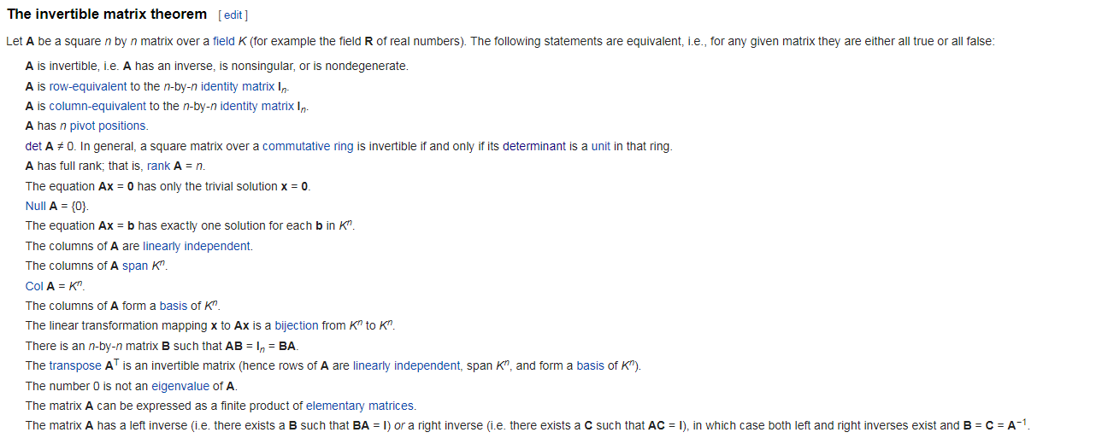

However, in more general cases, is not invertible. Hence we can take the derivative of log-likelihood for only one training data pair () over and use **stochastic gradient descent** method to numerically solve for the best :

For gradient **descent**, we use the opposite number to update the parameters.

We carry out the iterative method as:

Loop{

for i = 1:m {//Every training set

for j = 1:n { //Every parameter

}

}

}

Note: Whereas batch gradient descent has to scan through the entire training set before taking a single step—a costly operation if m is large—stochastic gradient descent can start making progress right away, and continues to make progress with each example it looks at. Often, stochastic gradient descent gets θ “close” to the minimum much faster than batch gradient descent. (Note however that it may never “converge” to the minimum, and the parameters θ will keep oscillating around the minimum of J(θ); but in practice most of the values near the minimum will be reasonably good approximations to the true minimum.

**Probabilistic interpretation**:

For the system mentioned in the first equation, we can also approach the problem using maximum-likelihood method. If we assume that the distribution of is i.i.d. normal, then the maximum-likelihood method results in:

**The above equation is EXACTLY the OLS fitting method! (Hence we can also say that the OLS method is a correct estimation iff is i.i.d. normal distribution)**

1. Logistic Regression

The form of logistic function:

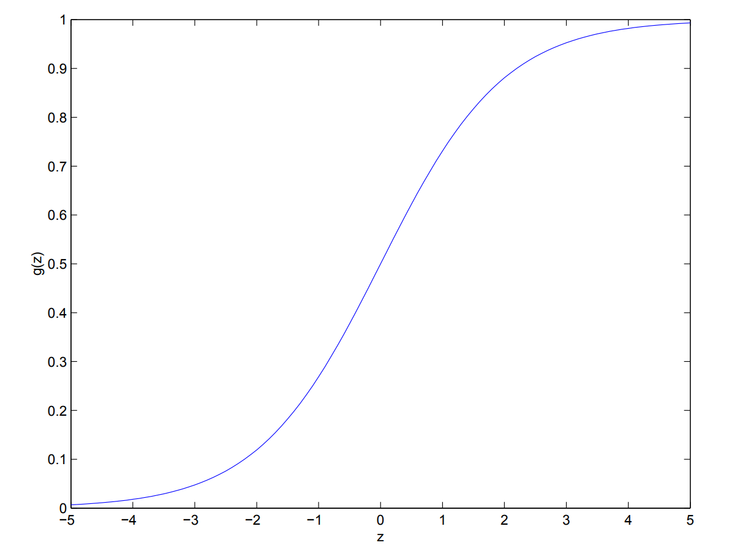

The purpose that logistic regression was introduced was to solve classification problems. Remember the derivative of *g(z)*:

The above form turned out to be VERY useful in later derivations!

Statement of problem in a classification problem: Given a training set *X* (m by n matrix with each row as one input), and a corresponding observed outputs(m by 1 vector, each element corresponds to one input row and **CAN ONLY BE 0 OR 1**), we hope to find a parameter vector (n by 1 vector), such that the probability for an input set to belong to class 1 is expressed as:

Denote:

We can re-write the probability function as:

Note: be careful that here represents the OBSERVED class, instead of the predicted possibility .

Again, we can use maximum-likelihood method to solve for the optimum parameter :

Again, we can take the derivative of log-likelihood for only one training data pair () over and use **stochastic gradient ascent** method to numerically solve for the best !

We carry out the iterative method as:

Loop{

for i = 1:m {//Every training set

for j = 1:n { //Every parameter

}

}

}

**Note: The above stochastic update equation is exactly the same as that for OLS, even though we started out from a totally different data model!**

1. Ridge and LASSO Regularization
2. Ridge regression

Cost function in Ridge regression is:

The highlighted part is the difference compared to OLS. The matrix is a diagonal matrix with non-negative elements representing the REGULARIZATION on the parameters.

The intuition behind regularization is to avoid OVERFITTING! If is zero, is equal to the estimator in OLS. If is infinity, becomes zero.

Closed-form solution of (assuming solvable, i.e. the matrix in bracket is invertible):

1. LASSO (Least Absolute Shrinkage and Selection Operator)

Cost function:

**Note 1**: LASSO is different from Ridge regression MAINLY because the nature of the cost function makes **some parameters shrink to zero**! Hence sometimes people also deem LASSO one of the dimension reduction techniques.

**Note 2**: The original form of LASSO regression is:

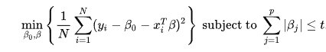

The cost function given above is the Lagrangian form.

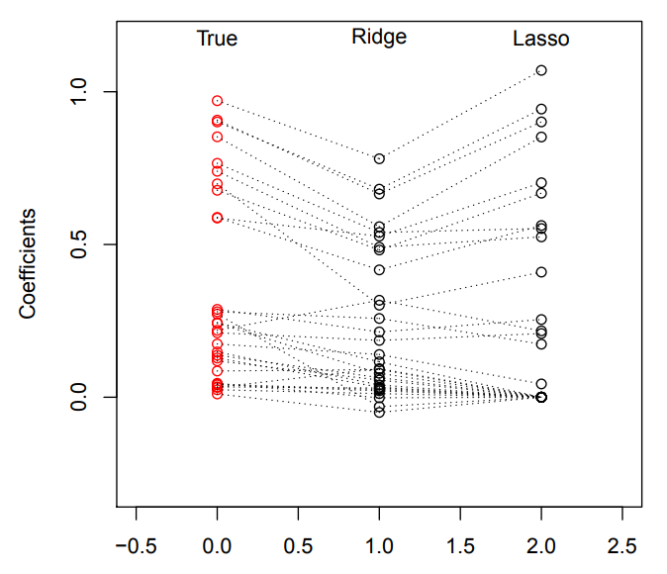

Figure: an example showing the parameters fitted with different methods.

1. Coefficient of determination (R2)

In too many cases, people tried to use R2 as a metric to determine the “goodness of fit”.

The determination of R2 is:

Among them *yi* is the observed/measured data, the averaged observed/measured data, *fi* is the predicted value using the fitted model (sometimes also referred to as ).

The logics behind R2 definition is: Out of all the variance we observed in dataset of *y*, how much variance can be explained by out fitted model? If the fitted model “perfectly” explains the variance, then there should be NO difference between the observed data and the prediction, and R2 should be one.