# Types of Report in SSRS

## Drill Down:

Drilldown reports initially hide details and enable the user to toggle conditionally hidden report items to control how much detail data they want to see. For a drill down report, when you open the report, you will only see the highest hierarchy that was define row group, you will have choices to toggled down that hierarchy and expand the table. The measures in that table will always be aggregated across the lowest hierarchy show on the table.

First Step, to establish this hierarchy, we need to drag columns to Row Group one by one according the toggle down path. For each group, change the group property visibility to hide, set the display can be toggled by its parent group. Another important thing is to for measure data, set the expression with aggregation function, so that it display the aggregated data for each group. And if the data type Is money, we can add a dollar sign, again, by changing the expression.

drill down:

a)drag columns into Row Groups according to hierachiel of the drill down pass

b)In group property, change the display option to HIDE

c)display can be toggled by the parent column

d)do b), c) to all group created

e)for meausres, aggregate data, set the expression in property to =sum(Fields!OrderQty.Value)

f) adding a dollar sign to money data

="$"& " " & sum(Fields!SalesAmount.Value)

## Drill Through:

It is a report that when a user click one item on the current report, it will jump to another report that provide the details of this particular item. It allows the user to switch one report to another report. Essentially, in the background, you need to pass a variable contains the value of that clicking item to the second report. In this case, the second report should be a parameterized report that can accept variable from first report as filter, and therefore show only the relevant information

Since we are jumping from one report to another, we will use the **go to report property**, choose the report you want to jump to. The next step is about passing parameter, choose the parameter in second report, and specify the column in the current report that you want to click through.

drillthrough:

a) right click the data to open text box property.

b) go to action, select go to report, select the report you want to go

c) select the parameter in the second report that you want to pass value to,

then assign value. this can be done in two ways. you can used a parameter in

current report, you can also choose to provide a column.

d) The second method can be better since it aviod the problem cause by multi-selection of parent report parameter

## Sub Report

It is a report that when you open the report, multiple sub reports will be presented along the content of the parent report. We have choices to include multiple sub-reports in the parent report. It is a very nice way to quickly generate a dashboard, but it has some performance issues, whenever the report is open, all sub report will be processed and this will potential take long time and any error in a single sub report will fail the entire report.

## Parameterized Report:

Give the user the option to specify a parameter value to run the report. For example in a parameterized sales report. We have a parameter territory. If the user enter USA, then it will give all the info of USA; If the use enter China, then it will go to China sales.

To create a parameterized report, when create the dataset, we need to embed a variable in the query. Then a report parameter corresponding to this query variable will automatically generated. After that, creating a dataset that hold the available value for that variable. Open the property of the variable, map this data set to variable, you will have choice to do multi-select, data type, visibility and etc.

a) parameterize the query when build the dataset, us in() to enable multi-selection. b)modify the parameter, define prompt, data type, null, blank, visibility. c)create a dataset for possible parameter values. d)in parameter, select get value from query, selection the new dataset created, value filed, label field. f) optionally, provide default value

# Parameterized Report with Stored Procedure

Everything is the same but for multi-selection. You will need a

In SQL Server Reporting Services, multi-value parameters are passed to SQL stored procedures as a comma-delimited string of the values. We need to parse/split the comma-delimited string into values that can be used in “IN” clause or operator in stored procedure.

## Book Mark

Bookmark is an SSRS Action that can be implemented to navigate to respective data

bookmark:a)add new dataset as a column. b)action, go to book mark item. c)bookmark property main table c)optional, create a page break

url: a)action, go to url, provide http link

document map(create a nevigation): a) advance property, document property

## Document Map

Document Map is created to navigate through different pages by creating a Navigation panel on report.

## Chart

Chart is one of the Report Item available on Toolbox. Data can be displayed in form of Chart to improve Data Visualization

## Cascading Parameterized:

A type of Parameterized Report which allow user to specify multiple parameter to run the report. With cascading parameters, the list of available values for one parameter depends on the value chosen in preceding parameter.

a)create parent dataset, the dataset where you draw columns. In parent table query, enbbed the product category parameter @prodcat, @prodsubcat, @prod.

b)create a dataset to provide value for @prodcat, using query

c)create a dataset to provide value for @prodsubcat, using dynamic query with @prodcat as filter

d)create a dataset to provide value for @prod, using dynamic query with @prodcat, @prodsubcat as filter

# Linked Report

A linked report helps us to prepare a report based on another report. We can create linked report in Report Manager. There are two situation that I open use linked report. First one is when I want to general a report portfolio for someone. What I do is to create linked report for each report I want to show. Put them in a folder and then pointer the user to that folder. Besides this, linked report also help us to define exact the same structure, format as another report, but will some adjustment. For example, while creating the linked report, we can change the parameter of the underlying report, to have the report show different set of data.

# Data Bar

Data Bar helps to visualize the numerical data in a text box using by inserting bar chart. It is very helpful when we applied data bar to a numerical column. We can directly figure out what’s larges value in that column, what’s the minimum value in that column and a general ideal of the distribution.

# Rendering? Explain?

**Issue with PDF🡪**Alternate blank pages when exported🡪**compress page item**+ **ConsumeContainerWhiteSpace ccws**

**Issue with EXCEL🡪**Merged Cells when exported to excel which avoids Pivots. 🡪 Move header to align with the cell

**Issue with CSV (Comma Separated Values ‘Text files’)🡪**Display Textbox number instead of Column Name when exported🡪name property of textbox

The common rendering problem happen when we want to export report as PDF file, Excel file or CSV file. For PDF file, sometimes we may find **unexpected blank pages** after export. The problem is as a result of the unused white space in the design page. The solution is to **compress page items**, and set the propery **ConsumeContainerWhiteSpace** as True. For Excel, we may find **merged cells** in the exported file. This is not good for many excel functions. Such as pivot table. A solution is to try to move header to **align with the cell** or table. For CSV file, we may find that it displays the **textbox number** instead of column name. To solve this, we need to change the **name property of textbox** to column name

# Drill through and Sub Report? And which is better in performance?

Both option will let you to access another separate report from current report. The major difference is when the user will be prompt a second report. For Drill through, the user will only go the second report when he or she click an attribute member on which we have define a go to report action. However, for a sub report, once the user choose to view the main report, all the subreport contained will be presented to the user, along with the content in the main report. Although subreport is a convenient way to assemble a main dashboard by referencing multiple sub-reports, it can have very bad performance. Since everything, including the content of main report, and the contents from sub-reports will be loaded in parallel. And anything goes wrong in any of the sub-report will throw an error for the main report.

Another difference is that for drill through, the only way to link current report to a second report is to assign value to a parameter in second report. For subreport, we can simple use subreport tool to connect embed one report into another.

The performance of Drill through is much better. For Subreport, although it is a convenient way to assemble a main dashboard by referencing multiple sub-reports, it can have very bad performance. Since everything, including the content of main report, and the contents from sub-reports will be loaded in parallel. And anything goes wrong in any of the sub-report will throw an error for the main report.

# Report Models

Report Models are generated for non-technical users to generate reports. It is one of the reporting features available at BIDS level. Report Models are available only till SSRS 2008

# Subscription

In Standard Subscription report can be delivered via Email or Windows File Share in **only one rendering** format to multiple users.

In Data Driven Subscription report can be delivered via Email or Windows File Share in **multiple rendering** formats to multiple users.

How to do a subscription?

Step 1. The **data source** should have **Credential Stored Securely in the report server**

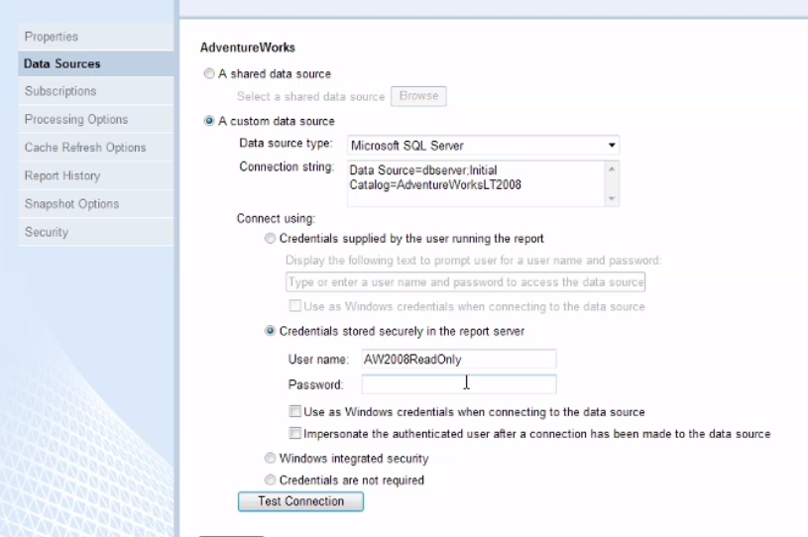

Step2. **Email or Window File Share**

Step 3. **Email info** (recipient, CC, BCC, subject, content), **report format** (PDF or CSV…), **Schedule**

# SSRS components

**Report Server**: this is the engine of Reporting Service that runs in the background. It talks to the database and can manage and deliver you reports

**Report Designer** (integrated into Visual Studio): This is the application to help us design and create these reports. Report Build does the same job.

**Report Manager**: Typically, the reports in Reporting Services are viewed by going to a website called Report Manger. This is where you can find different reports that have been created and view them online.

# SSRS reports components?

Data Source: A connection to source data on which we want to create report. It usually a database. It can be a shared source or an embedded source.

Dataset: this is the data that we are actually going to put into report. You can write a query to join multiple tables from data source, you can specify query parameter, and you can change the column name.

Report layout: define the data regions, chart, colors, font and many other properties to determine how a report is going to be presented. You may create different type of report from here…

# Deployment

In order to deploy reports on Report Server few properties need to set and taken care of:

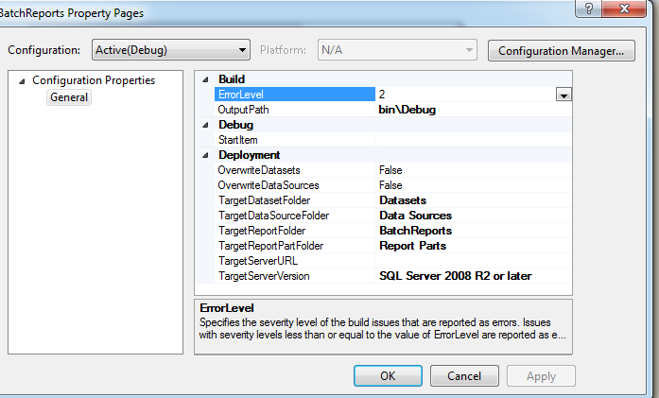

# Cache and Snapshot

**Cache:**

A report server can cache a copy of a processed report and return that copy when a user opens the report. Caching can shorten the time required to retrieve a report if the report is large or accessed frequently.

**Snapshot:**

A report snapshot is a report that contains layout information and a dataset that is retrieved at a specific point in time. Unlike on-demand reports, which get up-to-date query results when you select them, report snapshots are processed on a schedule and then saved to a report server.

# Add a $ to money data type

adding a dollar sign to money data

="$"& " " & sum(Fields!SalesAmount.Value)

# Row Group

Row grouping will define a hierarchy in the data. It is often used when you want to create drill down report. Similar to row grouping, column grouping also helpful to create dill down or navigation, but it works on column basis.

# Data Regions (Table, Matrix, List)

A data region is an object in a report that displays data from a report dataset. Report data can be displayed as numbers and text in a table, matrix, or list;

**A table** is a data region that presents data row by row. Table columns are static: you determine the number of columns when you design your report. Table rows are dynamic: they expand downwards to accommodate the data. You can add groups to tables, which organize data by selected fields or expressions.

**A matrix** is also known as a crosstab. A matrix data region contains both dynamic columns and rows: they expand to accommodate the data.

**A list** is a data region that presents data arranged in a freeform fashion. You can arrange report items to create a form with text boxes, images, and other data regions placed anywhere within the list.

# Ad-Hoc Report

**Report Model**

Creating a Report Model Project

Defining a Data Source for Your Report Model

Data Source View for Your Report Model

Define a report model: A report model is a ***metadata layer*** on top of a physical database that **identifies business entities, fields, and roles.** Models are defined using an XML language called Semantic Model Definition Language (SMDL). The file extension for report model files is .smdl

Publish to report server

**Report Builder**

Using Report Builder, users can select data and design reports without having to understand how and where the data is stored. Nor do they need to know any complex programming languages in order to create reports. They simply need to be familiar with the business model of your data.

When fields are dragged onto the design area, users are laying out the report and providing the information needed to retrieve the data at the same time.

# Actions

Go to report: this will create a link to a drill through report that is located on a report server.

Go to bookmark: this can be used to define a link to a bookmark in the current report.

Go to url: define a link to a Web page. Type or select the URL of a Web page or an expression that evaluates to the URL of a Web page

# Parameters

6. What is the difference between Filter and Parameter?

Add a filter to a dataset to limit the data in a report after the data is retrieved from an external data source. When you add a filter to a dataset, all report parts or data regions use only data that matches the filter conditions. On the other hand, parameter can do much more. A parameter can be bound to a filter, but it doesn’t have to be. A filter can be bound to a parameter, but it doesn’t have to be. In SSIS, we have two types of parameters, incl dataset parameter used in source query; report parameter used to filter the report by a user.

7. Explain different types of parameters in SSRS?

Dataset Parameter: The purpose of a Dataset Parameter (aka Query Parameter) is to perform a filter within the source query.

Report Parameter: The Report Parameter properties contain all of the settings related to a parameter (available values, default values, etc). A Report Parameter might or might not be associated to a Dataset Parameter. Unless it's hidden, the purpose of a Report Parameter is to interact with the user.

8. What are different properties in Parameters?

For a report parameter, it can have available values, default values, which can either from a specified dataset or a list. We can also define data types, visibility, and multi-selection

# Native Mode and Share point Mode

The Report server have Native Mode and SharePoint Mode.

**Native Mode:**  In native mode, a report server is a stand-alone application server that provides all viewing, management, processing, and delivery of reports and reports models. This is the default mode for report service instances.

**SharePoint Mode:** In SharePoint mode, a report server must run within a SharePoint server farm. The report server processing, rendering, and management features are represented by a SharePoint application server running the reporting services SharePoint shared service and one or more Reporting Service service applications. A SharePoint site provides the front-end access to report server content and operations

# Self-introduction

I’m an IT professional specialized in database and BI solutions. My career has focused on the process of converting unstructured data into user friendly and actionable business insights with the help of SQL server, SSIS, SSRS and SSAS.

I have done several project in Finance domain. I’m familiar with the data normalization process. I have hands on experience with Erwin to perform data modelling at both logic and physical level. I’m highly proficient in T-SQL programming in creating views, CTE, stored procedures, user defined function. I’m able to optimize T-SQL scripts to improve performance.

I also have hands on experience with creating SSIS packages. My most recent project at Balyasny asset Management Company was focusing on ETL strategy. I have hands on experience of using SSIS transformations like slow changing dimension, aggregation, fuzzy lookup, fuzzy group, derived column and etc. I’m able to implement transaction, logging, check points, and error handling while creating SSIS package

I commit myself to create efficient data analytical services and user-friendly report. I have experience with cube design as well as cube optimization using hierarchies, pre-aggregation and appropriate partition and storage modes. I really enjoyed my work while creating different type of report in SSRS such as parameterized report, drill down, drill through to enhance user experience.

To sum up, I really enjoy what have been doing so far. I enjoy working with technology; I enjoy working in a team. All my previous managers appreciated me as a hard worker and quick learner. Right now, I’m very interested in the insurance domain and currently looking for an opportunity in the property and casualty insurance industry.

DDL

On table

Table

Account# Police # Pemiumn

Account # whose totle premise is greatelr 100000

Table

Identity

Insert 100

Id 1 to 100

SSIS

# Recent project

I worked with investment managers and traders across the company to understand their business issues and my team redesigned the OLAP data mart related for fixed income to better accommodate the working flow and business requirement.

The original data were saved in MS Access Database, SQL server and Excel files. We build the whole ETL strategy to pull selected data, performing profiling, mapping, validation and transformation task and finally loaded into the fixed income data mart.

The data mart was then used for BI analysis functions as well as design, implementation and delivery of report. And Besides that, the on top of the data mart, the company can apply its third party application such risk management tools and portfolio management tools

# Insurance

I’m very interested in working on a project in the property and casualty industry. I have been taking a Casualty Actuarial Society certification and pass several exams. I’m kind of familiar with the claim data. I know how the life cycle of a claim look like and I’m familiar with how property insurance company estimate claim reserve.

Predict the outstanding claims for current policy at an insurance company.

It is a fact that a single accident can resolve to multiple payments, for some accident, this investigation, and payment process can last many years. At a particular point of time, in order to prepare insurance reserve, the company will have to estimate its outstanding claims, including all the possible payment in the future base on its current policy. What I did is to observe and quantify the pattern of claim development over year and apply historical pattern to current situation. I implemented this by building a run-off triangle.

# QA stuff

**What we normally check for in the Database Testing?**

In DB testing we need to check for,

1. The field size validation

2. Check constraints.

3. Indexes are done or not (for performance related issues)

4. Stored procedures

5. The field size defined in the application is matching with that in the db.

Black box testing and White box testing

**What steps does a tester take in testing Stored Procedures?**

First the tester should to go through the requirement, as to why the particular stored procedure is written for.

Then check whether all the required indexes, joins, updates, deletions are correct comparing with the tables mentions in the Stored Procedure. And also he has to ensure whether the Stored Procedure follows the standard format like comments, updated by, etc.

Then check the procedure calling name, calling parameters, and expected reponses for different sets of input parameters.

# Question to ask

1. Could you tell me more about this project at phili insurance? What’s the project about? Which stage of the project the team is currently working on and what the plan in the next a few months?
2. Could you tell me more about team, for example, who I’m going to work with, who I’m going to report to?
3. For this particular role, in the job description, it said 8 months, which good. I’m wondering if there is any possibility for extension.

# Security

Query level, condition on query itself, permission on stored procedure

Report level: visibility for showing and hiding the data

Report manager: different security role, content manager, brower, publisher, builder

Stored procedure in report

# Comma delimited UDF, user parameter

In SQL Server Reporting Services, multi-value parameters are passed to SQL stored procedures as a comma-delimited string of the values. We need to parse/split the comma-delimited string into values that can be used in “IN” clause or operator.

JRD meeting: During my last project, I was invited to participant in several JRD meeting by the business analyst. I was invited partially because I’m familiar with the working flow of a management company. My responsibility was to given suggestion on whether a specific business requirement is realizable or not.

Permission