FINS5545 Project B
Student ID: z5707852
Student Name: YIXIAO WANG
Word Count:4918

Executive summary
This project develops PortFoYou, a Streamlit application for comparing systematic fund designs, reviewing fund-level evidence, allocating a hypothetical amount and examining news sentiment for ten US equity sectors. The intended user understands common investment measures but may not be able to audit portfolio code. Each strategy is presented as a defined rule with a fact sheet. The application reads versioned calculations completed before deployment, giving the report and interface a common evidence base.
The fund evidence uses a walk-forward procedure. Month-end weights are estimated from an expanding window with at least 252 prior observations and take effect on the next relevant trading day. Equity and cryptocurrency returns are calculated on their respective calendars before cryptocurrency is aligned to the equity calendar for combined funds. All strategies are long-only and fully invested. Annualisation uses 252 observations for equity and combined funds and 365 for crypto-only funds. Sharpe assumes a zero risk-free rate, and the backtests assume zero transaction costs.
The principal comparison covers 4 January 2021 to 29 December 2023. Combined equal weight produced the highest combined-fund final wealth at $1.518 and an annual return of 14.98%. Its volatility was 21.25% and maximum drawdown was 28.75%. Minimum variance reduced those risk measures to 12.79% and 18.30%, respectively, while annual return fell to 7.04%. US Equity Equal Weight recorded the highest Sharpe ratio among the equity and combined funds at 0.817. On the same chronological window, Crypto Equal Weight returned 28.33% annually and Crypto Minimum Variance returned 20.15%. Their maximum drawdowns were 81.60% and 75.56%, respectively. The crypto minimum-variance rule reduced risk but did not improve return or Sharpe over this matched period.
The sentiment component applies VADER to deduplicated headlines. Scores are averaged first at ticker-day level and then across observed tickers in each sector, which limits the influence of firms with more headlines. Missing-news sector-days remain missing. The portfolio signal is lagged by one trading day and standardised from expanding prior history. The sentiment-tilted equity fund returned 12.55% annually, compared with 12.64% for equal weight. Sharpe declined from 0.817 to 0.812, and average monthly target turnover rose to 4.06%.
The main limitation is the investment sample. Three out-of-sample years provide only 36 monthly decisions, which cannot establish a persistent fund ranking or sentiment effect. The small manual headline review can locate classification errors but does not increase the number of investment observations. Further work should prioritise a longer locked record, implementation costs and portfolio outcomes over new periods.

1. Product objective and investor journey
PortFoYou was designed around a specific decision problem. A self-directed investor may understand common financial metrics but still find it difficult to compare portfolio rules whose assumptions, calendars and rebalancing conventions differ. A conventional performance leaderboard can make this problem worse because it places returns beside one another without showing how they were generated. PortFoYou addresses this by treating every combination of asset family and management method as a separate fund. Each fund has a stable name, a stated rule, an out-of-sample return history, current target holdings and consistent risk measures.
The application organises the investor journey into related tasks. The overview provides a compact comparison of the model funds. A user can then open a fact sheet to examine the method, growth of one dollar, volatility, Sharpe ratio, maximum drawdown and latest target holdings. The fund allocation screen translates percentages into dollar amounts for a user-specified total. Sector analytics display the level and history of news sentiment, while a separate portfolio simulator permits a user to combine selected securities. These functions share the same visual vocabulary but answer different questions. Fund comparison concerns systematic rules. Allocation concerns exposure to selected model funds. Sector sentiment concerns measured headline tone. The security-level simulator concerns arithmetic for a user-specified portfolio.
Investor-facing terminology was used throughout the interface. The mathematical shorthand “1/N” was replaced with “Equal Weight”. Minimum variance is described through its risk objective, and the three sector-allocation strategies identify their broad allocation stance. Explanations for geometric return, volatility, Sharpe ratio, drawdown and holdings are available from information controls. Detailed methodology and provenance are kept in a dedicated panel, allowing the main pages to retain the information density expected of a financial application. The result aims to make the evidence readable without concealing how it was constructed.
Product quality is assessed through traceability: a user should be able to connect each displayed result to a stated fund rule and a published artifact. This criterion influenced the application structure and the reporting approach.

2. Data and walk-forward fund design

2.1 Price data, returns and calendars
The investment universe contains 50 large US equities distributed evenly across ten sectors and ten cryptocurrencies. Adjusted closing prices are used because they provide the appropriate basis for total-return calculations when corporate actions affect quoted equity prices. Simple returns are calculated within each ticker after sorting observations by date. Duplicate ticker-date records are prohibited. This ordering is important: computing changes after a cross-asset merge could turn a missing market date into an artificial price movement.
Equity and cryptocurrency returns retain their native calendars during calculation. Equity observations follow trading days, while cryptocurrency prices are available seven days a week. Once both return panels have been constructed, cryptocurrency returns are left-joined to the equity calendar for combined strategies. The combined fund therefore makes decisions and records holding-period returns on the equity schedule. Weekend cryptocurrency movements enter through the returns already calculated on the cryptocurrency calendar; the code does not create returns from aligned price levels. The ten cryptocurrency observations dated 1 January 2024 are excluded so that the dataset ends on 31 December 2023 as intended.
The equity and combined out-of-sample period contains 753 observations from 4 January 2021 to 29 December 2023. Crypto-only fact sheets retain 1,187 daily observations from 1 October 2020 to 31 December 2023 so that each fund's full out-of-sample record remains available. Cross-family Figures 1 and 2 instead use the common chronological window from 4 January 2021 to 29 December 2023. Each family retains its native calendar inside that window: equity and combined funds use equity trading observations, whereas crypto-only funds retain seven-day returns. Annualisation therefore remains 252 for equity-calendar funds and 365 for crypto-only funds. This separates complete fund histories from like-for-like comparisons without imposing an inappropriate common annualisation factor.

2.2 Walk-forward timing
The backtest uses monthly decisions and an expanding estimation window. At a month-end decision date, only returns dated on or before that date are available to the portfolio rule. At least 252 observations are required before a fund becomes active. Target weights are applied from the next trading observation and remain in force until the following rebalance. The audit file records the decision date, training endpoints, first holding date, window size and solver status. This record permits a direct timing check for every holding period.
The expanding window was selected because the available history is short. A rolling window would discard early observations and introduce another parameter. Expansion provides a growing estimation sample, although it may respond slowly when return conditions change. It is one defensible design for this dataset and does not establish a universal preference.
All funds are long-only and constrained to sum to one. The constraint keeps the strategies comparable and excludes leverage, short selling and borrowing assumptions that would require additional implementation controls. Daily fund returns are calculated from logged target weights and the asset returns for the relevant holding period. Tests independently reproduce selected observations from those inputs. This check is stronger than comparing two output files because it verifies that the weight applied on a date is the one recorded by the rebalance process.

2.3 Fund families and portfolio rules
Equal-weight funds divide capital evenly across the available assets in their family. They serve as transparent benchmarks with low estimation requirements. Their weakness is that equal capital weights do not equalise risk contributions. Assets with larger volatility can dominate portfolio fluctuations, particularly within cryptocurrency. Even so, the benchmark is useful because any more complicated method must show that its additional estimation burden changes investor-relevant outcomes.
Minimum-variance funds solve for the long-only weights that minimise estimated portfolio variance. The implementation validates solver success, finite weights, full investment and compliance with bounds at every rebalance. The covariance matrix is scaled during optimisation so that small daily values do not cause the solver to stop at an unchanged starting point. Weight histories are also compared across methods and dates. This matters because an apparently successful optimiser can still produce a trivial solution if numerical tolerances overwhelm the objective.
Three combined sector-allocation profiles extend the required fund family. Their specifications were fixed before the final results were presented. Multi-Asset Active Sector Allocation places 70% in an inverse-volatility equity core, 20% in the two sectors with the strongest available lagged sentiment and 10% in equally weighted cryptocurrency. Balanced Growth allocates 80% to the core, 15% across three selected sectors and 5% to cryptocurrency. Aggressive Sector & Crypto uses a 50% core, a 30% sector allocation and a 20% cryptocurrency sleeve. Each profile preserves the long-only and full-investment constraints.
These profiles combine two ideas. The inverse-volatility core moderates concentration in more volatile equities, while the satellite changes sector exposure using information available at the decision date. The cryptocurrency sleeve determines much of the distinction between the balanced and aggressive profiles. The names describe their construction. They are exploratory product designs, and their parameters were fixed without searching for the best final-period Sharpe ratio.
Table 1 in Appendix A summarises the locked rules and annualisation conventions. The use of a common monthly schedule, full-investment constraint, zero risk-free rate and zero transaction-cost assumption makes within-family comparisons internally consistent. Transaction costs are omitted from the present calculation, so turnover differences remain relevant even where they do not affect the displayed net return.

2.4 Performance measurement
Growth of one dollar is the cumulative product of one plus each daily fund return. Geometric annual return converts final wealth over the observed duration to an annual rate. Annualised volatility equals the sample standard deviation of daily returns multiplied by the square root of the relevant annualisation factor. Sharpe uses annualised mean daily excess return divided by annualised volatility, with the annual risk-free rate set to zero. Maximum drawdown is the lowest value of wealth divided by its running peak minus one.
The measures capture different features of a return path. Final wealth and geometric return describe compounding. Volatility includes upside and downside variation, Sharpe relates average excess return to total volatility, and maximum drawdown records the worst observed peak-to-trough loss. Their joint interpretation is more informative than a ranking based on one column.

3. Out-of-sample results and fund fact sheets

3.1 Combined funds
Figure 1 in Appendix B shows the growth paths for the nine core funds over a common display period. The combined equal-weight fund finished at $1.518, equivalent to a 14.98% geometric annual return. Relative to US Equity Equal Weight, its 16.67% cryptocurrency allocation raised annual return by 2.34 percentage points, but volatility rose by 5.08 percentage points, maximum drawdown deepened by 8.43 percentage points and Sharpe fell from 0.817 to 0.763. The incremental return therefore did not improve risk-adjusted performance in this sample.
The combined minimum-variance fund reached $1.225 and returned 7.04% annually. Volatility fell to 12.79% and the maximum drawdown narrowed to 18.30%. These changes are economically meaningful because they match the fund's stated objective. The lower Sharpe ratio of 0.596 shows that the reduced risk was accompanied by a substantial reduction in average excess return. Minimum variance delivered a smoother path, but the available sample does not support treating it as the superior combined strategy for every evaluation criterion.
Figure 2 places annual return against annualised volatility. The combined equal-weight and minimum-variance funds form distinct points, confirming that the optimiser produced a materially different portfolio. Their position also illustrates why a risk-only objective should not be interpreted as a return forecast. The optimiser favoured assets and combinations associated with lower past covariance. If the subsequent period rewards exposures with higher estimated risk, the resulting fund can lag an equal-weight benchmark while still satisfying its design.
The three sector-allocation profiles occupied the region between these combined benchmarks. Multi-Asset Active Sector Allocation returned 11.46% with 17.96% volatility and a 24.18% maximum drawdown. Balanced Growth returned 10.57%, with volatility of 16.23% and drawdown of 21.38%. Aggressive Sector & Crypto returned 11.92%, while volatility increased to 22.46% and drawdown reached 30.94%. Its larger cryptocurrency sleeve increased risk without a proportionate gain in return during this period. Balanced Growth provided the least volatile result among the profiles, whereas the active and aggressive designs accepted more variability for a modestly higher annual return.
The weight histories in Figure B2 help explain these outcomes. Equal weight remains diffuse and stable. Minimum variance places larger weights in a smaller set of securities and changes as the expanding covariance estimate develops. The three profiles retain their declared core, sector and cryptocurrency budgets, while security weights within those components change over time. This visual distinction is an important implementation check. It also shows that similar ending values do not imply identical portfolio construction.

3.2 Equity and cryptocurrency funds
US Equity Equal Weight ended at $1.427 and returned 12.64% annually. Its volatility was 16.17%, maximum drawdown was 20.32% and Sharpe ratio was 0.817. This was the highest Sharpe ratio among the equity and combined core funds. The result gives the equal-weight benchmark an important role in evaluating the sentiment extension. A tilt must improve an already diversified equity portfolio, and any improvement should be judged after considering additional turnover.
The locked sentiment fund produced a very similar path. It ended at $1.424, with a 12.55% annual return, 16.16% volatility, a Sharpe ratio of 0.812 and a 20.26% maximum drawdown. Figure B1 isolates its drawdown history. The deepest loss occurred during 2022 and remained close to the equal-weight benchmark. The tilt therefore did not provide a distinct defence during the most important downside episode in the sample.
Figure 2 evaluates all funds over the common period from 4 January 2021 to 29 December 2023. Crypto Equal Weight grew $1 to $2.106, with a 28.33% annual return, 80.32% volatility, a Sharpe ratio of 0.717 and an 81.60% maximum drawdown. Crypto Minimum Variance grew $1 to $1.730, with a 20.15% annual return, 64.26% volatility, a Sharpe ratio of 0.608 and a 75.56% maximum drawdown. Minimum variance reduced volatility and the depth of the worst loss, but it also reduced return and risk-adjusted performance. Both drawdowns exceeded 75%, so risk optimisation did not remove the possibility of a severe loss of capital. Appendix A separately retains the complete crypto fact-sheet record beginning in October 2020; those full-history figures describe each fund but are not used for the cross-family ranking in Figure 2.

3.3 Reading the fact sheets
Appendix A reports the performance table for each core fund, and Appendix C reports the latest target holdings. The holding date is 30 November 2023 for every fund because the strategies share a month-end decision convention. Those weights apply to the following holding period. A common date does not mean the funds hold the same securities or weights. For example, an equal-weight fund spreads exposure uniformly, while a minimum-variance fund reflects the estimated covariance matrix and the sector profiles preserve their specified component budgets.
The fact sheet should be read as a compact account of one method over one sample. Growth shows the sequence of gains and losses, while the summary metrics condense that path. Holdings explain the current expression of the rule. No individual metric establishes a complete ranking. A fund with lower volatility may compound more slowly, and a high Sharpe estimate can coexist with a drawdown that many investors would find difficult to tolerate. The short evaluation period increases the uncertainty surrounding all such comparisons.

4. Ten-sector news sentiment index

4.1 Headline preparation and scoring
The news dataset contains headlines for the 50 equities. Exact duplicates are removed using ticker, date and title, while multiple distinct headlines for the same ticker-date are retained. The original title is preserved as raw text. VADER scoring uses capitalisation, punctuation, negation and intensifiers, so the text is not lowercased or stripped before the score is calculated. Each distinct title is scored once and the result is joined back to the cleaned ticker rows. VADER's compound score ranges from minus one to one and summarises the rule-based polarity assigned to the headline (Hutto and Gilbert, 2014).
Headline dates arrive in UTC, whereas the price calendar is timezone-naive. Dates are normalised before mapping. A headline published on an equity trading day is assigned to that date; a headline published on a weekend or holiday is moved to the next equity trading day. Mapping forward gives every headline a defined market date without pretending that the exchange traded when it was closed.
Aggregation proceeds in two stages. All headline scores for a ticker on a mapped date are averaged into a ticker-day score. The ticker-day scores are then equally weighted across observed companies in the sector. This approach gives a company one sector contribution on a date regardless of whether it receives one headline or twenty. The index measures average observed company tone instead of giving equal weight to every headline.

4.2 Coverage, missingness and interpretation
The resulting panel contains 10,060 sector-day rows, representing ten sectors across 1,006 equity trading dates from 2 January 2020 to 29 December 2023. News is observed on 9,832 rows, equal to 97.73% of the grid. Coverage is not uniform. Some sector-days include all five companies, while others represent a smaller subset. The artifact retains observed-ticker count, possible-ticker count and coverage share so that a value can be interpreted alongside its information base.
No-news rows remain missing. Filling them with zero would combine two different situations: a day on which VADER assigns neutral language to an observed headline and a day on which the dataset contains no headline for the sector. A zero score can itself be ambiguous because financial terms outside the lexicon may receive no polarity. Retaining missingness makes this limitation visible and prevents an absent observation from being treated as evidence of neutral news.
Figure 3 in Appendix D plots the daily index for all ten sectors. Short-term variation is substantial and isolated spikes occur across the sample. The figure is useful for comparing timing and broad sector differences, although the density of daily observations limits the precision with which any single event can be read. The application addresses this by combining a high-contrast heat map with a selectable sector time series. The underlying score remains available through hover information.

4.3 Tradable timing and model checks
The descriptive index cannot enter a same-day portfolio decision. For trading, the most recent sector score is lagged by one equity trading day. Standardisation uses an expanding history with at least 60 previous observations, and z-scores are clipped at plus or minus two. A headline mapped to Monday is first available to the Tuesday signal. If a required score is missing, the corresponding sector receives no tilt. These rules are recorded in the sentiment and weight artifacts so that the date used by each decision can be audited.
A blind student-labelled review was used as a limited diagnostic of model behaviour. The representative component contains 100 weighted observations, supplemented by 50 disagreement-enriched cases used to inspect error patterns. Estimated weighted accuracy was 46.82% for VADER and 53.07% for FinBERT. The 6.25 percentage-point difference was not statistically decisive in the exact paired McNemar test, which returned a p-value of 0.377. FinBERT is relevant because it is trained for financial language (Araci, 2019), although this small exercise cannot determine which model would support a more effective investment signal.
The manual review has a narrow role in this project. It can reveal polarity reversals, missed negation or vocabulary gaps. It cannot compensate for the small number of monthly allocation decisions, and classification agreement is not equivalent to return prediction. The portfolio comparison provides the more relevant test of economic value. A model that agrees more often with labels may still add noise to sector weights, especially when changes are small or short-lived.

5. Sentiment fusion and innovation
The locked fusion begins with the US Equity Equal Weight fund. At each monthly decision, the already-lagged sector z-score adjusts equity holdings while the portfolio remains long-only and fully invested. Cryptocurrency receives no adjustment because the supplied news covers the equity tickers. The base and tilted funds use the same return dates, decision schedule, annualisation rule, cost assumption and constraints. This matched design isolates the effect of the sentiment transformation from unrelated backtest choices.
Table 2 and Figure 4 in Appendix D compare the two funds. The sentiment tilt reduced annual return by 0.098 percentage points, from 12.64% to 12.55%. Annualised volatility fell by 0.007 percentage points, and maximum drawdown improved by 0.061 percentage points. These changes are economically small. Sharpe declined from 0.817 to 0.812. Average monthly target turnover increased from zero for the static equal-weight benchmark to 4.06% for the tilted fund, with total target turnover of 141.96% across the 36 decisions.
Because the research calculation applies zero transaction costs, the additional trading does not reduce the reported return. Under positive spreads or commissions, the relative result would become slightly less favourable unless the tilt generated an offsetting benefit in later data. The matched evidence provides no support for a claim that this locked sentiment rule improved the equity fund during the observed period.
A second specification uses a fixed 21-trading-day coverage-adjusted signal. It smooths recent sector scores and scales them by effective news coverage. This version is labelled exploratory because it was implemented after the locked result had been examined. It returned 12.41%, with a Sharpe ratio of 0.804 and a maximum drawdown of 20.37%. The full-period mean monthly rank information coefficient for the locked signal was minus 0.019, and half of the monthly observations were positive. The association is weak and changes sign across months.
The research design and presentation of the result provide the main innovation. The sector signal carries explicit source dates and coverage fields. Portfolio weights can be traced to the signal available at each decision. The base and enhanced funds are compared on matched observations. The exploratory extension remains separate from the locked result. This structure makes a negative outcome useful because it identifies where the added complexity entered and shows that the transformation did not earn a measurable advantage in this sample.

6. Application design and implementation
The Streamlit application presents the precomputed research through a compact financial-dashboard layout. The overview uses summary metrics and a comparison table to establish the fund universe. The comparison page allows several funds to be viewed on consistent axes. Selecting a fund opens its fact sheet, where performance, risk and current holdings are placed together. A user can therefore connect a fund name with both its historical path and its latest portfolio expression.
The fund allocation tool accepts a total amount and percentage weights across the existing model funds. It checks that the entries sum to 100% and then reports the corresponding dollar allocations. This is display arithmetic applied to published funds. It does not create a new historical strategy. The separate Portfolio Simulator lets a user select between two and fifteen US stocks or cryptocurrencies, enter long-only weights, and inspect a weighted historical scenario once the weights total 100%. The common history used for this calculation is disclosed in the interface.
Keeping these tools separate reduces ambiguity. A fund allocation combines model products whose return histories are already published. A security-level scenario reflects the user's selected assets and weights. The latter does not run optimisation or claim the walk-forward status of the model funds. This distinction appears in headings, descriptions and result labels.
The sentiment page uses a stronger colour scale than the first interface version because small daily changes were difficult to distinguish. A heat map supports cross-sector scanning, while the detailed time-series view supports inspection over time. Method definitions, source artifacts and sample information are available through a dedicated information control. This keeps repeated technical text away from the primary workflow while preserving access to provenance.
Usability changes were checked through focused application tests. The artifact loader validates schemas, fund identifiers and date relationships. Missing result files produce clear errors. Cached loading limits repeated disk access. The deployed application does not import the sentiment model or rerun the backtest, which keeps its dependency footprint suitable for Streamlit Community Cloud and ensures consistency with the report.

7. Critical reflection
The project is strongest where it is easiest to audit. Portfolio decisions have explicit dates, training windows and holdings. Returns are calculated before calendars are aligned. Optimiser outputs are checked for finite weights, full investment and variation across rebalances. The sentiment signal records its source date and is delayed before use. These controls address common sources of inflated backtest performance and make the final result reproducible from the published artifacts.
The limited historical period is the central weakness. The equity and combined results contain three out-of-sample years and only 36 monthly decisions. A small number of market episodes can therefore exert considerable influence on annual return, Sharpe and maximum drawdown. The crypto record is somewhat longer, although it still covers a narrow period and follows a different calendar. The reported rankings describe this sample and should not be assumed to persist.
This limitation also affects the interpretation of minimum variance. Covariance estimates change as observations enter the expanding window, and the selected weights reflect the conditions represented in that history. The method achieved lower volatility and drawdown in the combined fund, but its return was lower. Equal weight performed well despite making no covariance estimate. Three years are insufficient to establish a general preference between the two. They show how the rules behaved during the available evaluation period.
The sentiment exercise faces an even smaller effective sample because portfolios change monthly. The headline dataset is large in row count, yet thousands of headlines do not create thousands of independent investment decisions. Daily tone is noisy, company coverage varies, and VADER can assign zero when financial vocabulary is not represented. The manual review of 150 headlines helps diagnose individual errors, but its size and sampling design cannot validate an allocation rule. The small difference between VADER and FinBERT classification estimates does not answer whether either model predicts sector returns.
The portfolio evidence is more informative for the project objective. The locked sentiment tilt produced almost the same volatility and drawdown as equal weight, a slightly lower Sharpe ratio and additional turnover. The exploratory smoothed version also failed to improve the benchmark. These outcomes may reflect an uninformative signal, a weak transformation, an unsuitable horizon or an unfavourable sample. The current evidence cannot distinguish among those explanations with confidence.
Implementation assumptions further narrow the findings. Transaction costs, spreads, taxes and management fees are absent. These omissions matter most for strategies that rebalance away from a stable benchmark. Cryptocurrency results also omit venue, liquidity and custody considerations. The application is effective as an evidence browser and scenario tool, but a production system would need updated market data, operational controls and a formal process for investor suitability.

8. Three real-world recommendations
1. Extend the record under locked rules. The present strategy definitions and signal parameters should be frozen, with monthly target weights timestamped before subsequent returns are known. A shadow portfolio could then accumulate genuinely new evidence without placing capital at risk. Evaluation should cover at least one additional market cycle and report results by broad volatility and rate regimes. This would directly address the shortage of independent portfolio decisions and reduce reliance on one three-year period.
2. Introduce implementation costs and turnover controls. Each fund should be recalculated under documented spreads, commissions and management-fee assumptions. Gross and net returns should be reported together. For the sentiment strategies, a no-trade band or turnover penalty could be estimated using prior data and then tested prospectively. The aim would be to determine whether small changes in target weights survive realistic trading frictions. This is particularly important because the locked tilt added 141.96% total target turnover without improving the reported Sharpe ratio.
3. Evaluate sentiment through future portfolio outcomes. Further manual labels should be collected only where they investigate a specified material error, such as missed negation or recurring financial terminology. The main research effort should examine whether lagged sector scores have a stable relationship with subsequent returns across new periods. Any revised VADER lexicon, FinBERT signal or smoothing rule should be fixed using training information and assessed on untouched dates. Acceptance should depend on net portfolio results and stability across regimes, rather than on a small improvement in headline classification alone.

9. Conclusion
PortFoYou connects a reproducible fund pipeline with an application that makes portfolio rules, performance and holdings accessible to individual investors. The results show clear differences among the methods. Minimum variance reduced combined-fund volatility and drawdown while giving up return. Equal weight remained a strong benchmark. Larger cryptocurrency exposure increased risk substantially, and neither sentiment specification improved the risk-adjusted result of the equity benchmark.
The evidence remains preliminary because the core investment period contains three years and 36 monthly decisions. This limitation is more consequential than the number of news rows or the size of the manual-label exercise. The project establishes a transparent method for producing and reviewing fund evidence, but the sample cannot establish a durable fund ranking or a reliable sentiment effect. A longer locked record, assessed after costs and across new market conditions, is required before stronger investment claims can be supported.

Appendix A. Fund design and fact-sheet summary
Investor-facing fund | Locked rule | OOS sample | Periods/year
Multi-Asset Equal Weight | Equal across 50 equities and 10 cryptoassets | 2021–2023 | 252
Multi-Asset Minimum Variance | Long-only minimum estimated variance | 2021–2023 | 252
US Equity Equal Weight | Equal across 50 equities | 2021–2023 | 252
US Equity Sentiment Tilt | Equal-weight base plus lagged sector tilt | 2021–2023 | 252
Crypto funds | Equal weight or long-only minimum variance | 2020–2023 | 365
Sector allocation profiles | Fixed inverse-volatility core, lagged sector satellite and crypto sleeve | 2021–2023 | 252
Table 1. Locked fund families, decision rules and annualisation conventions.
Fund | Family | OOS period | Value of $1 | Annual return | Volatility | Sharpe | Max drawdown
Multi-Asset Active Sector Allocation | Combined | 2021–2023 | $1.383 | 11.46% | 17.96% | 0.694 | -24.18%
Aggressive Sector & Crypto Allocation | Combined | 2021–2023 | $1.400 | 11.92% | 22.46% | 0.614 | -30.94%
Multi-Asset Equal Weight | Combined | 2021–2023 | $1.518 | 14.98% | 21.25% | 0.763 | -28.75%
Balanced Growth Sector Allocation | Combined | 2021–2023 | $1.350 | 10.57% | 16.23% | 0.701 | -21.38%
Multi-Asset Minimum Variance | Combined | 2021–2023 | $1.225 | 7.04% | 12.79% | 0.596 | -18.30%
Crypto Equal Weight | Crypto | 2020–2023 | $3.897 | 51.93% | 80.95% | 0.926 | -81.60%
Crypto Minimum Variance | Crypto | 2020–2023 | $5.478 | 68.70% | 65.10% | 1.129 | -75.56%
US Equity Equal Weight | Equity | 2021–2023 | $1.427 | 12.64% | 16.17% | 0.817 | -20.32%
US Equity Sentiment Tilt — 21-Day Exploratory | Equity | 2021–2023 | $1.418 | 12.41% | 16.18% | 0.804 | -20.37%
US Equity Sentiment Tilt | Equity | 2021–2023 | $1.424 | 12.55% | 16.16% | 0.812 | -20.26%
Table A1. Full available historical fund fact-sheet metrics. Units: value per $1 invested, annual percentages and Sharpe ratio. Definitions: geometric annual return; equity/combined funds use 252 periods/year and crypto funds use 365; 0% risk-free rate and 0 bps transaction costs. Crypto histories begin in October 2020; cross-family Figures 1 and 2 use the common 2021–2023 period. Source: results/tables/performance_metrics.csv; generated by scripts/run_part_b.py.
Notes. Annual return is geometric. Sharpe uses annualised mean daily excess return and a 0% risk-free rate. Maximum drawdown is wealth relative to its running peak. Equity and combined funds use 252 periods per year; crypto funds use 365. The backtests apply a 0 basis-point transaction-cost assumption. Current holdings are dated 30 November 2023.

Appendix B. Fund performance exhibits
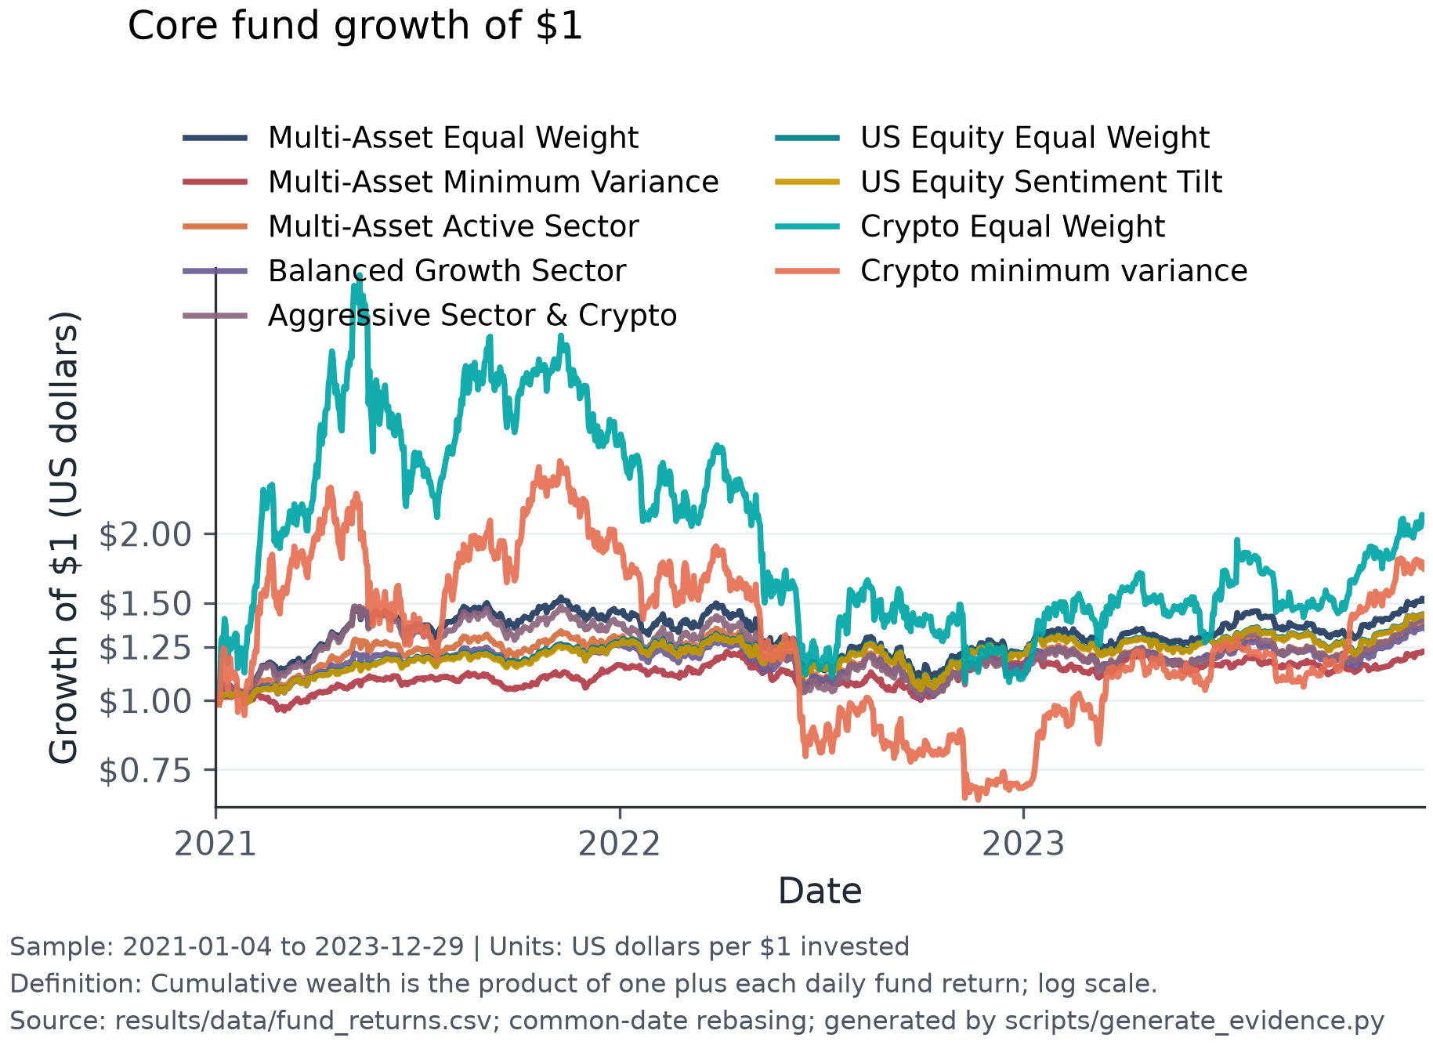
Figure 1. Growth of $1 for the core fund set. Crypto lines are rebased to the common 2021–2023 display period; the logarithmic scale preserves proportional comparisons.
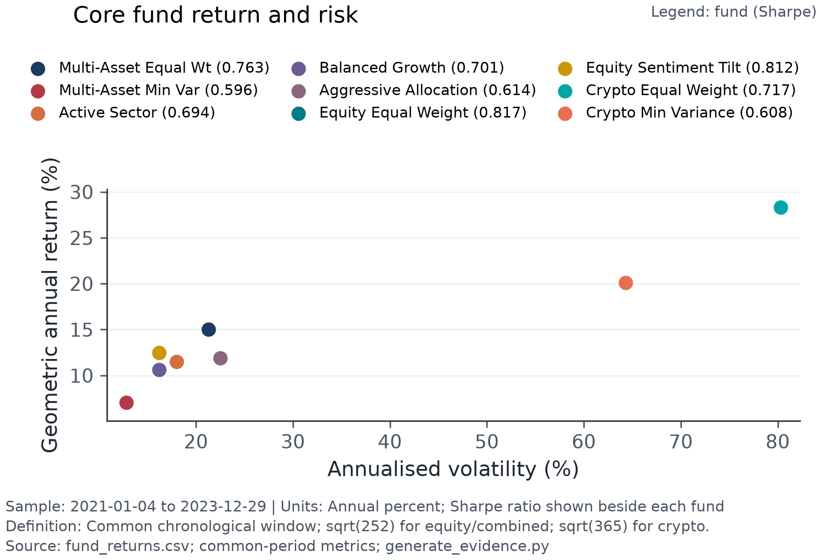
Figure 2. Geometric annual return versus annualised volatility over the common period, 4 January 2021–29 December 2023. Each family retains its native calendar; equity and combined funds use 252 periods per year and crypto funds use 365.

Appendix C. Current holdings, drawdown and weight history
Fund | Largest current target holdings
Multi-Asset Active Sector Allocation | DD 3.39%; DOW 3.39%; NEM 3.39%; NUE 3.39%; SHW 3.39%; other assets 83.06%
Aggressive Sector & Crypto Allocation | BA 3.00%; CAT 3.00%; GE 3.00%; MMM 3.00%; UPS 3.00%; other assets 85.02%
Multi-Asset Equal Weight | ABBV 1.67%; ABT 1.67%; ADA-USD 1.67%; ADBE 1.67%; AEP 1.67%; other assets 91.67%
Balanced Growth Sector Allocation | BA 2.60%; CAT 2.60%; GE 2.60%; MMM 2.60%; UPS 2.60%; other assets 87.02%
Multi-Asset Minimum Variance | WMT 19.86%; MRK 12.82%; ABBV 11.87%; KO 10.23%; GILD 10.15%; other assets 35.06%
Crypto Equal Weight | ADA-USD 10.00%; BCH-USD 10.00%; BTC-USD 10.00%; EOS-USD 10.00%; ETC-USD 10.00%; other assets 50.00%
Crypto Minimum Variance | BTC-USD 87.29%; TRX-USD 12.71%
US Equity Equal Weight | ABBV 2.00%; ABT 2.00%; ADBE 2.00%; AEP 2.00%; AMD 2.00%; other assets 90.00%
US Equity Sentiment Tilt — 21-Day Exploratory | ADBE 2.37%; AMD 2.37%; INTC 2.37%; NVDA 2.37%; QCOM 2.37%; other assets 88.14%
US Equity Sentiment Tilt | ADBE 2.16%; AMD 2.16%; INTC 2.16%; NVDA 2.16%; QCOM 2.16%; other assets 89.19%
Table B1. Current target holdings at the latest rebalance decision, 30 November 2023. The five largest positive weights are shown; remaining positive holdings are grouped and each row sums to 100%. Units: percent of target fund weight. Source: results/data/fund_weights.csv; generated by scripts/run_part_b.py.
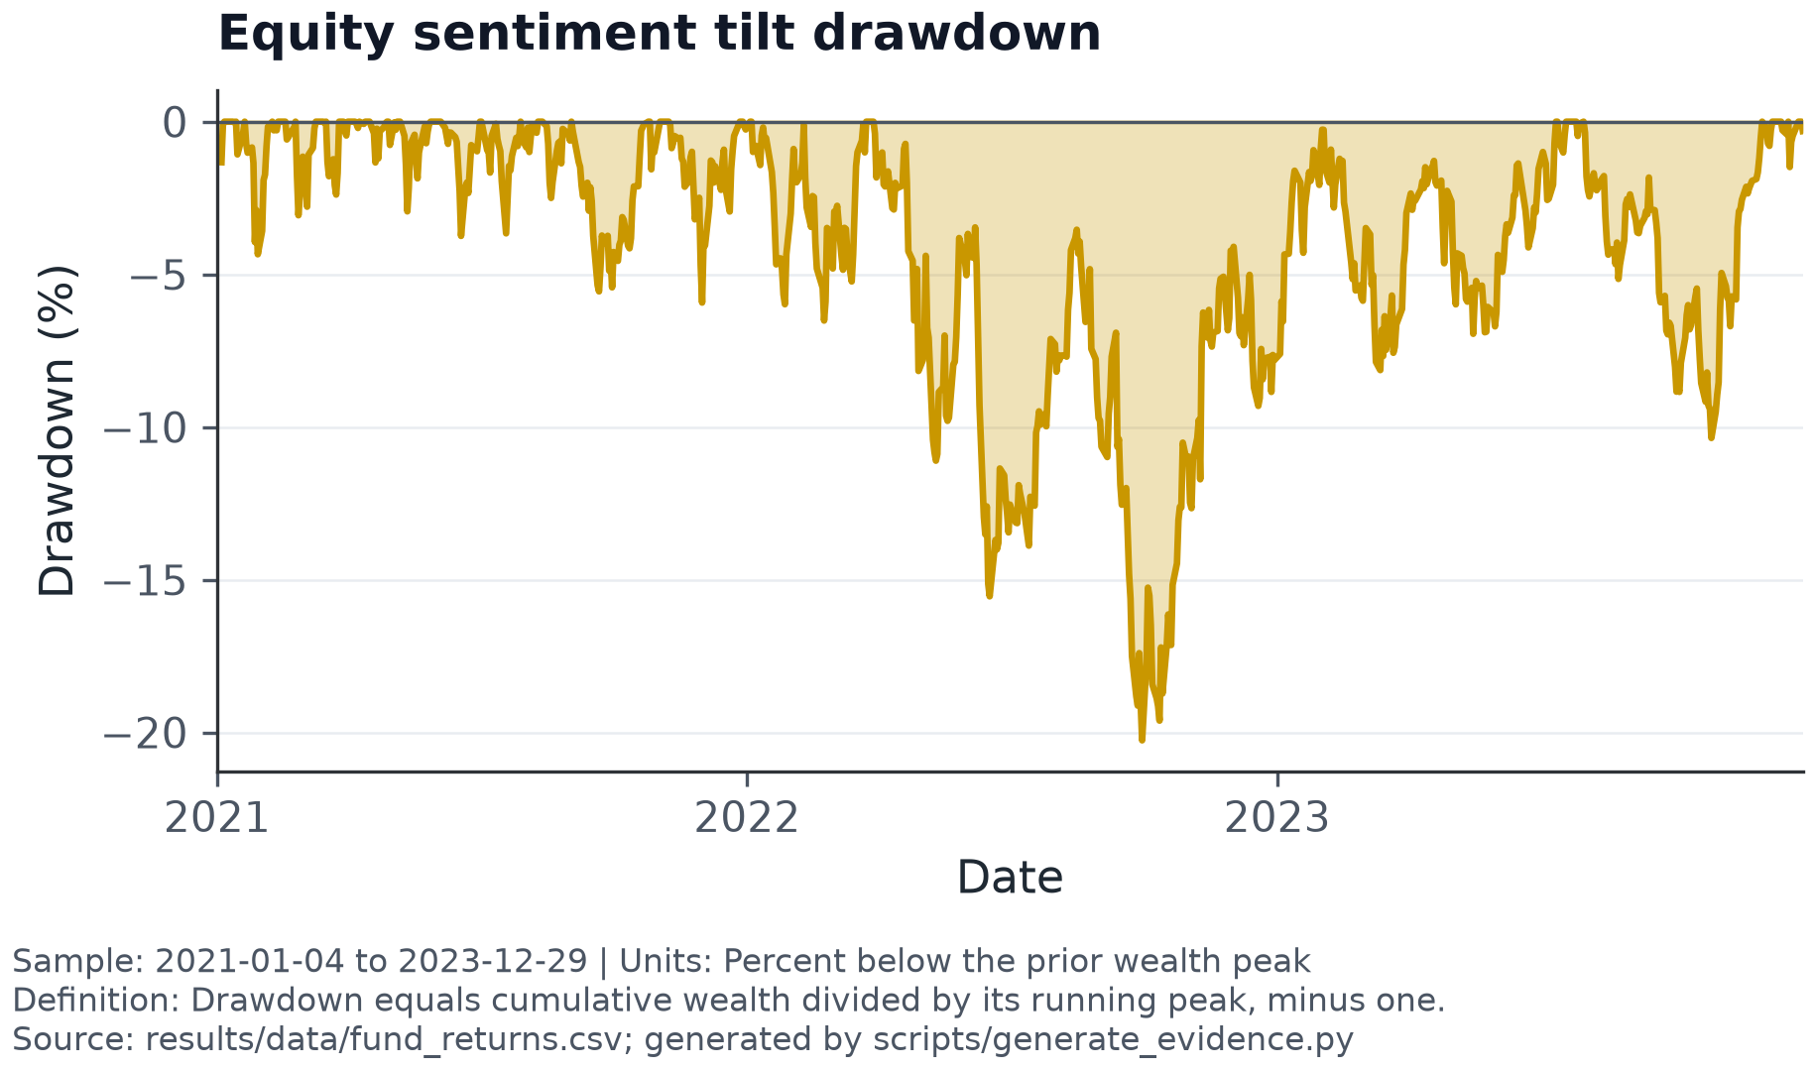
Figure B1. Drawdown of the locked equity sentiment fund. Drawdown equals wealth divided by its running peak minus one.
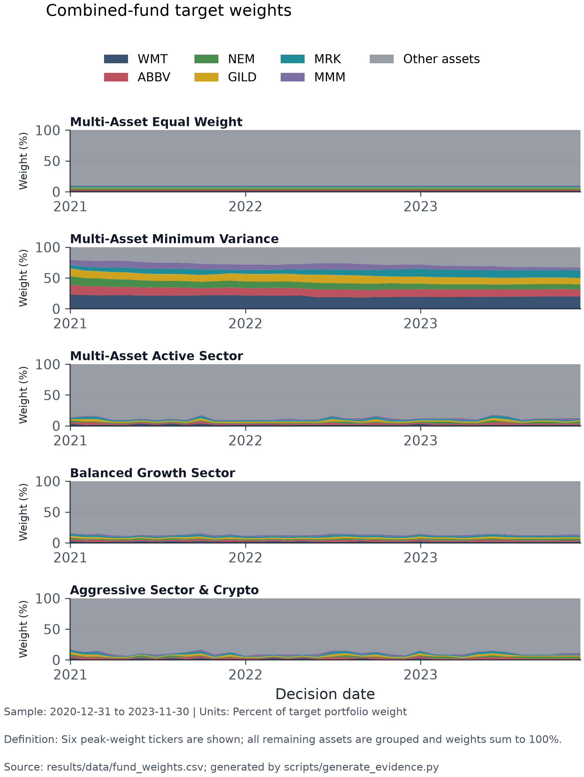
Figure B2. Combined-fund target weights over time. Six peak-weight tickers are shown and remaining holdings are grouped; weights sum to 100%.

Appendix D. Sentiment and fusion evidence
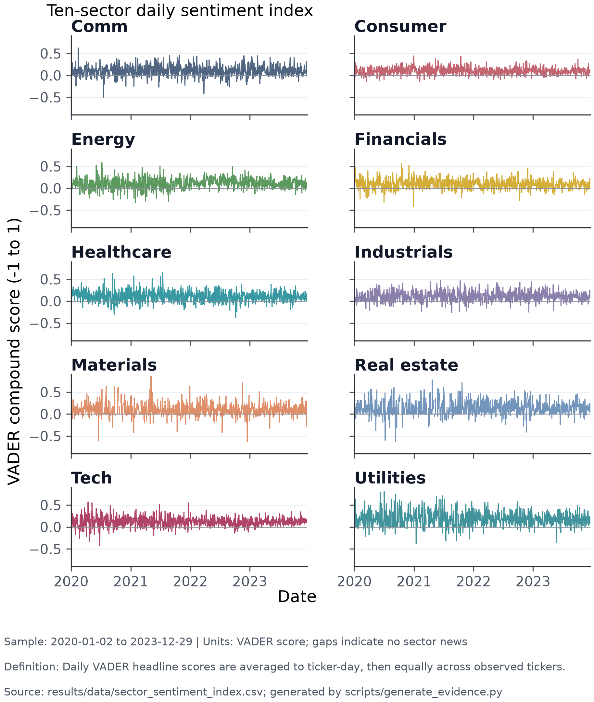
Figure 3. Daily ten-sector VADER compound index. Gaps represent sector-days without observed news.
Fund | Annual return | Volatility | Sharpe | Max drawdown | Monthly turnover
US Equity Equal Weight | 12.64% | 16.17% | 0.817 | -20.32% | 0.00%
US Equity Sentiment Tilt | 12.55% | 16.16% | 0.812 | -20.26% | 4.06%
Table 2. Matched locked sentiment-fusion comparison, 4 January 2021–29 December 2023. Units: annual return, volatility, drawdown and turnover are percentages; Sharpe is a ratio. Definitions: geometric annual return, 252 periods/year, 0% risk-free rate and 0 bps transaction costs. Source: results/tables/fusion_comparison.csv; generated by scripts/generate_evidence.py.
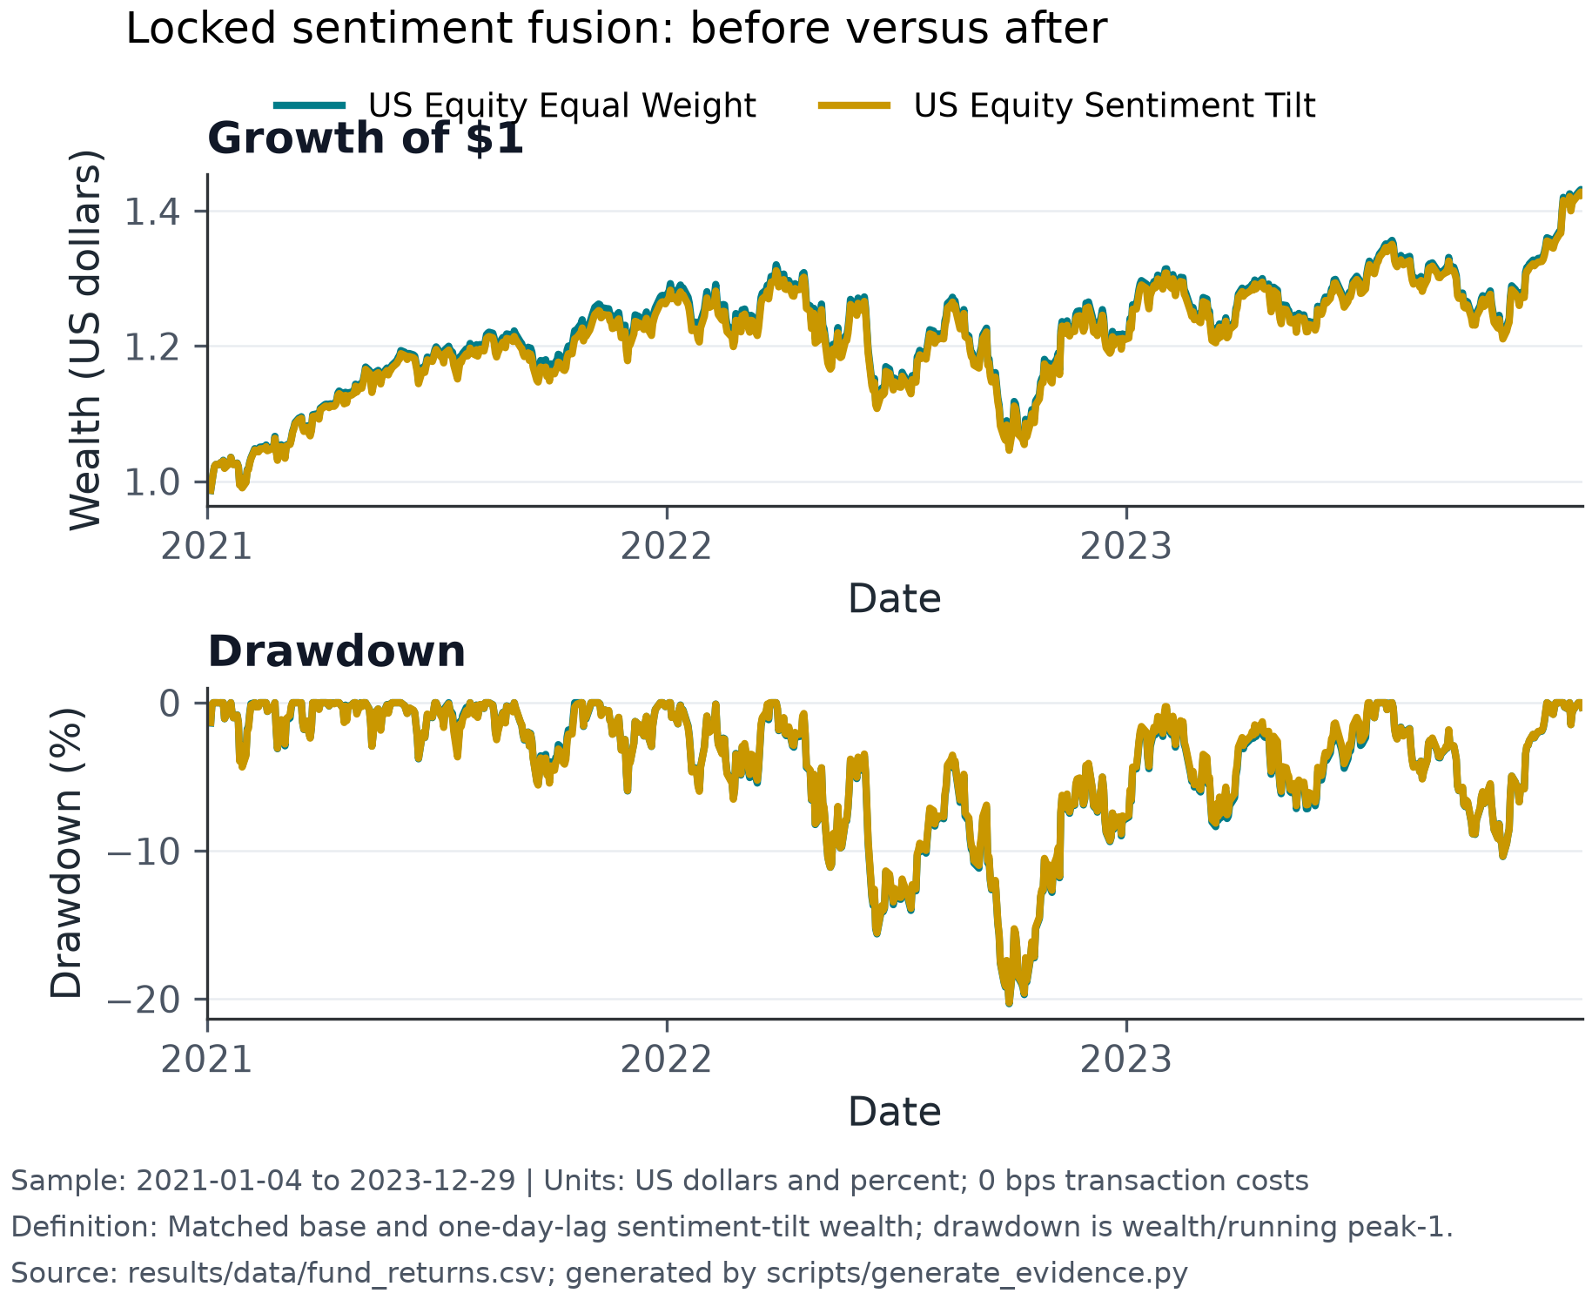
Figure 4. Locked equity sentiment fusion on matched dates: growth and drawdown before and after the lagged tilt.

Appendix E. Reproducibility and research assumptions
Core artifacts are generated by scripts/run_part_b.py. The application reads daily fund returns, monthly target weights, the sector sentiment index and performance metrics without rerunning the research pipeline. Focused tests cover adjusted-price return construction, calendar alignment after return calculation, separation of training and holding periods, portfolio constraints, reproduction of selected fund returns, metric calculations, headline-date mapping, signal lag, ticker-level sector weighting and application schema consistency.
The reported calculations omit taxes, investor fees, slippage and transaction costs under the stated 0 basis-point research assumption. Covariance estimates and sentiment classifications are subject to estimation error. The evidence ends in December 2023 and does not incorporate subsequent market information.

References
Araci, D. (2019). FinBERT: Financial Sentiment Analysis with Pre-trained Language Models. arXiv:1908.10063. https://arxiv.org/abs/1908.10063
Hutto, C. J., & Gilbert, E. (2014). VADER: A parsimonious rule-based model for sentiment analysis of social media text. Proceedings of the Eighth International AAAI Conference on Web and Social Media, 216–225. https://ojs.aaai.org/index.php/ICWSM/article/view/14550

