Hottest and coldest period predictions using 24 solar terms and parametric methods (MLE and MAP)
1.Problem definition
After evaluating the alignment between the traditional 24 Solar Terms and contemporary meteorological data from Beijing over the past 30 years, we seek to predict the future (2026) weather in Beijing by integrating climate data and traditional wisdom. To simplify the scope, we focus on ‘straight forward’ solar terms "Dashu" (Major Heat) and "Dahan" (Major Cold) and try to predict the hottest period and coldest period of Beijing in 2026.
2.Methodology
  - Data collection
We implemented an algorithm to iterate through historical meteorological data to find the hottest and coldest periods of each year. The temperature of a period is defined by the sum of average temperatures over a consecutive 15-day interval (since each solar term lasts for 15 days). Each 15-day period is represented by its median date, denoted as the Day of Year (DoY).
Below are the 30 results of DoY and the actual corresponding date.
(For example, 207 means the hottest 15 days in 1994 starts from the 200th day of that year to 215th day of that year.)

[207, 191, 205, 192, 184, 204, 201, 194, 191, 216, 200, 180, 225, 228, 215, 179, 205, 188, 204, 224, 195, 189, 217, 187, 209, 206, 167, 201, 200, 185]
[(1994, 7, 26), (1995, 7, 10), (1996, 7, 23), (1997, 7, 11), (1998, 7, 3), (1999, 7, 23), (2000, 7, 19), (2001, 7, 13), (2002, 7, 10), (2003, 8, 4), (2004, 7, 18), (2005, 6, 29), (2006, 8, 13), (2007, 8, 16), (2008, 8, 2), (2009, 6, 28), (2010, 7, 24), (2011, 7, 7), (2012, 7, 22), (2013, 8, 12), (2014, 7, 14), (2015, 7, 8), (2016, 8, 4), (2017, 7, 6), (2018, 7, 28), (2019, 7, 25), (2020, 6, 15), (2021, 7, 20), (2022, 7, 19), (2023, 7, 4)]
[20, -12, 11, 8, 20, 14, 14, 16, -19, 1, 18, -1, -20, 4, 19, 8, 10, 22, 28, 0, -12, -23, 24, 22, 29, 2, -6, 5, -1, -11]
[ (1994, 1, 20), (1994, 12, 19), (1996, 1, 11), (1997, 1, 8), (1998, 1, 20), (1999, 1, 14), (2000, 1, 14), (2001, 1, 16), (2001, 12, 12), (2003, 1, 1), (2004, 1, 18), (2004, 12, 29), (2005, 12, 11), (2007, 1, 4), (2008, 1, 19),(2009, 1, 8), (2010, 1, 10), (2011, 1, 22), (2012, 1, 28), (2012, 12, 30), (2013, 12, 19), (2014, 12, 8), (2016, 1, 24), (2017, 1, 22), (2018, 1, 29), (2019, 1, 2), (2019, 12, 25), (2021, 1, 5), (2021, 12, 30), (2022, 12, 20)]
Note: Negative values in the Dahan dataset represent dates in December of the preceding year.
2.2 Maximum Likelihood Estimation (MLE)
Prior to parametric estimation, we plotted a Q-Q plot, confirming that the extracted central dates follow a normal distribution.
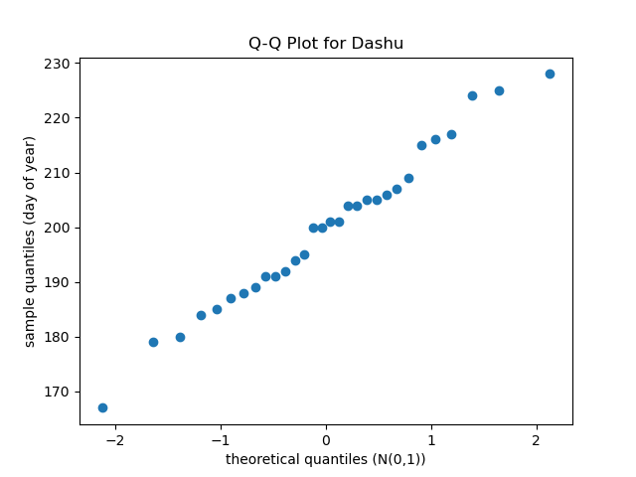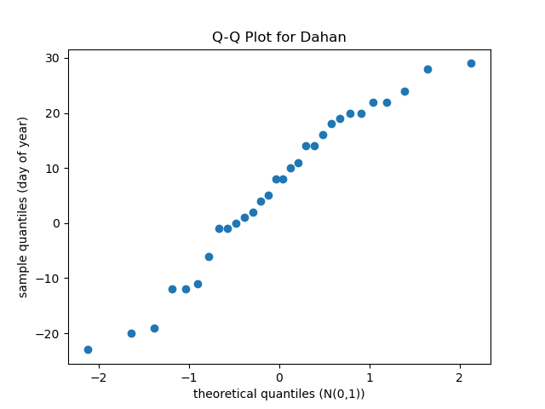
Based on the normality test, we assume central dates $d_{i}$ of the annual extreme temperature periods are are independent and normally distributed, i.e. $d_{i}\sim N(μ,σ^{2})$
The Likelihood function is formulated as:
$$L\left(μ,σ^{2}\right)=\prod_{i=1}^{30}{P\left(d_{i} \right| μ,σ^{2})}=\prod_{i=1}^{30}{\frac{1}{\sqrt{2πσ^{2}}}exp⁡(-\frac{{\left(d_{i}-μ\right)}^{2}}{2σ^{2}})}$$
To maximize this function, we take the partial derivative of $μ$ and $σ$ and set them to 0.
Solving these 2 functions, we can get:
${\hat{μ}}_{MLE}=\frac{1}{n}\sum_{i=1}^{n}{d_{i}}$ ${\hat{σ}}_{MLE}=\sqrt{\frac{1}{n}\sum_{i=1}^{n}{{(d_{i}-\hat{μ})}^{2}}}$
Applying our data to these equations, we get:
${\hat{μ}}_{DaShu}=199.63$ ${\hat{σ}}_{DaShu}=14.30$
$${\hat{μ}}_{Dahan}=6.33 {\hat{σ}}_{DaHan}=14.41$$
(The corresponding dates of ${\hat{μ}}_{MLE}$are 07-20 and 01-07)
Visualization of this process:
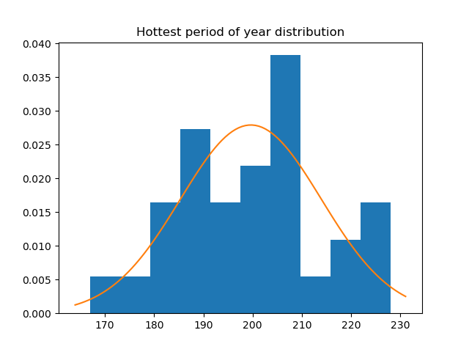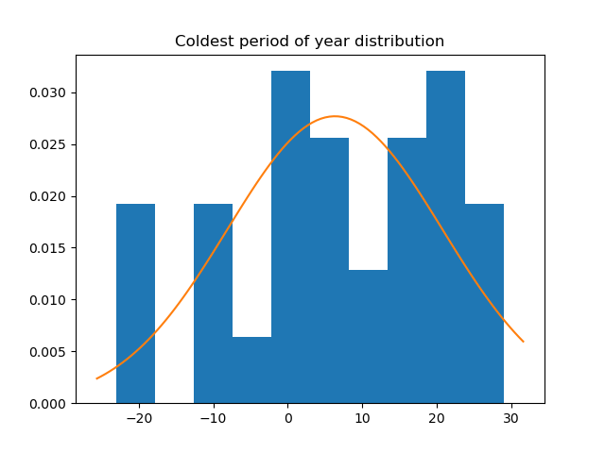
The blue bars represent the actual data distribution, and the orange line represents the normal distribution curve fitted via the MLE method.
2.4 Maximum A Posteriori (MAP) Estimation
If we rely completely on the data from the past 30 years, the model predicts the hottest period in Beijing this year to be from 07-13 to 07-26, and the coldest period from 01-01 to 01-14. However, we can incorporate the wisdom of ancient times to enhance the model.
According to the Hong Kong Observatory, the traditional "Dashu" period for 2026 is expected around 07-23 to 08-06, and "Dahan" around 01-20 to 02-03. We utilize the traditional solar terms as prior knowledge regarding how the temperature will behave.
MLE is a result based entirely on data, but the sample size of 30 years is limited, so MAP provides a more systematic way to combine ancient calendars with modern data to predict the real “Dashu” and “Dahan” in Beijing in 2026. Here, we use the 24 solar terms date of 2026 as the prior mean $μ_{prior}$ that is, $μ_{priorDashu}$= 211, $μ_{priorDahan}$= 27.
Because the traditional twenty-four solar terms give a fixed date range, not a probability distribution. Therefore, we still assume that the a priori distribution obeys the Gaussian distribution. Since the a priori standard deviation is a hypothesis, not a calculation from data, we tried two different a priori standard deviations:
Plan A: We assume that the boundary of the cycle of the ancient solar term cycle within 15 days is accurate. So suppose $σ_{prior}$= 7 days. That is, half of a solar term cycle.
Plan B: Let the contribution of MLE and the date of the ancient solar terms be equal, so assume that $σ_{prior}$= $σ_{data}$≈ 14 days, so the maximum post-probability estimate is precisely between the traditional date and the estimate of MLE.
Our MAP formula is as follows:
$${\hat{μ}}_{MAP}=\frac{σ_{data}^{2}}{σ_{prior}^{2}+σ_{data}^{2}}⋅μ_{prior}+\frac{σ_{prior}^{2}}{σ_{prior}^{2}+σ_{data}^{2}}⋅{\hat{μ}}_{​MLE}​$$
Therefore,
$w_{prior}$ = $\frac{σ_{data}^{2}}{σ_{prior}^{2}+σ_{data}^{2}}$ weight on the traditional date
$w_{data}$ = $\frac{σ_{prior}^{2}}{σ_{prior}^{2}+σ_{data}^{2}}$ weight on MLE
According to the formula, it can be seen that if $σ_{prior}$ → 0, then $w_{prior}$ → 1 and $μ_{MAP}$ → $μ_{prior}$, the results of MAP will completely follow the prediction method of ancient solar terms.
If $σ_{prior}$ → ∞, then $w_{data}$→ 1 and $μ_{MAP}$→ $μ_{MLE}$, the result of MAP will be exactly the same as MLE. Therefore, MAP is between the two, which is a precision-weighted interpolation between two data sources.
Visualization of this process:
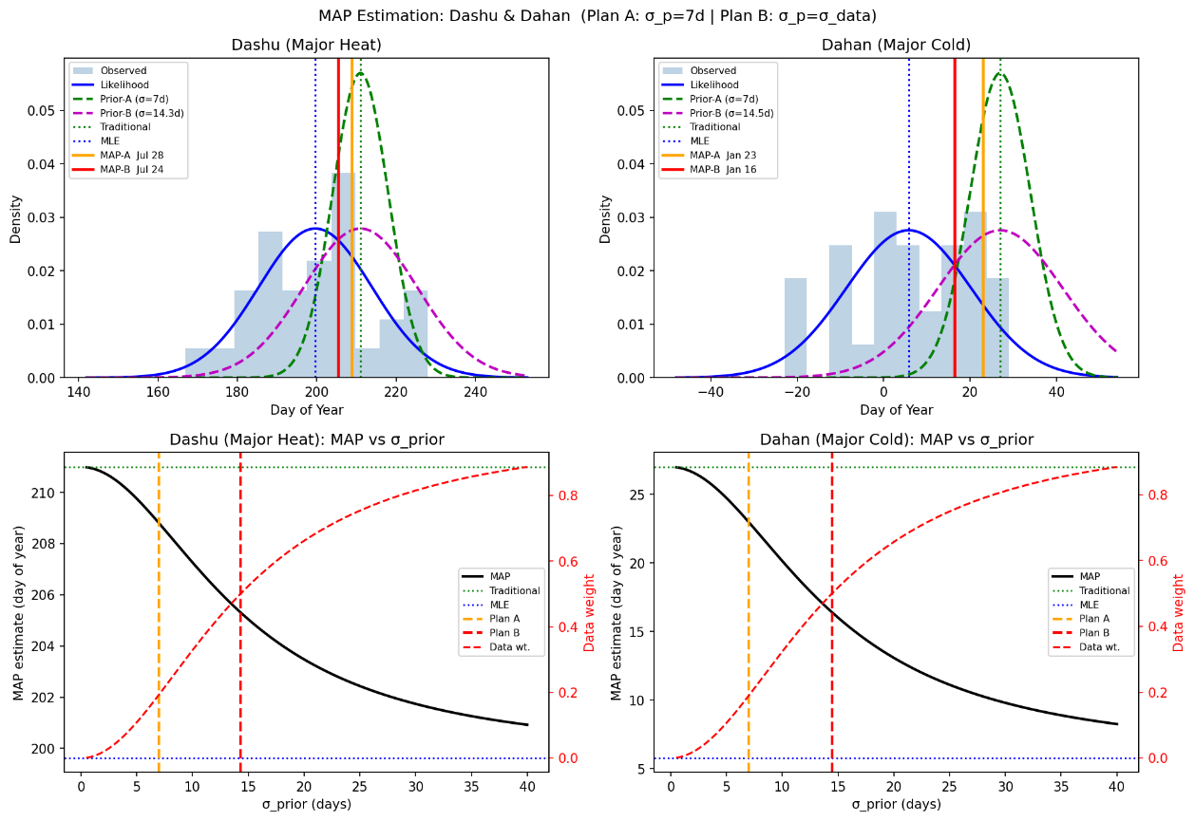
3. Results
Based on different methods, we made different predictions.
3.1 MLE: Data-Driven Baseline
Hottest period around: 07-20
Coldest period around: 01-07
3.2 MAP: Stronger Prior ($σ_{prior}$= 7 days)
Dashu: July 28 (DoY=208.8)
Dahan: January 23 (DoY=23.0)
3.3 MAP: Equal-Weight Prior ($σ_{prior}$=$σ_{data}$)
Dashu: July 24 (DoY=205.3)
Dahan: January 16 (DoY=16.4)
4. Discussion on the parametric methods used
The method we planned to use dictated the data we extract. In study [1], the researchers employed time-series modeling to fit continuous annual temperature. This was way too complicated, so instead of using the whole year’s temperature data, we extracted 2 ‘features’ (the central dates of the extreme temperature periods) from each year. This turned the problem to what we are familiar with and have learned in class. These extracted dates (features) follow a normal distribution; it allows for a highly efficient application of Maximum Likelihood Estimation (MLE).
Formulating MAP was tricky since traditional solar terms provide deterministic dates rather than probability distributions. We need to assume it follows a certain distribution to construct the prior. Experimenting with different assumptions also made us realize the beauty of MAP.
References:
[1] C. Qian, Z. Yan, and Z. Fu, “Climatic changes in the Twenty-four Solar Terms during 1960–2008,” Chinese Science Bulletin, vol. 57, no. 2–3, pp. 276–286, 2011.
[2] “二十四節氣,” Hong Kong Observatory. [Online]. Available: https://www.hko.gov.hk/tc/gts/astronomy/Solar_Term.htm

