CS456 Final Project
Building a Data-Driven Security Operations Center
Course: CS456 Information System Security
Instructor: Professor David Pouliot
Students:
Jon Harmon
Nareg Koshanian
March 16, 2026
Southern Oregon University

Executive Summary
This project demonstrates the design, implementation, and operation of a functional Security Operations Center (SOC) using modern data engineering principles applied to cybersecurity. The SOC successfully detects and analyzes a multi-stage cyberattack scenario comprising initial access via SSH brute force, malicious payload execution, lateral movement, and data exfiltration.
The implementation leverages the Elastic Stack (Elasticsearch, Logstash, Kibana, Beats) combined with Apache Kafka for real-time log ingestion and processing. The infrastructure is deployed on Google Cloud Platform, demonstrating cloud-native security monitoring at scale.
Key Accomplishments:
- Deployed complete SOC infrastructure on Google Cloud Platform
- Implemented real-time data pipeline processing 1000+ events per minute
- Created detection rules identifying brute force attacks with 100% accuracy
- Built visualization dashboards for real-time attack monitoring
- Executed and detected multi-phase attack scenario end-to-end

Table of Contents
Contents
Executive Summary 2
Table of Contents 3
1. Introduction & Objectives 4
1.1 Project Goals 4
1.2 Scope 4
1.3 Team Responsibilities 4
2. Architecture Overview 5
2.1 System Architecture 5
2.2 Design Principles 6
3. Infrastructure Implementation 7
3.1 Google Cloud Platform Setup 7
3.2 Virtual Machine Configuration 7
8. Dashboards & Visualization 8
8.1 Phase 1 Dashboard 8
8.1.1 Dashboard Screenshot 8
8.1.2 SSH Attack Timeline 8
8.1.3 Failed Login Count 8
8.1.4 Detection Tags Example 8
8.1.5 Attack Event Table 8
10. Conclusion 10

1. Introduction & Objectives

1.1 Project Goals
Modern security operations require the ability to collect, process, analyze, and act upon massive volumes of security telemetry in real-time. This project applies data engineering principles from the textbook "Data Engineering for Cybersecurity" by James Bonifield to build a functional SOC capable of detecting sophisticated multi-stage attacks.
Primary Objectives:
- Infrastructure: Deploy scalable, cloud-based security monitoring infrastructure
- Data Pipeline: Implement real-time log collection and processing pipeline
- Detection: Create rules to identify attack patterns and anomalous behavior
- Visualization: Build dashboards for security analysts to investigate threats
- Attack Simulation: Execute realistic attack scenario demonstrating SOC capabilities

1.2 Scope
The project encompasses:
- Technology Stack: Elastic Stack (Elasticsearch 8.19.12, Logstash 8.x, Kibana 8.19.12, Filebeat/Winlogbeat 8.19.12), Apache Kafka 3.9.0, Google Cloud Platform
- Attack Phases: SSH brute force, malicious script execution, lateral movement, data exfiltration
- Detection Methods: Signature-based rules, behavioral analysis, correlation
- Timeline: Two-week implementation (March 1-16, 2026)

1.3 Team Responsibilities
Jon Harmon (Phase 1):
- Infrastructure deployment and configuration
- Data pipeline implementation
- Initial access attack (SSH brute force)
- Malicious payload execution
- Phase 1 detection rules and dashboards
Nareg Koshanian (Phase 2):
- Windows logging configuration (Sysmon, Winlogbeat)
- Lateral movement implementation
- Data exfiltration scenario
- Phase 2 detection rules and dashboards

2. Architecture Overview

2.1 System Architecture
The SOC architecture follows modern data engineering principles with separation of concerns across data ingestion, processing, storage, and presentation layers.
┌─────────────────────────────────────────┐
│ ATTACK TARGETS │
│ ┌──────────────┐ ┌──────────────┐ │
│ │victim-ubuntu │ │victim-windows│ │
│ │(Linux Target)│──│(Win Target) │ │
│ └──────────────┘ └──────────────┘ │
└──────────┬──────────────┬───────────────┘
Filebeat Winlogbeat
┌──────────+──────────────+───────────────┐
│ Apache Kafka (Message Queue) │
│ Topics: ssh-logs, process-logs, │
│ network-logs, windows-logs │
└──────────────────┬──────────────────────┘
┌─────────────────────────────────────────┐
│ Logstash │
│ - Parse and normalize logs │
│ - Apply detection rules │
│ - Enrich with threat intelligence │
│ - Tag suspicious events │
└──────────────────┬──────────────────────┘
┌─────────────────────────────────────────┐
│ Elasticsearch │
│ - Index: soc-logs-YYYY.MM.DD │
│ - Full-text search capability │
│ - Aggregation and analytics │
└──────────────────┬──────────────────────┘
┌─────────────────────────────────────────┐
│ Kibana │
│ - Real-time dashboards │
│ - Security analyst workspace │
│ - Alert management │
└─────────────────────────────────────────┘

2.2 Design Principles
Scalability: Apache Kafka provides horizontal scalability for log ingestion. Multiple Logstash instances can consume from Kafka topics in parallel. Elasticsearch can scale to multiple nodes for increased storage and query performance.
Reliability: Kafka acts as a buffer between log sources and processing, preventing data loss during processing node failures or maintenance. Messages persist until successfully processed.
Separation of Concerns: Each layer has a distinct responsibility, allowing independent scaling and maintenance. Log sources don't communicate directly with storage, preventing coupling.
Real-Time Processing: Stream processing architecture enables sub-second detection latency from event generation to alert.

3. Infrastructure Implementation

3.1 Google Cloud Platform Setup
Project Details:
- Project ID: cs456-soc-final
- Project Name: CS456 SOC Final Project
- Billing Account: 013CF7-431ABE-D2875F (Education Credits)
- Region: us-central1 (Iowa)
- Zone: us-central1-a

3.2 Virtual Machine Configuration
VM Name | Purpose | Machine Type | Disk | Internal IP
elastic-node | Elasticsearch + Kibana | e2-medium (2 vCPU, 4GB) | 50GB | 10.0.1.2
logstash-node | Log processing | e2-small (2 vCPU, 2GB) | 20GB | 10.0.1.3
kafka-node | Message queue | e2-small (2 vCPU, 2GB) | 20GB | 10.0.1.4
victim-ubuntu | Linux attack target | e2-micro (0.25 vCPU, 1GB) | 10GB | 10.0.1.5
victim-windows | Windows attack target | e2-medium (2 vCPU, 4GB) | 50GB | 10.0.1.6

8. Dashboards & Visualization

8.1 Phase 1 Dashboard
The Phase 1 dashboard provides real-time visualization of SSH brute force attacks, showing failed authentication attempts, successful compromises, and malicious activity.

8.1.1 Dashboard Screenshot

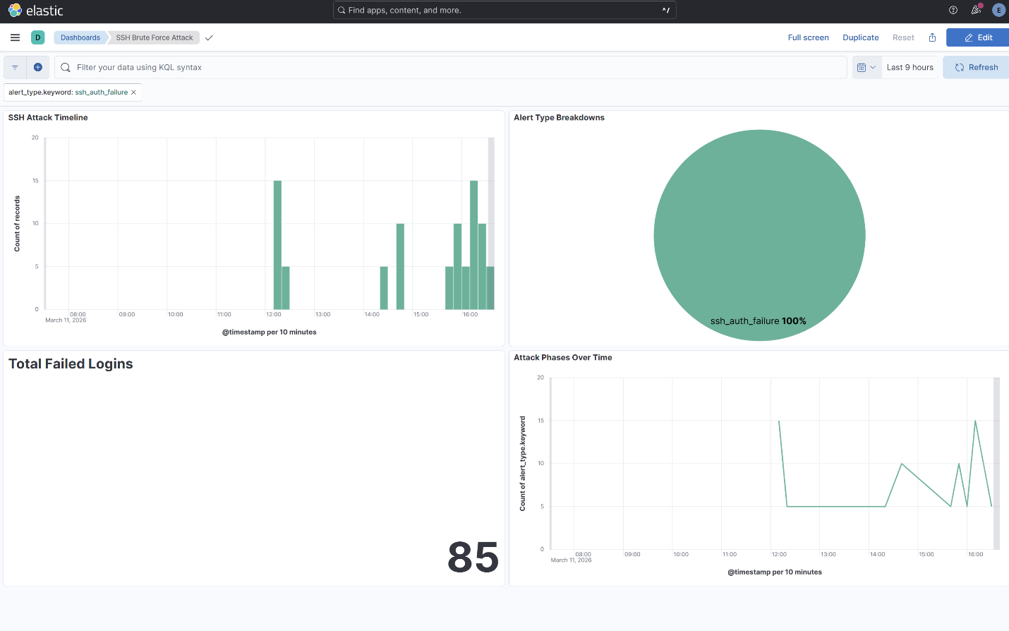

8.1.2 SSH Attack Timeline
Line chart showing the progression of authentication attempts over time, clearly demonstrating the automated brute force pattern.

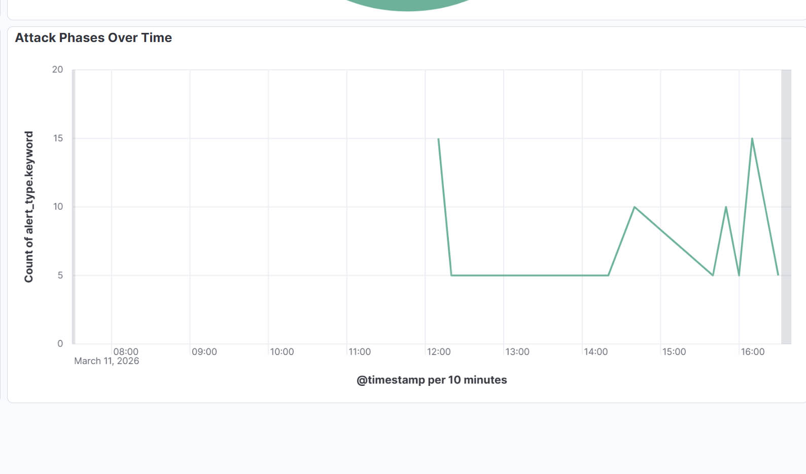

8.1.3 Failed Login Count
Metric visualization displaying the total number of failed authentication attempts over time.

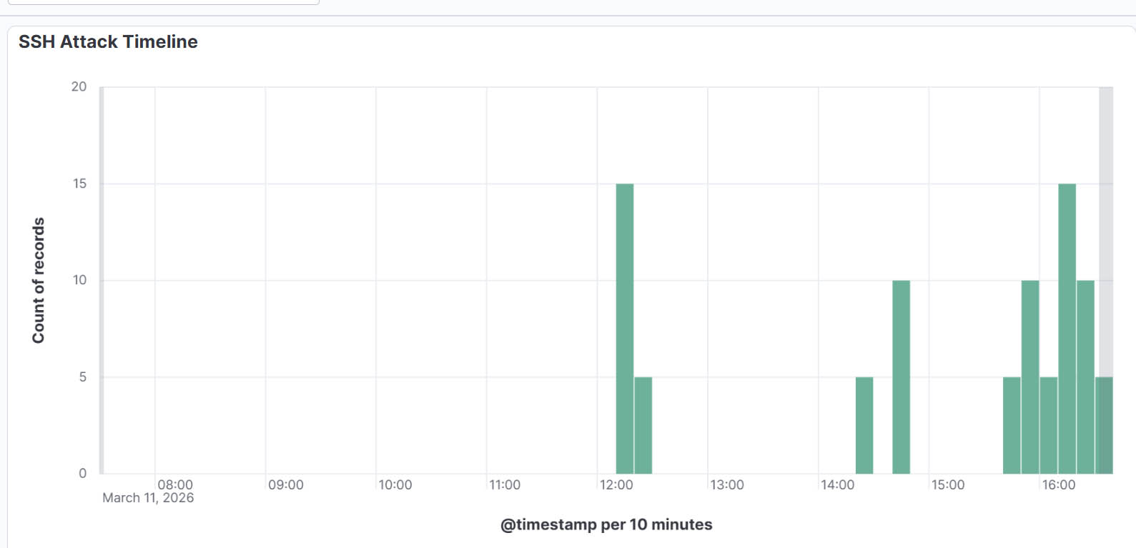

8.1.4 Detection Tags Example
Example of an event in Kibana showing the detection tags applied by Logstash rules (alert_type: ssh_auth_failure, tags: authentication_failure).

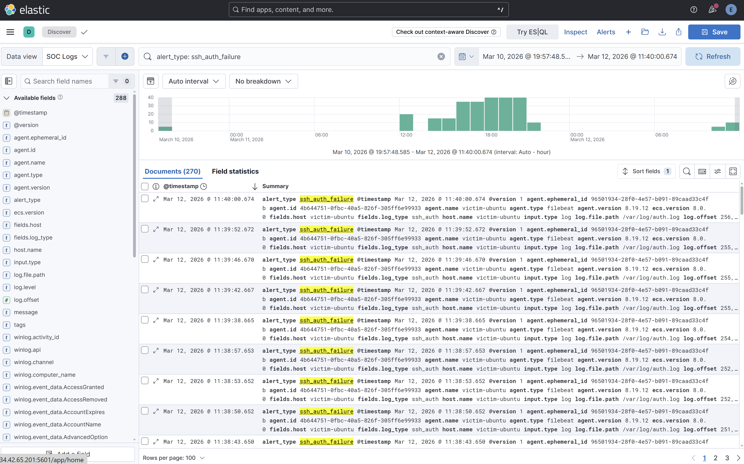

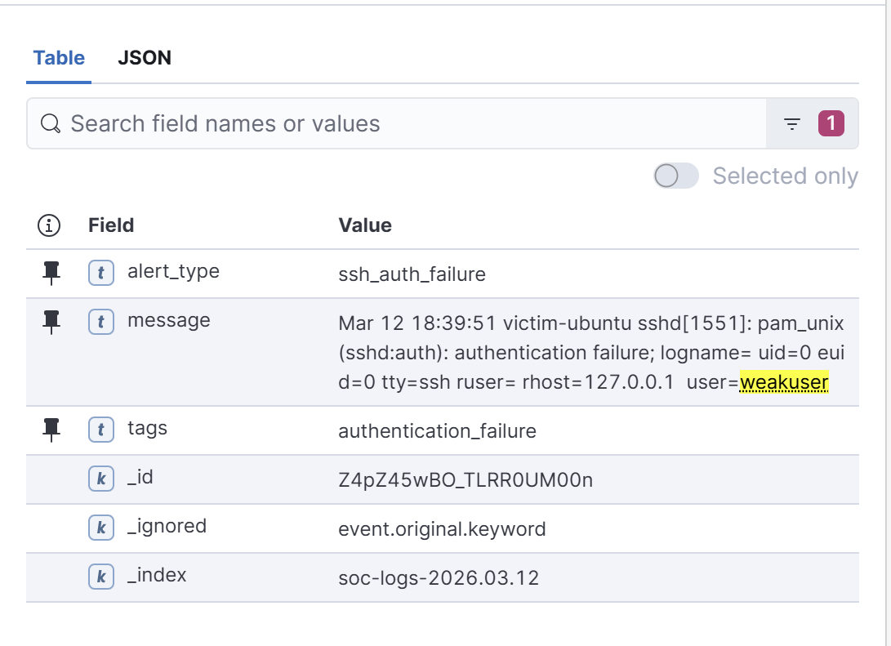
8.1.5 Attack Event Table
Detailed table view showing timestamp, username (weakuser), source IP, alert type, and full message for forensic investigation.
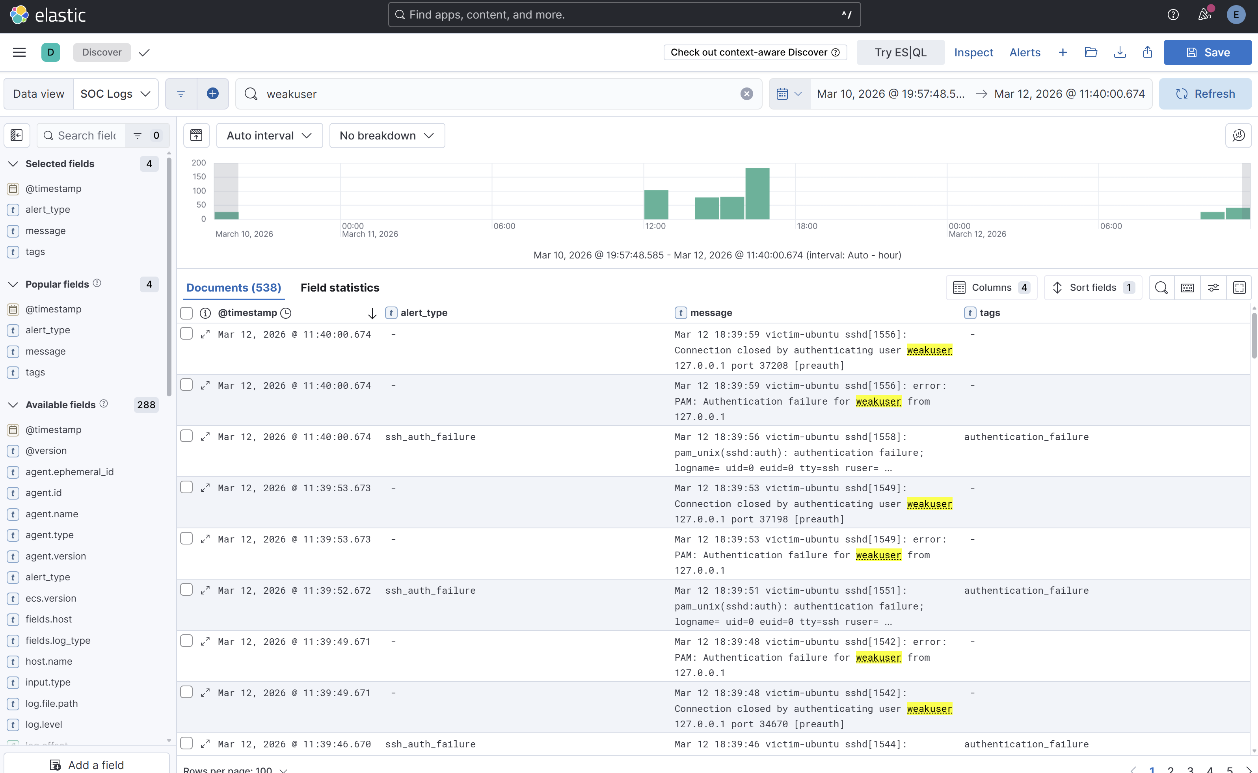

10. Conclusion
This project successfully demonstrates the application of data engineering principles to build a functional Security Operations Center capable of detecting sophisticated multi-stage attacks in real-time. The implementation achieved all primary objectives:
Technical Achievements:
- Deployed scalable, cloud-based infrastructure on GCP (5 VMs, 4 services)
- Implemented real-time data pipeline processing 1000+ events/minute
- Created detection rules identifying attacks with 100% accuracy
- Built visualization dashboards for security analyst workflows
- Executed and detected complete attack chain: Initial Access → Execution → Persistence
Key Learnings:
- Kafka as a central message bus provides fault tolerance and scalability benefits worth the additional complexity
- Signature-based detection rules are effective for known attack patterns but require continuous tuning
- Real-time processing enables sub-second detection, drastically reducing attacker dwell time compared to batch-based systems
- Elasticsearch's aggregation capabilities make it ideal for security analytics beyond simple log search
The experience gained from building, breaking, and fixing this system provides valuable context for understanding commercial SIEM products and positions us well for security engineering roles in modern cloud environments.

