|  |
| --- |
| ***GWJ #70 - Folklore*** |
| **[Untitled Game]** |
| **[game tag line]** |

|  |
| --- |
| JWR26, Smileasyougounder, Joe, TheAnonymousGhoul, Sianxn, Tim, Loxo HighScore  6-14-2024 |

|  |  |  |
| --- | --- | --- |
| Version | Date | Changes |
| 0 | 14/06/2024 | First draft shared with team |

Table of Contents

Contents

1. Theme & Wildcards 4

2. Game Overview 4

i. Concept 4

ii. Genre 4

iii. Target Audience 4

iv. Inspirations and References 4

3. Game Concept 5

i. High-Level Description 5

ii. Core Gameplay Mechanics 5

iii. 2.4. Story Synopsis 5

iv. Setting and World Design 5

4. Characters 5

i. Hero 5

ii. Protagonist 5

iii. Non-Playable Characters 5

5. Gameplay 5

i. Objectives and Goals 5

ii. Progression and Level Design 5

iii. Game Flow Diagram 5

iv. Player Actions and Controls 6

v. User Interface (UI) Design 6

6. Art and Visuals 6

i. Art Style 6

ii. Concept Art 6

iii. Character Designs 6

iv. Environment Designs 6

v. Animation Requirements 6

7. Sound and Music 7

i. Sound Effects 7

ii. Background Music 7

iii. Voice Acting (if applicable) 7

8. Development Team 7

iv. Roles and Responsibilities 7

9. Timeline 7

i. Milestones 7

# Theme & Wildcards

**Theme:** *Folklore*

**Wildcards:**

* *Transfer Takeover – play as different characters*
* *Actions have consequences – players actions persist between playthrough*
* *Turtles all the way down – use recursion in level design / story elements*

# Game Overview

## Concept

[TBD] Narrative driven adventure game where the player takes on the role of both the protagonist and the hero, crafting their own short story.

## Genre

[TBD]

## Target Audience

Fellow GWJ developers.

## Inspirations and References

* panzer dragoon
* drakengard
* breath of fire series

[TBD]

# Game Concept

## High-Level Description

[TBD]

## Core Gameplay Mechanics

## 2.4. Story Synopsis

[TBD]

## Setting and World Design

# Characters

## Hero

[TBD]

Goat(s)

## Protagonist

A dragon. [TBD]

## Non-Playable Characters

* The narrator
  + Unidentified speaker that tells the story as it is played out by the player
* Inworld NPCs
  + Can be killed by the protagonist

# Gameplay

## Objectives and Goals

* A single level is played twice, once as the protagonist, and then again as the hero, with the hero experiencing the world state left from the first playthough, with some minor adaptations

## Progression and Level Design

## Game Flow Diagram

## Player Actions and Controls

|  |  |
| --- | --- |
| **User input** | **Action** |
| Escape | Pause the game |

## User Interface (UI) Design

# Art and Visuals

## Art Style

## Concept Art

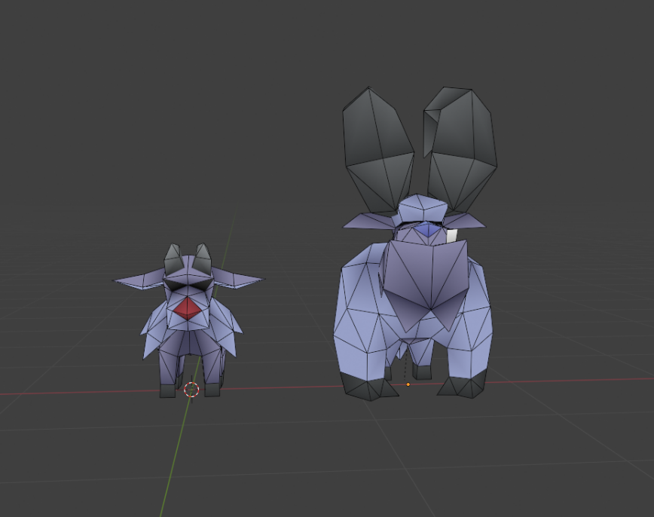

## Character Designs

[later]

## Environment Designs

[later]

## Animation Requirements

[later]

# Sound and Music

## Sound Effects

Ideally every “event” in the game world should have an associated sound effect

## Background Music

[tbd]

## Voice Acting (if applicable)

Potential voice over for the narrator

# Development Team

## Roles and Responsibilities

|  |  |  |
| --- | --- | --- |
| *Team Member* | *Role* | *Tasks* |
| JWR26 | Programmer |  |
| Tim | Programmer |  |
| Smileasyougounder | Programmer |  |
| Smileasyougounder | Artist |  |
| Joe | Artist |  |
| Sian | Narrative |  |
| TheAnonymousGhoul | Music |  |
| Loxo HighScore | Music |  |

# Timeline

## Milestones

* 18/06/2024 – first vertical slice for playtesting
* 23/06/2024 – Final submission