<Efficient Supply Chain Strategy for F&B Chains in Southeast Asia>

by
<SHI Jingwen>

A CAPSTONE PROJECT SUBMITTED FOR THE DEGREE OF MASTER OF COMPUTING
in the
GRADUATE DIVISION
of the
NATIONAL UNIVERSITY OF SINGAPORE
2024

Supervisor:
Prof. Varun Karamshetty
Examiners:
Prof. Prasanna Karthik Vairam

Declaration
I hereby declare that this project report is my original work
and it has been written by me in its entirety.
I have duly acknowledged all the sources of information
which have been used in this report.

This report has also not been submitted for any degree in
any university previously.



<SHI Jingwen>
14th April 2024

Executive Summary

Problem Definition
The rapid ascent of Online Food Delivery (OFD) platforms has reshaped the restaurant industry, introducing new dynamics in customer engagement and sales strategies. This transformation, while offering increased market reach and convenience, has prompted a closer examination of its impact on traditional revenue-enhancing methods like upselling - a critical factor in the profitability of restaurants. Amidst the growing dependence on OFD services, a paradox emerges: the digital interface, though broadening customer base, may simultaneously diminish the efficacy of upselling tactics due to the absence of direct customer interaction and other nuanced factors. This study delves into the effects of OFD platform reliance on the upselling capabilities within the Quick-Service Restaurant (QSR) industry, employing an empirical approach to uncover the underlying dynamics and identify potential mitigating factors.

Managerial Implications
The findings underscore a notable challenge: increased dependence on OFD platforms correlates with a significant reduction in upselling performance, marked by a decrease in revenue and transaction volume from upsold items. This adverse effect highlights a critical need for strategic adaptation by restaurants to sustain profitability in the digital era. Importantly, the study identifies customer affluence as a key mitigating factor, suggesting that targeting more affluent customer segments could partially counterbalance the negative impact on upselling capabilities. Additionally, the nuanced role of peak mealtime distribution in modulating these dynamic offers insights into customer flow patterns and their implications for sales strategy. These findings offer actionable guidance for restaurant operators and OFD platforms alike, emphasising the importance of tailored marketing strategies, enhanced digital engagement techniques, and a nuanced understanding of customer behaviour to optimise upselling opportunities and navigate the challenges posed by digital integration.

Keywords: Online Food Delivery (OFD) platforms; upselling; customer behaviour; Quick-Service Restaurants (QSR); digital marketing strategy; platform dependence

- Introduction
The landscape of the restaurant industry has undergone an ongoing momentum over the past decade, significantly propelled by the advent and proliferation of Online Food Delivery (OFD) platforms. This transformation is driven by a growing consumer predilection for convenience, efficiency, and the broad array of choices offered by online ordering systems (Kodali, S., & Cyr, M., 2020). The global pandemic, undoubtedly, further accelerated this shift, acting as a catalyst that entrenched online food delivery into the fabric of daily consumer habits. According to estimates by Statista (2024), the OFD sector's market size surged to over 1 trillion U.S. dollars, marking a stark increase from its own forecast of 154.34 billion dollars in 2021 (Poon, W. C., & Tung, H., 2022). Despite relaxed restrictions and the resurgence of dine-in services, the embeddedness of online ordering is expected to persist, with projections suggesting the market could expand to 1.65 trillion U.S. dollars by 2027 (Statista, 2024).

While OFD platforms have undeniably facilitated restaurants in reaching a wider customer base and fostering market presence, the repercussions on profit margins paint a more complex picture. The convenience of these platforms comes at a steep price, often involving commission fees that can escalate to 30% per order (Barbee, J. et al., 2021). This financial strain, coupled with the potential displacement of traditional dine-in sales, prompts a critical examination of OFD services' nuanced impacts on restaurant operations, particularly in the realm of upselling - a strategy critical for enhancing profitability in an industry characterised by razor-thin margins and intense competition (Karniouchina, K. et al., 2022). Building insights from the existing industrial studies, this paper aims to broaden the conversation by examining some of the specific impacts of OFD services on restaurants’ upselling capabilities.
The integration of OFD platforms introduces a paradox in consumer behaviour towards upselling - a sales technique aimed at encouraging customers to purchase additional items or higher-priced alternatives (Heidig, W., 2012). On one hand, digital environments may lower price sensitivity, ostensibly making customers more receptive to upselling (Zabin, J. & Brebach, G., 2004). Conversely, there are also anecdotal evidences suggest that consumers’ scepticism about food quality during delivery (Sharma, R. et al., 2021) and the absence of inter-personal interaction (Heidhues, P. & Kőszegi, B., 2018) may deter customers from indulging in add-ons or premium items, thus potentially undermining upselling efforts.

This study delves into the effects of OFD platforms on the upselling capabilities within the restaurant sector, employing an empirical lens through the analysis of a vast dataset from a Quick Service Restaurant (QSR) chain. This dataset encompasses approximately 50 million transactions across 99 outlets in 2018, providing granular insights into each sale, including the specifics of the item sold, quantity, time of purchase, and the mode of transaction (dine-in, take-away, or via OFD). Through this detailed examination, the research aims to shed light on how heightened reliance on food-delivery platforms may recalibrate restaurants' ability to upsell.

The investigation reveals a significant trend: an increased dependency on OFD platforms correlates with a diminished capacity for upselling within the restaurant industry. This reduction in upselling efficiency, a direct consequence of platform dependence, indicates a broader impact on restaurants' overall profit-generating capabilities.

Navigating beyond the immediate findings, this study also explores the broader implications of reduced upselling on restaurant profitability. It further identifies critical moderating factors (Thompson, G.M., 2010) - such as peak demand times, customer group sizes, and expenditure on core menu items - that could influence the dynamics between platform dependence and upselling efficacy. These insights are pivotal for restaurant operators and OFD platforms alike, offering strategic considerations for enhancing upselling opportunities in a digitally dominated market.

This research marks a significant contribution to the field of Operational Management (OM) by illuminating the intricate effects of OFD platform dependence on critical demand characteristics within the restaurant industry. It not only underscores the imperative for a nuanced understanding of these dynamics but also calls for an expanded discourse on devising strategies that can mitigate the challenges posed by OFD platforms. As the restaurant industry continues to navigate the complexities of digital integration, this study provides a foundational basis for further exploration, aiming to enrich the strategic toolkit available to restaurant operators in optimising their engagement with OFD services and maximising profitability.

- Literature Review
  - Evolution of the Restaurant Industry in the Post-COVID Era
The recent years have marked a significant transformation within the hospitality sector, notably within the restaurant industry, driven by digital innovations, increased market competition, and notably, the impacts of the COVID-19 pandemic. The pandemic necessitated immediate shifts to low-contact services such as online ordering, delivery, and pickup as primary revenue sources due to lockdowns and preventive measures, causing a significant downturn in traditional sales (Kim, J. & Lee, J.C., 2020). Despite facing challenges, the National Restaurant Association (NRA, 2024) forecasts a notable recovery for the restaurant industry in 2024, projecting sales to surpass $1.1 trillion for the first time, marking a significant resurgence.

The post-pandemic landscape for restaurants is anticipated to diverge markedly from pre-pandemic times, fuelled by the accelerated adoption of digital technologies. This encompasses investments in digital infrastructure like point-of-sale systems, online food ordering/delivering (OFD) platforms, and e-commerce solutions, alongside innovations in service delivery models to facilitate low-contact customer interactions. The pandemic era's reliance on digital tools such as videoconferencing and e-commerce has heightened consumer readiness to engage digitally with restaurants, further intensifying the competition with the emergence of novel services aimed at enhancing the dining experience through remote ordering and customization options (Milwood, P.A. & Crick, A.P., 2021). The rest of the paper will focus mainly on OFD platforms – one of the e-commerce solutions and their impacts on restaurant industry.

  - Evolution of OFDs and their impacts
The evolution of OFD platforms has significantly transformed the restaurant industry over the past decade. Initially, chain restaurants and later individual restaurants developed their own websites for take-out and delivery, followed by grocery stores offering online delivery in the early 21st century (Pozzi, A., 2013 and Relihan, L., 2017). However, the real change came with the rise of generalised online food delivery services that aggregate many different restaurants, which rapidly gained popularity and saw substantial revenue growth. According to NRA (2019), the industry had an estimated $825 billion in gross revenue in 2018, accounting for 6 percent of the restaurant market by 2020, and it was projected to double its market share by 2025. With the rapid development of multichannel operations within the hospitality sector, recent studies have put more emphasis on investigating the impacts of opening new OFD sales channels on brick-and-motor establishments as well as how customer behaviour varies across different channels.

Concerning the first investigation front, Feldman and his co-workers (2023) suggests that while launching new online channels could potentially boost restaurant revenues and contribute to its overall market expansion, they may also lead to the cannibalisation of offline in-person sales, known as “crowding-out”. Li, Z. and Wang, G., (2020), have also conducted an empirical analysis on the substitution effect of OFD platforms on restaurants’ takeout and dine-in channels, along with their overall effect on restaurant revenues. Collison (2020), took a step further to quantify the incremental effect of crowding-out year by year, leading to an increase in industrial’ revenues but a decrease in its profitability. More specifically, roughly 50% of every dollar spent on online food delivery services represents new revenue, while the other half is redirected from physical store sales.

In regarding to the second question, which explores consumption behavioural variations across channels. Past studies have demonstrated that online and offline customer behaviours diverge; however, these differences are sector-specific and hard to be generalised. For instance, it has been discovered that prices for electronic goods and computers are particularly sensitive to differences between online and offline sales channels (Goolsbee, A., 2001 and Prince, J.T., 2007), while the opposite measure could be observed in grocery shopping (Duch-Brown, N. et al. 2017). This paper adds to this line of research by examining how the up-selling ability vary between platform-based and in-person channels for the restaurant industry.

  - Upselling in restaurant industry
Upselling or “persuasive sales” is a refined sales technique utilized within the restaurant industry to encourage customers to opt for higher-priced items, upgrades, or additional add-ons, with the primary objective to raise the average order value (AOV) of each customer. (Yin, S., 2020). This strategy is not merely focused on increasing the establishment's revenue; it plays a pivotal role in enhancing the dining experience by offering suggestions that customers may not have initially considered. By introducing patrons to premium dishes, exclusive beverages, or supplementary ingredients, restaurants can significantly enrich the meal experience, tailoring it to the customer's unique tastes and preferences.

Traditionally, achieving successful upselling in restaurants involves a multifaceted approach, centred around the education and training of staff on the extensive menu offerings. This empowers servers to make informed, personalised recommendations that align with the customer's desires, whether it be suggesting a complementary side dish or highlighting the day's special (Wiesman, D.W., 2006). The ambiance of the restaurant also contributes to upselling success, with a comfortable and inviting atmosphere making patrons more inclined to indulge in additional purchases (Jenkins, W.Y., 2015). With the emergence of OFD platforms and digital menus, the upselling tactics have been revolutionised by facilitating the highlighting of higher-margin items or suggesting add-ons seamlessly during the ordering process (Urban, T.L. et al.2024).
Marketing researchers (Norvell, T et al., 2018) also underlines the benefits of upselling, which could extend beyond mere financial gains for the restaurant. It fosters an enhanced dining experience for customers, enabling them to explore new culinary delights and perfectly paired combinations they might otherwise overlook. In addition, upselling also contributes to more efficient inventory management, helping to minimize food waste by promoting items that are nearing the end of their shelf life (Blattberg, R.C. et al., 2008). Furthermore, when executed thoughtfully, upselling can fortify the relationship between the restaurant and its patrons, fostering a sense of loyalty and satisfaction that encourages repeat visits (Blattberg et al., 2008). However, there is limited empirical evidence on the impact of third-party OFD channels on the ability of restaurants to upsell. This study is trying to fill a gap by empirically quantifying the impact of digital platforms on traditional restaurants’ capability to conduct upselling tactics.

- Hypothesis Development
  - Upselling Ability
The ability to upsell is measured as the proportion of total number of transactions as well as the total dollar revenues made from upselling items within a restaurant. As mentioned in section 2.3, considering the razor-thin profit margins and the highly competitive environment of the hospitality industry, the capability to upsell is one of the key contributors to a restaurant’s bottom line (Ransom, D., 2009). There are some anecdotal evidences suggest that those digital channels considerably contribute to the ability of restaurants to upsell, by offering a dynamic and interactive customer experience that traditional face-to-face interactions may lack (Behera, R.K. et al., 2020). Furthermore, they also argue that these online tools excel in automatically presenting personalised recommendations and add-ons, driven by data analytics and customer ordering history. High-quality images and enticing descriptions further amplify the appeal of premium items, while the ease of adding extras with a simple click enhances the likelihood of customers upgrading their orders. This digital approach to upselling not only streamlines the process but also introduces a level of personalization and convenience that can lead to increased customer satisfaction and, ultimately, higher sales for the restaurant (Visser, M. & Schroeders, S., 2021). Therefore, these lead to the first hypothesis that:
Hypothesis 0 (H0) – Increased dependence on third-party OFD platforms contributes to an enhanced upselling ability.

On the other hand, there are also voices from mainstream media argue that delivery orders may contain fewer upsold products for reasons that are more specific to the restaurant sector. Due to the highly perishable nature and inevitable diminish in flavour once the food, such as fries and desserts, has been packed for delivery (Haddon, H. & Jargon, J., 2019). Moreover, according to Norvell (2018) one of the most effective tactics for upselling is through servers training to do so. As they are more easily to build a spontaneous interconnection with customers and subtly encourage them to purchase extra items, opt for meal upgrades, or experiment with a new, pricier dessert. However, this human interaction may not be successfully translated to the detached online environment, deteriorating the overall upsell efficiency. Last but not least, customers’ resistance against persuasive selling is also a big concern (Dewi, P. et al. 2023), robotic platform design sometimes makes the advertising process too aggressive and overwhelmed, leading to an adverse effect on consumers’ reaction towards upsell. Hence, a contradictory hypothesis has also been developed, such that:
Hypothesis 1 (H1) – Increased dependence on third-party OFD platforms deteriorates restaurants’ upselling ability.
Given these conflicting theoretical perspectives, the overall effect of growing reliance on third-party OFD platforms on restaurants’ upsell ability remains uncertain. Therefore, this study tries to testify these demonstrated hypothesis through an empirical approach.

- Data Description and Variable Construction
  - Empirical Study Setting
The previously constructed hypotheses (H0 and H1) for this practical study were tested based on a proprietary dataset from a chain of Quick-Service Restaurants (QSRs), which includes comprehensive data from around 50 million transactions across 99 QSRs nationwide in 2018. To maintain confidentiality, the exact locations of these QSRs are not revealed. The dataset captures information from an average operational span of 331 days per restaurant in that year, resulting in 32,695 data points on a restaurant-day basis. The dataset encompasses detailed records of each sale, including the number and sale price of each stock keeping unit (SKU) involved, alongside any applicable promotions or bundles, discounts, and the specific time of sale. It also details how each order was fulfilled, for example: in-store, pick-up, drive-through, or delivery through an OFD platform.

In the year of the study, the food delivery market was largely monopolised by a leading local service, which holds an estimated 85% market share. This dominant player was responsible for 96.1% of all orders made through delivery platforms, representing 10.7% of the QSR chain's total order volume. Despite this concentration, a smaller competitor was also active, and their presence is considered in the analysis of dependency on delivery services. Out of all transactions in this dataset, 11.1% were made through delivery platforms. This data helps the assessment of each store's reliance on external delivery services for business (detailed further in Section 4.3). The remaining 88.9% of transactions were non-platform-based, and the breakdowns are: dine-in (51.1%), take-away (27.8%), drive-through (6.1%), and the QSR chain's own delivery services (3.9%).

  - Upselling Ability
The targeted dependent variable in this empirical study is the QSR chain’s upselling capacity, denoted as $UpSell_{i,d}$, which is measured by both the (1) dollar revenues and (2) number of transactions made from upselling for each store ($i$) at any given day ($d$), as percentages of total sales revenues and check numbers, respectively. Capturing the restaurant’s reliance on these high profit-margin items in its daily operations, in essence. The further identification of upselling orders was made easy through a binomial factor named ‘QuickComboUpsell’ in the original dataset, which essentially categorised all transactions into either upsold or not.

  - Dependence on Platforms
The focused independent variable in this study is the level of reliance the QSR have on external OFD platforms, or so called: “platform dependence”. To understand this reliance, imagine posing the following question to a QSR manager: “On an average day, what fraction of your total sales would come from orders placed through delivery platforms?” This question aims to gauge a constant level of dependence, uninfluenced by daily fluctuations in restaurant demand due to unforeseen events. To quantify this dependence, a measure of sales generated via third-party delivery services as the percentage of total sales on each given day ($d$) for each store ($i$) was firstly generated, denoting as: $Platform{Ratio}_{i,d}=\frac{Platform{Sales}_{i,d}}{Total{Sales}_{i,d}}$, where $Total{Sales}_{i,d}$ refers to the sales made through all channels. Figure 1 below shows the flow of $Platform{Ratio}_{i,d}$ throughout the whole investigation period.

Figure 1: Median PlatformRatio(i,d) overtime

However, the metric of $Platform{Ratio}_{i,d}$ may not be an effective indicator of a restaurant's platform dependence as it could easily be influenced by unmeasurable idiosyncratic factors, deteriorating the overall model fitting capability. For example, an adverse weather condition or an extreme traffic congestion caused by road accidence could cause the customer demand from all channels (except OFDs) to drop significantly, as consumers might prefer delivery over dine-in or drive-through. These circumstances could impose endogenous risks, leading to biased estimation on the final results. Therefore, a further transformation on the $Platform{Ratio}_{i,d}$ variable was performed, which focuses on isolating the intrinsic platform dependency (denoted as:${Dependence}_{i,d}$) of each store on a given day, by eliminating those external noises.
More specifically, a moving average of $Platform{Ratio}_{i,d}$ over a relatively long time period was calculated and used instead as the independent variable. Such that:
$$Dependen{ce}_{i,d}= \frac{\sum_{d∈T_{d}}{PlatformRatio_{i,d}}}{|T_{d}|}$$
This involves considering a series of dates around a specific day $d$, denoted as $T_{d}$, which includes dates from $d-w$ to $d+w$, excluding day $d$ itself (hence, $T_{d}$ includes $\{d-w, …, d-1, d+1, …, d+w\}$, where $w$ represents the number of days before and after day $d$ included in the window, and the total number of days in this set ($T_{d}$), equals $2w-1$. By excluding day $d$ from our calculations, we aim to eliminate the influence of any idiosyncratic and daily-specific factors that could possibly affect a restaurant's dependence on OFD platforms. It is worthwhile to mention that during the data collection period, the QSR chain were conducting several promotional events. These activities, lasting more than a single day, may have had some systematic impacts on $Platform{Ratio}_{i,d}$. Although the designated model already adjusted for the effects of promotional campaigns, moving averages of platform shares were still applied to minimise any systematic impacts.

Essentially, this indicator ($Dependen{ce}_{i,d}$) is a moving average of the daily demand proportion sourced from these platforms. A robust day-to-day measure is guaranteed in this case by employing a sufficiently expended timeframe, devoid of abrupt fluctuations, while still accurately mirroring the evolving trend of platform dependence at a specific eatery. For instance, a growth of a restaurant's dependency on delivery platforms over the observed period would be reflected as an increase in the $Dependen{ce}_{i,d}$ value. Furthermore, a 14-day window was opted to compute the $Dependen{ce}_{i,d}$ value in this study. This span, effectively covering a month around the specific day in question, is selected to mitigate the influence of potential unseen variables that could concurrently sway both the dependence metric and the precision of demand forecasts. Any residual impacts were also addressed within the analytical framework, particularly through the adjustment for seasonal variations.

- Models and Results
A detailed discussion on the regression models used to test hypotheses H0 and H1 and analysis to the obtained results will be presented in this section.

  - Econometric Settings
Instead of making comparisons between QSRs, this study focuses on analysing how reliance on OFD platforms varies overtime within each one of them. This internal fluctuation serves as the basis for evaluating how platform dependence influences upsell capability, which is measured by proportions of order numbers and sale revenues generated from upselling

strategies. Mathematically, the following regression model is fitted and used to test H0 and H1:
$$logit\left({UpSell}_{i,d}\right)=γ_{i}+γ_{1}{Dependence}_{i,d}+γ_{2}^{T}X_{i,d}+ϵ_{i,d}^{γ}$$
The coefficient ($γ_{1}$) of independent variable (${Dependence}_{i,d}$) is the key parameter of interest, which measures the degree of impacts of one unit increase in platform dependence on QSR’s upsell ability. In addition, the constant term $γ_{i}$ captures those unobserved characteristics that are specific to each store location – these are the fixed effects for each site that help to offset any systematic differences which might influence the relationship between dependency and target variable. While the error component, $ϵ_{i,d}^{γ}$, follows a normal distribution with an expected mean of zero. A set of controlled variables is also used and encapsulated within the vector $X_{i,d}$, which is composed by the variables outlined in Table 1.
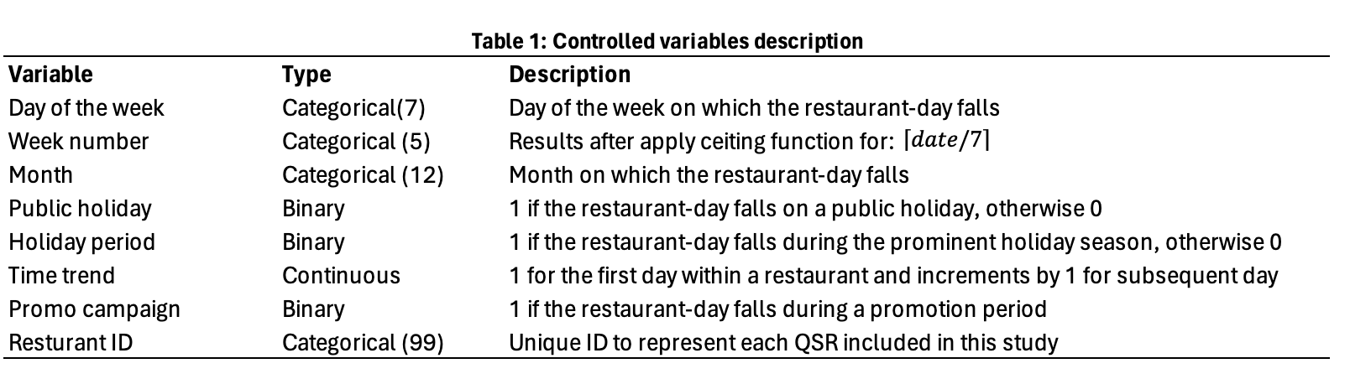

  - Regression Results
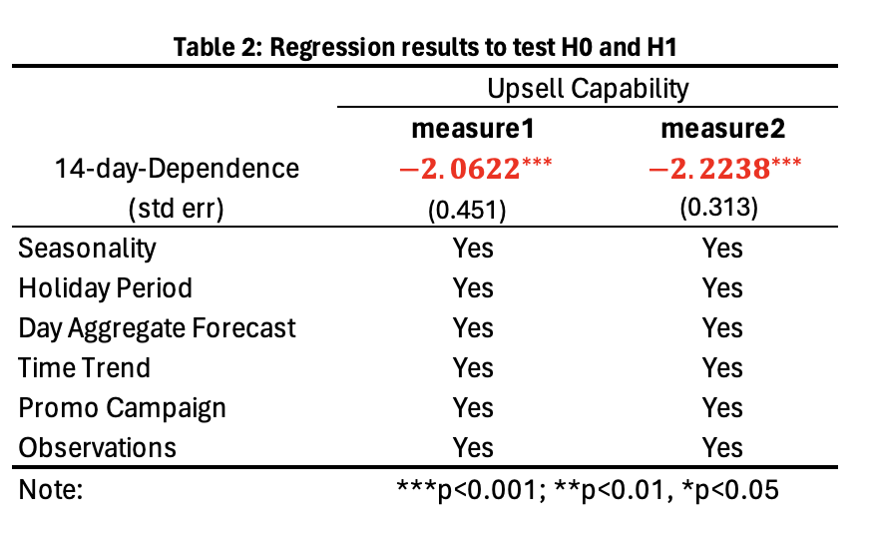
After fitting this logistic regression (section 5.1) with Generalised Linear Model (GLM), and taking systematic factors, such as seasonality, holiday, promotions, etc. into consideration.

Table 2 summarised the regressed coefficients for two measurements of upsell capability (as discussed in section 4.2), and the estimated standard errors are also adjusted for heteroskedasticity and autocorrelation, with clustering at the level of individual restaurant. More specifically, the coefficient (-2.0622) derived in measure1 showcased a negative relationship between platform dependence and dollar revenues made from upselling for each store at any given day, meaning that for every 10-percentage point increase in platform dependence, the proportion of sales revenue shrinks by 18.63% ($1-e^{-0.2062}$). With a standard error of 0.451 and a z-value of -4.571, the p-value is less than 0.001, which indicates that the relationship is statistically significant at common significance levels.

Similar output could also be observed in measure2, as a more negatively related coefficient (-2.2238) indicates a 20.05% ($1-e^{-0.2238}$) drop in total numbers of checks occurred at each store-level for every 10-percentage growth in platform dependence. This result is also statistically significant, with a p-value less than 0.001. Collectively, based on the insights derived from the fitted logistic regression model, H0 could be rejected with at least 99% confidence, and its counter hypothesis H1 such that increased dependence on third-party OFD platforms deteriorates restaurants’ upselling ability is supported.

- Moderation Analysis - Effects of Customer Traits
Even though the empirical results suggest an adverse impact on QSR’s ability to implement their upsell strategies with incremental dependence on OFD platforms, it is not easy for restaurants to forgo their use entirely in order to survive in this convenient-first digitalised era. Therefore, identifying factors that could mitigate or exacerbate this circumstance is crucial for restaurants to optimise their engagement with these platforms. This section, is dedicated to proposing potential moderating variables within the study context, detailing the methods used to measure these factors, and then presenting analytical models and results.

  - Moderators - Theory and Hypothesis
The moderators are all chosen based on a landmark analysis of restaurant management literature by Thompson (2010), which encompasses over fifty years of research and systematically outlines six critical dimensions of customer demand within the field. Moreover, this comprehensive review has become a key reference for understanding consumer behaviour in the context of dining establishments. Beyond patterns of demand arrival and selections made from the menu, this study highlights several crucial aspects of customer demand in dining settings, decomposed as following:
- Party size: it refers to the number of customers seated together at one table, with certain restaurants attracting larger groups, while others cater to a more personal dining experience.
- Party composition: it includes various traits such as the customer's age, gender, affluence, and ethnic background.
- Meal duration: it’s measured from the moment a party is seated until the table is cleared and prepared for new guests.
- Peak mealtime distribution: it shows how customer demand spreads throughout the day, with some stores experiencing rushes during lunch hours but quieter dinners, and others maintaining a steady flow of patrons during both major mealtimes.
Given the inter-connected nature of these elements, it’s plausible that the outlined factors have influences on how third-party delivery platforms affect the dependent variable (${UpSell}_{i,d}$) investigated in this study. Although ‘Meal duration’ is not examinable due to the limitations from original dataset, some more explorations could still be made to enrich the previous analysis by testing how the impact of platform dependence might be moderated with newly introduced factors including party size, party composition (i.e. customer opulence level) and peak mealtime distributions. As a result, the following hypothesis has been developed:
Hypothesis 2 (H2): Customer traits at the restaurant’s level, including party size, affluence level, and clustered mealtimes moderate the relationship between QSRs’ growing platform reliance and upsell capabilities.

  - Moderators - Variable Construction
    - Affluence
An average of revenue generated from each core menu item per transaction is used in this case to measure the opulence level of customers frequenting each restaurant. This metric sheds light on the purchasing power of eaters at different locations.

    - Party size
Similarly, an average quantity of core menu items included in each order is used as the measurement of customer numbers within each table. This figure serves as a proxy for determining the mean group size of diners, based on the common perception that larger groups are more likely to order more main dishes.

    - Peak Mealtime Distribution
This variable captures the pattern of customer footfalls throughout the restaurant-day by comparing the number of transactions during lunch (11am - 2pm) and dinner (7pm - 10pm) times. Normalisation is then applied by taking a natural logarithm of the lunch-to-dinner transaction ratio, resulting in a metric where a value of zero indicates an equal number of visits during lunch and dinner. A negative ratio suggests a dinner-dominated customer base, while a positive one points to a lunchtime preference.

Note: the regressive outcomes with moderating factors mentioned in above were all presented in standardised forms, for the purpose of easier interpretation. Meaning that each moderating factor was adjusted by subtracting its mean then dividing by its standard deviation. Histograms of these standardised version are also presented below.
Figure 2 Histogram of Customer Affluence Level

Figure 3 Histogram of Peak Mealtime
Figure 4 Histogram of Party Size

  - Moderators - Econometric Settings and Results
    - Model Specification
To examine Hypothesis H2, which incorporates the moderating effects of various consumer traits, additional interaction terms ($γ_{3}^{T}{Dependence}_{i,d}$) were introduced and added to the original regression model, such that:
$$logit\left({UpSell}_{i,d}\right)=γ_{i}+γ_{1}{Dependence}_{i,d}+γ_{2}^{T}X_{i,d}+γ_{3}^{T}{Dependence}_{i,d}*λ_{i}+ϵ_{i,d}^{γ}$$
More specifically, λi, is a vector representing three customer-related characteristics at each store-level, where were perceived to influence how platform dependency affects upsell capabilities. The coefficient $γ_{3}$ within the vector is meant to capture the level of these moderating effects. For a thorough analysis, each moderator was inserted into the regression model one by one, leading estimations of three distinct equations for the dependent variable.

    - Moderation Analysis Results
Table 3 summarised the approximated coefficients specified in this longer regression model (section 6.3.1), and the standard errors are also adjusted for heteroskedasticity and autocorrelation, clustering at the level of each individual restaurant. The coefficient values for Affluence, Party size, and Peak mealtime distribution reflect how these customer characteristics, when each is increased by one standard deviation, influence the dynamic between platform reliance and upsell capability (as measured by sales revenue).
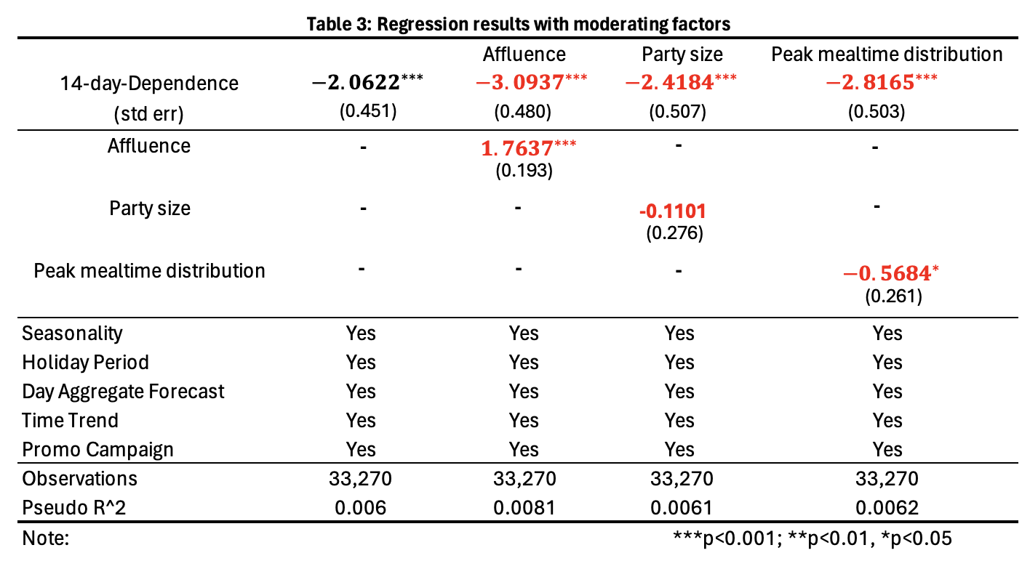

As mentioned in section 6.2, the first tested moderation factor refers to customers’ affluence level, which is measured by standard average sales revenue obtained per core menu item per order. With numbers displayed in Table 3, the strong positive coefficient for Affluence (1.7637; with p-value < 0.001) suggests that more affluent customers have a pronounced tendency to boost upsell revenues despite a growing reliance on the platform. Statistically, a store with one standard deviation ($0.48$) above the mean will have a 19.2% ($1-e^{-0.3093+2×0.048}$) reduction in upsell revenues for every 10-percent point increase in OFD dependence, compared to a 33.3% reduction for a restaurant one standard error below the mean. In essence, higher opulence strongly mitigates the decline in profit margins make from upselling that might otherwise occur with increased platform dependence.

For the second moderation factor - Part size, measured by the mean number of core menu items ordered per check. The negative coefficient (-0.1101; with p-value > 0.05) may not be accountable estimation in this case, due to the fact that it is notably deviated from the common significance level. Therefore, at least with the given dataset, party size may not have any obvious moderation effect on reduction in restaurant’s upsell ability.

The last investigated factor – Peak mealtime distribution, which is defined as an indicator variable such that more meals are served at lunch than at dinner time in a particular outlet. Unlike affluence level, the estimated coefficient in this case is negative (-0.5684 with p-value < 0.05). This suggests the restaurants that have more footfalls during lunch time than dinner peak will experience a much greater loss in sales percentage from upselling items, given the same amount of dependence increase in online platform.

- Robustness Verification and Alternative Explanations
Deriving insights on direct causality from a secondary dataset is often a complex task, however, several methodologies were applied in this study to discourage other indirect condisions for the observed effects, which will be furthered discussed in this session. In addition, robustness checks were also performed to improve the reliability of the final findings, drawing general insights beyond the confines of the major manuscript’s framework.

Firstly, by capitalising the variation in dependence that occurs within each individual store, multiple unobserved site-specific impacts, such as store size, local demographic profiles and competitors activate levels, were accounted for when developing the regression models. It is also worthwhile to mention that no technological or ownership transitions took place during the data collection timeframe. While some restaurants may have experienced changes in their competitive landscape, there were not uniform, and thus are unlikely to significantly skew the estimated outputs.

Secondly, as the final conclusions were drawn from the extent to which each restaurant relies on delivery platforms for its customer demand, any potential disruptive external factors, such as extreme weather, traffic fluctuation, or local events, need to be neutralised. Therefore, the focused day $d$ was excluded from platform dependence computation, and this metric has also been spread over an extensive time period (half-month before and half-month after) to further eliminate any systematic impacts that may last for multiple days.

Furthermore, different variable construction metrices were adopted in order to ensure robust results. In particular, two alternative measures of targeted dependent variable ($UpSell_{i,d}$) were defined, namely (1) dollar revenues and (2) number of checks percentages, and the results are shown in Table 2. Similarly, results based on alternative definitions for the three moderation factors were also computed and displayed in Table 4. Instead of averages, median sales revenue earned from core menu items and median number of core menu items per order were used to define customers’ Affluence level and Party size. The Peak mealtime distribution was accounted as an indicator to show more footfalls were occurred at lunch than at dinner.
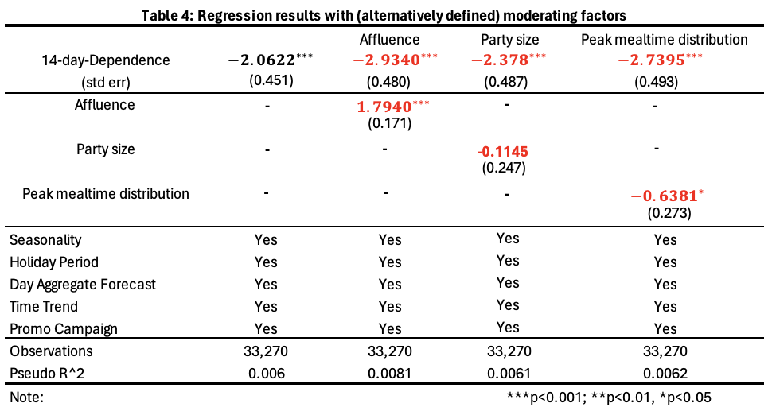

In summary, despite of the fact that different measurements were tested to gauge restaurant’s upsell ability and moderating factors, consistent observations were derived. Clarifying the genuine detrimental effects of increasing OFD platform dependence on restaurant’s ability to engage in its upsell strategies. Additionally, the study results robustly indicate the strong moderating effects of customer demand characters, including opulence levels and preferred mealtimes, have on overall deteriorated upsell capability.

- Conclusion
The comprehensive study explored the nuanced interplay between third-party Online Food Delivery (OFD) platforms and the upselling dynamics within the Quick-Service Restaurant (QSR) industry. Through a meticulously designed empirical analysis leveraging a proprietary dataset encompassing approximately 50 million transactions across 99 outlets, this research offers profound insights into how the evolution of OFD platforms is reshaping restaurant economics and customer engagement strategies.

A critical finding from this analysis is the statistically evident adverse impact of increased dependence on OFD platforms on restaurants' ability to upsell, a cornerstone for enhancing average order value and, by extension, profitability. The data unequivocally demonstrated that a surge in platform reliance correlates with a notable decrease in upselling efficacy, manifested through diminished revenue from upsold items and a reduction in the total number of transactions involving upsold products. Specifically, for every 10-percentage point increase in platform dependence, there was an 18.63% reduction in upselling revenue and a 20.05% decline in the number of upselling transactions, underscoring the significant economic implications of OFD platform integration.

Interestingly, the study also ventured into the domain of customer behaviour and its modulation of the observed relationship between OFD platform dependence and upselling performance. Based on the insights derived from several economic studies, it introduced three moderating factors - customer affluence, party size, and peak mealtime distribution - to the analysis. Among these, customer affluence emerged as a potent mitigator, suggesting that more affluent customer segments could cushion restaurants against the financial repercussions of shifting towards OFD-centric operations. In contrast, the impact of party size on moderating the OFD dependence-upselling dynamic was statistically inconclusive, indicating that the composition of customer groups might not play as significant a role in this context. The analysis concerning peak mealtime distribution revealed a nuanced understanding of customer flow patterns, where restaurants with a higher lunchtime footfall experienced a greater diminishment in upselling capabilities amid increasing platform reliance.

The study navigated through potential confounders and externalities, employing a robust analytical framework to ensure the reliability of its findings. By accounting for idiosyncratic store-specific factors and external influences such as weather and local events, the research upheld the integrity of its conclusions, revealing a consistent narrative about the challenges and opportunities presented by OFD platforms.

In essence, this study elucidates the double-edged sword of OFD platform engagement for the restaurant industry. While these platforms offer a conduit to expanded market reach and potential revenue growth, they also pose challenges to traditional revenue-enhancing strategies like upselling, especially in the absence of direct customer interaction. The mitigating effect of customer affluence highlights a pathway for restaurants to navigate the complexities of this new digital landscape - tailoring strategies to cater to more affluent demographics could potentially offset some of the adverse impacts on upselling capabilities.

Moving forward, this research underscores the imperative for restaurants to adapt their business models and marketing strategies to the realities of the digital economy. As the OFD sector continues to evolve, so too must the tactics employed by restaurants to maintain profitability and customer engagement. This might include developing more sophisticated digital upselling techniques, leveraging data analytics for personalised marketing, and exploring innovative ways to enhance the digital customer experience.

Ultimately, the transition towards greater OFD platform dependence is not just a technological or operational shift but a strategic one that necessitates a deep understanding of changing consumer behaviours and market dynamics. By navigating these waters with agility and strategic foresight, restaurants can harness the potential of OFD platforms to fuel growth while mitigating their impact on traditional revenue streams such as upselling.

References
- Barbee, J., Jayakumar, J., Touse, S. & Venkataraman, K. (2021) 'Retail’s need for speed: Unlocking value in Omnichannel Delivery', McKinsey & Company. Available at: https://www.mckinsey.com/industries/retail/our-insights/retails-need-for-speed-unlocking-value-in-omnichannel-delivery.
- Blattberg, R.C., Kim, B.D., Neslin, S.A., 2008. Cross-Selling and Up-Selling. In: Database Marketing: Analyzing and Managing Customers, pp.515-547.
- Collison, J. (2020) 'The impact of online food delivery services on restaurant sales', Stanford University. Available at: https://web.stanford.edu/~leinav/teaching/Collison.pdf.
- Dewi, P., Maja, M.A. and Hakiki, V.M., 2023. The role of persuasive dialogue in the negotiation of the sale of goods at Simpur Center, Bandar Lampung City. Journal of Public Relations and Digital Communication (JPRDC), 1(01), pp.42-48.
- Duch-Brown, N., Grzybowski, L., Romahn, A., and Verbove, F., 2017. The impact of online sales on consumers and firms. Evidence from consumer electronics. International Journal of Industrial Organization, 52, pgs 30-62. https://doi.org/10.1016/j.ijindorg.2017.01.002

- Feldman, P., Frazelle, A.E., Swinney, R., 2023. Managing relationships between restaurants and food delivery platforms: Conflict, contracts, and coordination. Management Science, 69(2), pp.812–823.
- Global Online Food Delivery Market Size (2024) Statista, 15 February. Available at: https://www.statista.com/statistics/1170631/online-food-delivery-market-size-worldwide/.
- Goolsbee, A., 2001. Competition in the Computer Industry: Online versus Retail. The Journal of Industrial Economics, 49(4), pp.487–499.
- Haddon, H., Jargon, J., 2019. Consumers love food delivery. Restaurants and grocers hate it. The Wall Street Journal.
- Heidhues, P., Kőszegi, B., 2018. Behavioral industrial organization. Handbook of Behavioral Economics: Applications and Foundations 1, 1, pp.517-612.

- Heidig, W., 2012. Upselling or upsetting?: studies on the behavioral consequences of upsell offers in service encounters. na.

- Jenkins, W.Y., 2015. Marketing strategies for profitability in small independent restaurants (Doctoral dissertation, Walden University).

- Karniouchina, E., Sarangee, K., Theokary, C., Kübler, R., 2022. The Impact of the COVID-19 pandemic on restaurant resilience: Lessons, generalizations, and ideas for future research. Service Science, 14(2), pp.121-138.

- Kim, J., Lee, J.C., 2020. Effects of COVID-19 on preferences for private dining facilities in restaurants. Journal of Hospitality and Tourism Management, 45, pp.67–70. https://doi.org/10.1016/j.jhtm.2020.07.008.
- Kodali, S. & Cyr, M. (2020) 'The state of the US grocery shopper - covid-19', Forrester, 22 December. Available at: https://www.forrester.com/report/The-State-Of-The-US-Grocery-Shopper-COVID19/RES163522/.
- Li, Z., Wang, G., 2020. The role of on-demand delivery platforms in restaurants. Available at SSRN 3813891.

- Milwood, P.A., Crick, A.P., 2021. Culinary tourism and post-pandemic travel: Ecosystem responses to an external shock. Journal of Tourism, Heritage & Services Marketing, 7(1), pp.23-32. https://doi.org/10.5281/zenodo.4516562

- Norvell, T., Kumar, P., Contractor, S., 2018. Assessing the customer-based impact of up-selling versus down-selling. Cornell Hospitality Quarterly, 59(3), pp.215-227.
- NRA 2024 state of the restaurant industry. (2024) NRA. Available at: https://restaurant.org/research-and-media/research/research-reports/state-of-the-industry/.
- Poon, W.C. & Tung, S.E.H. (2022) 'The rise of online food delivery culture during the COVID-19 pandemic: An analysis of intention and its associated risk', European Journal of Management and Business Economics. Available at: https://www.emerald.com/insight/content/doi/10.1108/EJMBE-04-2021-0128/full/html.
- Pozzi, A., 2013. The effect of Internet distribution on brick-and-mortar sales. The RAND Journal of Economics, 44(3), pp.569-583.

- Prince, J.T., 2007. The Beginning of Online/Retail Competition and Its Origins: An Application to Personal Computers. International Journal of Industrial Organization, 25(1), pp.139–156.

- Relihan, L., 2017. Is Online Retail Killing Coffee Shops? Estimating the Winners and Losers of Online Retail using Customer Transaction Microdata. PhD Dissertation, The Wharton School University of Pennsylvania.

- Sharma, R., Dhir, A., Talwar, S., Kaur, P., 2021. Over-ordering and food waste: The use of food delivery apps during a pandemic. International Journal of Hospitality Management, 96, p.102977.

- Thompson, G.M., 2010. Restaurant profitability management: The evolution of restaurant revenue management. Cornell Hospitality Quarterly, 51(3), pp.308–322.

- Urban, T.L. and Russell, R.A., 2024. Upselling at delivery. International Journal of Revenue Management, 14(1), pp.1-32.

- Visser, M. and Schroeders, S., 2021. Customer acquisition: sales and pricing. In Digital Marketing Fundamentals, pp.346-387. Routledge.

- Wiesman, D.W., 2006. The effects of performance feedback and social reinforcement on up-selling at fast-food restaurants. Journal of Organizational Behavior Management, 26(4), pp.1-18.
- Yin, S. (2020) 'Upselling vs. cross-selling: The ultimate guide', Shopify, 1 November. Available at: https://www.shopify.com/blog/upselling-and-cross-selling.
- Zabin, J. and Brebach, G., 2004. Precision marketing: The new rules for attracting, retaining, and leveraging profitable customers. John Wiley & Sons.

