**Cadence observations supporting NASA/ESA planetary exploration.**

Michael H. Wong (UC Berkeley) and Al Conrad (LBT)

**Summary:** Spacecraft exploration of the solar system is a high-profile activity that benefits from temporal context observations from space telescopes. Science from current and past missions has been extended by imaging and spectroscopic time-series data from HST, and JWST’s unique capabilities may play a similar role for future spacecraft missions.

**Successful examples:** We use two specific cases to illustrate past/current examples of specific programs that support and extend spacecraft observations in the outer solar system. Many other cases could be made if there were more space available.

* *Juno at Jupiter:* Juno is making unique discoveries at Jupiter thanks to its instrument suite and its highly eccentric polar orbit. Measurements over a range of distances sample different regions of the magnetosphere, while HST observations have been able to link auroral phenomena that map along field lines to the changing spacecraft location [bonfond etc.]. In some cases, HST visible-wavelength context imaging was able to identify cyclonic vortices as the sites of tranient luminous events seen by Juno in the UV [giles], deep density reversals in vortices detected by the MWR [bolton], and convective storms associated with lightning clusters [imai,wong20,23]. The specific science results from Juno were not known in advance, but the science was enhanced by cadence observations from HST.
* *Voyager at Neptune:* HST did not come online until years after the Voyager Neptune encounters. Still, it became the only facility capable of following up on Voyager’s discovery of two dark vortices on Neptune [smith], a type of phenomenon now known to persist for only 2–4 years thanks to long-term HST observations [hsu].

**Future opportunities:** Upcoming missions:

* *Europa:* Missions to Europa include ESA JUICE (launched April 2023) and NASA Europa Clipper (launching October 2024). Learning more about the composition of Europa plumes will support Europa Clipper mission planners [Fig. 1]. It should be possible to use JWST to find plume sources on the surface. Attempts to measure plume composition by taking spectra must be at a regular cadence because plume occurrence times and frequencies are not currently known.
* *Titan:* Titan will be visited by Dragonfly (launching 2026). Understanding weather systems on Titan will support Dragonfly mission planners. It is possible to use JWST to monitor clouds in Titan’s atmosphere, with spectra enabling measurement of the opacity profiles as a function of altitude [Fig. 2]. To understand weather patterns on Titan, clouds must be monitored at a regular cadence.

**Challenges and solutions:** Direct mission supporting observations require campaign durations of several years (e.g., Juno entered orbit in 2016 and will continue until 2025). This is longer than possible for a single GO proposal, and TAC variability can threaten program continuity. A potential solution is program extension with Director approval (relying on community input).

Cadence observations can account for an amount of observing time that grows over time, potentially affecting the amount of compelling GO science from other programs if less overall time is available. This could be addressed by allocating Director’s Discretionary (DD) time (relying on community input) for observations that extend longer than typical GO program durations of 1–3 cycles.

Suggested programs may claim more actual mission value than they can deliver. Mission support letters are currently accepted for GO programs, but these are provided to the TAC panels only after voting is complete (as with team experience). Mission support letters thus have a very limited potential to describe positive mission value for GO programs. A potential solution is for TACs to consider mission support in their decision of an initial GO program, with program extension via DD time available only if the program demonstrates strong mission-supporting science value.

**References:**

1. bonfond et al, more?
2. giles et al
3. bolton et al 2021
4. imai et al 2020
5. wong et al 2020
6. wong et al 2023
7. smith et al 1989
8. hsu et al 2019

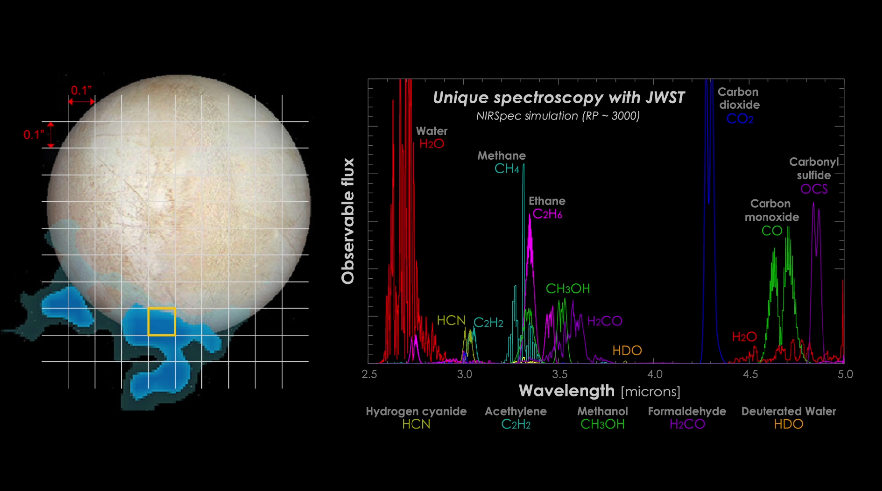

**Fig. 1 —** Pre-launch, Europa spectral observations were expected to measure gas and ice composition at Europa, in association with any plumes if present. Credits: NASA-GSFC/SVS, Hubble Space Telescope, Stefanie Milam, Geronimo Villanueva. URL: https://www.nasa.gov/feature/goddard/2017/nasa-s-webb-telescope-will-study-our-solar-system-s-ocean-worlds

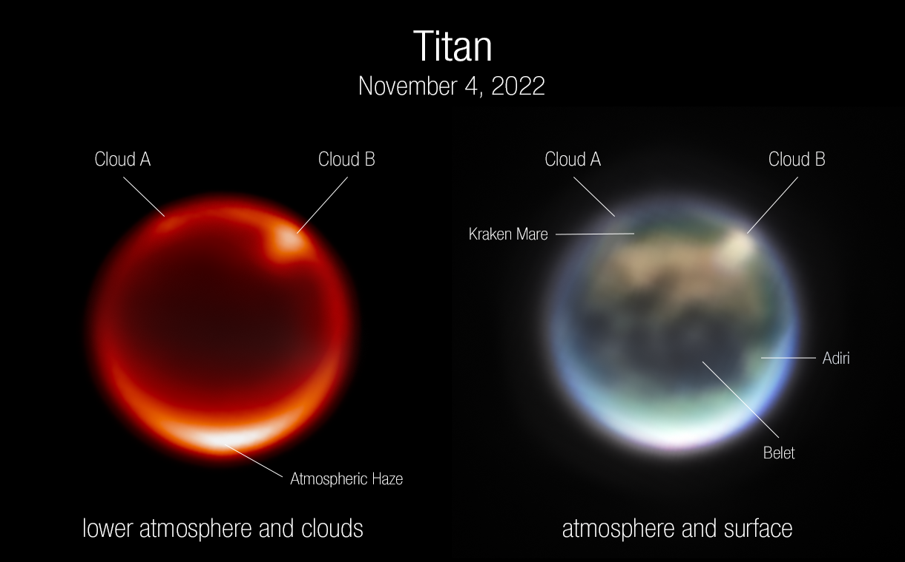

**Fig. 2 —** JWST spectra of Titan can measure variability of a multitude of atmospheric properties, from cloud spatial distribution to vertical profiles. Credits: NASA, ESA, CSA, Webb Titan GTO Team, Alyssa Pagan. URL: https://blogs.nasa.gov/webb/2022/12/01/webb-keck-telescopes-team-up-to-track-clouds-on-saturns-moon-titan/

**Additional co-authors/co-signers:**

JWST Jovian System ERS team

JWST GTO teams