User Interface

1. Click “File” tab and a menu is displayed. This menu can be used to exit the program. Click “Exit” to exit the program.
2. Click “Help” tab and a menu is displayed. This menu has two choices Instructions and Thread Count.
3. Click on “Instructions” to open up a second window (shown below) that has a list of instructions. Click “OK” to return to the UI.

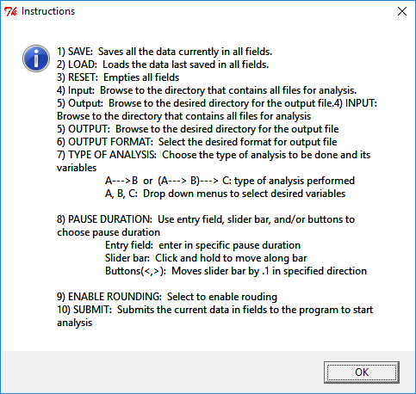

1. Click on “Thread Count” to change the thread count. The new window(shown below) will open. Click the “close” to return to the UI.

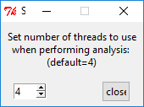

1. Click “Save” to store all the values currently in all the fields in the UI.
2. Click “Load” to load all the values currently stored by the UI.
3. Click “Reset” to reset all the values currently in all fields in the UI to default values.

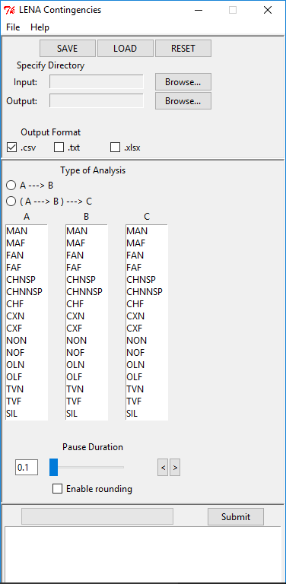

Input and Output

1. Find the “Specify Directory” section and there will be two Browse buttons. (shown below)
2. Click on “Browse” located on the same line as Input
3. Navigate to the folder that contains the ITS files you want to analyze. Select the folder and then click “OK”.
4. Click on “Browse” located on the same line as Output
5. Navigate to the folder where the output needs to be stored. Select the folder and then click “OK”.
6. Find the “Output Format” section and there will be three checkboxes
7. Click the boxes corresponding to the desired format of the output files

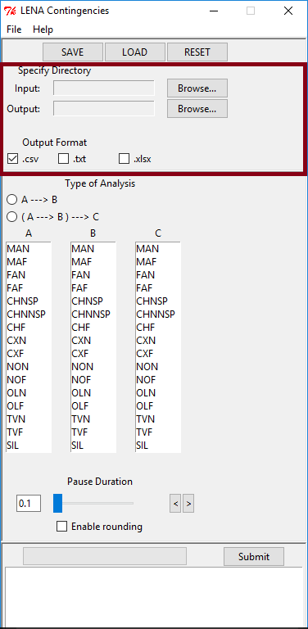

Analysis

1. Find the “Type of Analysis” section and there will be two choices and menus for A, B, and C. (shown below)
2. Contingencies for two-event (A 🡪 B) or three-event sequences ((A 🡪 B) 🡪 C) can be computed. Click the circle corresponding to the desired sequence.
3. Select events from each menu corresponding to the needed fields

An example (For RVC): (shown below)

* + 1. Select ((A 🡪B) 🡪C) by clicking the circle.
    2. For the first event (A) select “CHNSP” (child – near – speech-related)
    3. For the second event (B) select “MAN” (male adult – near)
    4. Also for the second event (B) select “FAN” (female adult – near).
    5. For the third event (C) select “CHNSP” (child – near – speech-like)

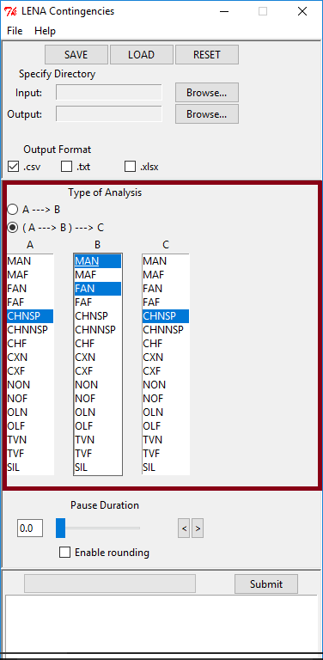

Pause Duration

1. Find the “Pause Duration” section (shown below)

For RVC, a pause length of 2 seconds is based on the 2 second being the average latency between mother and infant vocalizations (Northrup & Iverson, 2015).

1. The entry field will display the current pause length value.
2. Click into the entry field to directly enter a specific pause length.
3. The slider can be clicked and dragged to the desired pause length.
4. The buttons “<” and “>” when clicked will change the pause length by .1 increments.
5. Click the box to enable rounding. Enabling rounding reduces the precision of the results.

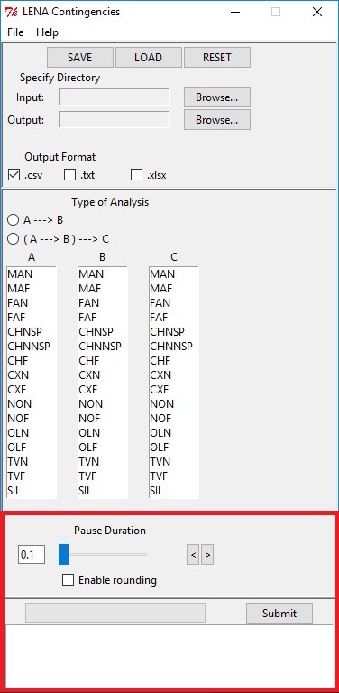

Submit

1. Once all fields are filled click the “Submit” button. (shown above)
2. The program will run the analysis and the progress bar will show the status of the analysis. Once the bar is full the analysis is complete. The output will be stored in the folder designated.