I used pytest to test my modals. I had to put a file named ‘pytest.ini’ into my root directory so pytest knew where my database settings were ie the path to the database. Until I did this I received errors about the database not being found. I had to set up a new directory named ‘tests’ in my root directory. Inside this directory I put in a subfolder named booking which contained a file named ‘test-models’. This is where a copy of the original booking model was tested. Directly inside this folder I created a factories file.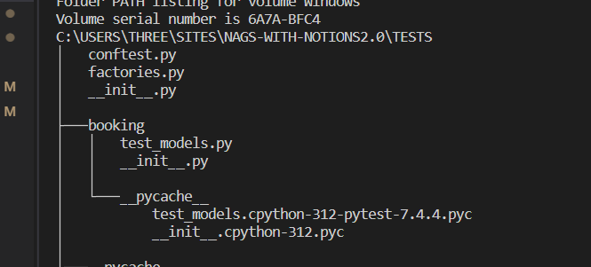

This factories file imported my Booking model and allows fake data to be entered. Using the factory-boy import I was able to create fake instances of the booking model called fixtures. To test the Booking model I used the location attribute and set it to ‘Ratoath’. In the factories file I used the assert command which meant the value Ratoath was expected to be found in the fake booking application. I kept getting a runtimeerror of ‘no database found’ but when I looked up the factoryboy documentation and inserted the argument of ‘factory.Factory’ into my fake class this error stopped. The test then passed and confirmed that location was an attribute associated with the Booking model.

