User Story #29 – Login & Registration

As an assessor I can verify the use of **a role-based login and registration functionality** so that a pass grade may be awarded.

*Role-based login*

The screenshot below shows how user ‘johnwalshe’ has staff status. While other users do not. By having staff status only ‘johnwalshe’ can enter the admin area.

Only ‘staff’ can create and edit events. See in the image below johnwalshe can create and edit events as he is a staff member.

As Rebecca is not ‘staff’ the option to create events is not present in the header.

Additionally, Rebecca cannot edit an event as she is not designated staff status.

*Registration Functionality*

Test: Click ‘Book Now’ button as unregistered user.

Outcome: A flash image presents telling the user they must login to book

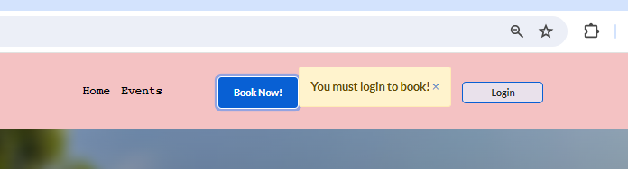

The user is then automatically redirected to the login page, where a message saying ‘don’t have an account? Register is shown. The user knows he/she must register to login and can proceed.



Upon clicking ‘Register’ the user is brought to the registration page.

Test: Input Testperson1 with password &p34K_(8*

Outcome:

Bug: the password feedback info is not updating

A green flash message presents telling the user their registration has been successful

The new users name is presented in the top right of the footer



As a registered ‘logged in’ user the new user can now create a booking.

The new user can be found in the Django admin – which relates to the database

As a logged in user I wish to book an event by using the browser. This test also covers as a tester I can see evidence of CRUD

Test: Click ‘Book Now!’ button as a logged in user.

Outcome: User is taken to the ‘Create New Booking Page’

I input the following information and then pressed submit

A green success message appears saying ‘New booking created’. The booking is also displayed in the ‘booking page’ on top of the list of other bookings.

The new booking is also in the database

As a user I can update the information in my booking.

Outcome: Clicking on ‘Your Bookings’ brings the user to their bookings. An option to ‘Edit’ or ‘Delete’ is clearly visible.

Clicking ‘update’ brings the user to the ‘create booking page’ with all the original information present

The following text was added to the message box.

Upon clicking submit a message appears stating ‘booking updated’. The updated booking is also visible in the bookings list.

As a user I would like to be able to delete my booking.

Test: Click the delete button.

Upon clicking the delete button the user is given an option as to proceed. The booking date is used for reference.

Clicking the cancel button brings the user back to the bookings page and all bookings are still present.

However, clicking the delete button here presents the user with a ‘Booking deleted’ image and the booking is no longer present in the users ‘bookings’. The booking instance has also been removed from the database.

Testing ‘Create Event’

As an admin I want to be able to add events that users can view

Test: Login in as a user with Admin status and expect to see a ‘create event’ option in the header.

Outcome: The ‘Create Event’ button is present as expected

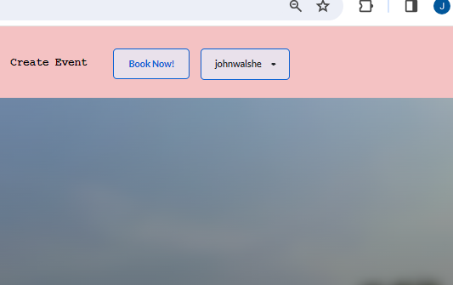

As expected clicking the ‘create event button’ brings the admin to a create event page

The following form was submitted. It was expected that the admin would see this event, with the image in the ‘Events’ section.

Outcome:

This is a bug, as the author should be able to make more than one event.

The author field was removed. This form was then submitted.

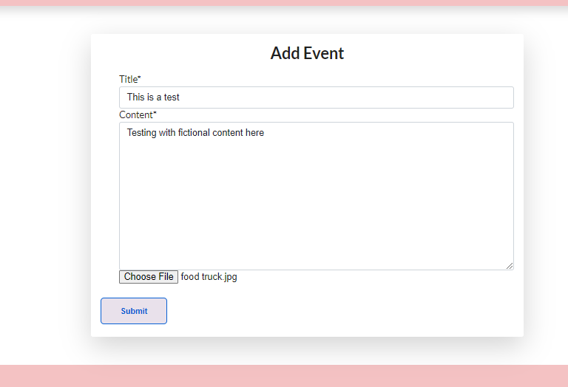

Outcome: Test failed. The event was not submitted. The page just returned to the same page. Upon further investigation the removal of the ‘status’ field from the event entry form caused the error. Returning this field corrected this issue.

As expected the event image presents. However the image is too wide. Col-8 offset-2 from bootstrap fixed this

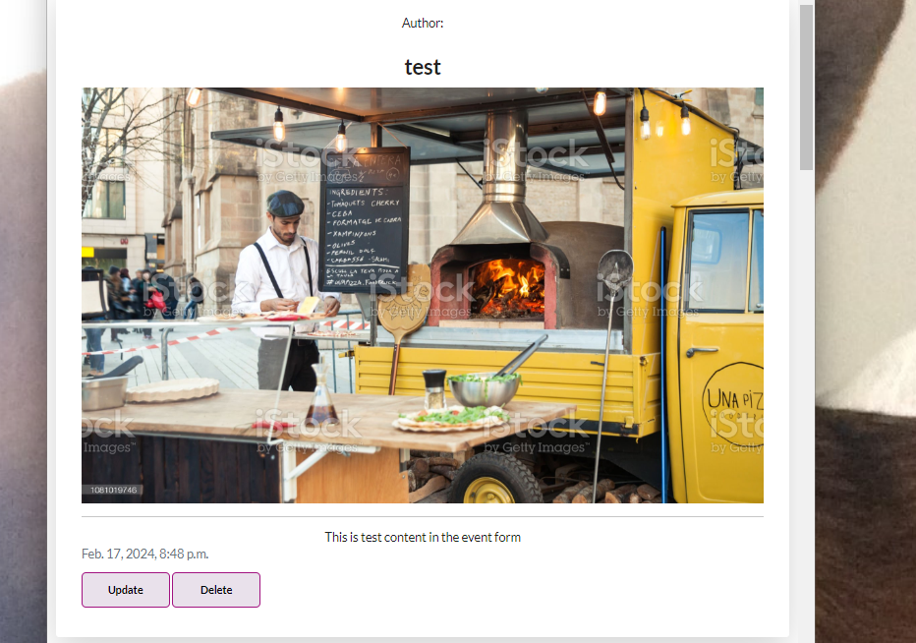

Test: Click the events update button. Expected outcome. Superuser redirected to event form.

As expected the superuser is brought to the Add Event form with the previous detail present.

Test. ‘This is updated text’ is entered into the content section. Outcome: As expected, the updated text is present and the user is redirected to the events page. BUG However the ‘clear’ button does not work for the current image and a new image cannot be uploaded. By inserting crispy forms a red warning appears

If the user deletes an image and submits this then the image is deleted. Once deleted the user can edit the image again and put in a new image.

Below is the image erased

New image attached

New image successfully uploads

Test: Delete event by clicking delete button.

Outcome: As expected user is brought to ‘Are you sure?’ section

Clicking ‘cancel’ brings the user back to the events section. Clicking ‘delete’ successfully deletes the image.

Page links testing:

Test: Clicking the logo in the header should return the user to the home page

|  |  |  |  |  |  |  |
| --- | --- | --- | --- | --- | --- | --- |
| Home | Events Pg | Create Ev | Your bookings | Login | Reg page | Create bk |
| Checkmark with solid fill | Checkmark with solid fill | Checkmark with solid fill | Checkmark with solid fill | Checkmark with solid fill | Checkmark with solid fill | Checkmark with solid fill |

Test: Clicking ‘home’ button in header should return user to home page

|  |  |  |  |  |  |  |
| --- | --- | --- | --- | --- | --- | --- |
| Home | Events Pg | Create Ev | Your bookings | Login | Reg page | Create booking |
| Checkmark with solid fill | Checkmark with solid fill | Checkmark with solid fill | Checkmark with solid fill | Checkmark with solid fill | Checkmark with solid fill | Checkmark with solid fill |

Test: Clicking ‘Events’ button should bring user to events listing page

|  |  |  |  |  |  |  |
| --- | --- | --- | --- | --- | --- | --- |
| Home | Events Pg | Create Ev | Your bookings | Login | Reg page | Create booking |
| Checkmark with solid fill | Checkmark with solid fill | Checkmark with solid fill | Checkmark with solid fill | Checkmark with solid fill | Checkmark with solid fill | Checkmark with solid fill |

Test: Clicking ‘Book now’ in header brings *logged in* user to ‘create new booking’

|  |  |  |  |  |
| --- | --- | --- | --- | --- |
| Home | Events Pg | Create Ev | Your bookings | Create booking |
| Checkmark with solid fill | Checkmark with solid fill | Checkmark with solid fill | Checkmark with solid fill | Checkmark with solid fill |

Test: Clicking ‘Create Event’ in header *superuser* to ‘create event’

|  |  |  |  |  |
| --- | --- | --- | --- | --- |
| Home | Events Pg | Create Ev | Your bookings | Create booking |
| Checkmark with solid fill | Checkmark with solid fill | Checkmark with solid fill | Checkmark with solid fill | Checkmark with solid fill |

Test: Clicking ‘Go back’ on the create booking page brings the user to ‘your bookings’

|  |
| --- |
| Create Booking |
| Checkmark with solid fill |

Test: Clicking designed by ‘John’ in footer on all pages brings you to John Walshe github

|  |  |  |  |  |  |  |
| --- | --- | --- | --- | --- | --- | --- |
| Home | Events Pg | Create Ev | Your bookings | Login | Reg page | Create booking |
| Checkmark with solid fill | Checkmark with solid fill | Checkmark with solid fill | Checkmark with solid fill | Checkmark with solid fill | Checkmark with solid fill | Checkmark with solid fill |

Test: Clicking ‘Book Now’ on the hero image jumbotron directs user to ‘Create Booking’

|  |
| --- |
| Home |
| Checkmark with solid fill |

Application has passed lighthouse Accessibility Testing