Name: Gaojie Wang Email: [gaojie.wang@utdallas.edu](mailto:gaojie.wang@utdallas.edu)

• How to deploy the solution.

I used Firefox on Linux.

Any other OS and browser should also work fine.

1. Download and extract the zip file.

2. Open index.html.

3. Observe the parsed data.

• Language chosen and why?

JavaScript.

No need to compile, no need to set up anything. Just a web browser will do the job.

• Source code.

This project included some online bootstrap template.

Important source code:

xml2html.html, myxsl.xsl, myscript.js

• High-level design. (A Visio diagram or hand drew the image)

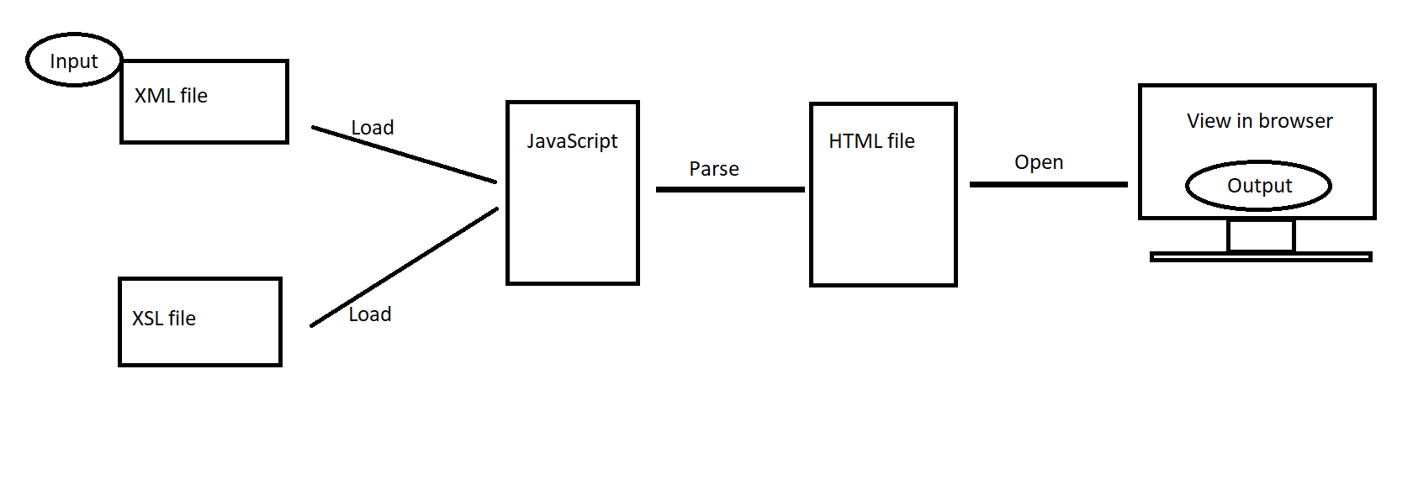

• Screenshots of formatted data presentation, in case we are not able to run the solution.

