Android Repackaging – Group 2

Name: Deepti Kanuri

**Task 1 - Obtain an Android App (APK file)**

1.Founded the IP – 10.0.2.4 of Android VM by running ifconfig command in the Android Terminal app.

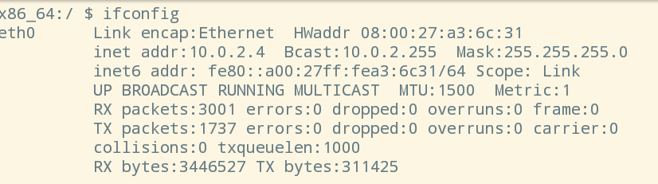

2.Installed the app “RepackagingLab.apk” using below command in Ubuntu VM.

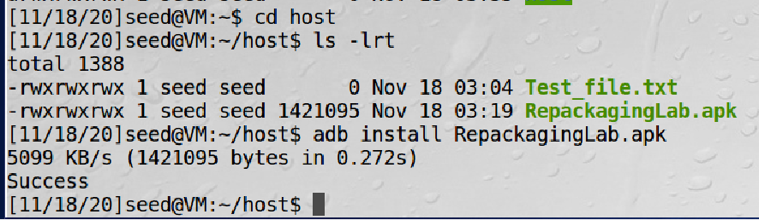

**Task 2 - Disassemble Android App**

1.Disassembled the Android App using APKTool. This tool converts the dex code to smali code.

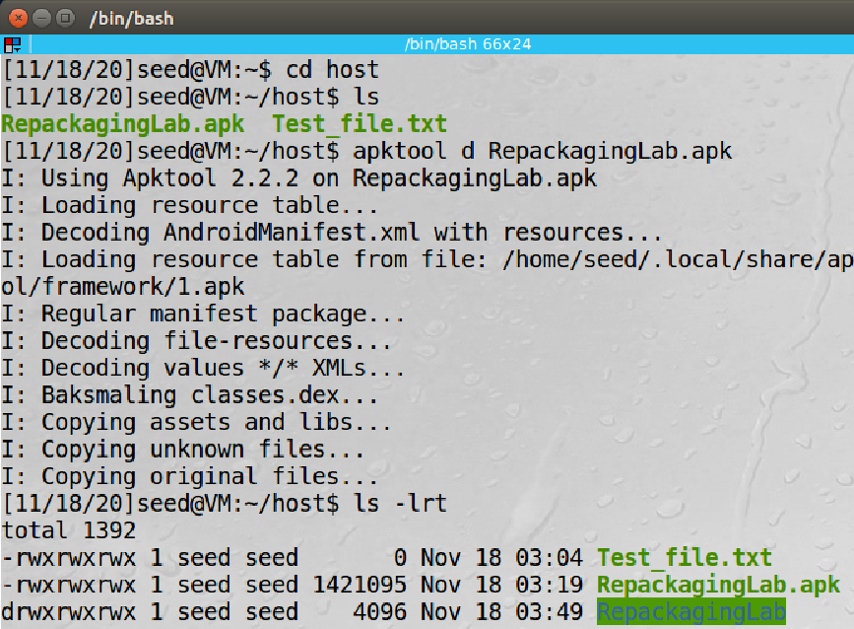

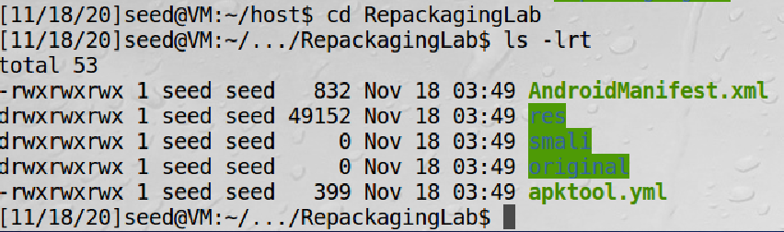

**Task3 - Inject Malicious Code**

1.I modified the AndroidManifest.xml file using sublime text and injected Malicious Java code as given in the Reference document. Also, I modified the user permissions to allow the app to access Contacts from the Android VM.

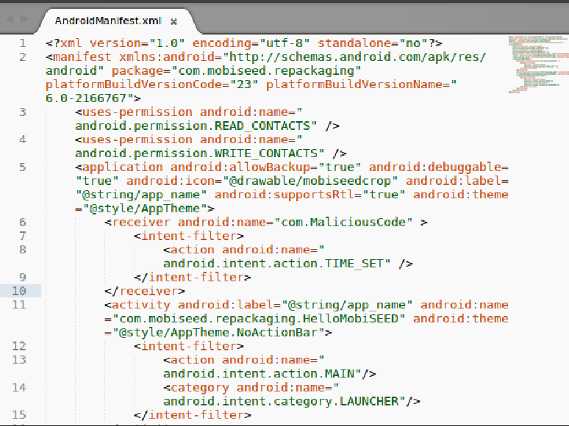

**Task 4 - Repack Android App with Malicious Code**

1.Repackaged the Android App with Malicious code using APKTool .

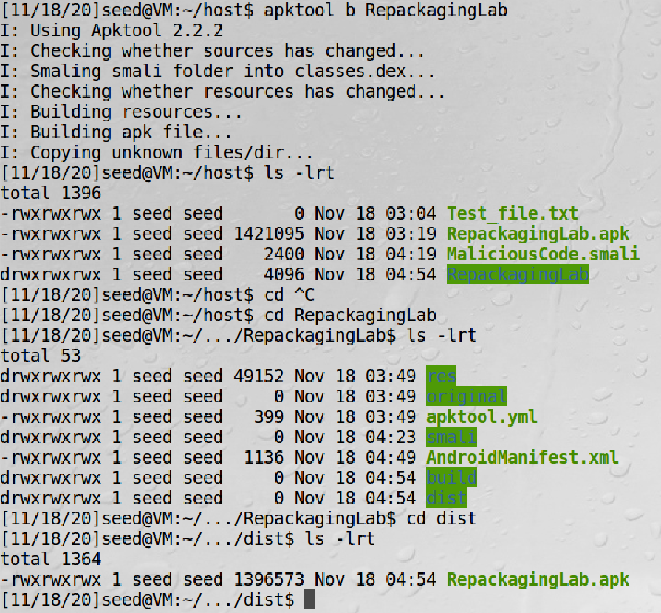

2.Generated the public and private key pair using the keytool command.

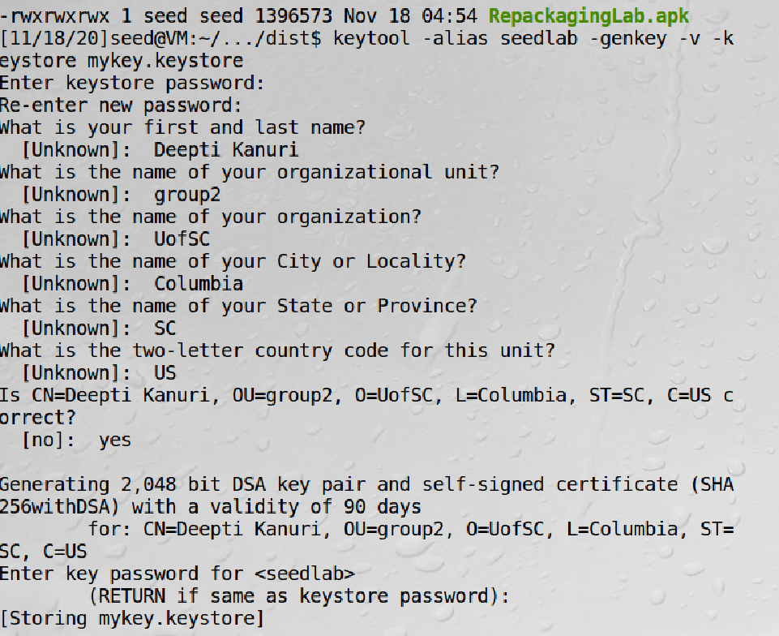

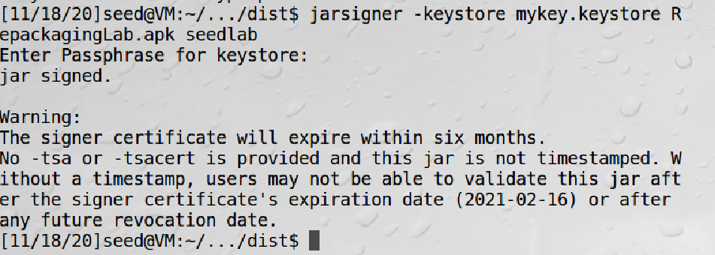

**Task 5 - Install and Reboot**

1.In this step I first deleted the app from the Android VM and the re-installed this app using adb command.

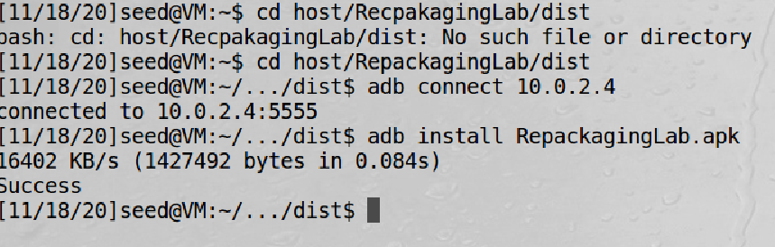

2.Gave the permission to access the contacts by navigating to settings>apps>Repackaging Lab> contacts.

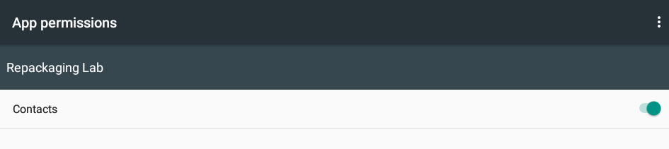

3.Firstly, I saved a dummy contact name at time 4.26AM. Then I changed the time of the Android VM to 10.30 AM by navigating through settings>Data and Time. Lastly, when the contacts app was opened the contact information was deleted.

