**Question 1**

Consider again the example application of Bayes rule in Section 6.2.1 of Tom Mitchell’s textbook (or slide page 6 of Lecture 6-2). Suppose the doctor decides to order a second laboratory test for the same patient, and suppose the second test returns a positive result as well. What are the posterior probabilities of *cancer* and ¬*cancer* following these two tests? Assume that the two tests are independent.

**Answer**

Since,

P (cancer | +) => P (+ | cancer) * P(cancer) / (P (+ | cancer) * P(cancer) + P (+ | ¬cancer) * P(¬cancer)).

=> 0.98 * 0.008 / (0.98 * 0.008 + 0.03 * 0.992)

=> 0.0078 / (0.0078 + 0.0298)  
=> 0.21

And,

P (cancer | ++) => P (+ | cancer) * P (cancer | +) / (P (+ | cancer) * P (cancer | +) + P (+ | ¬cancer)

* P (¬cancer | +))

We know that,

P (cancer | +) => 0.21 and,

P (¬cancer | +) => 1 - P(cancer|+) => 0.79

Therefore,

P(cancer|++) => 0.98 * 0.21 / (0.98 * 0.21 + 0.03 * 0.79)

=> 0.21 / (0.21 + 0.02)

=> **0.91**

P (¬cancer | ++) => 1 - P (cancer | ++) => 1 - 0.91 => **0.09**

**Question 2**

Consider a learned hypothesis, *h*, for some Boolean concept. When *h* is tested on a set of 100 examples, it classifies 80 correctly. What is the 95% confidence interval for the true error rate for *ErrorD(h)*?

**Answer**

M = Misclassified Examples

N = Total Examples

errorD(h) => m/n

=> 20/100

=> **0.20**

95% confidence interval =>

errorD(h) ± 1.96 * **√**[(errorD(h)*(1 – errorD(h)) / n]

=> 0.20 ± 1.96 * **√** [(0.20*(1-0.20)) / 100]

=> **0.1216 to 0.2784**

**Question 3**

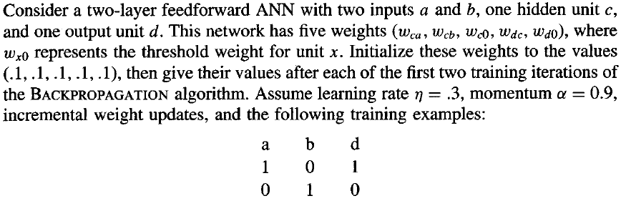

(Answer Below)

