Word Ladder Generation Tool

Authors
Ashman Malik (s5062234) -
Jake Jones (s2890487) – 2810ICT

Contents
1. Problem Statement 1
2. User Requirements 3
3. Software Requirements 3
4. Software Design 4
5. Unit Tests 9
6. Requirement Acceptance Testing 11
7. User Instructions 13

Problem Statement

The goal of this project was to repair an undocumented python program (word_ladder.py) that was used to generate a word ladder based on words in a provided dictionary file (such that each word produced differs from the previous one on the ladder by one letter, connecting a specified start word to a finish word. The identity of the original programmer of word_ladder.py is unknown.

The following functionality was also added to the program:
- Users can now add a second dictionary file to blacklist certain words from being included in paths.
- Users can now elect to find the OPTIMAL path, all possible UNIQUE paths or the single SHORTEST path.

NOTE: The ‘optimal path’ is the path that the program can find the fastest, ‘all possible unique paths’ is a single set of possible paths that do not share any common words and the ‘shortest path’ is the shortest path found between the two words (out of all possible unique paths).

NOTE: When finding the shortest path, this process can take much longer because all possibilities need to be explored – the duration of this delay is variable.

User Requirements
The following outlines the user requirements for the program:

- The user shall be able to specify a file name for a dictionary file (*.txt).
- If elected, the user may also specify a blacklist dictionary file (*.txt).
- All files provided must be in the .txt format and contain a single word per line (no spaces).
- The user shall be able to enter any word as the start word and the any as target word provided they are in the dictionary supplied and are of equal length (numbers and punctuation are not accepted).
- The user will have the option of producing the shortest generated path to the target word.
- The user will have the option to generate the optimal (fastest) path, all the unique paths or the shortest path from source to target word.

Software Requirements

The following outlines the software requirements for the program:

- The program will accept file names (and paths) as input for a dictionary file.
- The program will accept file names (and paths) as input for a blacklist dictionary file.
- The program will only accept files that are saved in the *.txt format.
- If files do not exist, the error will be handled appropriately and terminate the program.
- The program will accept input for the start and target words in the form as a series of alphabetical characters. Punctuation and numerical characters will not be accepted and will produce an error.
- The program will provide an option of asking for the shortest path from a start word to a target word.
- The program will perform as it originally when you when the user asks for the OPTIMAL path. In particular, ‘lead’ will become ‘gold’ in 3 steps (lead->load->goad->gold) and ‘hide’ will become ‘seek’ in 6 steps (hide->side->site->sies->sees->seek).
- The program will find ALL possible unique paths from the start word to the target and will display all the paths from source to target word (if specified).
- When finding the shortest path, the program will find the shortest path possible between the start word and the target word (that it can find). NOTE: This process may take some time.
- All possible user input errors will be handled appropriately.

Software Design

High Level Design – Logical Block Diagram

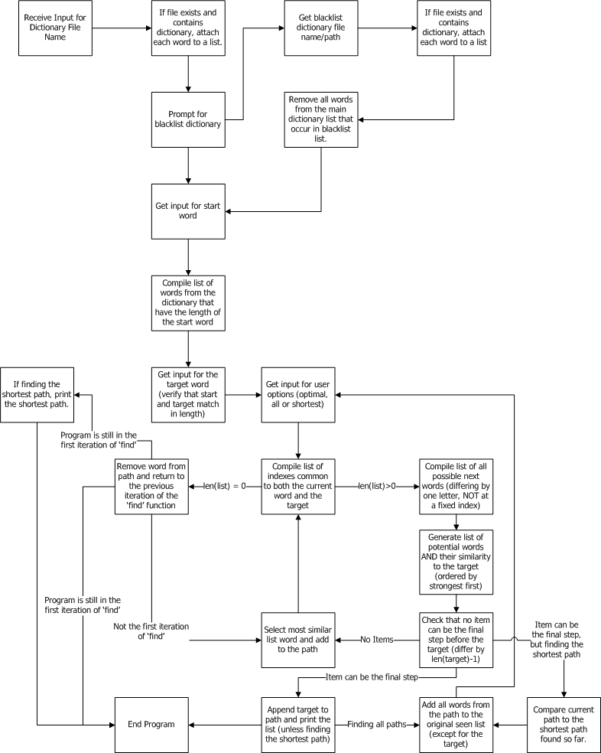

List of all functions in the software.
Input Function (inputCheck)
This function does the same job as the regular input() function, however it also checks for actual input length and for the presence of letters or numbers (if specified). If the input does not match the requirements, the prompt is looped until it does.
Input Parameters
- prompt (default = “”) – String. Provides a message to prompt the user when asking for input.
- Check (default = True) – Boolean. A switch for disabling (when False) the checking for punctuation and number characters in the input.
Side Effects
- None
Return Value
- text – String. The string of text given by the user.

Generate Dictionary List (getListFromFile)
This function gets input for a file name/path, iterates through all the lines in the file and appends them to a list. The list is then returned. All relevant error handling related to the files is done within this function.
Input Parameters
- None
Side Effects
- None
Return Value
- lines – List. A list of all words in the file specified.

String Comparator (same)
This function takes two strings. It generates a list of all the individual characters that occur in the same position in each string. It then returns the length of that list. Thus, it compares the similarity between the current step in the word ladder and the final target.
Input Parameters
- item – String. The word currently at the latest step on the ladder.
- target – String. The target word specified by the user
Side Effects
- None
Return Value
- Integer. The value equivalent to the number of characters that are common to both words given to the function (position-sensitive).

Matching Words List Builder (build)
This function generates a list of words from the dictionary matching a pattern given to it in the form of a string. A ‘.’ character is used to denote a wild card (meaning it can be any character).
Input Parameters
- pattern – String. A string to be matched by the function against the contents of ‘words’. A ‘.’ character denotes a wildcard.
- words – List. A list of words obtained from the dictionary file.
- seen – Dictionary. A dictionary of words whose values are Boolean. Each key is a word that has already been seen by the program and cannot be used again.
- list – List. The list of potential words for the next step in the word ladder that have already been identified.
Side Effects
- None
Return Value
- List. The list of all possible words in the provided dictionary that match the pattern specified.

List of all data structures in the software. (eg linked lists, trees, arrays etc)
path – Semi-Tree (List)
The current semi-tree of the word ladder. The final item is the one being used for the current recursion of the find function, and removed if no path can be found when using it. The semi-Tree consists of a list of strings.
Functions: find()

seen – Dictionary
The dictionary containing all the words of the working dictionary that the program has already encountered each time the find function (and its recursions) is called. Consists of strings as keys, and Boolean values.
Functions: find(), build()

originalSeen – Dictionary
The dictionary representing the original state of the ‘seen’ before the find function is called, the seen dictionary is copied from this variable. This is important when finding multiple paths, as seen needs to be reset before each path is found. This dictionary also contains blacklisted words and words that have already been seen in another path determined. Consists of strings as keys and Boolean values.
Functions: None (used only in the main code)

words – List
The list of words provided by the dictionary that has a length equal to the length of the start and/or target word. This is also the pool from which valid words are appended to potentialNextWords. Consists of a list of strings.
Functions: find(), build()

potentialNextWords – List
Initially a list of all possible words that can be next in the path (ie. differing to the final word in the path by one letter). Eventually it becomes a list of tuples with the first value being the similarity of the potential next word to the target word (integer) and the second being the potential next word (string). Has two states, a list of strings and a list of tuples (as described).
Functions: find(), build(), same()

fixedIndexes – List
A list of indexes at which there is a matching letter for both the current final word in the path and the target word. Consists of a list of integers.
Functions: find()

Detailed Design – Pseudocode for all non-standard and non-trivial algorithms that operate on datastructures

Generate Dictionary List (getListFromFile)
try:
open file name from input
except:
print “Error, dictionary file does not exist”
terminate the program
lines = generate a list of lines from the file (using readlines function)
for line in range(length of lines)
strip the line (remove newline character)
if the line has no content left (ie. is blank):
remove it from lines
if the length of the lines list is 0 (file is empty):
print “Error, file is empty.”
terminate the program
return lines

String Comparator (same)
Generate list of characters that are in the same position in both item and target
Return the length of the list (ie. how many characters are the same)

Matching Words List Builder (build)
Generate list of words for word in words if the word matches the pattern, is not in the seen dictionary and not in the list already.
Return the list.

Path Finder (find)
list = blank list
fixedIndexes = blank list

compile a list of indexes at which the final word in the path, and the target word have matching letters

for index in range (length of the word):
if the index is not in fixedIndexes:
build list of words from the dictionary based on the index being a wild card (ie. differing from the latest word only one letter)

if there are not potential next words in the list:
return False (and break the function)

list = Generate AND sort (REVERSE) new list of all words in the list and their similarity to the target as tuples.

for similarity, word in list:
if the similarity is greater than or equal to the length of target – 1:
if the similarity is the length of target – 1:
append the word to the path
return True (and break the function)
add item to seen dictionary with a value of True

for match, item in list:
append the item to the path
if running the function recursively yields True:
return True (and break the function)
remove the word from the path and move on to the next (if the recursive run yields false)

Configuration management and version control

Provide detailed description on how version control tools are used during the development process. In addition to your description, you could append a log or screenshot of your version control activities.

Unit Tests

No | Test Case | Expected Results | Actual Results
1.0 | Filename input and Handling Functions
1.1 | Test a filename that does not exist.* | FileNotFound and SystemExit exceptions are raised. | Both exceptions raised
1.2 | Test a file that does not contain any words.* | SystemExit exception is raised (exit code 0). | Exception raised
2.0 | Check Word Input
2.1 | Test string containing punctuation (need to slightly alter the function to return rather than print the message). | Display error message – “Error, cannot include numbers or punctuation.” | Error message returned correctly
2.2 | Test string containing numbers (need to slightly alter the function to return rather than print the message). | Display error message – “Error, cannot include numbers or punctuation.” | Error message returned correctly
2.3 | Test that the function will detect error when the input includes spaces. | Display error message – “Error, cannot include numbers or punctuation.” | Error message returned correctly
2.4 | Test string with valid input – ‘word’ | Output the word entered – ‘word’ | ‘word’
3.0 | Word Comparator Functionality
3.1 | Input two strings and verify that the function returns the number of letters common to each. | Input: ‘list’, ‘seek’ > Output: 0 | 0
3.2 |  | Input: ‘lead’,’gold’ > Output: 1 | 1
3.3 |  | Input: ‘letter’,’letter’ > Output: 6 | 6
4.0 | Matching Words List Builder Functionality
4.1 | Test that comparing words to a pattern works. | Input: ‘test’, [‘test’, ‘assert’, ‘best’], {}, [] > Output: [‘test’] | [‘test’]
4.2 | Test that having ‘.’ as a wildcard works correctly. | Input: ‘.est’, [‘test’, ‘assert’, ‘best’], {}, [] > Output: [‘test’, ‘best’] | [‘test’,’ best’]
4.3 | Test that including words in the seen dictionary stops them from appearing in the output. | Input: ‘.est’, [‘test’, ‘assert’,’ best’], {test: True}, [] > Output: [‘best’] | [‘best’]
4.4 | Test that including words in the list parameter stops them from appearing in the output. | Input: ‘.est’, [‘test’, ‘assert’, ‘best’], {}, [‘test’] > Output: [‘best’] | [‘best’]
5.0 | Finding Paths Functionality
5.1 | Test that function compiles the word ladder correctly in common cases. NOTE: Target word is not included in output as it is appended outside the function. | Input: ‘lead’, [all words in dictionary of length 4], {‘lead’: True}, ‘gold’, [‘lead’] > Output: ['lead', 'loads', 'goads'] | ['lead', 'loads', 'goads']
5.2 |  | Input: ‘hide’, [all words in dictionary of length 4], {‘hide’: True}, ‘seek’, [‘hide’] > Output: ['hide', 'side', 'site', 'sits', 'sies', 'sees'] | ['hide', 'side', 'site', 'sits', 'sies', 'sees']
5.3 | Test that the correct path is returned when it only involves one step (start > target) | Input: ‘hide’, [all words in dictionary of length 4], {lead: True}, ‘seek’, [‘lead’] > Output: ['lead'] | [‘lead’]
5.4 | Test that function returns false when there is no path found (error message is handled outside the function in the word_ladder.py code). | Input: find('asfd', [all words in dictionary of length 4], {'asfd':True},'xxxx', ['asfd'] > Output: False (path is not found) | False
5.5 | Test the event when the start word is the same as the target word** | Input: 'lead', [all words in dictionary of length 4], {'lead':True},'lead', ['lead'] > Output: False (fixed indexes contains all indexes, so potentialNextWords remains empty) | False
*Cannot test print output with unit test module, HOWEVER, test file outputs the appropriate messages successfully.
** This potential issue (mismatched length between the start and target words) has since been handled at the input stage of the program. Thus, this case will not actually occur when the program is run under normal conditions.
NOTE: Except for the conditions above, errors which the program cannot encounter (eg. having start and target words of different lengths etc.) were NOT included in the unit testing program.

Requirement Acceptance Testing

Software  Requirement No | Test | Implemented (Full /Partial/ None) | Test Results (Pass/ Fail) | Comments (for partial implementation or failed test results)
1 | The program will accept file names (and paths) as input for a dictionary file. | Full | Pass | Complete.
2 | The program will accept file names (and paths) as input for a blacklist dictionary file. | Full | Pass | Complete.
3 | The program will only accept files that are saved in the *.txt format. | Full | Pass | Complete.
4 | If files do not exist, the error will be handled appropriately and terminate the program. | Full | Pass | Complete.
5 | The program will accept input for the start and target words in the form as a series of alphabetical characters. Punctuation and numerical characters will not be accepted and will produce an error. | Full | Pass | Complete.
6 | The program will provide an option of asking for the shortest path from a start word to a target word. | Full | Pass | Complete.
7 | The program will perform as it originally when you when the user asks for the OPTIMAL path. In particular, ‘lead’ will become ‘gold’ in 3 steps (lead->load->goad->gold) and ‘hide’ will become ‘seek’ in 6 steps (hide->side->site->sies->sees->seek). | Full | Pass | Complete.
8 | The program will find ALL possible unique paths from the start word to the target and will display all the paths from source to target word (if specified). | Full | Pass | Complete.
9 | When finding the shortest path, the program will find the shortest path possible between the start word and the target word (that it can find). NOTE: This process may take some time. | Full | Pass | Complete.
10 | All possible user input errors will be handled appropriately. | Full | Pass | Complete.

User Instructions
Note: all input (except file-names) is case-insensitive.

- Open the file word_ladder.py.
- When prompted for a dictionary provide dictionary file name (or path) followed by the return key.
- When prompted for a blacklist dictionary, ‘Y’ or ‘N’ (‘yes’ or ‘no’ respectively) followed by the return key, as this step is optional. If the ‘Y’ is selected, enter the file path when prompted; otherwise continue to the next step.
- When prompted, enter a start word followed by the return key. A valid start word can be any word present in dictionary.
- When prompted, enter a target word followed by the return key. A valid target word can be any word present in dictionary.
- Select the path finding option desired by typing in ‘optimal’, ‘all’ or ‘shortest’ followed by the return key. The appropriate path(s) will be delivered as outlined below.
  - Optimal: Delivers the optimal path. The optimal path is the fastest path the program can find (this path is usually the shortest also, however not necessarily)
  - All: Delivers a list of all possible unique paths from the start word to the target word.
  - Shortest: Delivers the shortest path of all possible paths. Note that this option may take some time (up to approximately 120 seconds) because the program will determine all possibilities before selecting the shortest one. In many cases, however, this process is quick.

Additional Requirements
- Successful running of this program (and the test program) requires an installation of Python 3.5.2. Running under a python version below this may be unpredictable and cause the program to become unstable.
- Any dictionary file provided to the program must contain a list of words in which each word is on a single line (without spaces). Multiple words on a line separated by spaces will be merged together by the program (which should be avoided).

