# Data

* Team IDs
* Team Names
* Points

# UI

* Colour Design: Light text on dark background
* Font: [Hack](https://sourcefoundry.org/hack/) by Source Foundry, or similar

# UX

* Teams with a score of zero will not be shown on the leaderboard
* Teams will be ordered in descending order by points
* Teams with an equal score will share the same rank
* Teams with an equal score occupy the proceeding ranks
* Points will change in an animated fashion
* Responsive – fit all elements nicely
* Mobile friendly – mobile view

# Suggestions

* Pos #1 has a larger font size than pos #2, which has a larger font size than the rest
* Game orchestrator messages
* Integration with countdown / countup timer
* Animated background – perhaps the game page or invite page background animation

# Code

The site will use the CTF API endpoint POST: /api/ctf/leaderboard.json to retrieve a dictionary of teams and their current scores. This endpoint will be called every 10 seconds,  
and the team ordering will be rearranged upon completion of data parsing.

// Data Structure

data[<teamID>] = { /* integer */

name: <teamName>, /* string */

points: <teamPoints> /* integer */

}

# Mockup / Storyboard Ideas

???

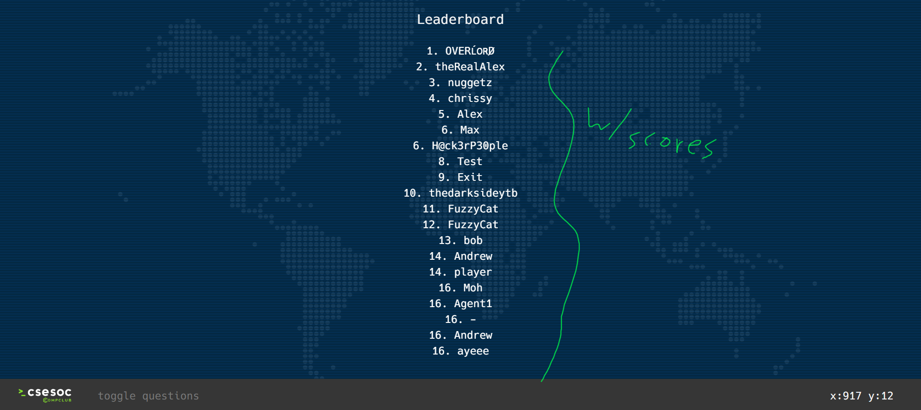

Console Text / Terminal

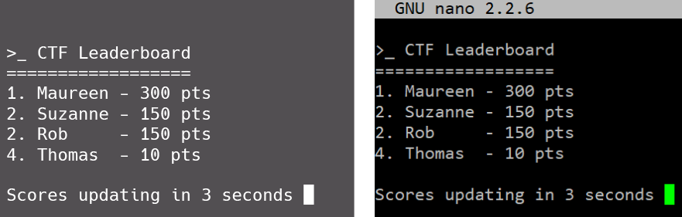

Race Style

