Project name: Mp3 player

Mp3 Player
Project Explanation
Edition：Ver1.0

Total pages | 7 | Text | 4 | Appendix | 0 | date | 2012-6-1
Maker： Jianguang Wu |  |  |  | Approver：

Version History

Index | Content Modified | Modifier | Modify date | Whether review | Review date
1 | Create | Jianguang Wu | 2012.5.14 | yes | 5-15

Content
1 Project Summary 4
1.1 Project Name 4
1.2 Project Background 4
1.3 Project Requirement 4
1.4 Function Description 4
1.5 Project Objectives 5
1.6 Development Environment 5
1.7 Key Technologies 5
1.8 Development System 5
2 System Structure 6
2.1 System Structure Diagram 6
2.2 Function Description of Modules 7
3 Design Demand 7

Project Summary

Project Name

Mp3 Player

Project Background

21 Century is an era of information technology. People will work in front of the computer more time because of the large amount information communication, thereby increasing the burden and pressure for people. Combined with rhythm of life, people will get physical and mental fatigue. In this physical condition on work, people can not work efficient, and also easy to make mistakes. With the destination—using music to make people relaxed and to work better, we design the software. The software is easy to use. The user interface is clear; people can use it quickly when first time. The software support MP3 format audio files.

Project Requirement

It is developed by C language and standard library functions in Windows platform, with the GUI interface for clients.
Complete the control operation about the MP3 player based on the MCI (Media Control Interface).

Function Description

- The software can handle the error message of the player correctly.
Open file error and media type error cannot happen when the player is running, and the software must handle these errors and show proper messages.

- Write the normal and error information to the logs. If mp3 file is played, the software should write the information of the song to the logs.

- Create play list by using XML. Store the media directories to the XML file by assigning the main directory and combine with the logs. When the player is re-running, it can continue play starting from last end point.

- Retrieve the audio information of the mp3 file. It should be able to load the information of the current playing mp3 file from the log and display it on the console with hotkey.

- Perform play, pause, stop, adjust volume, jump forward, jump backeard, display remaining time and change play mode when playing music,

- Inquiry mp3 files. It should be able to check whether the audio file exists or not in the playlist. It is better to support regular expression.

- Support directory management. The player can auto refresh the XML file when the media directory changes.

Project Objectives

① Improve programming skills in C
② Learn MCI interface development
③ Learn the process of development project
④ Learn basic audio knowledge.
⑤ Master the using of Win32 API

Development Environment

System Environment：Windows XP
Develop Environment：VC++6.0/Visual Studio 2008

Key Technology

Programming with C
MCI(Media Control Interface)
Multithreaded programming technology
Windows programming

Development System
Development system as below:

PM
TL
PRL
SCML
PE1
PE2
PE3
PEn

Responsibilities of project roles:

Index | Role | Responsibility | Remark
1 | PM | Trainer, the person should have experience of development and management. He should track the project process and check the progress and goal before each process of the project | Part-time
2 | TL | Team leader, the person should be skillful at management. The main responsibility is to lead the team to accomplish the train program and report the progress of the project to PM.  Should also take charge of the project module. | Full-time
3 | PRL | Reviewer, the person should have strong technical skill. The main responsibility is to organize the review and check the review result.  Should also take charge of the project module. | Full-time
4 | SCML | Administrator, the person should be dedicated and good at handle details. The main responsibility is to track the development process and result based on the rules, and manages the process result. Learn how to use the template of next process before the process start, and explain to the other leaders. | Full-time
5 | PE1 | Project Engineer of module 1 | Full-time
6 | PE2 | Project Engineer of module 2 | Full-time
7 | PE3 | Project Engineer of module 3 | Full-time

System Structure

System Structure Diagram

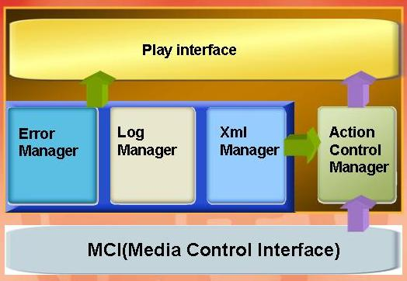

Module Function Description

Module Name | Function Requirement | Function Description
Play Interface | The user interacts with the mp3 player. | The user operates the mp3 player through the GUI interface.  This module should communicate with action module.
Action Control Manager | Perform actions after receive user request. | Provide initialization function of the player and create play list.  Send the command to MCI interface after receive the call from interface.  Handle the MCI return value.
Error Manager | Error handler module | Hide software error and show the proper error message to the user.
Log Manager | Write to logs | Output the playing information of the user.
XML Manager | Store media data | Store the media data of the directory with XML file.

Design Demand

- The interface functions should be clearly defined. And the design should be high cohesion, low coupling. Your codes should be accordance with the coding specification.
- Follow the coding specification of C.
- No specific requirement of the GUI user interface, you can design the unique interface of your team.

