PHINMA- Cagayan de Oro College  College of Information Technology Education | 


Project Title: “The Development of a Web-Based Smart Waste Collection Monitoring System with GPS Tracking and SMS Notification for the City Environment and Natural Resources Office (CLENRO), Cagayan de Oro City”
RESEARCHERS
Castillo, Robert D.
Madlos, John Mark O.
Esdicul, Kristine Say N.
Yee, Kurt Andrey A.
Balaba, Niño Christian P.
OCTOBER 2026

I. Title of the Study
The Development of a Web-Based Smart Waste Collection Monitoring System with GPS Tracking and SMS Notification for the City Environment and Natural Resources Office (CLENRO), Cagayan de Oro City
II. Introduction
Collecting solid waste is one of the basic services of a local government, and it depends on schedules, routes, vehicles, and people working together every day. Republic Act No. 9003, the Ecological Solid Waste Management Act of 2000, places solid waste management duties on local government units, so a dependable way to monitor collection work matters. In Cagayan de Oro City, CLENRO oversees waste collection and works with barangay officials, collection supervisors, truck drivers, and collectors on the ground.
Where monitoring is done manually, it is hard to tell where a collection truck is, whether it is following its assigned route, and whether a scheduled collection was finished. Changes in schedule or delays may reach barangay officials and residents late. Paper or scattered records are also slow to search, which makes it harder to prepare reports for review.
A web-based system can keep this information in one place that authorized users open through a browser. The Global Positioning System (GPS) can report a vehicle’s location so it can be shown on a digital map. Short Message Service (SMS) can send schedule changes and delay notices to people’s mobile phones without requiring them to log in anywhere.
This study proposes a Web-Based Smart Waste Collection Monitoring System with GPS Tracking and SMS Notification for CLENRO. Authorized users will manage collection schedules, routes, vehicles, drivers, and collection areas, and will record the status of each collection. GPS tracking will show the position of collection vehicles on a map. The system will send SMS notifications about schedules, schedule changes, and delays, and it will store all collection data in one database for record keeping and report generation.
III. Statement of the Problem
The general problem of this study is how a web-based system with GPS tracking and SMS notification can support the monitoring and coordination of waste collection operations of CLENRO in Cagayan de Oro City.
Specifically, the study looks at these limitations in current monitoring practices:
- Limited vehicle monitoring. Manual monitoring makes it hard to know the current location of collection vehicles and to check whether they are following their assigned routes.
- Scheduling and coordination difficulties. Managing schedules, routes, and collection activities by hand makes coordination harder and makes it difficult to confirm whether scheduled collections were completed.
- Delayed communication. Schedule changes, delays, and other updates may not reach barangay officials, collection teams, and residents on time.
- Manual record keeping. Collection records kept on paper or in separate files are difficult to organize, retrieve, and review later.
- Slow report preparation. Putting together reports on completed and missed collections from manual records takes time and delays review by CLENRO officers.
These problems point to the need for a web-based system that combines GPS tracking and SMS notification to support vehicle monitoring, scheduling, communication, and record management.
IV. Objectives of the Study
General Objective
To develop and implement a web-based Smart Waste Collection Monitoring System with GPS Tracking and SMS Notification that addresses the problems in waste collection monitoring and gives CLENRO and other authorized users timely information about collection operations in Cagayan de Oro City.
Specific Objectives
- To gather information, through survey questionnaires and interviews, about the existing collection schedules, routes, monitoring procedures, record keeping, and communication practices of CLENRO and the barangays it serves.
- To design the system, including its user roles, use cases, database, architecture, and interfaces, based on the requirements gathered.
- To develop a web-based platform where authorized users can manage and monitor collection schedules, routes, vehicles, drivers, collection areas, and collection records.
- To implement GPS tracking that displays the location and movement of collection vehicles on a digital map.
- To develop an SMS notification feature that sends updates on collection schedules, schedule changes, and delays.
- To evaluate the system’s functionality, usability, reliability, performance efficiency, and security through testing with authorized users and selected respondents.
V. Significance of the Study
The study will benefit the following:
- CLENRO Head and Authorized Officers. They will be able to oversee collection operations from one platform and review collection reports without compiling them by hand.
- CLENRO Personnel. They will manage schedules, routes, vehicles, and monitoring records in one system instead of separate files.
- Barangay Officials and Staff. They will be able to follow collection schedules and activities in their barangays and learn about delays sooner.
- Waste Collection Supervisors, Truck Drivers, and Collectors. They will have clear access to assigned routes and schedules, and a simple way to update and report the status of each collection.
- Residents. They will receive SMS notices about collection schedules, changes, and delays.
- Future Researchers. They may use the study as a reference for later work on web-based waste management, GPS tracking, and and notification systems.
VI. Scope and Delimitation
Scope
- Development of a web-based smart waste collection monitoring system for CLENRO, Cagayan de Oro City.
- Core features: collection scheduling, route management, vehicle and driver management, GPS tracking, collection status monitoring, SMS notification, collection record management, and reports.
- Type of study: Development, web-based.
- Type of system: Management and information system.
- Client: City Environment and Natural Resources Office (CLENRO), Cagayan de Oro City.
- Users: eight user types, listed in Table 1. Residents do not log in to the system. They only receive SMS notifications.
Table 1. System Users and Their Main Responsibilities
No. | User | Main Responsibility
1 | System Administrator | Manages user accounts, permissions, and system settings.
2 | CLENRO Head / Authorized Officer | Oversees waste collection operations and reviews reports.
3 | CLENRO Personnel | Manages collection schedules, routes, vehicles, and monitoring records.
4 | Barangay Officials / Staff | Monitor waste collection activities and schedules in their respective barangays.
5 | Waste Collection Supervisors | Supervise collection teams and verify collection progress.
6 | Garbage Truck Drivers | Follow assigned routes and update collection statuses.
7 | Waste Collectors | Assist in collection operations and report completed or missed collections.
8 | Residents | Receive SMS notifications about waste collection schedules and updates.
Delimitation
- The system covers the collection routes and areas identified by CLENRO during the development and testing phase.
- GPS tracking depends on the availability, accuracy, and connectivity of the GPS-enabled device used in each collection vehicle.
- SMS notification depends on the availability and reliability of the chosen SMS gateway or service provider. Messages are one-way, from the system to the recipient.
- The system does not include waste bin sensors, automatic route optimization, or a mobile application. It is accessed through a web browser.
- Resident contact numbers are limited to those encoded in the system by authorized personnel.
VII. Methodology
Research Design
The study follows a developmental research approach and uses the Agile methodology for repeated cycles of design, development, testing, and improvement of the system.
Conceptual Framework
Input | Process | Output
Survey and interview results on current collection practices; user roles and requirements; hardware and software requirements | Requirements gathering, system design, Agile development, testing, and evaluation | Web-based smart waste collection monitoring system with GPS tracking and SMS notification
Respondents
The respondents will be CLENRO officials and personnel, barangay officials and staff, waste collection supervisors, truck drivers, and collectors. Residents may be included in the evaluation to assess the SMS notifications. The final number of respondents will be set with the research adviser and CLENRO, based on the people available during data gathering.
Development Tools
Component | Tool
Frontend | HTML, CSS, JavaScript, Bootstrap
Backend | PHP and Node.js
Database | MySQL
GPS tracking | GPS-enabled device in each collection vehicle
Mapping | Leaflet with OpenStreetMap
SMS notification | SMS gateway/API
UI/UX design | Figma
Research Process
- Requirements Gathering. After the request to the City Mayor is approved, the researchers will conduct interviews and distribute the survey questionnaire (Appendix A) to CLENRO officials and personnel, barangay officials, supervisors, drivers, and collectors to learn how schedules, routes, monitoring, records, and communication are currently handled.
- System Design. The researchers will prepare the use case diagram, entity-relationship diagram, system architecture, and interface prototypes (Appendices B to E).
- Development. Features will be built in Agile sprints: user and access management, scheduling and routes, GPS tracking, collection status and records, SMS notification, and reports.
- Testing. The system will go through unit, integration, security, and user acceptance testing using the functional test cases in Appendix F.
- Evaluation. Selected users will answer the System Usability Scale (SUS) questionnaire and give feedback on functionality, reliability, and usefulness.
Data Analysis
Survey responses will be scored with the weighted mean using the scale below. SUS responses will be scored in the standard way: for odd-numbered items, subtract 1 from the rating; for even-numbered items, subtract the rating from 5; add the results and multiply by 2.5. A score above 68 is considered above average usability.
Mean Range | Interpretation
4.21 to 5.00 | Strongly Agree
3.41 to 4.20 | Agree
2.61 to 3.40 | Neutral
1.81 to 2.60 | Disagree
1.00 to 1.80 | Strongly Disagree
Ethical Considerations
Participation is voluntary, and respondents will be informed of the purpose of the study before they answer. Personal information, including mobile numbers, will be handled according to the Data Privacy Act of 2012 (Republic Act No. 10173), used only for the purposes of the system, and protected through user accounts, role-based access, and encrypted passwords.
VIII. Review of Related Literature
Several studies show how web-based monitoring, GPS tracking, and SMS alerts have been used in waste collection. Singo, Katili, and Suhada (2021) developed a web-based information system for monitoring waste transport vehicles in Gorontalo Regency. Pujari and Aluri (2021) built a garbage bin management system that uses GPS and GSM to report bin location and send SMS alerts. Each of these systems focuses on one part of the problem, either vehicle monitoring or bin alerts.
Other studies looked at the operational side of collection. Morais et al. (2023) proposed a smart waste collection routing method that takes workload into account, and tested it on a real case. Brouwer et al. (2023) compared different approaches to monitoring waste bins and examined how they could make collection more efficient. Henaien, Ben Elhadj, and Chaari Fourati (2024) presented a smart solid waste management system that combines IoT, GPS, and real-time monitoring.
Taken together, these studies show that the technologies are workable and useful for waste collection. What they do not offer is one system that brings scheduling, vehicle tracking, SMS notification, and record management together for a city waste office and the barangays it works with. This study aims to fill that gap for CLENRO.
IX. Expected Output
The final output is a working web-based smart waste collection monitoring system with the following:
- Web dashboard for waste collection management
- Collection scheduling and route management
- Vehicle and driver management
- GPS tracking of collection vehicles on a map
- Collection status updates and collection records
- SMS notifications for schedules, schedule changes, and delays
- Monitoring reports for CLENRO officers
- User accounts with role-based access for the user types in Table 1
The system is expected to improve monitoring and coordination of collection work and to give authorized users and residents timely information.
X. References
Brouwer, Y., Barbosa-Póvoa, A. P., Antunes, A. P., & Ramos, T. R. P. (2023). Comparison of different waste bin monitoring approaches: An exploratory study. Waste Management & Research, 41(10), 1570–1583. https://doi.org/10.1177/0734242X231160691
Henaien, A., Ben Elhadj, H., & Chaari Fourati, L. (2024). A sustainable smart IoT-based solid waste management system. Future Generation Computer Systems, 157, 587–602. https://doi.org/10.1016/j.future.2024.03.056
Morais, C. S. de, Ramos Jorge, D. R., Aguiar, A. R., Barbosa-Póvoa, A. P., Antunes, A. P., & Ramos, T. R. P. (2023). A solution methodology for a smart waste collection routing problem with workload concerns: Computational and managerial insights from a real case study. International Journal of Systems Science: Operations & Logistics, 10(1), Article 2086717. https://doi.org/10.1080/23302674.2022.2086717
Pujari, U., & Aluri, M. (2021). Design and implementation of garbage bin management with location and SMS alerts using GSM and GPS. Turkish Journal of Computer and Mathematics Education, 12(4), 1839–1845. https://doi.org/10.17762/turcomat.v12i4.13426
Singo, T. S., Katili, M. R., & Suhada, S. (2021). Sistem informasi monitoring kenderaan pengangkut sampah di Kabupaten Gorontalo. Diffusion: Journal of Systems and Information Technology, 1(1).
XI. Appendices
Appendix A. Survey Questionnaire
Survey Questionnaire for CLENRO Officials and Personnel, Barangay Officials, and Waste Collection Personnel
This questionnaire gathers information about current waste collection operations, the problems encountered, and the features needed in the proposed system. Your answers will be used only for this study. Please rate each statement using the scale below.
1 = Strongly Disagree, 2 = Disagree, 3 = Neutral, 4 = Agree, 5 = Strongly Agree
Respondent Information
Name (optional): ______________________________
Position/Role: ______________________________
Office/Barangay: ______________________________
Years of service: ________
Part I. Waste Collection Operations
A. Efficiency and Workflow
- Our current waste collection processes are efficient.
- Waste collection activities are completed according to the scheduled time.
- We often rely on manual processes to record and monitor waste collection activities.
- Waste collection information is easy to access when needed.
- We have clear and standard procedures for waste collection operations.
B. Data Management
- Our current way of storing and managing waste collection records is organized.
- It is easy to retrieve specific waste collection records when required.
- We have problems with incomplete, duplicated, or inconsistent collection records.
- It is easy to prepare waste collection reports from our current records.
C. Communication
- Communication among CLENRO, barangay officials, and waste collection personnel is effective.
- Collection schedules and schedule changes are communicated promptly.
- Delays in waste collection are communicated properly to the people concerned.
D. Vehicle and Route Monitoring
- Waste collection vehicles are monitored effectively during collection.
- Assigned collection routes are monitored properly.
Part II. Challenges and Needs
- We often encounter delays during waste collection operations.
- Errors or mistakes often occur in the current monitoring process.
- A large amount of time is spent on repetitive manual recording.
- We have difficulty tracking the location of collection vehicles.
- We have difficulty checking whether scheduled collections have been completed.
- We have difficulty retrieving previous collection records.
- Delays or changes in collection schedules are sometimes communicated late.
- We need a more organized system for managing collection schedules and routes.
- We are interested in using technology to improve waste collection monitoring.
Part III. Open-Ended Questions
- What are the main waste collection activities currently done in your area of responsibility?
- What are the biggest challenges you encounter during waste collection?
- What problems do you experience with the current scheduling and routing of collection?
- How are collection vehicles currently monitored?
- How are collection records currently made, stored, and retrieved?
- How are schedule changes and delays currently communicated?
- What features would you like to see in the proposed system?
- How do you think GPS tracking could help collection operations?
- How could SMS notifications help communication about waste collection?
- What other suggestions do you have for the proposed system?

Appendix B. Use Case Diagram
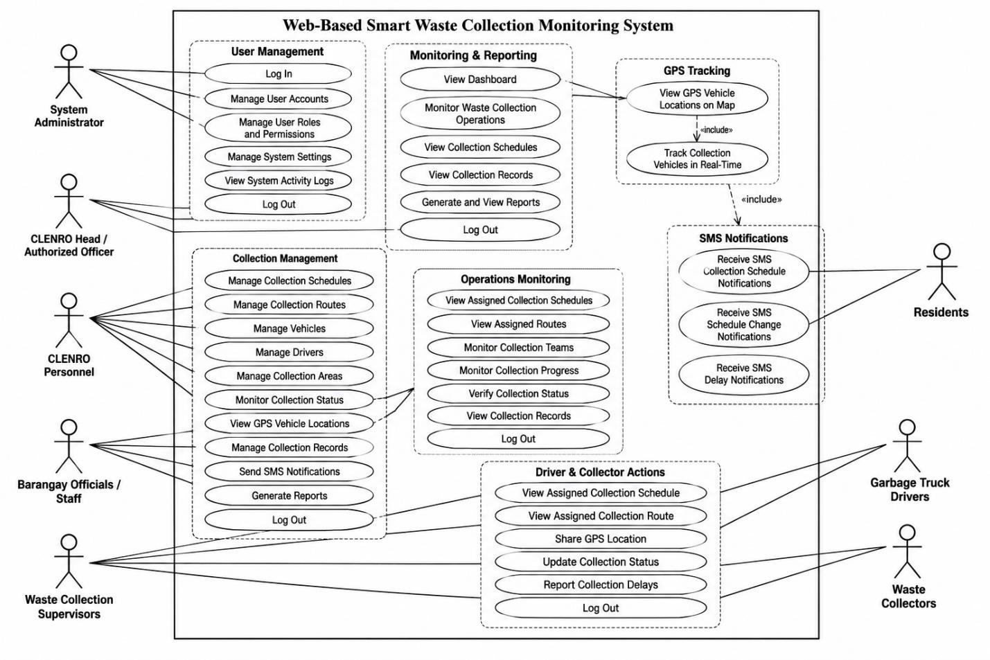
Figure B.1. Use case diagram of the Web-Based Smart Waste Collection Monitoring System.

Appendix C. Entity-Relationship Diagram (ERD)
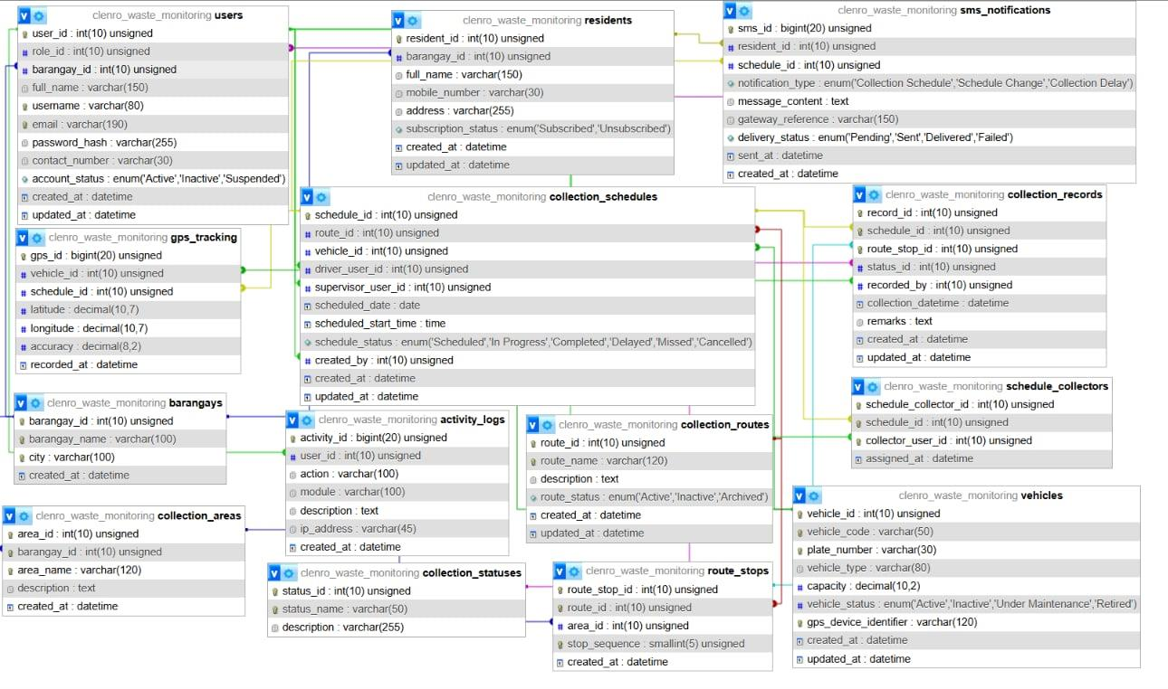
Figure C.1. Entity-relationship diagram of the proposed system.
Appendix D. System Architecture
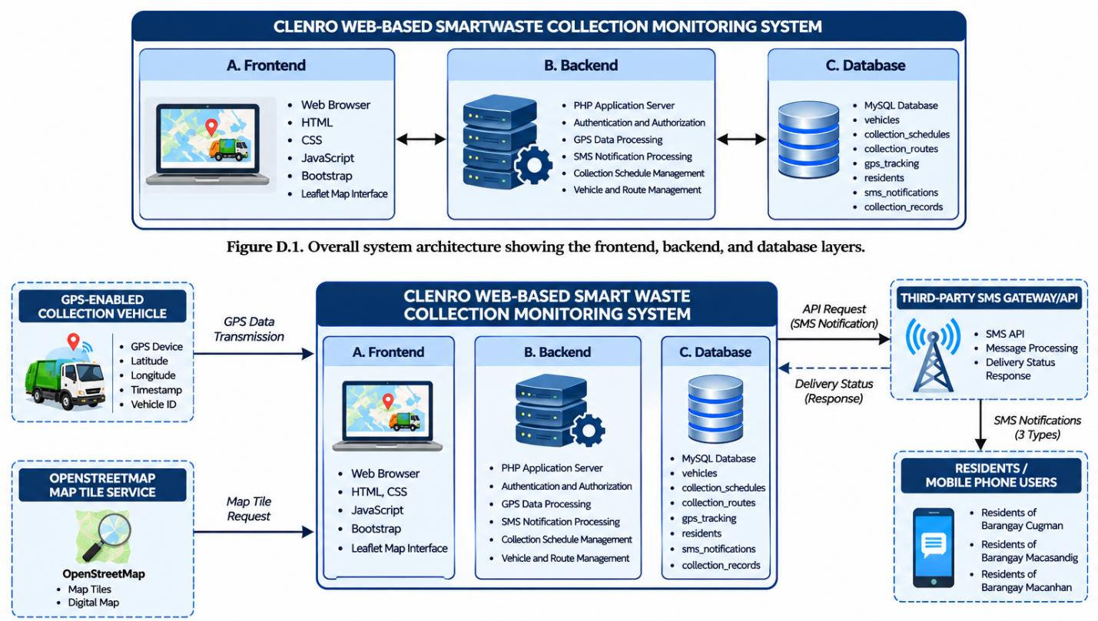
Figure D.1. Overall system architecture showing the frontend, backend, and database layers.
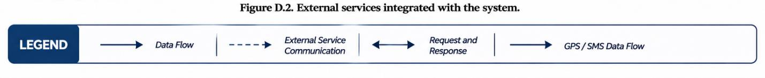
Figure D.2. External services integrated with the system.
Appendix E. Figma UI/UX Prototypes
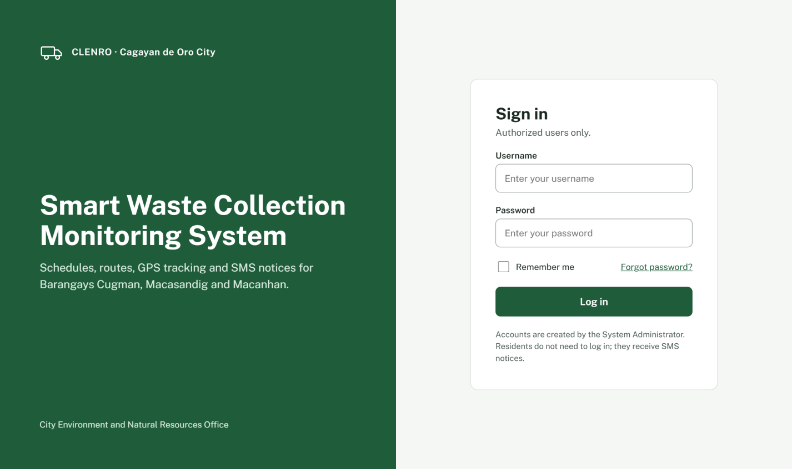
Figure E.1. Login page prototype.
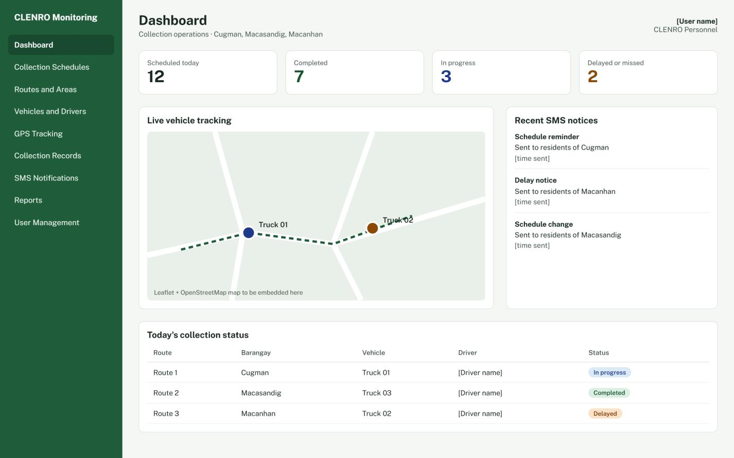
Figure E.2. System dashboard prototype.
Appendix F. Testing Instruments
System Usability Scale (SUS) Questionnaire
Scale: 1 = Strongly Disagree, 2 = Disagree, 3 = Neutral, 4 = Agree, 5 = Strongly Agree
No. | Statement | 1 | 2 | 3 | 4 | 5
1 | I would like to use this system frequently.
2 | I found the system unnecessarily complicated.
3 | I found the system easy to use.
4 | I think I would need technical support to use this system.
5 | I found the system features well integrated.
6 | I found there was too much inconsistency in the system.
7 | I believe most users can learn to use this system quickly.
8 | I found the system very difficult to use.
9 | I felt confident using the system.
10 | I needed to learn many things before I could use the system.

Functional Testing Instrument: Sample Test Cases
Feature | Test | Expected Result | Actual Result | Pass/Fail
Login | Log in with valid credentials | User logs in and the dashboard for their role is displayed.
Login | Log in with invalid credentials | Access is denied and an error message is shown.
Access Control | Open a module not allowed for the user’s role | Access is denied.
Collection Schedule | Create a collection schedule | Schedule is saved and displayed.
Route Management | Add and assign a collection route | Route is saved and shown to the assigned driver.
Vehicle and Driver Management | Add a vehicle and assign a driver | Vehicle and driver details are saved and displayed.
GPS Tracking | View truck location | Correct truck location is displayed on the map.
Collection Status | Driver updates the collection status | New status is saved and visible to CLENRO and barangay users.
SMS Notification | Send a schedule change notice | Intended recipient receives the SMS and the log records it.
SMS Notification | Send a delay notice | Intended recipient receives the SMS and the log records it.
Collection Records | Record a completed collection | Record is saved and displayed.
Reports and Analytics | View collection reports | Correct collection data is displayed.
Logout | Log out of the system | User is logged out securely.

