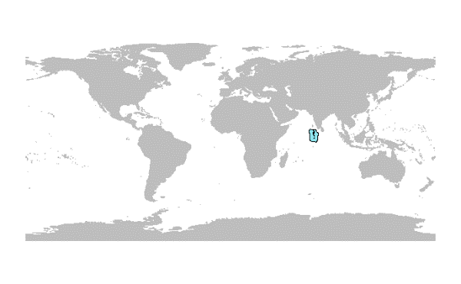**NAME OF THE COUNTRY**

**INTRODUCTION – General context**

Short introduction relative to each country

Associated bibliography.

(bleaching events, hurricanes, COTs outbreaks?)

**ID CARD**

Coral reef area (km²)

Proportion of the world’s coral reefs

Number of regions where they are represented?

1. **Description of the state of the data available**

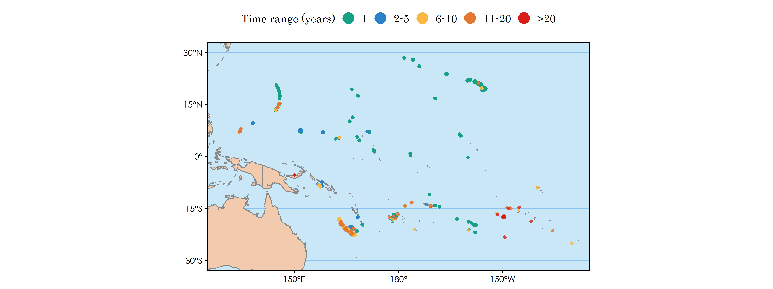

**Figure 1.** Sites location and duration of the associated monitoringprograms.

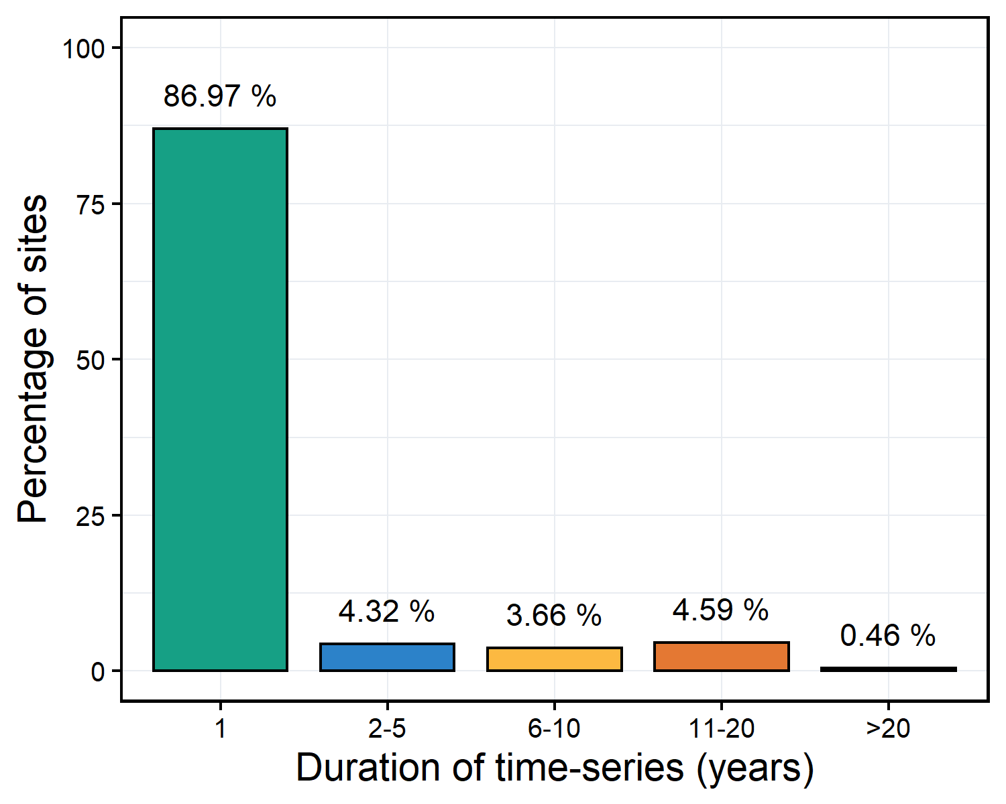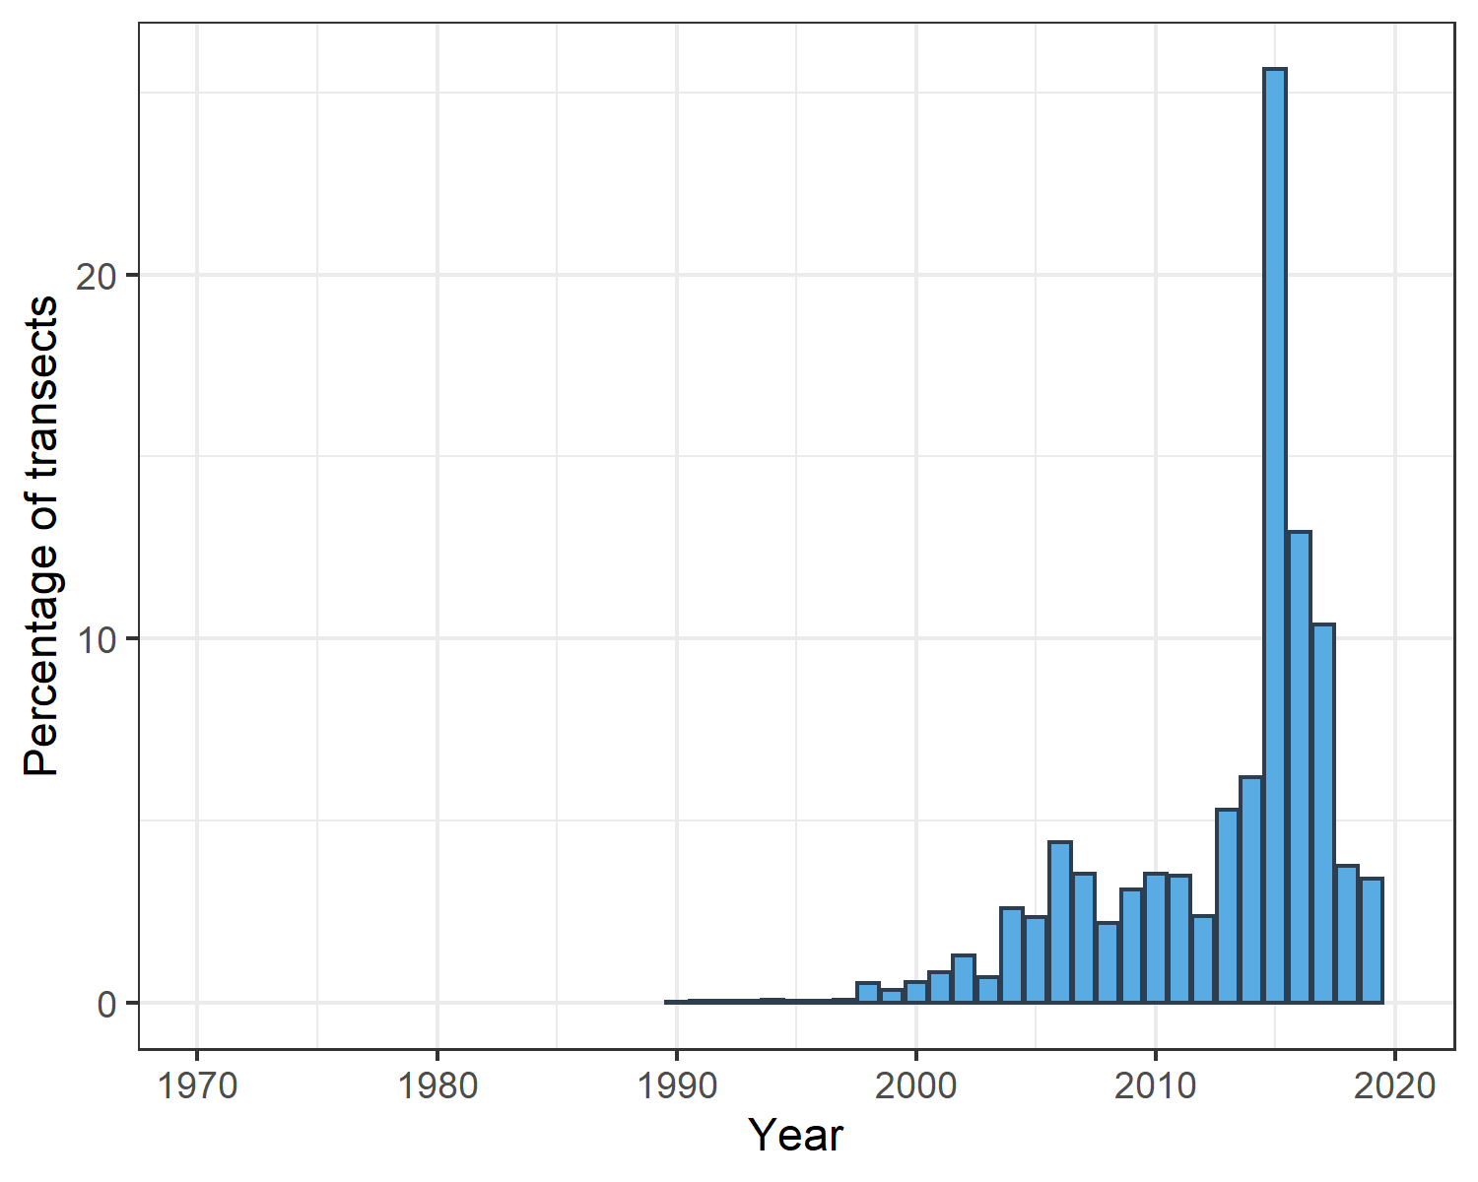

**Figure 2.** The proportion of sites within each category describing the duration for which data were collected (A), and the proportion of the total number of transects monitored each year (B).

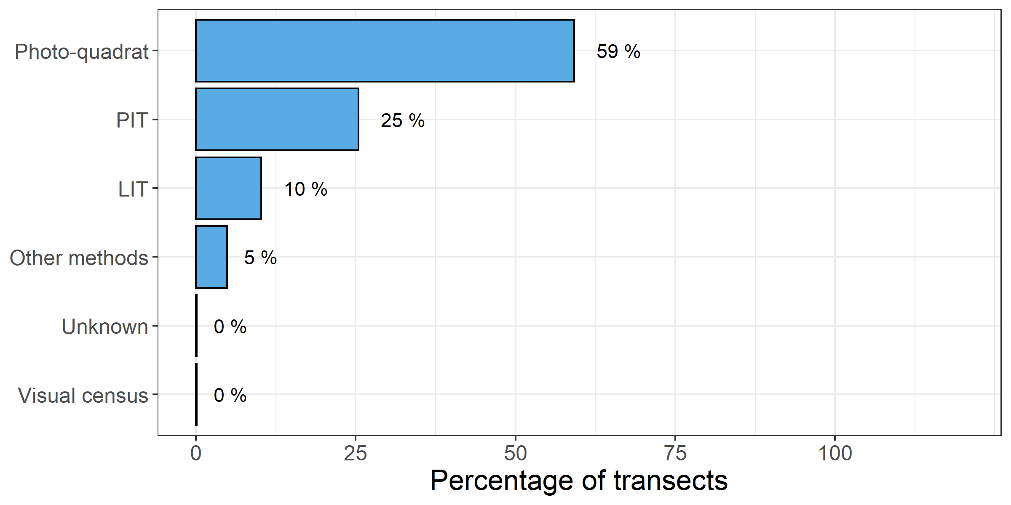

**Figure 3.** The proportion of the total number of transects monitored in the GCRMN Pacific region using each method. PIT: Point Intercept Transect; LIT: Line Intercept Transect. Other methods include chain intercept transect, cross intercept transect and video-transect.

1. **Evolution of the health status of coral reefs**

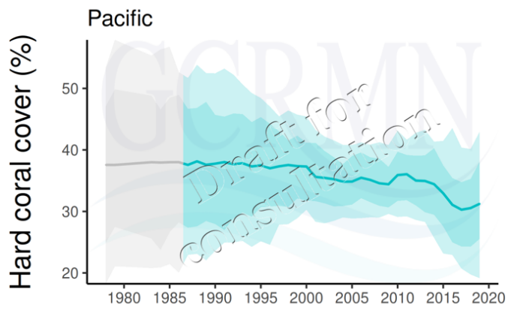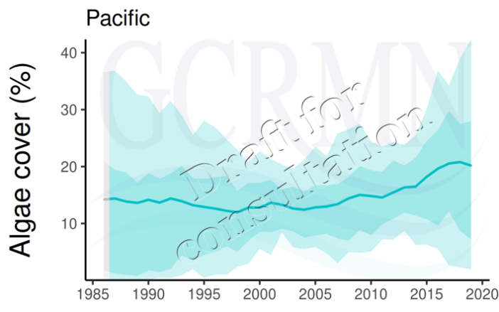



Ratio

**Figure 5.** Modelled cover of live hard coral (A), algae (B) and the ratio between both “communities”/groups ( in the studied area). The solid line represents the predicted marginal mean and ribbons represent 80% (lighter shade) and 95% (darker shade) credible intervals. Grey areas of the temporal series represent times for which no observed data were available.

Short paragraph describing the tendencies, the level of confidence of the results, depending on the amount of data available in the database.

(5 to 10 lines?)

.

.

.

.

1. **Analysis of the data coverage through the CBD indicators and recommendations**

|  |  |  |  |
| --- | --- | --- | --- |
| **Indicator** | **Currently included in the monitoring framework**  **(?)** | **Calculable/computable using the data available in the GCRMN database** | **Major limitations/**  **Potential issues**  (short list, more detailed in the associate paragraph?) |
| **Live Coral Cover** | YES/NO/% ? | YES/NO/%  When possible give values |  |
| **Coral Reef Extent** |  |  |  |
| **Fleshy algae cover and cover for key benthic groups** |  |  |  |
| **Fish abundance and biomass** |  |  |  |
| **[Percentage/Area] of coral reefs included in [effectively managed] MPAs and OECMs** |  |  |  |
| Index of coastal eutrophication? |  |  |  |

Does the data coverage effectively represent the state of the coral reefs? What are the potentially missing data and why? (included in the table?), further developed in this paragraph?

Positive recommendations (for future guidelines)

.

.

.

.

Bibliography? Or rather at the end