MIDUS Stress Pilot

Contents

Aim 1 Analysis Plan 2

Summary of Findings 2

Examine Stress Domains 3

Step 1 – Check Distributions 4

Step 2 – Examine Correlations Between Items 5

Step 3 – Examine Internal Consistency Reliability (α) 8

Step 3 – Conduct Factor Analyses 9

Step 4 – Other Exploratory Cluster Analysis 14

# Aim 1 Analysis Plan

## Summary of Findings

*Examining Stress Domains*.

After Winsorizing to remove outliers, stress measures at both waves of MIDUS had long right tails (few people with high levels of stress). Despite the non-normal distributions, the differences between correlations based on raw values (Pearson) or on the ranks which are robust to non-normality (Spearman) were comparable (± .05). Based on the conceptual grouping of stress measures (inequality/discrimination and perceived), Cronbach’s alpha was low for across domains and waves (.61 to .69), but high enough to suggest overlap among the measures. Using confirmatory factor analysis, items loaded significantly onto their conceptual factors, but fit indices indicated low to adequate fit. Comparing a slightly altered grouping: inequality, discrimination, and perceived, yielded good to excellent fit to the data. Sensitivity analyses based on taking the (skewed) stress measures and converting into categorical variables based on quintiles yielded nearly identical fit and factor loadings, again suggesting minimal impact of the skewed distributions on the overall models. Preliminary exploratory work to identify distinct patterns or classes of people with unique stress profiles yielded little useful insight and seemed instead to show a more or less even gradient.

In summary, current results suggest reasonable fit to the data of the stress measures forming 2-3 correlated factors. The reliability of scales based on these factors is on the low end, representing the fact that the stress measures are only modestly inter-correlated. Thus conceptually grouping these measures seems empirically sound. More questionable is whether it is appropriate to use scale scores from these domains or leave each stress measure separate.

## Examine Stress Domains

In MIDUS, the following stress measures are available

|  |  |
| --- | --- |
| Inequality | Work Inequality |
| Family Inequality |
| Home Inequality |
| Lifetime Discrimination |
| Daily Discrimination |
| Chronic Job Discrimination2 |
| Objective | Stressful Life Events2 |
| ~~SLE Impact Short~~ |
| ~~SLE Impact Long~~ |
| Perceived | Family Strain |
| Friend Strain |
| Partner Strain |
| Perceived Stress2 |
| Context | Parental Abuse1 |
| Sibling Abuse1 |
| CTQ Total2 |
| Neighborhood Quality |
| SES |
| Resources |

*Note. Superscripts indicate variables that are only available at wave 1 or 2, respectively.*

### Step 1 – Check Distributions

This was done after winsorizing each variable to pull in outliers based on visual inspection.

Substantial skew is evident for many distributions.

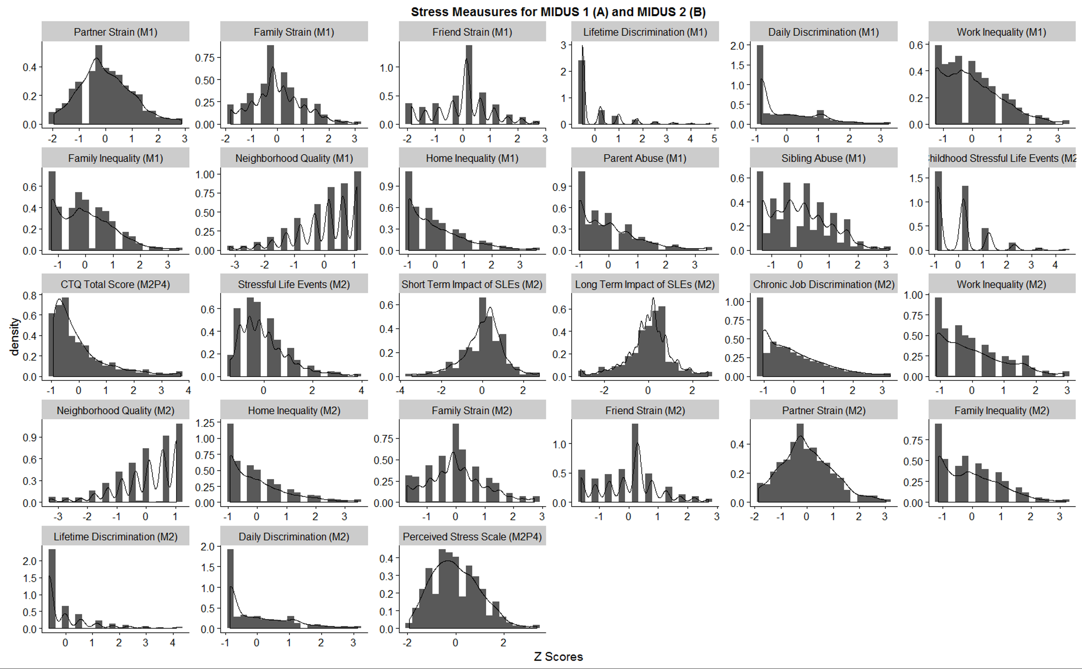

### Step 2 – Examine Correlations Between Items

Given the skew in the data, I examined both Pearson correlations and Spearman (based on ranks, so less sensitive to skew / outliers). The histogram below shows that the differences in magnitude between the Pearson and Spearman correlations (across stress measures from MIDUS 1/2) were negligible (± .05 typically). Therefore, I only present the familiar Pearson correlations.

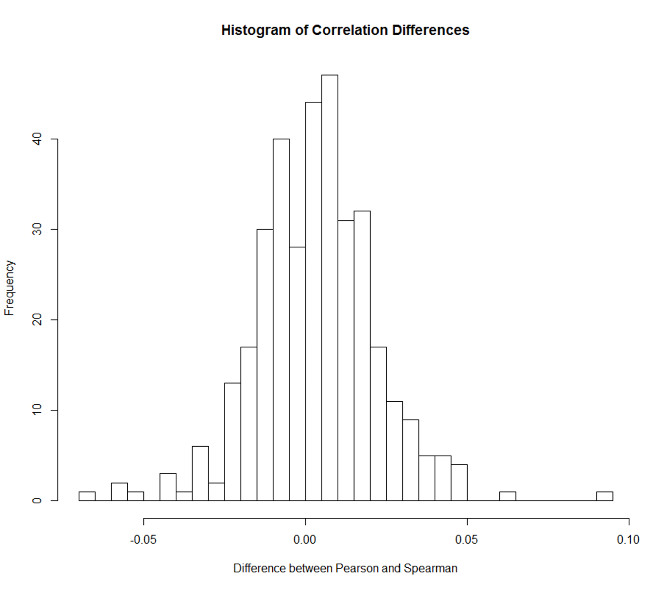

The heatmap correlation matrix has been clustered to group more similar variables empirically. There does seem to be some support for Elissa’s conceptual grouping of the variables, with discrimination tending to be together, inequality being together, and perceived strain together.

MIDUS 1 (~ year 1995)

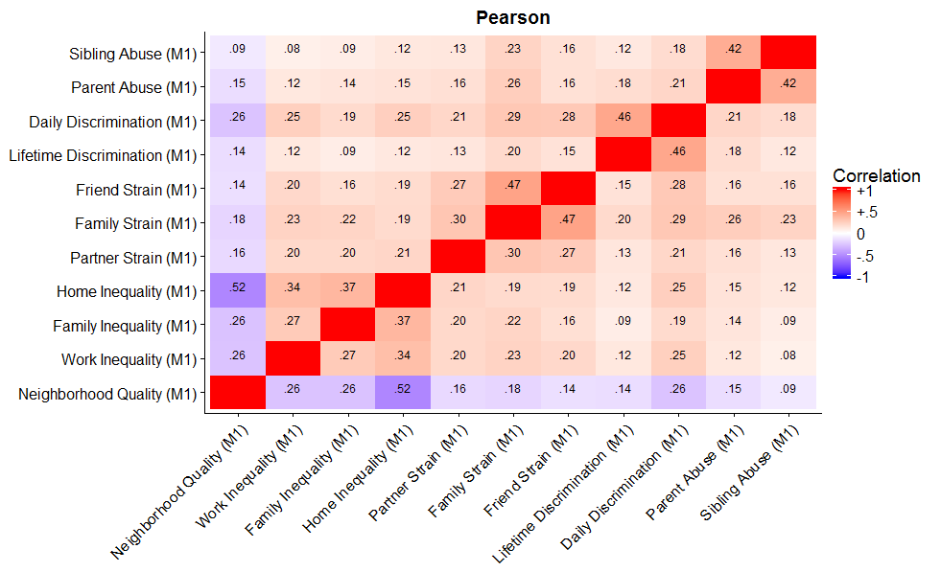

MIDUS 2 (~ year 2005)

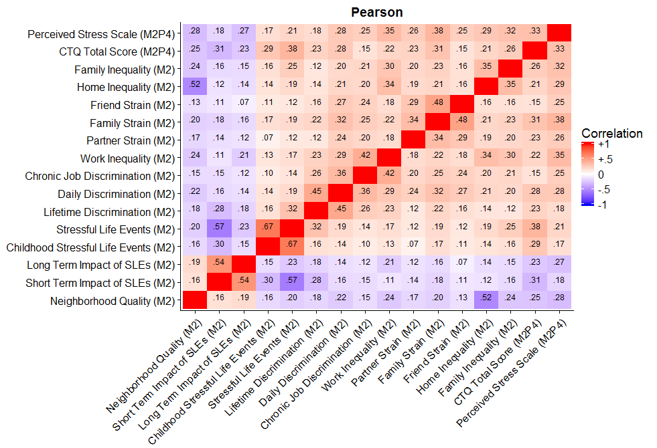

### Step 3 – Examine Internal Consistency Reliability (α)

Reliability is fairly low. It is somewhat higher in MIDUS 2 due to one additional item available for inequality (job discrimination) and one additional item for perceive stress (the PSS). It would be difficult to justify these from this perspective as scales, although it certainly indicates that the items do hang together, or the reliabilities would be much lower.

|  |  |  |
| --- | --- | --- |
|  | MIDUS 1 | MIDUS 2 |
| Inequality | 0.62 | 0.69 |
| Objective | Stressful Life Events2, alpha not possible | |
| Perceived | 0.61 | 0.66 |

### Step 3 – Conduct Factor Analyses

I first ran confirmatory factor analyses, based on the conceptual groupings. Based on the fit, I also tried one alternate model separating discrimination from more general inequality.

There is some concern with the factor analyses regarding the skewed distributions. To examine how big an effect this might be, I tried a few models. First I ran the model treating the data as continuous and using a robust maximum likelihood estimator. Second, I cut all the stress measures into categorical variables. I did this by binning them into quintiles (5 levels). Due to the skew on some variables, fewer than five levels occurred (e.g., if 50% of people were the very lowest possible, then the bottom levels would be collapsed). For the categorical data, I ran two models. One using maximum likelihood (CatML) and one using weighted least squares (CatWLSMV). The reason is that with categorical items, ML does not yield fit indices, but should give the most accurate factor loadings. By contrast, WLSMV may be slightly less accurate, but gives (approximate) fit indices, which are useful for comparison. In the following tables, all factor loadings are fully standardized so they are comparable.

*MIDUS 1: Conceptual Grouping CFA Results*

Model fit was not bad, but also not optimal. Items loaded significantly on their conceptually specified factor (discrimination/inequality versus perceived stress). Reassuringly, factor loadings were nearly identical between the continuous and categorical variables, suggesting minimal impact of the skewed distributions. Fit indices were perhaps more strongly impacted.

=================================================

M1 M1CatML M1CatWLSMV

-------------------------------------------------

LifeDisc<-DISC 0.47 *** 0.50 *** 0.53 ***

(0.03) (0.03) (0.02)

DayDisc<-DISC 0.65 *** 0.62 *** 0.67 ***

(0.03) (0.02) (0.02)

WorkIneq<-DISC 0.48 *** 0.52 *** 0.53 ***

(0.02) (0.02) (0.02)

HomeIneq<-DISC 0.47 *** 0.52 *** 0.56 ***

(0.02) (0.02) (0.02)

FamIneq<-DISC 0.43 *** 0.46 *** 0.50 ***

(0.03) (0.02) (0.02)

FamStrain<-PERC 0.71 *** 0.71 *** 0.72 ***

(0.01) (0.01) (0.01)

FriStrain<-PERC 0.65 *** 0.68 *** 0.68 ***

(0.01) (0.01) (0.01)

ParStrain<-PERC 0.46 *** 0.47 *** 0.50 ***

(0.02) (0.02) (0.02)

=================================================

*** p < 0.001, ** p < 0.01, * p < 0.05

*Note*. Standardized factor loadings with standard errors in parentheses.

M1 Fit: CFI = 0.821, RMSEA = .092, SRMR = .058

M1CatWLSMV Fit: CFI = 0.919, RMSEA = .076

*MIDUS 1: Alternate Grouping CFA Results*

Model fit on the revised model was excellent. Again there was a very close match between continuous and categorical variables, suggesting minimal impact of distribution skew.

=====================================================

M1Alt M1AltCatML M1AltCatWLSMV

-----------------------------------------------------

LifeDisc<-DISC 0.51 *** 0.60 *** 0.61 ***

(0.02) (0.02) (0.02)

DayDisc<-DISC 0.90 *** 0.90 *** 0.92 ***

(0.02) (0.03) (0.03)

WorkIneq<-INEQ 0.57 *** 0.57 *** 0.60 ***

(0.02) (0.02) (0.02)

HomeIneq<-INEQ 0.62 *** 0.65 *** 0.66 ***

(0.02) (0.02) (0.02)

FamIneq<-INEQ 0.57 *** 0.54 *** 0.56 ***

(0.02) (0.02) (0.02)

FamStrain<-PERC 0.70 *** 0.71 *** 0.72 ***

(0.01) (0.01) (0.01)

FriStrain<-PERC 0.66 *** 0.69 *** 0.68 ***

(0.01) (0.01) (0.01)

ParStrain<-PERC 0.46 *** 0.47 *** 0.50 ***

(0.02) (0.02) (0.02)

=====================================================

*** p < 0.001, ** p < 0.01, * p < 0.05

*Note*. Standardized factor loadings with standard errors in parentheses.

M1Alt Fit: CFI = 0.978, RMSEA = .034, SRMR = .027

M1AltCatWLSMV Fit: CFI = 0.987, RMSEA = .033

*MIDUS 2: Conceptual Grouping CFA Results*

Model fit was around the acceptable to good range. Close matches between continuous and categorical variables, suggested minimal impact of distribution skew as in the data for MIDUS 1.

=================================================

M2 M2CatML M2CatWLSMV

-------------------------------------------------

LifeDisc<-DISC 0.50 *** 0.51 *** 0.52 ***

(0.02) (0.02) (0.02)

DayDisc<-DISC 0.63 *** 0.62 *** 0.66 ***

(0.02) (0.02) (0.02)

JobDisc<-DISC 0.60 *** 0.58 *** 0.59 ***

(0.02) (0.02) (0.02)

WorkIneq<-DISC 0.59 *** 0.61 *** 0.62 ***

(0.02) (0.02) (0.02)

HomeIneq<-DISC 0.43 *** 0.44 *** 0.49 ***

(0.02) (0.02) (0.02)

FamIneq<-DISC 0.42 *** 0.42 *** 0.48 ***

(0.02) (0.02) (0.02)

PSS<-PERC 0.53 *** 0.53 *** 0.61 ***

(0.03) (0.03) (0.03)

FamStrain<-PERC 0.74 *** 0.74 *** 0.74 ***

(0.02) (0.02) (0.01)

FriStrain<-PERC 0.62 *** 0.66 *** 0.65 ***

(0.02) (0.02) (0.01)

ParStrain<-PERC 0.50 *** 0.52 *** 0.54 ***

(0.02) (0.02) (0.02)

=================================================

*** p < 0.001, ** p < 0.01, * p < 0.05

*Note*. Standardized factor loadings with standard errors in parentheses.

M2 Fit: CFI = 0.874, RMSEA = .064, SRMR = .055

M2CatWLSMV Fit: CFI = 0.929, RMSEA = .063

*MIDUS 2: Alternate Grouping CFA Results*

Model fit on the revised model was good. Again there was a very close match between continuous and categorical variables, suggesting minimal impact of distribution skew.

=====================================================

M2Alt M2AltCatML M2AltCatWLSMV

-----------------------------------------------------

LifeDisc<-DISC 0.56 *** 0.58 *** 0.56 ***

(0.02) (0.02) (0.02)

DayDisc<-DISC 0.73 *** 0.74 *** 0.74 ***

(0.02) (0.02) (0.02)

JobDisc<-DISC 0.55 *** 0.55 *** 0.62 ***

(0.03) (0.03) (0.02)

WorkIneq<-INEQ 0.64 *** 0.66 *** 0.72 ***

(0.02) (0.03) (0.02)

HomeIneq<-INEQ 0.56 *** 0.58 *** 0.58 ***

(0.02) (0.02) (0.02)

FamIneq<-INEQ 0.54 *** 0.53 *** 0.55 ***

(0.02) (0.02) (0.02)

PSS<-PERC 0.53 *** 0.52 *** 0.61 ***

(0.03) (0.03) (0.03)

FamStrain<-PERC 0.74 *** 0.74 *** 0.74 ***

(0.02) (0.02) (0.01)

FriStrain<-PERC 0.62 *** 0.66 *** 0.65 ***

(0.02) (0.02) (0.01)

ParStrain<-PERC 0.50 *** 0.52 *** 0.54 ***

(0.02) (0.02) (0.02)

====================================================

*** p < 0.001, ** p < 0.01, * p < 0.05

*Note*. Standardized factor loadings with standard errors in parentheses.

M2Alt Fit: CFI = 0.925, RMSEA = .051, SRMR = .051

M2AltCatWLSMV Fit: CFI = 0.956, RMSEA = .051

### Step 4 – Other Exploratory Cluster Analysis

Some preliminary exploratory analyses using mixture models to attempt to identify discrete “patterns” or classes of stress levels (e.g., there could be a large group of “low stress” people, and then smaller groups that have “high inequality stress”, another with “high perceived stress” and another class with “high all stress” or something like that). However, preliminary work suggests that even with a large number of classes, the stress profiles are not very distinct, but instead seem to represent a gradient from lower to higher, suggesting that continuous scores may be a better approach.

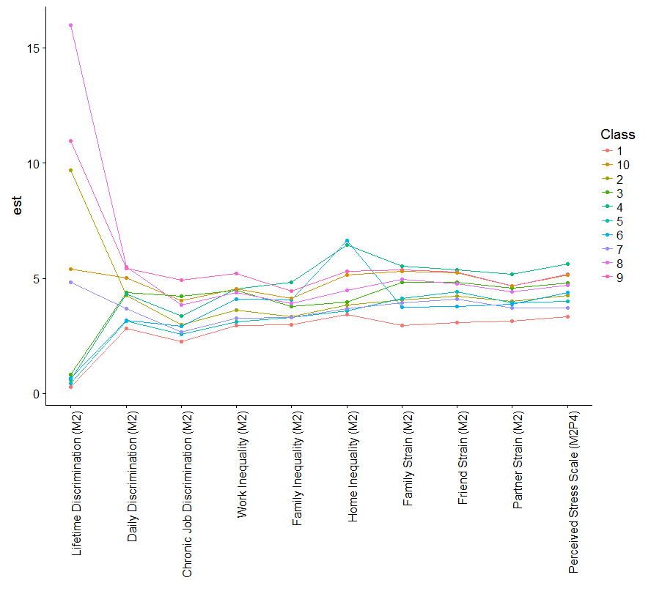

### Step 5 – Stress Predicting Mortality

Some preliminary exploratory analyses using mixture models to attempt to identify discrete

Table XX. Cox Proportional Hazard Models Predicting Mortality from MIDUS 1 Stress

|  |  |  |  |  |
| --- | --- | --- | --- | --- |
|  | **Model 1** | **Model 2** | **Model 3** | **Model 4** |
| **SEPARATE MODELS** |  |  |  |  |
| **Discrimination** | *p* < .001 | *p* < .001 | *p* < .001 | *p* = .001 |
| Lifetime | 1.02 [0.94, 1.10] | 1.02 [0.94, 1.10] | 1.06 [0.98, 1.14] | 1.02 [0.94, 1.11] |
| Daily | 1.14*** [1.06, 1.22] | 1.13*** [1.05, 1.22] | 1.11** [1.04, 1.20] | 1.12** [1.04, 1.20] |
| **Inequality** | *p* < .001 | *p* < .001 | *p* < .001 | *p* = .010 |
| Work | 1.03 [0.95, 1.12] | 1.04 [0.96, 1.13] | 1.04 [0.95, 1.13] | 1.02 [0.94, 1.11] |
| Home | 1.17*** [1.10, 1.24] | 1.18*** [1.11, 1.26] | 1.18*** [1.11, 1.26] | 1.10** [1.03, 1.18] |
| Family | 1.07 [1.00, 1.14] | 1.07* [1.00, 1.15] | 1.04 [0.98, 1.12] | 1.03 [0.96, 1.10] |
| **Strain** | *p* < .001 | *p* = .002 | *p* < .001 | *p* = .019 |
| Family | 1.04 [0.96, 1.12] | 1.05 [0.97, 1.14] | 1.06 [0.98, 1.15] | 1.02 [0.94, 1.10] |
| Friends | 1.13** [1.05, 1.21] | 1.11** [1.03, 1.19] | 1.11** [1.03, 1.20] | 1.10** [1.02, 1.18] |
| Partner | 0.97 [0.91, 1.04] | 0.99 [0.92, 1.06] | 0.99 [0.92, 1.06] | 0.98 [0.92, 1.05] |
| **SIMULTANEOUS MODELS** | *p* < .001 | *p* < .001 | *p* < .001 | *p* = .001 |
| **Discrimination** |  |  |  |  |
| Lifetime | 1.01 [0.94, 1.09] | 1.01 [0.93, 1.09] | 1.05 [0.97, 1.13] | 1.01 [0.94, 1.10] |
| Daily | 1.08* [1.00, 1.16] | 1.07 [0.99, 1.15] | 1.05 [0.98, 1.13] | 1.08* [1.01, 1.17] |
| **Inequality** |  |  |  |  |
| Work | 1.02 [0.94, 1.11] | 1.03 [0.95, 1.12] | 1.02 [0.94, 1.11] | 1.01 [0.93, 1.10] |
| Home | 1.15*** [1.07, 1.22] | 1.16*** [1.09, 1.24] | 1.16*** [1.08, 1.23] | 1.08* [1.01, 1.15] |
| Family | 1.06 [0.99, 1.14] | 1.06 [1.00, 1.14] | 1.03 [0.96, 1.10] | 1.02 [0.95, 1.09] |
| **Strain** |  |  |  |  |
| Family | 1.00 [0.92, 1.08] | 1.01 [0.93, 1.09] | 1.02 [0.95, 1.11] | 0.99 [0.92, 1.07] |
| Friends | 1.10* [1.02, 1.18] | 1.08* [1.01, 1.17] | 1.09* [1.01, 1.17] | 1.08* [1.01, 1.16] |
| Partner | 0.95 [0.88, 1.01] | 0.96 [0.89, 1.03] | 0.97 [0.90, 1.04] | 0.97 [0.90, 1.04] |

*Note*. Models are: unadjusted (1); adjusted for sex, race, parental education, welfare in childhood (2); adjusted for Model 2 + participant education, work (3); adjusted for Model 3 + smoking, worst alcohol use, physical activity, and body mass index (4). Table shows standardized hazard ratios with 95% confidence intervals. * *p* < .05, ** *p* < .01, *** *p* < .001.

Table XX. Cox Proportional Hazard Models Predicting Mortality from MIDUS 2 Stress

|  |  |  |  |  |
| --- | --- | --- | --- | --- |
|  | **Model 1** | **Model 2** | **Model 3** | **Model 4** |
| **SEPARATE MODELS** |  |  |  |  |
| **Discrimination** |  |  |  |  |
| Lifetime |  |  |  |  |
| Daily |  |  |  |  |
| **Inequality** |  |  |  |  |
| Work |  |  |  |  |
| Home |  |  |  |  |
| Family |  |  |  |  |
| **Strain** |  |  |  |  |
| Family |  |  |  |  |
| Friends |  |  |  |  |
| Partner |  |  |  |  |
| **SIMULTANEOUS MODELS** |  |  |  |  |
| **Discrimination** |  |  |  |  |
| Lifetime |  |  |  |  |
| Daily |  |  |  |  |
| **Inequality** |  |  |  |  |
| Work |  |  |  |  |
| Home |  |  |  |  |
| Family |  |  |  |  |
| **Strain** |  |  |  |  |
| Family |  |  |  |  |
| Friends |  |  |  |  |
| Partner |  |  |  |  |

*Note*. Models are: unadjusted (1); adjusted for sex, race, parental education, welfare in childhood (2); adjusted for Model 2 + participant education, work (3); adjusted for Model 3 + smoking, worst alcohol use, physical activity, and body mass index (4). Table shows standardized hazard ratios with 95% confidence intervals. * *p* < .05, ** *p* < .01, *** *p* < .001.