MIDUS Stress Pilot Study Report

Updated: 11 October 11, 2016

Aim 1

Objective: Extensive evidence links higher stress with poor psychological, behavioral, and physical outcomes. Stress is not unidimensional but varies in domain, duration, and severity; however, most stress research tests individual stress measures leaving open the question are all stressors equally important for health? The current study compares the prospective relationship between different stress measures and all-cause mortality.
Methods: Participants were 7,074 adults from the Midlife in the United States Study with data on at least one stress measure and mortality. Eight stress measures were assessed in the mid-1990s from three domains: (1) discrimination, daily and lifetime; (2) inequality, family, home, and work; (3) interpersonal strain, family, friend, and partner. Mortality data were assessed from informants connected to participants and national death index searches up to 2015, approximately 20 years after the initial stress surveys were completed. Missing data were addressed using multiple imputation. Analyses were conducted using Cox proportional hazard models with age at death or censorship. The following covariates were adjusted in models: sex, race, parental education, welfare in childhood, education, work, smoking, alcohol use, physical activity, and body mass index.
Results: Each domain of stress predicted significantly earlier mortality independent of all covariates (all p < .05). Within domains, daily discrimination, home inequality, and interpersonal strain from friends predicted earlier mortality (all p < .01) and these unique associations were sustained in a multivariate model simultaneously including all stress measures (all p < .05 for those three stress measures).
Conclusions: Psychosocial stress measures emerged as robust predictors of all-cause mortality up to 20 years later after adjusting for several potential confounding factors. Each of the three conceptual domains of stress were predictive, but daily discrimination, perceived home inequality, and interpersonal strain from friends emerged as unique predictors independent of the other stress measures.

Cox Proportional Hazard Models Predicting Mortality from MIDUS 1 Stress (mid 1990s)
 | Model 1 | Model 2 | Model 3 | Model 4
SEPARATE MODELS
Discrimination | p < .001 | p < .001 | p < .001 | p = .001
Lifetime | 1.02  [0.94, 1.10] | 1.02  [0.94, 1.10] | 1.06  [0.98, 1.14] | 1.02  [0.94, 1.11]
Daily | 1.14***  [1.06, 1.22] | 1.13***  [1.05, 1.22] | 1.11**  [1.04, 1.20] | 1.12**  [1.04, 1.20]
Inequality | p < .001 | p < .001 | p < .001 | p = .010
Work | 1.03  [0.95, 1.12] | 1.04  [0.96, 1.13] | 1.04  [0.95, 1.13] | 1.02  [0.94, 1.11]
Home | 1.17***  [1.10, 1.24] | 1.18***  [1.11, 1.26] | 1.18***  [1.11, 1.26] | 1.10**  [1.03, 1.18]
Family | 1.07  [1.00, 1.14] | 1.07*  [1.00, 1.15] | 1.04  [0.98, 1.12] | 1.03  [0.96, 1.10]
Strain | p < .001 | p = .002 | p < .001 | p = .019
Family | 1.04  [0.96, 1.12] | 1.05  [0.97, 1.14] | 1.06  [0.98, 1.15] | 1.02  [0.94, 1.10]
Friends | 1.13**  [1.05, 1.21] | 1.11**  [1.03, 1.19] | 1.11**  [1.03, 1.20] | 1.10**  [1.02, 1.18]
Partner | 0.97  [0.91, 1.04] | 0.99  [0.92, 1.06] | 0.99  [0.92, 1.06] | 0.98  [0.92, 1.05]
SIMULTANEOUS MODELS | p < .001 | p < .001 | p < .001 | p = .001
Discrimination
Lifetime | 1.01  [0.94, 1.09] | 1.01  [0.93, 1.09] | 1.05  [0.97, 1.13] | 1.01  [0.94, 1.10]
Daily | 1.08*  [1.00, 1.16] | 1.07  [0.99, 1.15] | 1.05  [0.98, 1.13] | 1.08*  [1.01, 1.17]
Inequality
Work | 1.02  [0.94, 1.11] | 1.03  [0.95, 1.12] | 1.02  [0.94, 1.11] | 1.01  [0.93, 1.10]
Home | 1.15***  [1.07, 1.22] | 1.16***  [1.09, 1.24] | 1.16***  [1.08, 1.23] | 1.08*  [1.01, 1.15]
Family | 1.06  [0.99, 1.14] | 1.06  [1.00, 1.14] | 1.03  [0.96, 1.10] | 1.02  [0.95, 1.09]
Strain
Family | 1.00  [0.92, 1.08] | 1.01  [0.93, 1.09] | 1.02  [0.95, 1.11] | 0.99  [0.92, 1.07]
Friends | 1.10*  [1.02, 1.18] | 1.08*  [1.01, 1.17] | 1.09*  [1.01, 1.17] | 1.08*  [1.01, 1.16]
Partner | 0.95  [0.88, 1.01] | 0.96  [0.89, 1.03] | 0.97  [0.90, 1.04] | 0.97  [0.90, 1.04]
Note. Models are: unadjusted (1); adjusted for sex, race, parental education, welfare in childhood (2); adjusted for Model 2 + participant education, work (3); adjusted for Model 3 + smoking, worst alcohol use, physical activity, and body mass index (4). Table shows standardized hazard ratios with 95% confidence intervals. * p < .05, ** p < .01, *** p < .001.

Concordance Indices
 | Model 1 | Model 2 | Model 3 | Model 4
Covariates Only | - | .569 | .599 | .666
SEPARATE MODELS
Discrimination | .555 | .588 | .612 | .671
Inequality | .571 | .603 | .616 | .672
Strain | .544 | .583 | .608 | .668
SIMULTANEOUS MODELS | .583 | .609 | .623 | .675
Note. Models are: unadjusted (1); adjusted for sex, race, parental education, welfare in childhood (2); adjusted for Model 2 + participant education, work (3); adjusted for Model 3 + smoking, worst alcohol use, physical activity, and body mass index (4). Table shows concordance indices.

Using random forest survival analyses (similar to in Eli’s project), in models including the covariates using in the survival analyses, friend strain and home inequality were the highest ranked stress measures, followed by work inequality, family strain, and lifetime discrimination.

Aim 2
The purpose of this aim is to address the lack of a tool to assess overall levels of resources by developing a scale that is broad, reliable, and brief enough to be administered to a wide range of populations that minimizes participant burden (Psychosocial Resources Questionnaire; PSRQ).
Flow chart of items and scales through the development stage of the PSRQ

Fit indices for the final CFA model for the PSRQ and multiple group invariance testing
 |  | Invariance Testing
 | PSRQ Final | Age Groups | Sex | Race Groups
N Parameters | 192 | 319 | 250 | 250
χ² | 4092.73 | 5162.39 | 4970.85 | 4289.32
DF | 483 | 1706 | 1100 | 1100
P | < .001 | < .001 | < .001 | < .001
CFI | 0.957 | 0.960 | 0.954 | 0.962
RMSEA | 0.045  [0.044, 0.047] | 0.041  [0.04, 0.042] | 0.044  [0.043, 0.045] | 0.041  [0.04, 0.042]
WRMR | 2.356 | 2.764 | 2.683 | 2.652
Note. Overall sample size for the PSRQ Final, age, and sex models was 3,621. For the race group invariance test, 160 adults who were neither White/European American nor African American were excluded.
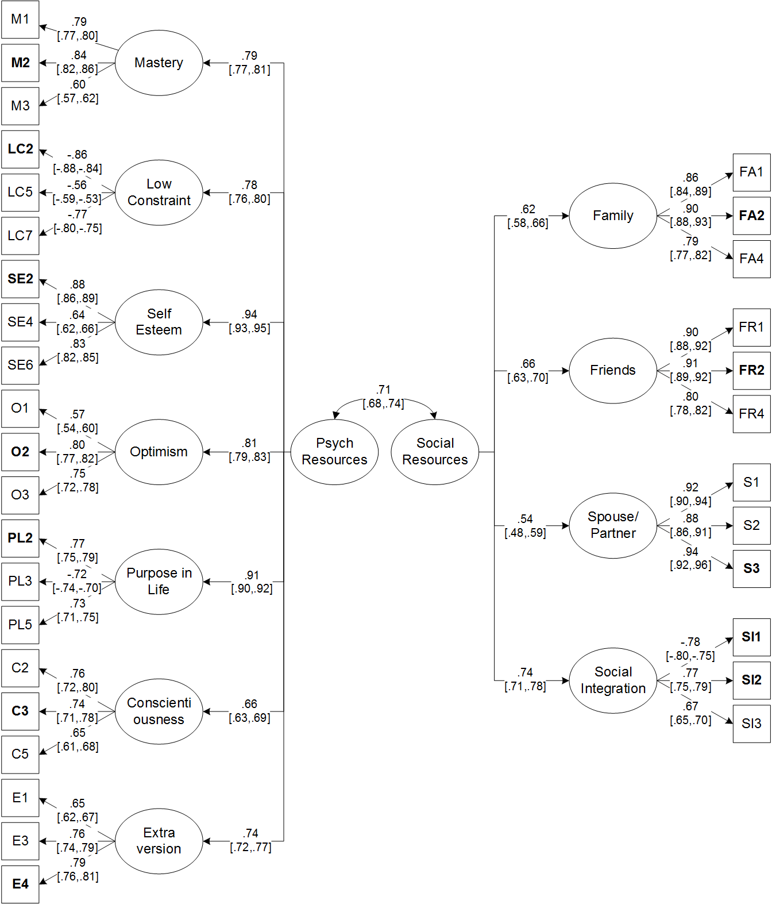
Final PSRQ CFA model. All results are standardized with 95% confidence intervals. Fit indices are reported in the table.

Comparison of psychological and social resource factor scores from the PSRQ and PSRQ-SF in the development sample. The first row shows density plots of scores from each questionnaire. The second row shows each raw score plotted against the other along with a line of perfect agreement. The third row shows Bland Altman plots along with 95% limits of agreement.

Psychosocial Resources Questionnaire – Short Form (PSRQ-SF) Version 1
Please indicate how strongly you agree or disagree with each of the following statements.
 | AGREE |  |  |  | DISAGREE
 | Strongly | Some  what | A little | Neither agree or disagree | A little | Some  what | Strongly
When I really want to do something, I usually find a way to succeed at it. | 1 | 2 | 3 | 4 | 5 | 6 | 7
I often feel helpless in dealing with the problems of life. | 1 | 2 | 3 | 4 | 5 | 6 | 7
I take a positive attitude toward myself. | 1 | 2 | 3 | 4 | 5 | 6 | 7
I have a sense of direction and purpose in life. | 1 | 2 | 3 | 4 | 5 | 6 | 7
I don’t feel I belong to anything I’d call a community. | 1 | 2 | 3 | 4 | 5 | 6 | 7
I feel close to other people in my community. | 1 | 2 | 3 | 4 | 5 | 6 | 7

 | A lot | Some | A little | Not at all
Please indicate how well each of the following describes you.
Responsible | 1 | 2 | 3 | 4
Active | 1 | 2 | 3 | 4
The next question is about your family. Please circle the appropriate number for your family.
How much do they understand the way you feel about things? | 1 | 2 | 3 | 4
The next question is about your friends. Please circle the appropriate number for your friends.
How much do they understand the way you feel about things? | 1 | 2 | 3 | 4
The next question is about your spouse/partner. Please circle the appropriate number for your spouse/partner.
How much does he or she appreciate you? | 1 | 2 | 3 | 4

Answer according to your own feelings, rather than how you think "most people" would answer.
 | AGREE |  |  | DISAGREE
 | A lot | Some  what | Neither agree or disagree | A little | A lot
I’m always optimistic about my future. | 1 | 2 | 3 | 4 | 5

