Causal Analysis

Joshua F. Wiley

2019-05-29

Download the raw R markdown code here <https://jwiley.github.io/MonashDoctoralStatistics/Causal_Analysis.rmd>.

# Causal Analysis Theory

The general goal of causal analysis is to quantify the causal effect of one variable on another. Arguably, much perhaps even most of science has the goal of causal analysis, although not always couched in such direct language.

Often, methods are taught that seemingly separate whether an analysis is causal or not based on whether it comes from an experiment or RCT (causal) or any other non-randomized design. This is not, strictly, true. Rather, experiments or RCTs help ensure the assumptions required for a causal analysis are met.

## Terminology

Before we consider different scenarios, there are some common terms / language to define.

* $Y$ refers to our outcome of interest. For simplicity, let $Y$ be a binary variable (e.g., Depressed or Not Depressed; Presence or Absence of Hyperactive symptoms). We indicate these separate outcomes, respectively as $Y_{1}=(Y=1)$ and $Y_{0}=(Y=0)$.
* $X$ refers to our exposure of interest. For simplicity, let $X$ be a binary variable as well (e.g., Treatment vs Control; Diagnosed with Cancer). We represent these as $X_{1}=(X=1)$ and $X_{0}=(X=0)$.
* $C$ refers to covariates that are confounds and generally common causes of both $X$ and $Y$ that were measured and available for analysis.
* $O$ refers to covariates that are confounds and generally common causes of both $X$ and $Y$ that were **O**mmitted from assessments, so are not available for analysis.
* $I$ refers to instrumental variables; that is variables that cause $X$ but do not cause $Y$.
* $P$ refers to proxy variables, that are caused by or in other ways may be proxies for unmeasured covariates or common causes, $O$, but do not themselves cause $X$ or $Y$
* $L$ refers to collider variables, that are measured and may be controlled for, but are not causes of $X$ or $Y$, but are caused by $O$ where at least one $O$ also causes $X$ and another also causes $Y$.
* $M$ refers to a mechanism, that is on the causal path between $X$ and $Y$. Again, for convenience, we assume this is a binary variable where $M_{1}=(M=1)$ and $M_{0}=(M=0)$ represent values of the mechanism when it is present or absent.

We use upper case letters to refer to the variables, and lower case letters to refer to specific values of them. For example: $Y=y$ indicates $Y$ equalling some specific, constant value, $y$, so that $Y$ no longer varies but is a constant, although we do not care **which** specific constant (i.e., it does not matter whether it is $Y=1$ or $Y=0$). The same applies to the other variables defined, $X=x$ refers to the exposure being held at some specific value of $X$, $C=c$ refers to covariates being held at some specific value of $C$, etc.

## Counterfactuals

Another key concept in causal analysis is the idea of counterfactuals also called expected outcomes. Counterfactuals underpin much of causal analysis. Counterfactuals refer to *what would have happened* under another reality. This is the core of causal reasoning. What would have to this person’s depression if they had been given treatment instead of the control or the control instead of the treatment?

Formally, we write expected outcomes as:

$$E(Y_{x})$$

which indicates the outcome, $Y$, when $X=x$. The counterfactual or expected outcomes framework allows us more formal definitions of causal effects under different situations. Using the counterfactual framework, we can define the causal direct effect of our exposure, $X$, on the outcome, $Y$ as:

$$E(Y_{X_{1}}-Y_{X_{0}})$$

This represents the expected difference in the outcome when the exposure is held at 1 vs 0.

Note that $Y_{x}$ will be the factual, observed outcome for some people, but will be a counterfactual, not observed outcome for other people. For example, for everyone actually receiving treatment, $Y_{X_{1}}$ will be the factual outcome, but $Y_{X_{1}}$ will be a counterfactual outcome for everyone actually receiving the control condition[1]. Also note that there is an assumption that for everyone with $X=1$, $Y_{X_{1}}=Y$. This means that the observed outcome data, are the outcomes associated with a specific level of the exposure. This could be violated if, for instance, there was measurement error on the exposure (e.g., someone who received treatment misclassified as control; someone listed as not diagnosed with cancer, but cancer was actually present) or if someone had both exposures but only one recorded (e.g., someone was not diagnosed with cancer; outcomes were assessed 4 weeks later and in that interim gap, cancer was diagnosed but not collected/assessed by the study).

## Confounding

In experiments or RCTs, we may randomly assign people to a specific level of the exposure, $X$. However, in other settings, individuals’ level of the exposure, $X$, may not be randomly assigned. When levels of the exposure are not randomly assigned, there may exist confounding that if not measured and accounted for introduces bias in the estimate of the causal effect of our exposure $X$ on the outcome $Y$. Most of our discussions today will focus on these cases and attempting to adjust for confounding.

We say that a set of measured covariates is sufficient to eliminate confounding if:

$$Y_{x}⊥X|C$$

read: the expected outcome $Y_{x}$ is independent of the exposure, $X$ given (conditioned, covaried on, at specific strata of) $C$. Thus the causal effect is:

$$E(Y_{X_{1}}-Y_{X_{0}}|C)$$

If $Y_{x}⊥X|C$ is true, then regardless of the study type, we can **estimate** the causal effect of $X$ on $Y$ based on sample data as:

$$E(Y|X=1,c)-E(Y|X=0,c)$$

Randomized designs, such as experiments and RCTs, are powerful because the randomization can ensure that $Y_{x}⊥X$ without requiring any $C$, eliminating the need or concern to identify, measure, and appropriately adjust for $C$. However, if confounders are appropriately mmeasured and modelled, causal estimates can be obtained from observational data.

## Confounding Examples

Now, let’s look at some different causal models that may arise and the consequences of different choices.

In the following figure, $C$ is an observed confounder that causes both $X$ and $Y$. If $C$ is ignored, the causal estimate of $X$ on $Y$ will be biased. Adjusting for $C$, we can get an unbiased estimate of the causal effect of $X$ on $Y$.

C is a common cause of X and Y

In the following figure, $X$ is not a cause of $Y$, so the correct estimate of the causal effect is 0. In the graph, there are two, omitted confounders: $O1$ and $O2$. $L$ is a collider caused by both $O1$ and $O2$, but $L$ does not cause $X$ or $Y$. In this case, analyzing $X$ and $Y$ alone will provide a correct causal estimate. However, adjusting for $L$ while looking at the $X$ effect on $Y$ will induce bias. Specifically, adjusting for $L$ will result in unblocking a backdoor path from $X$ to $Y$ via $O1$, $L$, and $O2$ leading to an (incorrect) apparent causal effect of $X$ on $Y$. Adjusting for collider variables can open backdoor paths and cause bias. **Adjusting for more variables is not always better.**

L is a collider and covarying for it will induce bias by unblocking a backdoor path from X to Y

In the following figure, $O$ is a common cause of $X$ and $Y$ but it was omitted from measurement so we cannot adjust for it. However, $O$ is only connected to $X$ via $C$ which is measured. In this instance, adjusting for $C$ eliminates the bias due to $O$ which was not measured.

O is unmeasured, but covarying for C eliminates bias due to O

When $O$ is a common cause of $X$ and $Y$ its omission will result in a biased causal estimate. In the following figure, $I$ is an instrumental variable that is a cause of $X$ but not of $Y$. With $O$ omitted, adjusting for $I$ will not reduce bias from $O$ and in fact tends to exacerbate the bias from the omission of $O$. As with the collider example, this is another case where adjusting for the wrong variable can exacerbate bias.

O is unmeasured, I is an instrument (influences X not Y), covaring for I when O unmeasured may exacerbate bias due to O

The following diagram shows a case where $O$ is omitted and a common cause of $X$ and $Y$. We do not have $O$, but we do have a proxy measure of $O$, $P$. $P$ does not cause $X$ or $Y$, but adjusting for it can reduce bias from omitting $O$.

Proxy variable P though not causal can be used to reduce bias from omitting O

# Causal Effect Decompositions

A common task in causal analysis is not only examining the causal effect of one variable, $X$, on another, $Y$, but decomposing this effect, such as identifying specific mediators or mechanisms. Previously, distinctions often were made between mediation and moderation models, where mediation models tested mechanisms linking $X$ and $Y$, moderation models tested whether the causal effect of $X$ on $Y$ differs across some third variable. Recently, these have been unified into a four-way decomposition of the effect of $X$ on $Y$ where another variable, $M$ may act both as mediator and moderator of the effect[2]. Following is a diagram of a mediation model.

Mediation model with confounder C

Previously we defined counterfactual outcomes based on level of the exposure: $Y_{X_{1}}$ and $Y_{X_{0}}$. Now that we have a mechanism as well, we need further counterfactuals, including what would have happened to the mediator if the exposure were set at specific values.

$$M_{X_{1}}$$

$$M_{X_{0}}$$

as well as specific counterfactuals for the outcome under different actual occurrences of the exposure and mediator.

$$Y_{X_{1}M_{1}}$$

$$Y_{X_{1}M_{0}}$$

$$Y_{X_{0}M_{1}}$$

$$Y_{X_{0}M_{0}}$$

Together, these pieces allow us to decompose the causal effect of $X$ on $Y$ into four parts:

1. Controlled direct effect ($CDE$): $Y_{X_{1}M_{0}}-Y_{X_{0}M_{0}}$
2. Reference interaction ($INT_{ref}$): $(Y_{X_{1}M_{1}}-Y_{X_{1}M_{0}}-Y_{X_{0}M_{1}}+Y_{X_{0}M_{0}})(M_{X_{0}})$
3. Mediated interaction ($INT_{med}$): $(Y_{X_{1}M_{1}}-Y_{X_{1}M_{0}}-Y_{X_{0}M_{1}}+Y_{X_{0}M_{0}})(M_{X_{1}}-M_{X_{0}})$
4. Pure indirect effect ($PIE$): $(Y_{X_{0}M_{1}}-Y_{X_{0}M_{0}})(M_{X_{1}}-M_{X_{0}})$

Based on this four-way decomposition, we also can define various composites of these:

* Total effect: $CDE+INT_{ref}+INT_{med}+PIE$
* Total indirect (mediated) effect: $PIE+INT_{med}$
* Pure direct effect: $CDE+INT_{ref}$
* Portion attributable to interaction: $INT_{ref}+INT_{med}$

# Marginal Structural Models (MSMs)

One of the primary tools for estimated causal effects are marginal structural models (MSMs). MSMs estimated marginal effects rather than conditional effects as in regression models.

MSMs will match regression under some special conditions, but often do not. Marginal models focus on the population average, not for specific conditions or groups and they model expected outcomes, rather than directly observed data. Often, MSMs adjust for confounds by using approaches such as Inverse Probability of Treatment Weights (IPTWs).

IPTWs can be calculated several ways, but often what are known as “stabilized weights” (*sw*) are used, which are the ratio of the probability of the exposure to the conditional probability of the exposure, where it is conditioned on the relevant covariates, $C$. Weights are calculated for each person, $i$, as:

$$swx_{i}=\frac{P(X=x_{i})}{P(X=x_{i}|C=c_{i})}$$

For cases where there is mediation, a second weight is needed, for the mediator, here the numerator is the conditional probability of having the mediator $M$, given the exposure $X$. The denominator is the same but now conditional on the exposure, the covariates used for the exposure, $C$, **and any additional covariates required to adjust for bias from the mediator to the outcome**, $CM$.

$$swm_{i}=\frac{P(M=m_{i}|X=x_{i})}{P(M=m_{i}|X=x_{i},C=c_{i},CM=cm_{i})}$$

Using these IPTWs, we could, for example, estimate the controlled direct effect of the exposure using the MSM:

$$E(Y_{xm})=b_{0}+b_{1}*X+b_{2}*M+b_{3}*X*M$$

The weights for this would be the product of the exposure and mediator weights described previously:

$$swx_{i}*swm_{i}$$

These IPTWs address confounding, so no further adjustment in the model is needed for confounding. By using the IPTWs, we create a pseudo-population in which there is no confounding (or at least, in which we have adjusted for confounding as best we are able to). Once we have done that, we estimate the parameters of the MSMs typically using regular regression software.

# MSMs and Causal Analysis in R

For many MSMs, the main complicated task is estimating the IPTWs. To estimate them in R, we use the ipw package. The following code setups up the packages we need and loads a small sample dataset from the internet.

options(digits = 2)  
  
## one new packages: ipw, use one of the codes below to install  
# install.packages("ipw", type = "binary")  
# install.packages("ipw")  
  
## once installed, run  
library(data.table)  
library(ipw)  
  
## read in sample dataset from online  
d <- fread("https://stats.idre.ucla.edu/stat/data/hsbdemo.csv")  
d[, GoodRead := as.integer(read > 50)]  
d[, GoodSocst := as.integer(socst > 60)]  
d[, GoodMath := as.integer(math > 52)]  
d[, GoodScience := as.integer(science > 55)]  
d[, honors := as.integer(honors == "enrolled")]

Following is a causal diagram representing our view of the world. In words, this diagram indicates belief that being in honors (exposure) has acausal effect on being a good reader (mechanism) and being good in social studies (outcome). Socioeconomic status and school type are seen as common causes both of being in honors and being good in social studies. Writing ability is seen as a unique confound of the effect from being a good reader to being good in social studies.

MSM mediation model

To estimate a MSM, we first must generate IPTWs for our exposure, honors. This we accomplish using the ipwpoint() function. It is common to graph or otherwise summarise the weights after being made and often, to create truncated weights, here using trunc = .01. The goal of truncating weights is to avoid extreme weights (either very large or very small). In this case, it does not appear to much matter from the figures, but we may use the truncated weights anyways (it is only the top and bottom .01 that are truncated).

swx <- ipwpoint(  
 exposure = honors,  
 family = "binomial",  
 link = "logit",  
 numerator = ~ 1,  
 denominator = ~ ses + schtyp,  
 data = d,  
 trunc = .01)  
  
par(mfrow = c(1, 2))  
ipwplot(weights = swx$ipw.weights, logscale = FALSE)  
ipwplot(weights = swx$weights.trunc, logscale = FALSE)

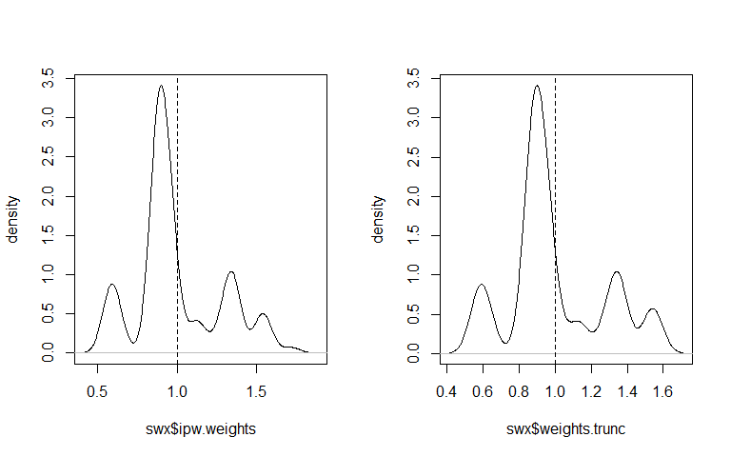

Raw and truncated stabilized IPTWs for exposure

summary(swx$ipw.weights)

## Min. 1st Qu. Median Mean 3rd Qu. Max.   
## 0.58 0.89 0.89 1.00 1.13 1.72

summary(swx$weights.trunc)

## Min. 1st Qu. Median Mean 3rd Qu. Max.   
## 0.58 0.89 0.89 1.00 1.13 1.54

Next we repeat the same process for the mechanism. Now the numerator has the exposure as well and we add the new confound that only is expected to confound the mediator outcome path, writing.

swm <- ipwpoint(  
 exposure = GoodRead,  
 family = "binomial",  
 link = "logit",  
 numerator = ~ 1 + honors,  
 denominator = ~ 1 + honors + ses + schtyp + write,  
 data = d,  
 trunc = .01)  
  
par(mfrow = c(1, 2))  
ipwplot(weights = swm$ipw.weights, logscale = FALSE)  
ipwplot(weights = swm$weights.trunc, logscale = FALSE)

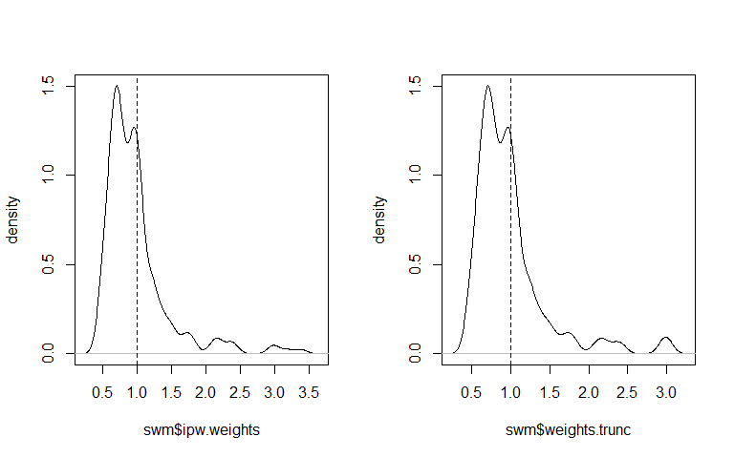

Raw and truncated stabilized IPTWs for mediator

## check a summary of the product of weights  
summary(swx$weights.trunc * swm$weights.trunc)

## Min. 1st Qu. Median Mean 3rd Qu. Max.   
## 0.5 0.6 0.7 1.0 1.2 3.2

Finally, we can estimate our MSM. As the outcome is binary, we use a logistic model. For comparison, we also run a regular GLM with covariates added. For the MSM, we leave out confounds, but utilize weights, by specifying the weights argument and using the product of our exposure and mediator IPTWs. Finally, we can get a summary of the results to evaluate them and confidence intervals[3]. Note that warnings about non-integers in the the MSM are okay as these are related to the weighting.

## glm approach with covariates  
mglm <- glm(GoodSocst ~ honors + GoodRead + ses + schtyp + write,  
 data = d, family = binomial())  
  
## msm approach  
msm <- glm(GoodSocst ~ honors + GoodRead,  
 data = d, family = binomial(),  
 weights = swx$weights.trunc * swm$weights.trunc)  
  
## glm results  
summary(mglm)

##   
## Call:  
## glm(formula = GoodSocst ~ honors + GoodRead + ses + schtyp +   
## write, family = binomial(), data = d)  
##   
## Deviance Residuals:   
## Min 1Q Median 3Q Max   
## -1.793 -0.738 -0.316 0.705 2.630   
##   
## Coefficients:  
## Estimate Std. Error z value Pr(>|z|)   
## (Intercept) -7.0720 2.0974 -3.37 0.00075 ***  
## honors 0.1101 0.5519 0.20 0.84193   
## GoodRead 0.8326 0.4220 1.97 0.04852 *   
## seslow -1.8682 0.5804 -3.22 0.00129 **   
## sesmiddle -0.8219 0.4142 -1.98 0.04719 *   
## schtyppublic 0.1020 0.4811 0.21 0.83208   
## write 0.1176 0.0386 3.05 0.00229 **   
## ---  
## Signif. codes: 0 '***' 0.001 '**' 0.01 '*' 0.05 '.' 0.1 ' ' 1  
##   
## (Dispersion parameter for binomial family taken to be 1)  
##   
## Null deviance: 252.23 on 199 degrees of freedom  
## Residual deviance: 180.47 on 193 degrees of freedom  
## AIC: 194.5  
##   
## Number of Fisher Scoring iterations: 5

confint(mglm)

## Waiting for profiling to be done...

## 2.5 % 97.5 %  
## (Intercept) -11.5590 -3.263  
## honors -0.9800 1.194  
## GoodRead 0.0094 1.673  
## seslow -3.0782 -0.779  
## sesmiddle -1.6436 -0.012  
## schtyppublic -0.8347 1.063  
## write 0.0469 0.199

## msm results  
summary(msm)

##   
## Call:  
## glm(formula = GoodSocst ~ honors + GoodRead, family = binomial(),   
## data = d, weights = swx$weights.trunc * swm$weights.trunc)  
##   
## Deviance Residuals:   
## Min 1Q Median 3Q Max   
## -1.706 -0.674 -0.501 0.792 3.448   
##   
## Coefficients:  
## Estimate Std. Error z value Pr(>|z|)   
## (Intercept) -1.664 0.269 -6.19 6e-10 ***  
## honors 1.267 0.380 3.34 0.00085 ***  
## GoodRead 0.754 0.370 2.03 0.04190 *   
## ---  
## Signif. codes: 0 '***' 0.001 '**' 0.01 '*' 0.05 '.' 0.1 ' ' 1  
##   
## (Dispersion parameter for binomial family taken to be 1)  
##   
## Null deviance: 240.50 on 199 degrees of freedom  
## Residual deviance: 214.39 on 197 degrees of freedom  
## AIC: 246.1  
##   
## Number of Fisher Scoring iterations: 4

confint(msm)

## Waiting for profiling to be done...

## 2.5 % 97.5 %  
## (Intercept) -2.223 -1.2  
## honors 0.528 2.0  
## GoodRead 0.028 1.5

# Activity (Workbook)

Run a GLM and MSM for the following causal model.

Workbook causal model

# Additional Resources

* VanderWeele, T. (2015). *Explanation in causal inference: methods for mediation and interaction*. Oxford University Press.
* VanderWeele, T. J. (2014). A unification of mediation and interaction: a four-way decomposition. *Epidemiology, 25*(5), 749.
* VanderWeele, T. J. (2009). Marginal structural models for the estimation of direct and indirect effects. *Epidemiology*, 18-26.
* Robins, J. M., Hernan, M. A., and Brumback, B. (2000). Marginal structural models and causal inference in epidemiology. *Epidemiology*, 550-560.
* Cole, S. R., & Hernán, M. A. (2008). Constructing inverse probability weights for marginal structural models. *American Journal of Epidemiology, 168*(6), 656-664.
* Pearl, J. (2009). *Causality*. Cambridge University Press.

1. Note that although we are only talking about binary outcomes and exposures, the general principles hold true for continuous outcomes and continuous exposures. In the case of continuous exposures, however, would hold the exposure at different specific levels and must assume some functional form mapping the continuous exposure to the outcome, such as linear, etc.
2. VanderWeele, T. J. (2014). A unification of mediation and interaction: a four-way decomposition. *Epidemiology, 25*(5), 749.
3. Some notes on the use of p-values here: Nature: <http://dx.doi.org/10.1038/d41586-019-00857-9> JAMA: <http://dx.doi.org/10.1001/jama.2019.4582> PeerJ: <http://dx.doi.org/10.7287/peerj.preprints.27657v1> Am Stat: <http://dx.doi.org/10.1080/00031305.2018.1527253> Am Stat: <http://dx.doi.org/10.1080/00031305.2019.1583913>