Activity 1

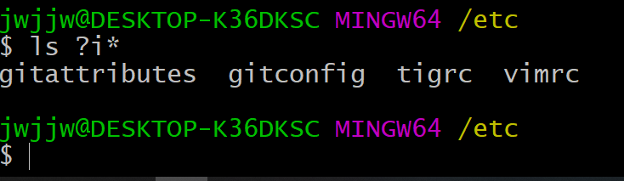In this activity, we must get to our /etc. file and see what is in there, also to see if we can pick a list files in it. There I wanted to list all the files that had I as its second character. I typed “ls ?i\*”. My output:

Activity 2

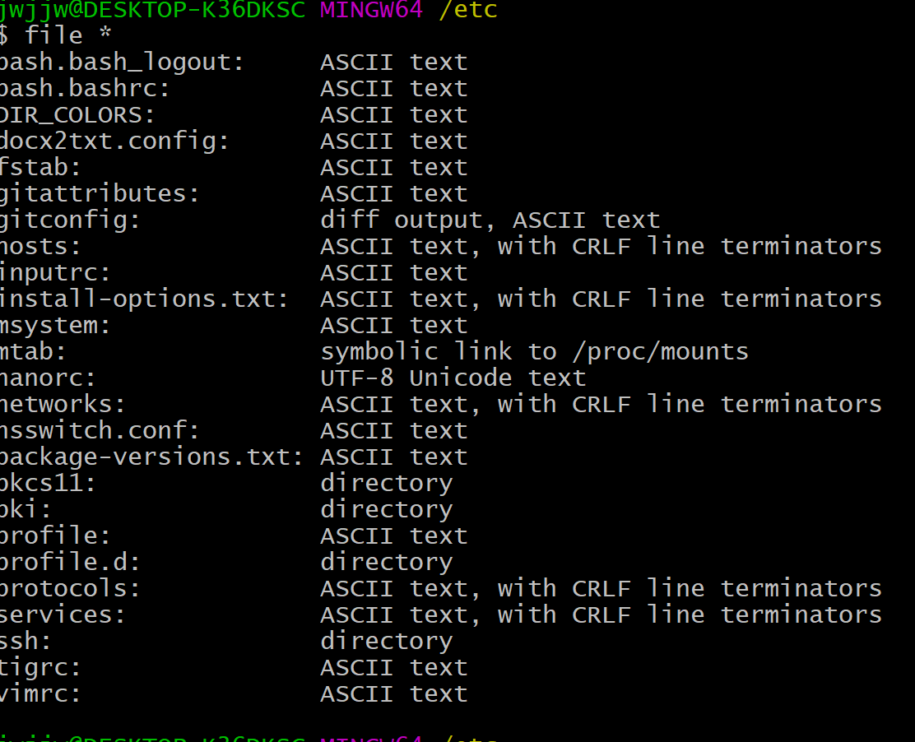 This part of the exercise they want me to list the file types of this directory. I typed “file \*”. My output:

Activity 3

They want to see the files with a 3 letter extension. I typed “ls \*.???”. My output: 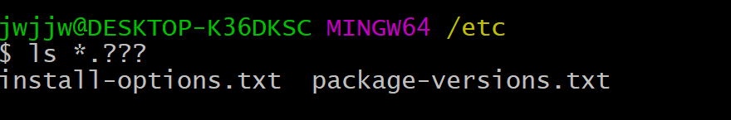

Activity 4

Here the tutorial wanted to only see the contents of this file that had an uppercase character at the beginning of it.

“ls [[:upper:]]\*”

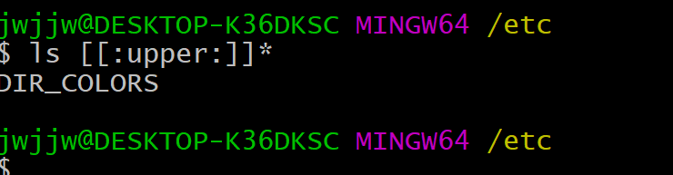Output:

Activity 5

In this exercise, are goal was to list files that are 4 characters long in name.