TeamLead Application

**Developer Guide**

**Table of Contents**

About this Document 4

Installing the Toolchain 4

Source Control 4

Integrated Development Environment 5

Accessing the Source Code 5

Application Structure 6

**Version History**

The following table depicts the revision history of this document.

| App Version | Author | Description | Date | Sections |
| --- | --- | --- | --- | --- |
| 0.6.0 | James Williamson | Original draft | 05/03/2017 | All |
|  |  |  |  |  |

# About this Document

This document describes how to get started developing TeamLead source code. It explains how to acquire and use the tool set and become familiar with the structure of the application.

# Installing the Toolchain

This section outlines the tools that are required for development with the TeamLead application.

## Source Control

The source control software used is Git, available for free at <https://git-scm.com/>. Git is a powerful open-source software configuration management tool. From the home page, click “downloads” (<https://git-scm.com/downloads>) to get started with the installation. Git Bash is highly recommended as it makes the process much easier. Figure 1 illustrates an example of the command prompt it provides.

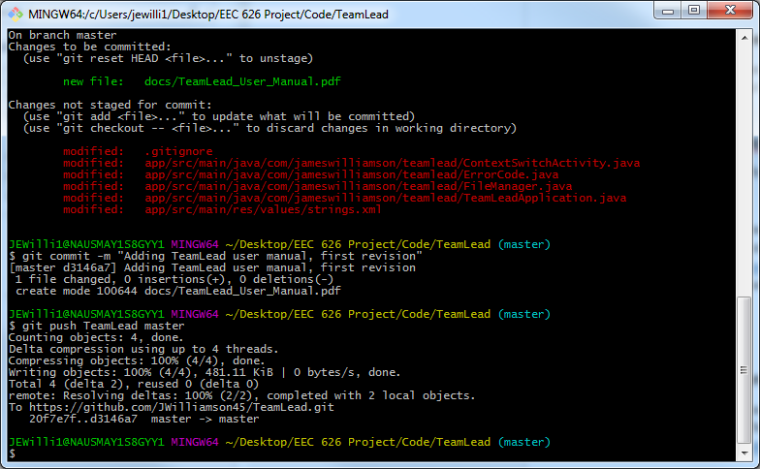

Figure 1: Pushing code to GitHub via Git Bash

Resources to assist in learning or refreshing the user on use of Git are available throughout the site.

## Integrated Development Environment

The IDE used to develop TeamLead is Android Studio, an all-in-one powerful build environment available from <https://developer.android.com/studio/index.html>.

Download and install Android Studio to edit, build, and test the TeamLead source code.

# Accessing the Source Code

TeamLead is an open-source application, and as such, its source code is stored in a publicly accessible repository on GitHub. The URL to access this repository is: <https://github.com/JWilliamson45/TeamLead>. This URL is also listed on the “about” dialog from within the application.

Figure 2 shows the repository home page.

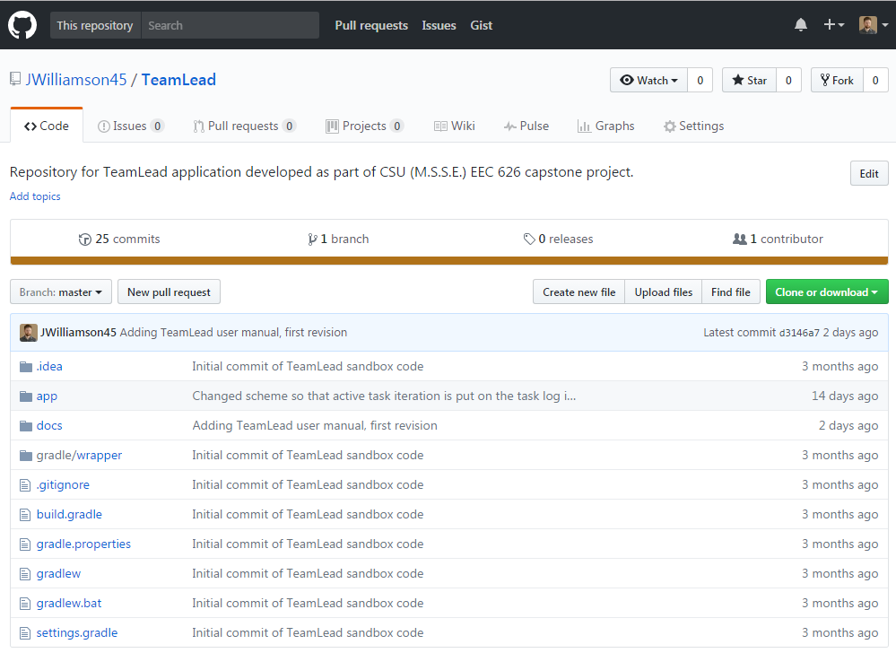

Figure 2: TeamLead repository home page

The /app folder contains the source code. The project outline, user manual, and other documentation can be found in the /docs folder. Other “gradle” files are used to build the source code.

Click the green “Clone or download” button to download a copy of the source code (this will prompt you to checkout, or alternative, download a .zip archive).

# Application Structure

An overview of the structure of the application is illustrated in Figure 3.

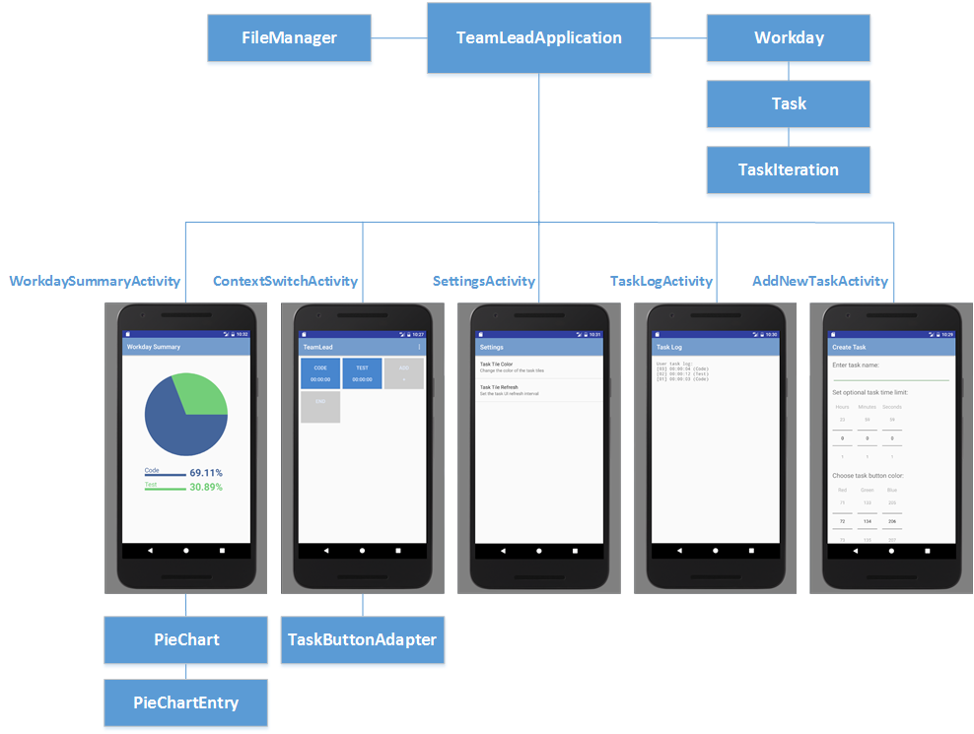

Figure 3: TeamLead application structure

TeamLeadApplication subclasses the Android Application class and includes the Workday model as a form of global application storage. The Workday object maintains a list of Tasks and a queue of TaskIterations as tiles are clicked on the ContextSwitchUI (second from left in Figure 3 on the row of activities). Other objects access the Workday model through functions provided by the TeamLeadApplication.

The FileManager is used to load and store the Workday from persistent storage should the application require this action (for instance, storing data if the application is forcibly closed before the user ends the workday). The usage of load and store operations is tied to the lifecycle of the ContextSwitchActivity.

The UI of the application is structured around five activities – the WorkdaySummaryActivity; the ContextSwitchActivity; the SettingsActivity; the TaskLogActivity; and the AddNewTaskActivity. The ContextSwitchActivity uses a TaskButtonAdapter to render the task tiles from the data stored in the Workday, and is the primary source of user input throughout the application usage. The WorkdaySummaryActivity creates and draws a PieChart based on the content of the Workday. For full details on using these activities, refer to the TeamLead Application User Manual.