TeamLead Application

**User Manual**

**Table of Contents**

Overview 4

The Home Screen 4

Adding a Task 7

Delete or Edit a Task 8

The Settings Menu 9

Viewing the Task Log 9

Resetting the Workday 10

Changing User Preferences 11

The Workday Summary 13

**Version History**

The following table depicts the revision history of this document.

| App Version | Author | Description | Date | Sections |
| --- | --- | --- | --- | --- |
| 0.6.0 | James Williamson | Original draft | 05/01/2017 | All |
|  |  |  |  |  |

# Overview

TeamLead is an Android application that provides a mechanism for simple and straightforward time management and accounting.

When you begin your day, open the TeamLead application and press the appropriate task button each time you switch up what you’re doing. The app will track the time you’ve spent on each task, how many times you’ve switched to a different task (referred to as “context switching” throughout this document), whether or not you’ve exceeded a predefined time limit for a particular task, and more. Once your day is concluded, a graph is shown illustrating the allocation of your time.

This manual describes how to use some of the fundamental features of the application.

# The Home Screen

The default home screen is shown in Figure 1.

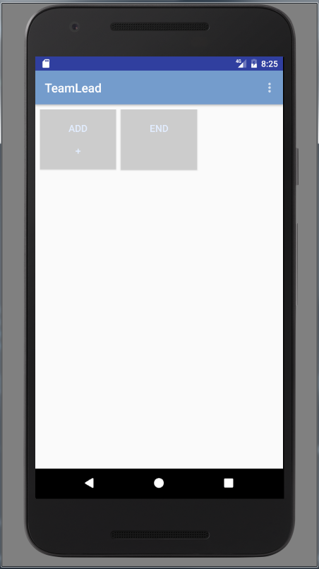

Figure 1: Default application home screen

On this screen, there are two special tiles labelled “add” and “end.” Pressing the “add” button will allow you to specify a new task tile. Pressing the “end” button will signify the end of the workday and generate a workday summary. Figure 2 illustrates the home screen with two user-defined task tiles added.

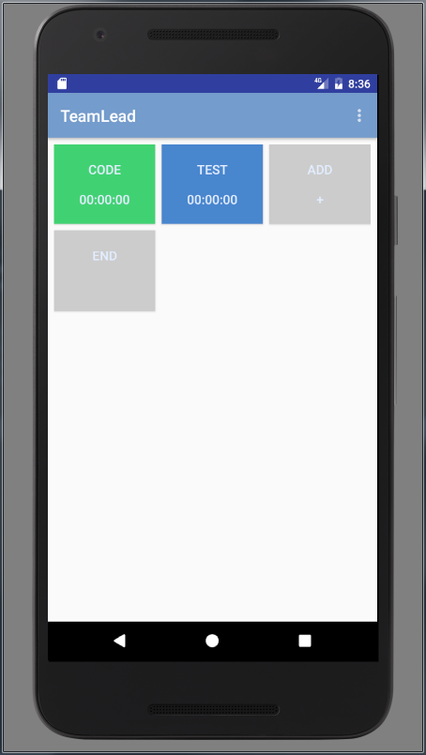

Figure 2: Home screen with user-defined task tiles added

Pressing any user-defined task tile will cause a “context switch” to that task; the button will appear pressed, and the timer will begin ticking while time is recorded against that activity. Figure 3 depicts a running “code” task.

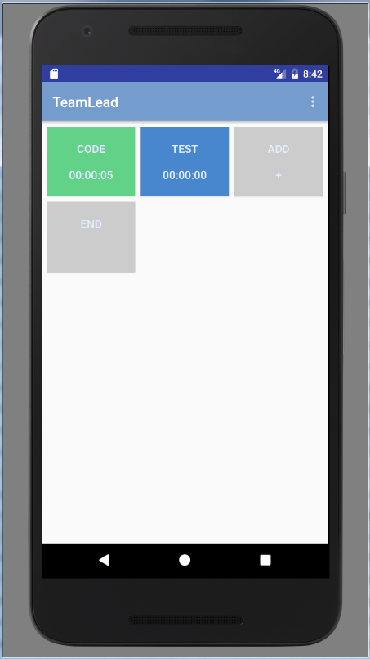

Figure 3: Home screen with active task

The selected task will stay active until a different task tile is pressed, or the workday is ended or reset.

# Adding a Task

Pressing the “add” button on the home screen will display a different screen that allows you to specify a new task tile. The add task screen is shown in Figure 4.

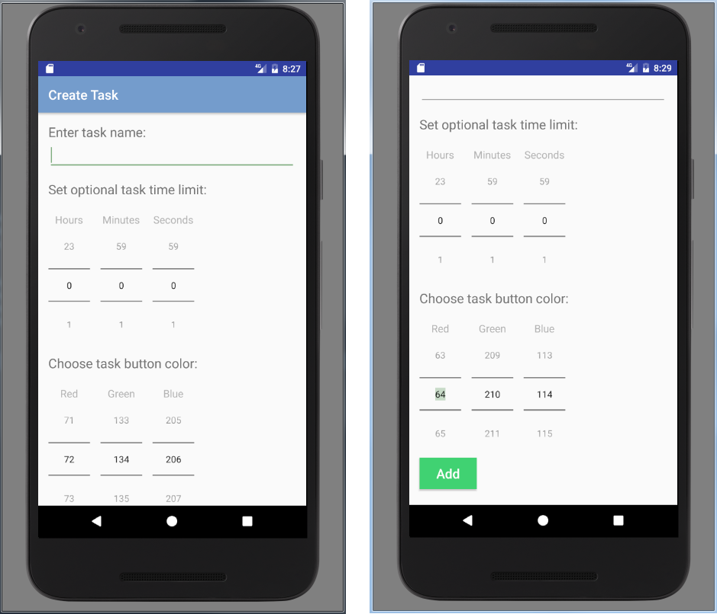

Figure 4: The screen used to specify a new task (left: upper scroll area, right: lower scroll area)

Through this screen, you may specify the task name (required), task time limit (optional), and task button color (optional).

The task name is used to identify the task and must be a unique string up to eight characters in length.

The task time limit can be used to notify you if the time spent on the task has exceeded your specified threshold. If no value is specified, the time limit is disabled.

The task button color changes the look of the task tile on the home screen. You can use the RGB sliders to change this color; a preview is shown on the “add” button as shown in Figure 4 each time the color is adjusted. By default, blue is specified. Task tiles are not required to have a unique color.

When finished, press the “add” button to add the task to the home screen as a new task tile.

# Delete or Edit a Task

Once a task has been added to the home screen, it can be deleted or edited by pressing and holding the task tile. Upon a press-and-hold, the context menu shown in Figure 5 appears.

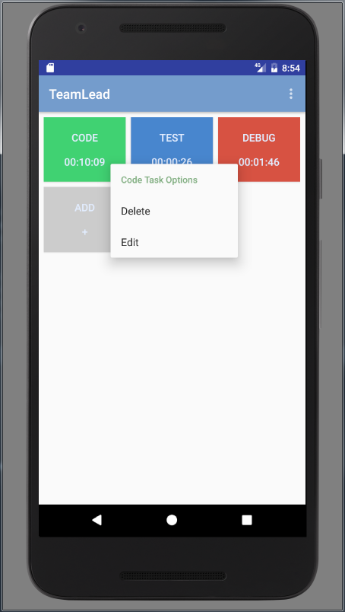

Figure 5: Task tile context menu

Select “delete” to remove the task tile. Alternatively, select “edit” to change the characteristics of the task. The special gray task tiles cannot be removed or modified.

# The Settings Menu

Figure 6 depicts the settings menu, which can be accessed by clicking the three white dots on the upper right corner of the screen.

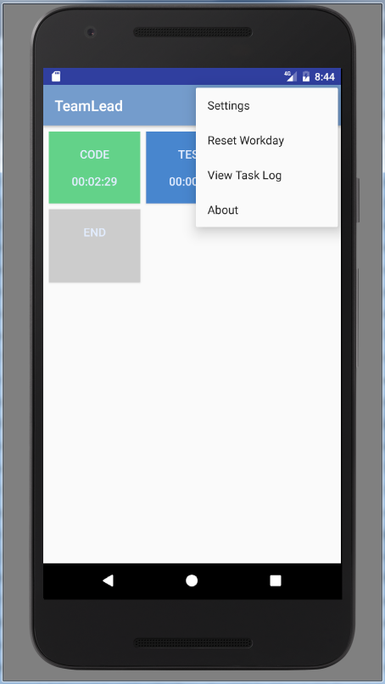

Figure 6: Settings menu expanded

## Viewing the Task Log

The task log allows you to see a text record of the full sequence of tasks that have been performed, including the amount of time spent on each individual iteration. An example of a task log is illustrated in Figure 7.

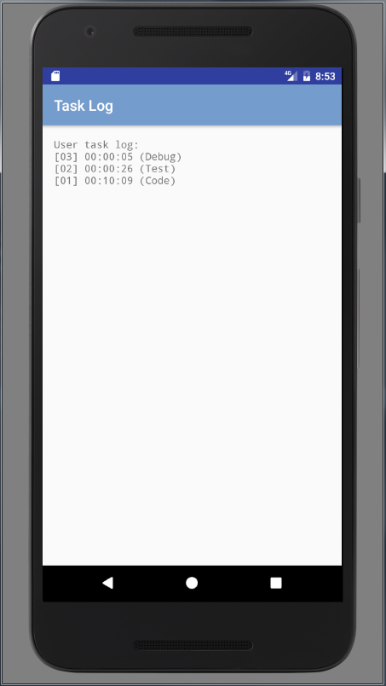

Figure 7: Sample task log

Here, the user first spent 10 minutes and 9 seconds on the “code” task, before switching to “test” for 26 seconds. The current active iteration (topmost record) is “debug” at five seconds and counting.

If no tasks have been selected, or the workday is reset, this log will be empty.

## Resetting the Workday

If you wish to clear all timing data, you can select “reset workday,” which will display the dialog shown in Figure 8.

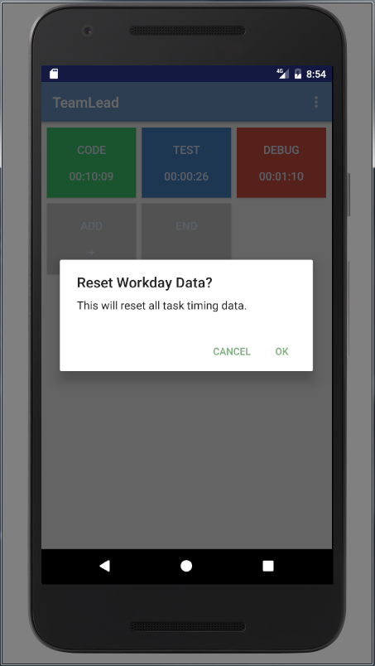

Figure 8: Workday reset confirmation dialog

Pressing “OK” resets all timing data to zero and clears the task log. The user task tiles are left intact; if you wish to delete them, you must use the “long-press” method and manually select “delete task.”

## Changing User Preferences

Other user preferences may be modified by clicking “settings,” such as the task tile refresh rate shown in Figure 9.

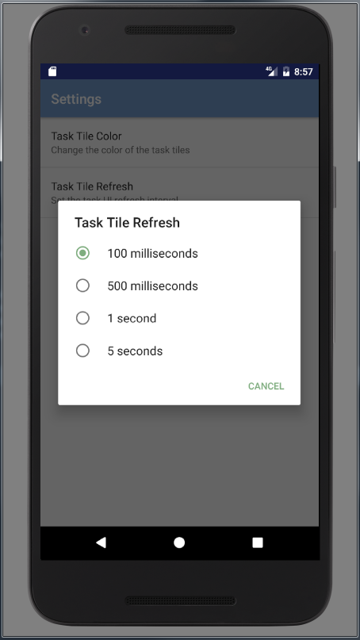

Figure 9: Task tile refresh settings dialog

This changes the rate at which the timers on the home screen are updated. The default value is 100 milliseconds.

# The Workday Summary

Pressing the “end” button on the home screen will signify the end of the workday and generate a workday summary. An example is shown in Figure 10.

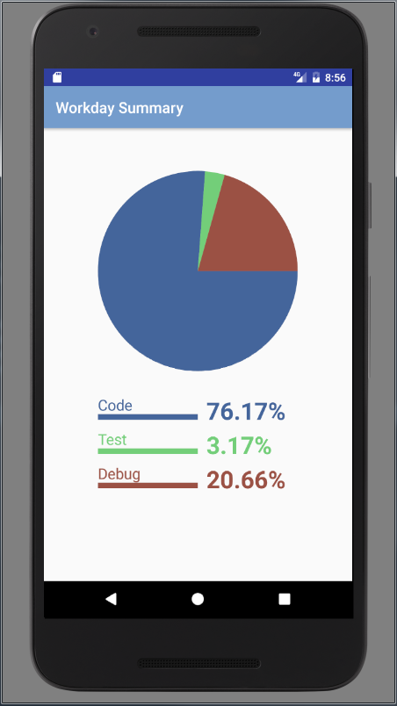

Figure 10: Sample workday summary

This screen visualizes the time allocation of your workday; the percentage of each pie chart segment corresponds to the time spent on the sum of every iteration of each task. If there are numerous tasks, these are drawn with different colors to show the contrast.

Additionally, a file containing the workday information is written to the device file system (the file is named “TL_Workday_<date>” and placed in the /Documents folder) upon generation of this screen. Once this graph is shown and the file is saved, the workday is considered concluded and all values are reset to zero.