Hobo Logger Deployment, retrieval, and data entry Standard Operating Procedure

Software
- Download Hoboware from https://www.onsetcomp.com/hoboware-free-download/
Getting a new hobo logger
- If you just purchased a hobo logger or you received it from a partner agency, you need to add the hobo logger serial number into hobo logger database:
  - Open the access database titled “HoboLogger_MetaData.accdb” on the Pdrive (path: P:\Lake Champlain FWCO\SALMON PROGRAM\Projects\HabitatData\HoboLoggers\Databases)
  - Open the “LookupTbl_HoboLoggers”
  - Enter the serial number in the serial number column, enter the data it was purchased if known, the type of logger it is (water temp, water temp and light, depth, etc.), the hobo logger model, and the owner of the logger.
  - Save the table by clicking the save icon in the top left of the database and close the table.
Connecting and launching hobo logger (If you have any issues, refer to the HOBOware User's Guide pdf file provided in this folder)
- Open Hoboware on computer
- Connect shuttle to computer with dongle
- Insert hobo logger into the shuttle and wait a second
- Press the shuttle lever down and hold for a second before releasing
  - Lights on the hobo logger should go to green
- Make sure the logger is not logging.
  - In hoboware go to the “Device” tab along the top and click “Stop…”
- Make sure the unit is logging in metric
  - Select the unit system key depicted below and select “SI” to ensure the logger is logging in metric (C)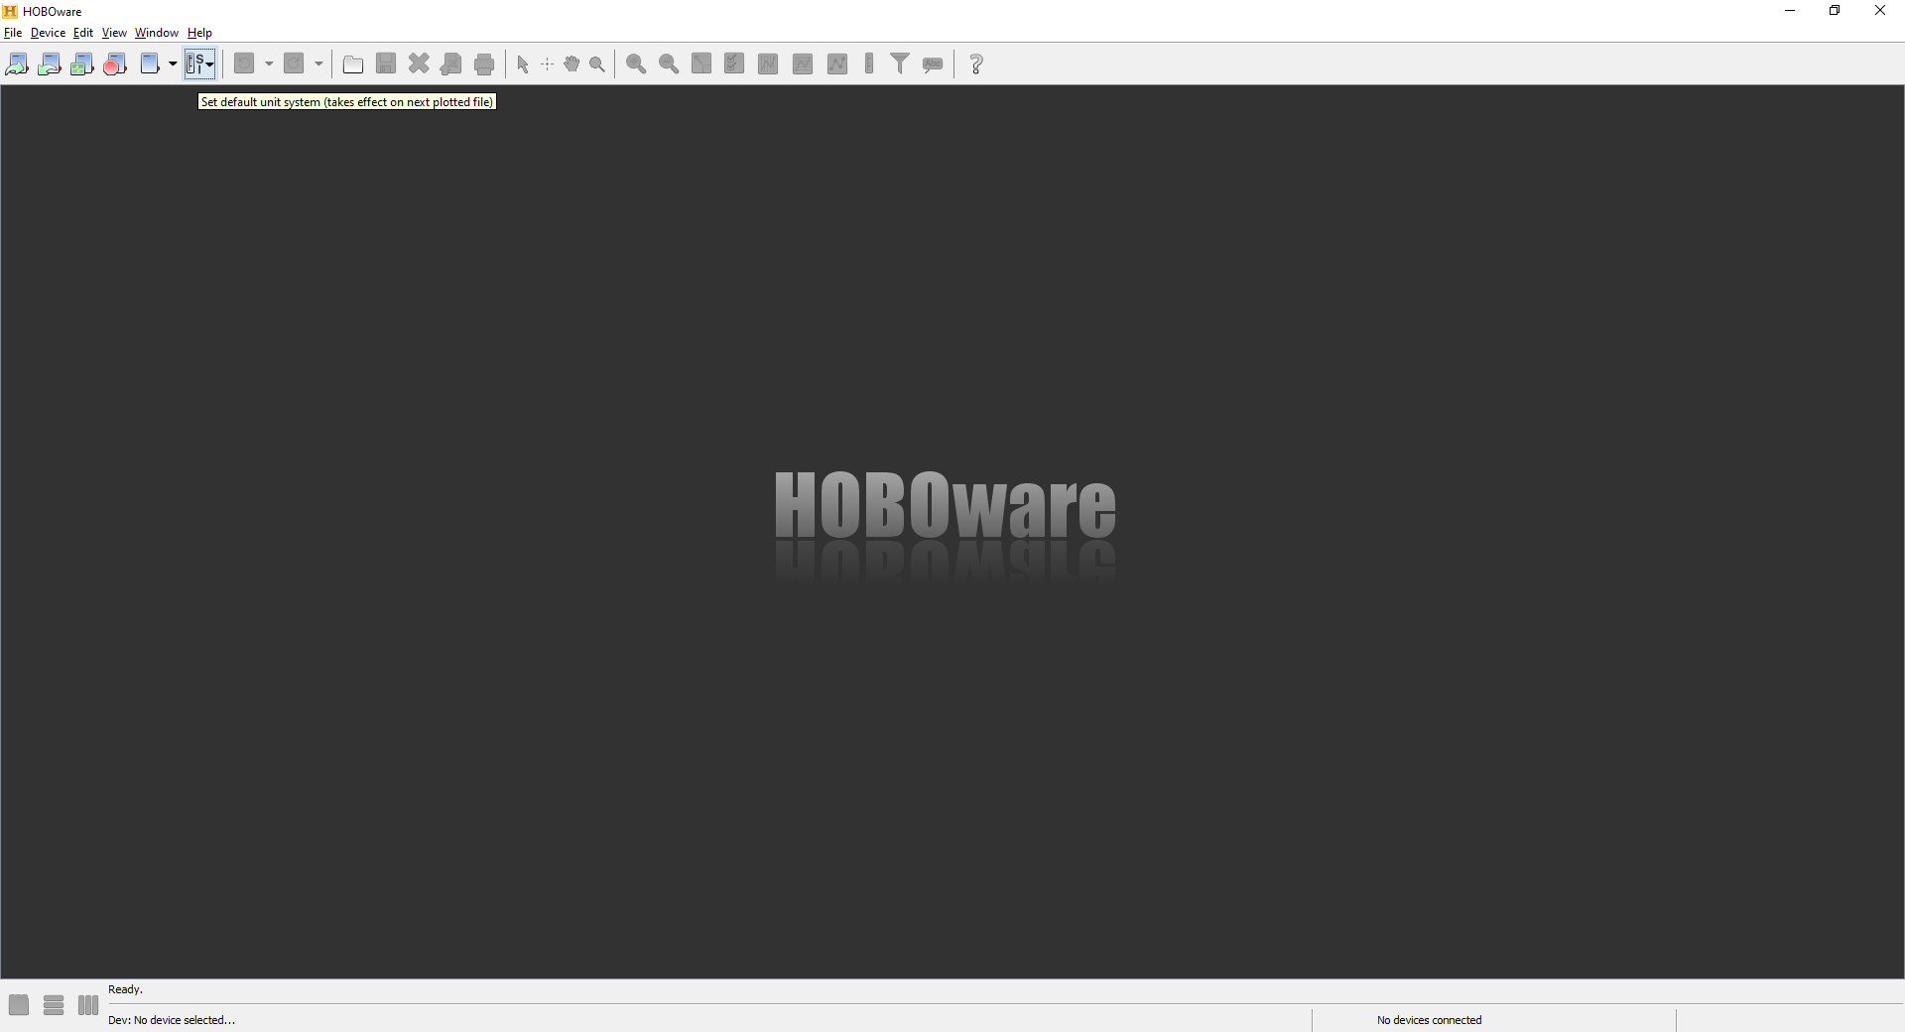
- Launch hobo logger and erase existing data
  - In the “Device” tab click “Launch…”
  - In the launch popup window
    - Make sure all Update the logging interval to 10 minutes
    - On the start logging dropdown menu select “Now”
    - Click “Start”
Deploying hobo logger
- Now the hobo logger is running and can be deployed
- Take the hobo logger to the site you would like to deploy it
- Record the serial number, date and time of deployment, and, if this is a new hobo logger site (i.e., not an established hobo logger deployment site listed in the access database Site table), take a waypoint with a GPS.
- Secure the logger in an area where it will remain submerged for the duration of the deployment. Chains, concrete blocks, zipties, and PVC piping are useful tools for setting
- Once you’re back in the office, open the access database
  - Open the “tbl Hobo Deployment”
  - Make entries for all hobo loggers deployed
    - HoboID is the site and deployment date (so BQ_Temp6_20210812 would be a hobo logger deployed in the Boquet river at site 6 on August 12, 2021)
    - Serial number is the serial number of the hobo logger (*Note it will not let you enter a hobo logger serial number that is not in the lookuptbl_hobologger)
    - SiteID should be one of the sites listed in the LookupTbl_Sites. If you deployed the hobo logger in a site not listed in the LookupTbl_Sites you will need to create a new entry in the LookupTbl_Sites table.
    - DeploymentDateTime is the GMT time when the hobo logger was deployed (YOU WILL NEED TO CONVERT THE LOCAL TIME TO GMT).
    - Leave RetrievalDateTime and Downloaded columns empty.
Retrieving hobo logger
- Visit the site a hobo logger was deployed and record the date and time you remove the hobo logger from the water as well as the serial number of the logger.
- Return to the office with retrieved hobo loggers and rinse and dry them off.
- Open Hoboware on computer
- Connect shuttle to computer with dongle
- Insert hobo logger into the shuttle and wait a second
- Press the shuttle lever down and hold for a second before releasing
  - Lights on the hobo logger should go to green
- Make sure the logger is not logging.
  - In hoboware go to the “Device” tab along the top and click “Stop…”
- Download the hobo logger data
  - In hoboware go to the “Device” tab along the top and click “Readout device”
- Use the HoboID from the access database to populate the filename and file description.
- Make sure the temperature is set to C and the Offset from GMT is set to 0
- Export the data to csv
  - Click the “File” tab and select “Export table data”
  - The file name should be the HoboID (e.g., BQ_Temp2_20210511.csv). Save the .csv and .hobo files to the correct river within the (P:\Lake Champlain FWCO\SALMON PROGRAM\Projects\HabitatData\HoboLoggers\Downloads) pathway.
- In the access database
  - Open the tbl Hobo Deployment
  - Fill in the RetrievalDateTime column with the GMT time the logger was pulled from the site (YOU WILL NEED TO CONVERT THE LOCAL TIME TO GMT) and check each “Downloaded” box once a logger has been downloaded.
  - If a hobo loggers was not recovered, leave the RetrievalDateTime and Downloaded columns blank and add a comment under the “Status” column in the LookupTbl_HoboLoggers
- Save all tables within the database and close the database

