  - Lake Champlain FWCO Salmon Team Hobo Loggers
  - Data Management & Workflow Plan: 2021-2025
The intent of this document is to describe the processes required to manage the data as well as map the locations of pertinent files/data of this study. Though it does incorporate some components of a Data Management Plan (DMP), it is intended to compliment the DMP and provide specific details associated with the data workflows. Overall, this document should be written in a manner that could allow the project to be easily handed over to a new person to allow them to follow the workflows.

Project Overview
This monitoring program is intended to document the spatiotemporal changes in water temperature in tributaries of Lake Champlain in light of various fisheries projects pertaining to landlocked Atlantic salmon Salmo salar restoration and climate change.
Using temperature loggers (Onset HOBO waterproof temperature data loggers; Model: U22-001 Pro V2), we will monitor and compare the spatiotemporal changes in temperature among tributaries of Lake Champlain. To obtain water temperature measures, US Fish and Wildlife Service (USFWS) personnel will maintain a conduct a sampling effort in the St. Louis River (i.e., Hwy 2 bridge to Spirit Lake) for 1 week per month for 5 consecutive months (i.e. May through September). There will be 5 zones for which replicate sampling will be conducted (i.e., orange circles, Fig. 1). 3 fyke nets will be deployed in each zone and lifted for 3 consecutive days (i.e, black circles below). A traditional eDNA water sample (e.g. 1 liter) will be collected on the outside end of each fyke net prior to retrieving the fyke nets within each zone. One electrofishing transect in each zone for each week sampling will also be conducted. Finally, one horizontal larval fish tow along these same transects will be conducted to test whether any efficiency is gained from the "plankton net decant" approach. This total effort would equate to 250 traditional gear samples and 250 eDNA samples per year for two years. The remaining 50 samples would be allocated to the inland lake project, for which USFWS interested in understanding whether cold water species are present. This will yield a total of 300 samples per year.
The Strategic Plan for Lake Champlain Fisheries 2020 calls for the restoration of landlocked Atlantic salmon Salmo salar (hereafter referred to as salmon) in the Winooski, Boquet, and Saranac Rivers. To evaluate restoration progress, the Strategic Plan emphasizes the importance of first monitoring the recruitment of salmon spawners into each river and preferred habitat followed by their subsequent spawning success and recruitment of fry. Therefore, redd mapping has been proposed as an action item to evaluate spawning success spatially and temporally in these rivers.
Since 2015, redd surveys have been conducted in the Boquet and Winooski Rivers. We will be conducting redd surveys to locate and document the distribution of redds, or absence of redds, in established (fixed) sites in the Boquet and Winooski Rivers each fall from later October through early December. A team of two or more individuals will be used for each redd survey. Each site will be visited at least once every two weeks (replicate sampling) to ensure redds laid down early, or late, in the season are captured by the survey. For each trip to a site; trip-specific, redd-specific, and fish-specific data will be collected.

Site and Trip specific data
Prior to the season, redd surveyors should visit each site to become familiar with their locations and familiarize themselves with what the substrate looks like prior to redds being laid down. This is an opportunity for experienced staff to train new staff in on how to work the equipment and go over the datasheets/Survey123.
Surveys should start in the late morning and end in the early afternoon to maximize sunlight and visibility. All staff should wear polarized sunglasses to see better into the water. When a team arrives at a site, they will begin at the upstream end and will record the site ID, date, members of the team, start time, surface water temperature, and weather conditions. Staff should then start walking downstream along the riverbank since this generally provides some elevation and increases the observable area as well as reduces disturbance to the water which can disturb salmonids in the area, reduce visibility, and provides more opportunity for accidents. However, staff will need to wade into the river if there are areas that cannot be seen from the riverbank. Surveyors will stop and collect redd- or salmonid-specific data (see below) if any are spotted. Once the surveyors reach the downstream-most point of the site, they will record an end time. Additionally, since water conditions can the accuracy of redd surveys (Dunham et al. 2001), surveyors will provide a trip-specific ranking of the visibility at the end of the site.

Redds
Once a redd is identified, surveyors should wade into the river and approach the redd being careful not to disturb it. Surveyors will then take a GPS location of the redd on the hand-held GPS unit and record the redd waypoint name on the datasheet. After the redd has been digitally marked with a GPS waypoint, surveyors should physically mark the redd so it will not be recounted during replicate visits to this site. To do this, fill a small cotton bag with rocks and tie a piece of flagging tape to it. This marker can they be dropped in the pot of the redd.
Since other Salmonidae species occupy these rivers and produce redds of varying sizes (Eddy and Underhill 1978) and salmon can create “test” redds (incomplete redds; Dunham et al. 2001), surveyors will take length, width, and depth measurements of the redd. Using a rolatape and marked wading staffs (or trekking poles), surveyors will measure the maximum depth of the pot, usually in the center. Be sure the measure stick is plume (straight up and down) when taking the measurement. When taking length and width measurements, find the endpoints of the length/width and put the trekking poles at these points. Ensure the poles are plume (straight up and down) and use the measuring tape to measure the distance between the trekking poles. Lengths should be taken from the upstream-most, central portion of the pot to the downstream-most, central portion of the tailspill. Widths should be taken at the widest part of the pot. Finally, surveyors will document the dominant substrate of the pot and tailspill. These measures will be used as a covariate to determine whether substrate impacts redd production.

Assessing Surveyor Efficiency
Besides physically marking redds and thoroughly surveying an entire site, having more experienced surveyors paired with less experienced surveyors when working in multiple teams can reduce error (Muhfeld et al. 2006). Additionally, redd detection efficiency of individual surveyors can be assessed. This can be done by having all surveyors sample a given reach on the same day with surveyors working independently rather than in teams. The most experienced surveyor should be the last surveyor to sample the reach. Redd counts and locations should be compared across surveyors. Discrepancies between surveyors will allow data analysts to incorporate individual surveyor errors into their spawner population estimate.

Fish
In addition to knowing the size of redds, knowing if specific salmonid species are near a given redd can help discern whether a redd should be classified as a salmon redd or another salmonid species. Therefore, surveyors should take waypoints where any salmonids are seen while surveying a site and provide an estimated total length and sex (if apparent).

References
Dunham, J., B. Rieman, and K. Davis. 2001. Sources and magnitude of sampling error in redd counts for Bull Trout. North American Journal of Fisheries Management 21:343–352.
Eddy, S., and J. C. Underhill. 1978. How to Know the Freshwater Fishes, 3rd edition. Wm. C. Brown Company Publishers, Dubuque, Iowa.
Muhlfeld, C. C., M. L. Taper, and D. F. Staples. 2006. Observer error structure in bull trout redd counts in Montana streams: implications for inference on true redd numbers. Transactions of the American Fisheries Society135:643–654.

Roles and Responsibilities
Data Trustee: William Ardren
Data Steward: Jonah Withers
Data Custodians: Jonah Withers, Kurt Heim
Data Producers: Bryan Ross, Ryan Schleicher, Zachary Eisenhauer, Dylan Jennison, Shelby Scarfo, Nicole Balk, Jonah Withers, Kurt Heim

Data Management Timeline
This study began in September 2014 in the Winooski River and September 2015 in the Boquet River. Data collection is scheduled to continue until 2025 when the DMP and project objectives are reassessed.

File Locations
Table 1. Locations and owners of data, files, scripts, and other pertinent information for the study.
Data/File | File Name | Location | Owner | Link/Folder Path
Completed Datasheets |  | Binder in Salmon team technician bookshelf | Jonah_withers@fws.gov | Hard copies
Completed Datasheets | P:\Lake Champlain FWCO\SALMON PROGRAM\Projects\Lake_Champlain_Redd_Surveys\CompletedDataSheets | Lake Champlain FWCO P:drive | Jonah_withers@fws.gov | P:\Lake Champlain FWCO\SALMON PROGRAM\Projects\Lake_Champlain_Redd_Surveys
Survey123 Form | LakeChamplainReddSurveys | ArcGIS Online | Jonah_withers@fws.gov | Survey123 Form
Redd Survey Data (Hosted Feature Layer) | LakeChamplainLandlockedAtlanticSalmonReddSurveys | ArcGIS Online | Jonah_withers@fws.gov | Hosted Feature Layer
Survey Data (Layer View) | LakeChamplainLandlockedAtlanticSalmonReddSurveys (Public View) | ArcGIS Online | Jonah_withers@fws.gov | Layer View
Metadata file | TBD | TBD | Jonah_withers@fws.gov | TBD
Dashboard | LakeChamplainReddSurveys | ArcGIS Online | Jonah_withers@fws.gov | Redd Survey Dashboard
QC R Script | LC_ReddSurvey_QC.Rmd | USFWS GitHub | Jonah_withers@fws.gov | Git Hub
Data conversion R Script | WriteAccessTablesToGeoDB.R | USFWS GitHub | Jonah_withers@fws.gov | Git Hub
Lake Champlain FWCO Access Database | AtlanticSalmonReddSurveyLakeChamplainTrib.accdb | Lake Champlain FWCO P:drive | Shared | P:\Lake Champlain FWCO\SALMON PROGRAM\Projects\Lake_Champlain_Redd_Surveys
Data Correction Log | LLS_ReddSurvey_DataLog_2021.docx | Lake Champlain FWCO P:drive | Shared | P:\Lake Champlain FWCO\SALMON PROGRAM\Projects\Lake_Champlain_Redd_Surveys
AGOL Backups | LakeChamplainLandlockedAtlanticSalmonReddSurveys.gdb | Lake Champlain FWCO P:drive | Shared | P:\Lake Champlain FWCO\SALMON PROGRAM\Projects\Lake_Champlain_Redd_Surveys\ArcGIS

Data Workflows
This study has numerous steps that are required in order to ensure the integrity of the data remains intact. Therefore, this section is intended to describe the steps within this workflow that are illustrated in Figure 1.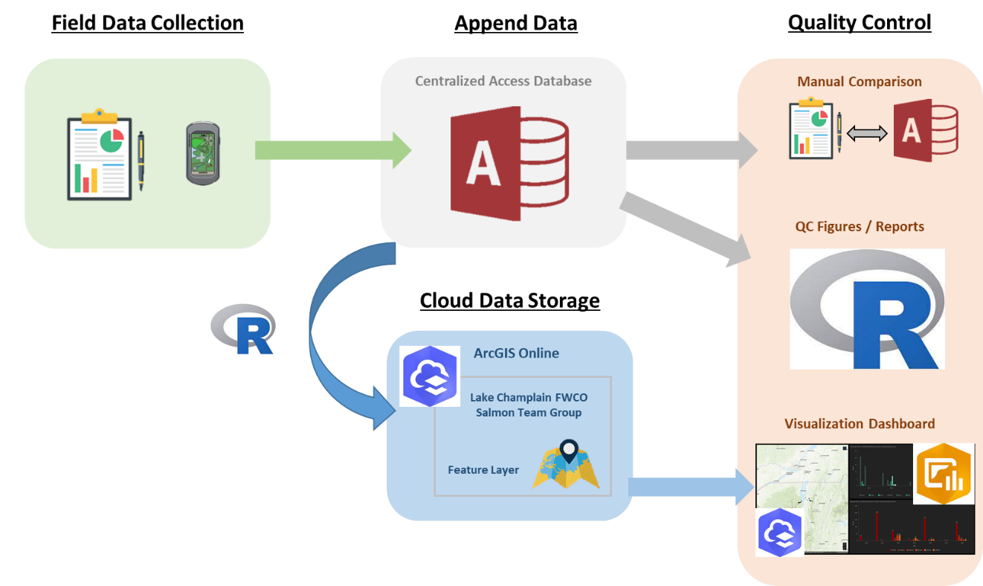
Figure 1: This illustration demonstrates the Lake Champlain FWCO workflow from field data collection to appending data to a centralized Access database. See text for explanations of each step.

Field Data Collections
The field data pertaining to Atlantic salmon redd surveys are being collected and recorded on rite-in-the-rain paper data sheets and hand-held Garmin GPS units. Although Survey 123 and other digital recording software can improve data collection workflows, a limited number of iPads has delayed the incorporation of Survey123 into this workflow. However, a Survey123 has been created and is being hosted if management decides to incorporate Survey 123, or other digital data collection tools, into this workflow. In the absence of using a digital collection tool, a form has been created in the Microsoft Access database which restricts answers to limited choices to reduce and prevent transcription errors. When the survey was published, the form template was saved to ArcGIS Online (AGOL) and the hosted feature layer (relational feature data) was created in AGOL.

Data Structure (click to expand)
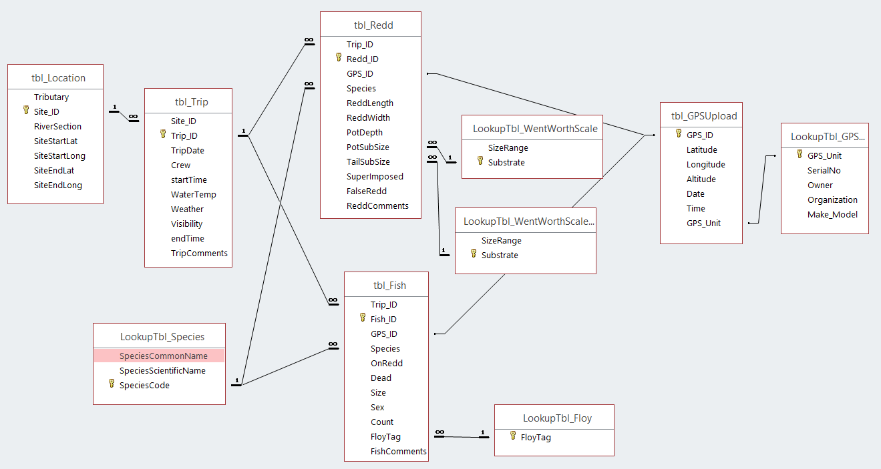

Data Dictionaries (click to expand)

tbl_Location
Field Name | Data Type | Definition | Domains | Domain Definitions
Tributary | Character | Tributary name (e.g. Boquet River)
Site_ID | Character | Unique ID of a specific site within a river
RiverSection | Character | Area Sampled within tributary (e.g. north branch)
ReachStartLat | Numeric | Latitude where a site begins (format: dd.dddddd)
ReachStartLong | Numeric | Longitude where a site begins (format: dd.dddddd)
SiteEndLat | Numeric | Latitude where a site ends (format: dd.dddddd)
SiteEndLong | Numeric | Longitude where a site ends (format: dd.dddddd)

tbl_Trip
Field Name | Data Type | Definition | Domains | Domain Definitions
Site_ID | Character | Unique ID of a specific site within a river
Trip_ID | Numeric | Unique ID of a specific visit to a site. This is auto-generated.
TripDate | Datetime | Date in when the trip occurred
Crew | Character | List of individuals on trip. First initial and last name of each person
startTime | Datetime | Start time of redd survey on this given trip
WaterTemp | Numeric | Surface water temperature (degrees Fahrenheit)
Weather | Character | Weather conditions
Visibility | Character | Water clarity on a scale of 1 to 5 with 1 being low and 5 being high | 1 | Low
Visibility | Character |  | 2
Visibility | Character |  | 3 | Medium
Visibility | Character |  | 4
Visibility | Character |  | 5 | High
endTime | Character | End time of redd survey on this given trip
TripComments | Datetime | Date in which the record was edited

tbl_Redd
Field Name | Data Type | Definition | Domains | Domain Definitions
Trip_ID | Numeric | Unique ID of a specific visit to a site. This is auto-generated.
Redd_ID | Numeric | Unique ID of a redd identified. This is auto-generated.
GPS_ID | Character | Unique ID of a specific waypoint name used to mark coordinates of redd location. These include 2-digit GPS number, date, site number, and redd number (e.g., 01-yymmdd-04-01)
Species | Character | Species suspsected to have made redd (3 digit code from species lookup table) | ALS | Atlantic salmon
Species | Character |  | BKT | Brook trout
Species | Character |  | BWN | Brown trout
Species | Character |  | RBT | Rainbow trout
Species | Character |  | SLR | Sea lamprey
ReddLength | Numeric | Length of redd measured from center, upstream-most past of the redd's pot to the downstream-most part of the redd's tailspill in centimeters
ReddWidth | Numeric | Width of redd’s pot measured from the widest part of the pot in in cm
PotDepth | Numeric | Depth of redd’s pot measured at the deepest part of the pot in in cm
PotSubSize | Character | Dominant substrate type of redd’s pot | Bedrock | Consistent
PotSubSize | Character | Dominant substrate type of redd’s pot | Boulder | >256 mm
PotSubSize | Character | Dominant substrate type of redd’s pot | Clay | .98 - 3.9 µm
PotSubSize | Character | Dominant substrate type of redd’s pot | Cobble | 64 - 256 mm
PotSubSize | Character | Dominant substrate type of redd’s pot | Pebble | 2 - 64 mm
PotSubSize | Character | Dominant substrate type of redd’s pot | Sand | 62.5 µm - 2 mm
PotSubSize | Character | Dominant substrate type of redd’s pot | Silt | 3.9-62.5 µm
TailSubSize | Character | Dominant substrate type of redd’s tailspill | Bedrock | Consistent
TailSubSize | Character | Dominant substrate type of redd’s tailspill | Boulder | >256 mm
TailSubSize | Character | Dominant substrate type of redd’s tailspill | Clay | .98 - 3.9 µm
TailSubSize | Character | Dominant substrate type of redd’s tailspill | Cobble | 64 - 256 mm
TailSubSize | Character | Dominant substrate type of redd’s tailspill | Pebble | 2 - 64 mm
TailSubSize | Character | Dominant substrate type of redd’s tailspill | Sand | 62.5 µm - 2 mm
TailSubSize | Character | Dominant substrate type of redd’s tailspill | Silt | 3.9-62.5 µm
SuperImposed | Numeric | Number of redds the GPS coordinate corresponds to
FalseRedd | Character | Is this a false or incomplete redd? | Yes/No
ReddComments | Character | Any comments associated with the redd

tbl_Fish
Field Name | Data Type | Definition | Domains | Domain Definitions
Trip_ID | Numeric | Unique ID of a specific visit to a site. This is auto-generated.
Fish_ID | Numeric | Unique ID of a fish identified. This is auto-generated.
GPS_ID | Character | Unique ID of a specific waypoint name used to mark coordinates of redd location. These include 2-digit GPS number, date, site number, and redd number (e.g., 01-yymmdd-04-01)
Species | Character | Species suspsected to have made redd (3 digit code from species lookup table) | ALS | Atlantic salmon
Species | Character |  | BKT | Brook trout
Species | Character |  | BWN | Brown trout
Species | Character |  | RBT | Rainbow trout
Species | Character |  | SLR | Sea lamprey
OnRedd | Character | Was the fish seen on a redd? | Yes/No
Dead | Character | Was the fish dead? | Yes/No
Size | Integer | Estimated total length (inches)
Sex | Character | What was the sex of the fish? | Male
Sex | Character | What was the sex of the fish? | Female
Sex | Character | What was the sex of the fish? | Unknown
Count | Integer | Number of fish at this waypoint
FloyTag | Character | Was there a color tag on the fish? If so what color? | None
FloyTag | Character | Was there a color tag on the fish? If so what color? | Orange
FloyTag | Character | Was there a color tag on the fish? If so what color? | Pink
FloyTag | Character | Was there a color tag on the fish? If so what color? | Yellow
FishComments | Character | Any comments about the fish or where it was found

tbl_GPSUpload
Field Name | Data Type | Definition | Domains | Domain Definitions
GPS_ID | Character | Unique Identifier the waypoint taken
Latitude | Numeric | Latitude where waypoint was taken in decimal degrees (dd.dddddd)
Longitude | Numeric | Longitude where waypoint was taken in decimal degrees (dd.dddddd)
Altitude | Numeric | Altitude where waypoint was taken (in feet)
Date | Datetime | Date when waypoint was taken
Time | Datetime | Time when waypoint was taken
GPS_Unit | Character | Creation date of record

Cloud Data Storage
AGOL is a cloud-based data storage platform for Service employees to use for collecting and managing their data. For this project, hosted feature layer (LakeChamplainReddSurveys) is “owned” by the user (e.g., jonah_withers@fws.gov) that created them and are stored in their respective AGOL account.

Additional Details (click to expand)
To protect the hosted feature layer from being deleted or modified, a feature layer view (LakeChamplainReddSurvey (Public View)) was created in AGOL for creating dashboards and accessing with R. The layer view is shared with the public in order to be accessible by R while the hosted feature layer is only shared with the owner and the Lake Champlain Fish and Wildlife Conservation Office (LCFWCO) Salmon Team group. All layers in AGOL are set to “Prevent this item from being accidentally deleted” in the settings.
The LCFWCO Salmon Team group within AGOL is owned/managed by one individual to control accessibility to the data (Table 1). Only members of the group can view or edit the data.
Warning: If an employee leaves the service or responsibilities are reassigned to a new individual, the forms, data, maps, and dashboards will need to be transferred to the new person. If this does not happen before an account is terminated, everything is lost on that users account and cannot be recovered.

Quality Assurance/Quality Control
Survey123 forms used for data collection were designed to reduce errors when entering data into forms. Errors are prevented by implementing required fields, calculated fields, and incorporating standardized domains in field options (refer to table 1 to find the Survey123 form that houses these operations). The required fields must have data input before submitting a survey.
Since digital data collection is not being used at this time due to limited hardware and time for training staff, data are being manually recorded on rite-in-the rain paper and GPS coordinates are being logged on individual Garmin Rhino units. At the end of each week, all original copies of datasheets should be stored in a binder within the LCFWCO salmon team office and digital copies should be archived on the LCWFCO’s public drive (refer to table 1 to find the directory). GPS’s should be downloaded weekly to prevent data loss if units are damaged or lost during field operation. GPS downloads should be uploaded and archived to the LCFWCO’s public drive (refer to table 1 to find the directory).
After original copies are stored and backed up digitally, data are transcribed to a centralized Microsoft Access database stored on the LCFWCO’s public drive (refer to table 1 to find the directory). An Access form (Frm_Trip) was created to reduce errors when transcribing data. Errors are prevented by implementing unique identifying fields auto-generated, standardized fields for each variable, relational tables, and restricting responses to preset responses. Additionally, GPS coordinates should be uploaded to the GPS table (tbl_GPSUpload) within the Access database.
The data should then be run through an R Markdown script (LC_ReddSurvey_QC.Rmd; Table 1) to ensure data are not missing, coordinates are within a sampling area or zone, and values are within expected values. In addition, an R script (WriteAccessTablesToGeoDB.R; Table 1) should be run to provide an up-to-date geodatabase to be pushed to AGOL and the LCFWCO’s public drive (refer to table 1 to find the links and path). Once the geodatabase has been updated and pushed to AGOL, the dashboard (Table 1) can be used for a rapid visualization of data to inspect for possible errors, as well as a means to track progress in the field.
Finally, the Access database can be visually compared to the raw datasheets to ensure no data is missing or has been entered incorrectly. If any data need to be culled or corrected, the changes must be noted in the data log (Table 1). Once data are corrected, the collector that corrects the error notes the data and their initials in the data log. Then run the quality control R Markdown and dashboard update again to ensure all corrections were made and processed.

Software Details (click to expand)
In order to run the R Markdown script, the user will need to download the latest R, R Studio, ArcGIS Pro, and an offline ArcGIS Pro license. The offline license can be accessed by opening ArcGIS Pro, opening settings, select licensing, and checking the Authorize ArcGIS Pro to work offline box. Once you have the license, the expiration date will appear in the license boxes. In addition, the feature layer will need to be share with the public on AGOL. In order to run Survey123 and access AGOL shared layers and dashboards, individuals will need to change their role by clicking request a change to your role here.

AGOL Backups (click to expand)
Everything stored on ArcGIS Online is backed up on the shared drive (Table 1). The hosted feature layer is backed up at the end of the field season and all data have been checked. All other files are backed up every time a change is made.

