  - Lake Champlain FWCO Salmon Team Hobo Loggers
  - Data Management & Workflow Plan: 2021-2025
The intent of this document is to describe the processes required to manage the data as well as map the locations of pertinent files/data of this study. Though it does incorporate some components of a Data Management Plan (DMP), it is intended to compliment the DMP and provide specific details associated with the data workflows. Overall, this document should be written in a manner that could allow the project to be easily handed over to a new person entering the Data Trustee, Data Steward, or Data Custodian role to allow them to follow the workflows.

Project Overview
This monitoring program is intended to document the spatiotemporal changes in water temperature in tributaries of Lake Champlain in light of various fisheries projects pertaining to landlocked Atlantic salmon Salmo salar restoration and climate change. To obtain water temperature measures, US Fish and Wildlife Service (USFWS) personnel will maintain water temperature loggers (Onset HOBO waterproof temperature data loggers; Model: U22-001 Pro V2) at fixed sites within tributaries of Lake Champlain.

Roles and Responsibilities
Roles and responsibilities listed below follow US Fish and Wildlife Service data management guidelines. Descriptions of these roles and responsibilities can be found here.
Data Trustee: William Ardren
Data Steward: Jonah Withers
Data Custodians: Jonah Withers, Kurt Heim
Data Producers: Bryan Ross, Ryan Schleicher, Zachary Eisenhauer, Dylan Jennison, Shelby Scarfo, Jonah Withers, Kurt Heim

Data Management Timeline
This data management workflow is intended to help collect and archive data and meta-data associated with temperature and light profilers across various projects. Therefore, the timeline is indefinite or until the databases are deemed obsolete and replaced by a more preferred workflow.

File Locations
Table 1. Locations and owners of data, files, scripts, and other pertinent information for the study.
Data/File | File Name | Location | Owner | Link/Folder Path
Completed Datasheets |  | Binder in Salmon team technician bookshelf | Shared | Hard copies
Completed Datasheets | P:\Lake Champlain FWCO\SALMON PROGRAM\Projects\Lake_Champlain_Redd_Surveys\Datasheets\CompletedDataSheets | Lake Champlain FWCO P:drive | Shared | P:\Lake Champlain FWCO\SALMON PROGRAM\Projects\HabitatData\HoboLoggers\DataSheets\CompletedDataSheets
Metadata file | TBD | TBD | Jonah_withers@fws.gov | TBD
QC R Script | LCFWCO_HoboLoggerQC.Rmd | USFWS GitHub | Jonah_withers@fws.gov | Git Hub
Lake Champlain FWCO Access Database | HoboLogger_MetaData.accdb | Lake Champlain FWCO P:drive | Shared | P:\Lake Champlain FWCO\SALMON PROGRAM\Projects\HabitatData\HoboLoggers\Databases
Data Correction Log | HoboLogger_DataLog_2021.docx | Lake Champlain FWCO P:drive | Shared | P:\Lake Champlain FWCO\SALMON PROGRAM\Projects\HabitatData\HoboLoggers

Data Workflows
This workflow has numerous steps that are required in order to ensure the integrity of the data remains intact. Therefore, this section is intended to describe the steps within this workflow that are illustrated in Figure 1.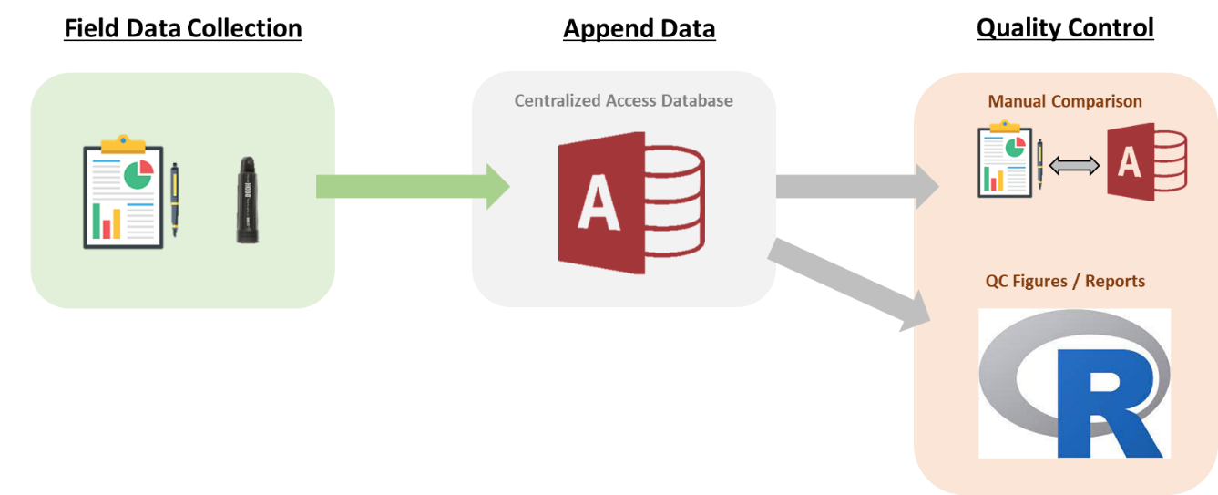
Figure 1: This illustration demonstrates the Lake Champlain Fish and Wildlife Conservation Office (LCFWCO) hobo logger workflow from field data collection to appending data to a centralized Access database. See text for explanations of each step.

Field Data Collections
The field data should be collected and recorded on rite-in-the-rain paper data sheets. Loggers should be programmed to log and record once every 30 minutes at a minimum; however, this can be adjusted to log at a finer scale depending on project needs. Staff should download and redeploy loggers on a regular basis (minimum of every three months) to ensure data are not lost if the logger is destroyed, stolen, corrupted, or damaged in some way. To remove data prior to logger deployment and data following logger retrieval within the field, it is crucial staff record the serial number of the logger and the date and time the logger is being retrieved and/or deployed in the field. When entering deployment and retrieval times into the Access database, dates and times should first be standardized to GMT + 0:00 time zone. Hobo loggers should be downloaded in the GMT + 0:00 time zone and both a .csv and .hobo file should be saved to the LCFWCO public drive (pathway to directory can be found in Table 1).

Data Structure (click to expand)
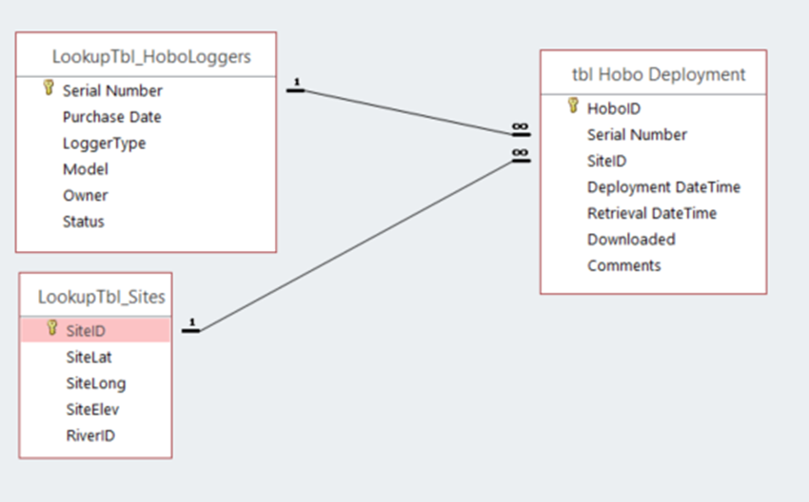

Data Dictionaries (click to expand)

tbl Hobo Deployment
Field Name | Data Type | Definition | Domains | Domain Definitions
HoboID | Character | Filename of the hobo logger download (River, Site, and deployment date; e.g., BQ_Temp5_20210812)
Serial Number | Character | Serial number of hobo logger
SiteID | Character | Unique ID of location where hobo logger is deployed (e.g. Temp5)
Deployment DateTime | Date | Date and time a logger was deployed in the field (GMT)
Retrieval DateTime | Date | Date and time a logger was recovered from the field (GMT)
Downloaded | Yes/No | Was the logger downloaded? | Yes/No
Comments | Character | Any comments associated with the deployment or retrieval of a logger such as “missing as of 2021-01-10”

LookupTbl_HoboLoggers
Field Name | Data Type | Definition | Domains | Domain Definitions
Serial Number | Character | Serial number of hobo logger
Purchase Date | Date | Date when logger was purchased
LoggerType | Character | Probes associated with the logger (e.g.; water, water and light, etc.)
Model | Character | Model of the hobo logger
Owner | Character | Agency the hobo logger belongs to
Status | Character | Is it damaged, missing, etc.

LookupTbl_Sites
Field Name | Data Type | Definition | Domains | Domain Definitions
Site_ID | Character | Unique ID of location where hobo logger is deployed (e.g. Temp5)
SiteLat | Numeric | Latitude of site (dd.dddddd)
Site_Long | Numeric | Longitude of site (dd.dddddd)
SiteElev | Character | Elevation of the site (feet)
RiverID | Character | River the site is located in

Quality Assurance/Quality Control
Since digital data collection is not being used at this time due to limited hardware and time for training staff, data are being manually recorded on rite-in-the rain paper and GPS coordinates are being logged on individual Garmin Rhino units. Following a hobo logger deployment and/or retrieval, all original copies of datasheets should be stored in a binder within the LCFWCO salmon team office and digital copies should be archived on the LCWFCO’s public drive (refer to table 1 to find the directory). Waypoints associated with hobo logger deployments should also be downloaded following the deployment to prevent data loss if units are damaged or lost during field operation. GPS downloads should be uploaded and archived to the LCFWCO’s public drive (refer to table 1 to find the directory).
After original copies are stored and backed up digitally, data are transcribed to a centralized Microsoft Access database stored on the LCFWCO’s public drive (refer to table 1 to find the directory) by a Data Custodian. If a hobo logger is deployed in a new site, GPS coordinates should be uploaded to the Site table (LookupTbl_Sites) within the Access database if a new site has been created. Once the site table is up-to-date the Data Custodian will enter the deployment and retrieval times for each logger in GMT + 00:00 time format. Data entry should be checked by a second individual to prevent transcription errors.
The data should then be run through an RMarkdown script (LCFWCO_HoboLoggerQC.Rmd; Table 1) to ensure data files were downloaded in the correct time zone (GMT + 00:00) and temperature unit (Celsius), if there are any missing files, and that site coordinates were entered correctly.
Finally, the Access database can be visually compared to the raw datasheets to ensure no data is missing or has been entered incorrectly. If any data need to be culled or corrected, the changes must be noted in the data log (Table 1). Once data are corrected, the collector that corrects the error notes the data and their initials in the data log. Then run the quality control RMarkdown again to ensure all corrections were made and processed.

Software Details (click to expand)
In order to download the hobo loggers the user will need to download Hoboware from the website here. In order to run the RMarkdown script, the user will need to download the latest R and R Studio.

