Nur Asyira Fitri Binte Razali
P03 | S10270371F
CVNL Assignment
Technical Documentation
Changi Airport Virtual Assistant
RNN INTENT CLASSIFICATION

Table of Contents
1. Problem Context & Real-World Application 4
1.1 Business Problem 4
1.2 Proposed AI Solution 5
1.2.1 System Workflow 5
2 Dataset: ATIS Dataset 6
2.1 Why ATIS Dataset? 6
2.2 Selected Intent Categories 7
2.3 Dataset Statistics 7
3 Data Preprocessing Pipeline 8
3.1 Data Loading and Filtering 8
3.2 Vocabulary Construction 9
3.3 Text Tokenization and Padding 10
3.4 Class Imbalance Handling 10
4 Model Design & Architecture 11
4.1 iteration 4: Bidirectional LSTM + Dropout (Layer-by-Layer Explanation) 11
4.2 Design Decisions 12
5 Implementation Details 13
5.1 Technology Stack 13
5.2 Hyperparameters 13
5.3 Training Configuration 14
6 Iterative Model Development 14
6.1 Iteration 1: Baseline Simple RNN 14
6.1.1 Performance: 15
6.1.2 Observations: 15
6.2 Iteration 2: RNN with Dropout 17
6.2.1 Performance: 18
6.2.2 Observations: 18
6.2.3 Improvement: 18
6.3 Iteration 3: Bidirectional RNN + Dropout 20
6.3.1 Architecture Changes: 20
6.3.2 Rationale: 21
6.3.3 Example Benefit: 21
6.3.4 Performance: 21
6.3.5 Observations 21
6.3.6 Improvements 21
6.4 Iteration 4: Bidirectional LSTM (FINAL MODEL) 23
6.4.1 Architecture Changes: 23
6.4.2 Rationale: Why LSTM over RNN? 23
6.4.3 LSTM Gate Functions: 24
6.4.4 Observations 24
6.4.5 Improvements 24
6.5 Why This is the Best Model: 25
6.6 Model Comparison 27
6.7 Stability comparison 27
7 Performance Analysis & Evaluation steps 27
7.1 Evaluation Metrics 27
7.2 Confusion Matrix Analysis 28
7.3 Training Curves 28
8 Appendices 29
14 Setup and Reproducibility 30
14.1 Setup and Imports 30
14.2 Reproducibility Setup 31
14.3 Device Configuration 31
14.4 Directory Setup 32
14.5 Visualisation Style 32
15 ATIS Dataset Loading and Intent Selection 32
15.1 Overview 32
15.1.1 Dataset Loading 32

Problem Context & Real-World Application
Real-World Scenario: Changi Airport Operations
Singapore Changi Airport serves over 60 million passengers annually and operates as a major international hub. The airport faces continuous challenges in managing passenger inquiries, operational communications, and service requests across multiple touchpoints including information counters, digital channels, and staff communication systems.

Business Problem
Current Challenges:
- High Volume: Thousands of text-based queries daily across chat, email, and messaging platforms
- Manual Triage: Staff manually categorize and route queries, leading to delays and inconsistencies
- Response Time: Passengers expect immediate assistance, especially for time-sensitive issues
- Multilingual Complexity: Diverse international passenger base with varying communication styles

Proposed AI Solution
An intelligent text classification system that automatically categorizes incoming text queries into actionable intent categories, enabling:
- Automated Routing: Direct queries to appropriate departments or automated response systems
- Priority Handling: Identify urgent requests (e.g., baggage issues, special assistance)
- Data Analytics: Track query patterns to optimize staffing and service improvements
- Integration Ready: Can be deployed with chatbots, customer service platforms, or staff tools

System Workflow
Passenger Query (Text) → AI Classification (Intent Detection) → Instant Routing (Automated) → Appropriate Department (Human Expert)

Use Case Examples:
1. Flight Status Query
- Query: "What time does SQ308 to Tokyo depart?"
- AI Classification: `flight` intent
- Routing: → Flight Information Desk / Operations Team
- Response Time: Instant (automated) or <30 seconds (staff)
2. Ground Transport
- Query: "How do I get from Terminal 3 to downtown Singapore?"
- AI Classification: `ground_service` intent
- Routing: → Transport Coordination Team
- Response Time: Automated with shuttle/taxi/MRT options
3.Special Assistance
- Query: "Are there wheelchair accessible seats available?"
- AI Classification: `capacity` intent
- Routing: → Special Assistance Services
- Response Time: High priority, immediate staff attention
4. Terminal Navigation
- Query: "Where is the Jewel Changi?"
- AI Classification: `airport` intent
- Routing: → Customer Service / Automated directions
- Response Time: Instant map and walking directions

Dataset: ATIS Dataset

Why ATIS Dataset?
The assignment provided three dataset options: ATIS, SNIPS, or Twitter US Airline Sentiment. I selected the ATIS (Air Travel Information System) dataset for the following strategic reasons:
- Aviation Domain Relevance
- Contains real airline queries collected from actual air travel information systems
- Queries are naturally phrased by real users, not templates
- Directly applicable to Changi Airport passenger assistance scenarios
- Vocabulary and phrasing align with aviation terminology used at airports
- Intent-Based Classification (vs Sentiment)
- Provides specific actionable intents (flight status, ground transport, pricing)
- Maps directly to airport department structure
- Enables immediate query routing vs just sentiment analysis
- More useful for operational efficiency than sentiment alone
- Real-World Application
- Queries reflect actual passenger needs and phrasing patterns
- Covers common airport scenarios (flights, transport, facilities)
- Enables development of practical, deployable solution
- Benchmark dataset used in NLP research - proven effectiveness

Selected Intent Categories
Based on ATIS dataset analysis and Changi Airport operational requirements, 8 relevant intents were selected:
Intent Category | Airport Use Case | Example Query
flight | Flight status, gate changes, departures | What flights go from Boston to Denver?
airfare | Ticket pricing, fare classes | Show me the cheapest flights to Singapore
airline | Airline information, carrier details | Which airlines fly to London?
ground_service | Ground transport, taxis, buses | How do I get from the airport to city?
airport | Terminal directions, facilities | Where is the immigration checkpoint?
aircraft | Aircraft type, configuration | What aircraft is used on this route?
flight_time | Departure/arrival times, duration | What time does the 6pm flight arrive?
capacity | Seating, special assistance needs | Does this flight have wheelchair access?

Dataset Statistics
Full ATIS Dataset
Total Training Samples | 4978
Total Test Samples | 893
Original Intent Categories | 22
Selected 8-Class Subset
Training Samples | 4672
Test Samples | 803
Intent Class | 8
Vocab Size | 834

Data Preprocessing Pipeline
Data preprocessing is critical for transforming raw text into a format suitable for neural network training. Our pipeline consists of four main stages:

Data Loading and Filtering
Process:
- Load full ATIS dataset from HuggingFace (22 intent categories)
- Filter to keep only 8 Changi-relevant categories
- Re-map intent labels to continuous range (0-7)
- Split into training (4,978) and test (893) sets
- Check class distribution
- Apply weight lost to handle class imbalace
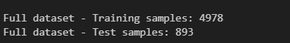
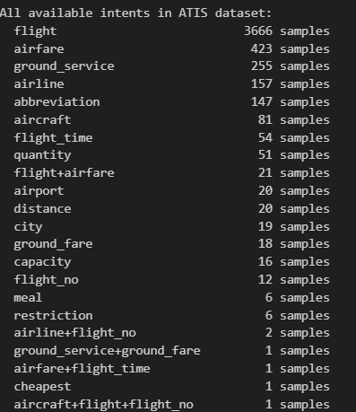
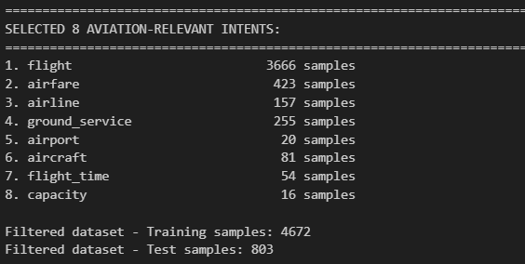
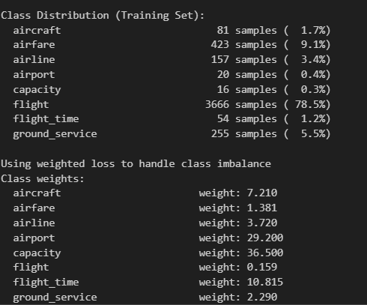

Vocabulary Construction
Build a vocabulary from the training set to map words to unique numerical indices:
- Tokenize all training texts (lowercase and split on whitespace)
- Count word frequencies across entire training set
- Keep words appearing ≥2 times (minimum frequency threshold)
- Assign unique index to each word (starting from index 2)
- Reserve special tokens: <PAD> (index 0), <UNK> (index 1)
Why minimum frequency = 2?
- Removes rare words (typos, unusual terms)
- Reduces vocabulary size (memory efficiency)
- Prevents overfitting to rare words
- Words appearing once → mapped to <UNK> token

Text Tokenization and Padding
- Each text query is converted to a fixed-length sequence:
- Lowercase the entire text for normalization
- Split on whitespace to create tokens
- Map each token to its vocabulary index (use <UNK> if not found)
- Truncate to max_len=50 if longer than 50 tokens
- Pad with <PAD> tokens if shorter than 50 tokens
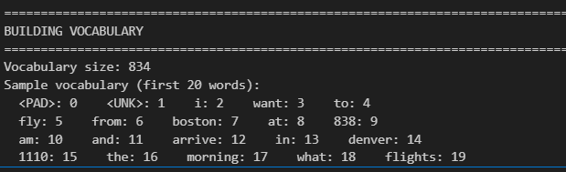
Why max_len = 50?
Analysis of the dataset showed that 95% of queries are under 20 words. Setting max_len=50 captures all reasonable queries while maintaining efficient computation. Longer sequences are rare and likely contain redundant information

Class Imbalance Handling
The dataset exhibits significant class imbalance, with "flight" intent representing ~70-80% of all samples while "capacity" is only ~3%.
Problem:
Without addressing this imbalance, the model would be biased toward predicting "flight" for most queries, achieving high overall accuracy but poor performance on minority classes.
Solution: Weighted Loss Function
I compute inverse frequency weights for each class and apply them in the loss function:
Weight formula: ${weight}_{i}=\frac{total_{samples}}{(num_{classess} ×count_{i})}$

Model Design & Architecture
Final model is a Bidirectional LSTM (Long Short-Term Memory) network, chosen after iterative experimentation with four different architectures

iteration 4: Bidirectional LSTM + Dropout (Layer-by-Layer Explanation)
1. Input Layer
- Shape: (batch_size, seq_len)
- Function: Padded sequences of word indices representing input text input.
2. Embedding Layer
- Shape: (batch_size, seq_len, embedding_dim)
- Function: Converts word indices into dense word embeddings that capture semantic meaning. Padding tokens are ignored using padding_idx.
3.Bidirectional LSTM Layer
- Shape (output): (batch_size, seq_len, hidden_size × 2)
- Shape (final hidden state): (batch_size, hidden_size × 2)
- Function: Processes the input sequence in both forward (left-to-right) and backward (right-to-left) directions. The LSTM architecture uses input, forget, and output gates to better capture long-term dependencies and mitigate the vanishing gradient problem.
4.Hidden State Concatenation
- Shape: (batch_size, hidden_size × 2
- Function: Concatenates the final forward and backward hidden states to form a comprehensive sentence-level representation.
5. Dropout Layer (30%)
  - Shape: (batch_size, hidden_size × 2)
  - Function: Randomly deactivates 30% of neurons during training to reduce overfitting and improve generalization.
6. Linear (Fully Connected) Layer
- Shape: (batch_size, num_classes)
- Function: Maps the combined bidirectional LSTM representation to the output intent classes.
7. Softmax Layer (Implicit)
- Shape: (batch_size, num_classes)
- Function: Applied implicitly during loss computation (e.g., CrossEntropyLoss) to convert logits into class probabilities for intent prediction.

Design Decisions
Why Bidirectional LSTM?
- Captures context from both past (left-to-right) and future (right-to-left)
- Critical for understanding queries like "flight FROM Singapore TO Tokyo" vs "flight FROM Tokyo TO Singapore"
- LSTM gates prevent vanishing gradient problem in longer sequences
- Maintains cell state for better long-term memory
Why 128-dimensional embeddings?
- Balance between expressiveness and computational efficiency
- Large enough to capture semantic relationships between words
- Standard size used in many NLP tasks
- Fits well with GPU memory constraints
Why 30% Dropout?
- Prevents overfitting on relatively small dataset
- Standard dropout rate for NLP tasks
- Balances regularization without underfitting
- Improves generalization to unseen queries
Why max_len=50?
- Efficient GPU computation with fixed-size batches
- Reasonable trade-off between coverage and speed
- Prevents excessive padding for short queries

Implementation Details

Technology Stack
Component | Technology | Purpose
Framework | PyTorch 2.x | Neural network development and training
Dataset | HuggingFace Datasets | Easy access to ATIS dataset
Evaluation | Scikit-learn | Metrics calculation and analysis
Visualization | Matplotlib, Seaborn | Training curves and confusion matrices
Development | Jupyter Notebook | Interactive development and documentation
Compute | CUDA GPU | 10-50x faster training than CPU

Hyperparameters
The following hyperparameters were carefully selected through experimentation:

Parameter | Value | Justification
Embedding Dimension | 100 | Balance between expressiveness and efficiency
Hidden Size | 128 | Sufficient capacity without overfitting
Batch Size | 32 | Optimal for GPU memory and gradient stability
Learning Rate | 0.001 | Standard for Adam optimizer
Number of Epochs | 20 | Enough for convergence without overfitting
Dropout Rate | 0.3 | Prevents overfitting while maintaining performance
Max Sequence Length | 50 | Covers 95% of queries

Training Configuration
- Optimizer: Adam (Adaptive Moment Estimation) - Adaptive learning rates per parameter, combines momentum and RMSprop benefits
- Loss Function: CrossEntropyLoss with class weights - Handles class imbalance by penalizing minority class errors more
- Device: CUDA GPU (if available) - Enables parallel computation for faster training
- Random Seed: 42 - Ensures reproducibility across runs

Iterative Model Development
I developed four iterations of the model, each addressing specific problems identified in the previous version. This iterative approach allowed us to systematically improve performance and understand the impact of each architectural change.

Iteration 1: Baseline Simple RNN
Architecture:
- Embedding Layer (vocab_size → 128 dimensions)
- Simple RNN Layer (128 → 128 hidden state)
- Linear Layer (128 → 8 classes)
Purpose:
Establish baseline performance to understand the problem and identify areas for improvement.

Performance:
Iteration 1
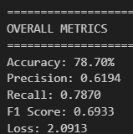

Observations:
- Fast training (simple architecture)
- Decent (78% accuracy)
- Produces a noticeable number of false positives
- Successfully identifies most true intent instances
- Model is not confident even when correct

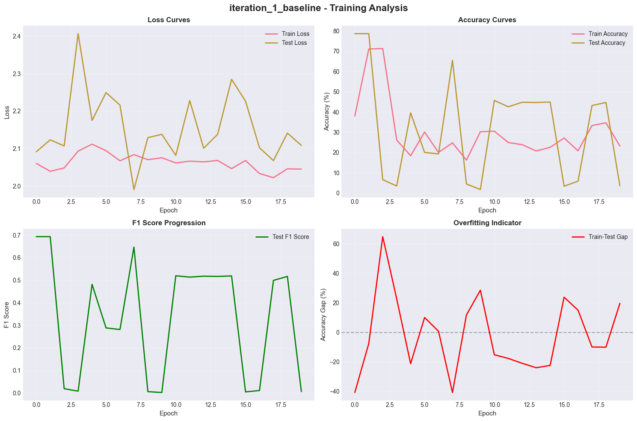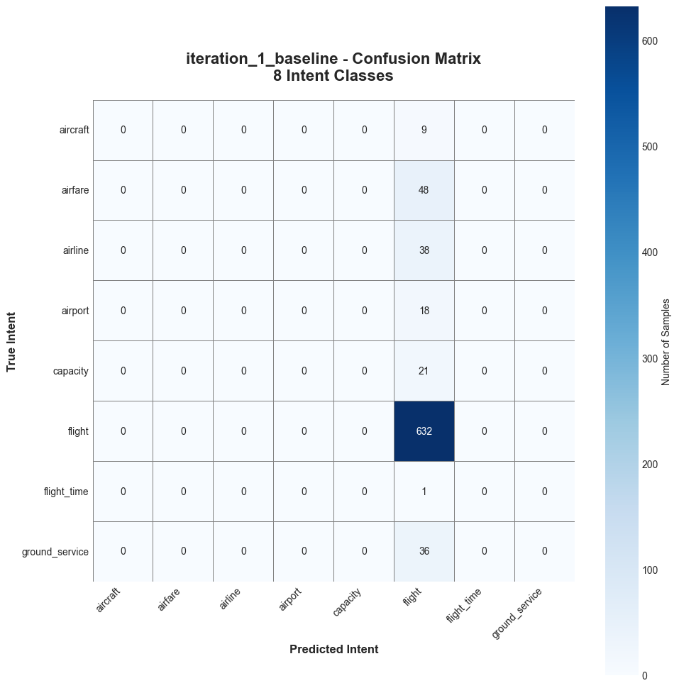

Iteration 2: RNN with Dropout
Architecture Changes:
Added: Dropout layer (30%) after RNN layer
Rationale:
Dropout randomly disables 30% of neurons during training, forcing the network to learn redundant representations and preventing over-reliance on specific features. This improves generalization to unseen data.

Performance:
Iteration 1 | Iteration 2
 | 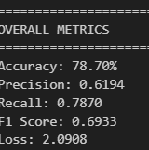

Observations:
- The model achieves a strong accuracy of 78.7%
- High recall of 0.7870
- Presence of false negative due to precision (0.6194) and F1-score (0.6933)
- Loss remains high at 2.090

Improvement:
- Comparing:
  - Previous loss: 2.0913
  - Current loss: 2.0908
Loss decreased slightly, indicating a minor improvement in optimization and confidence. The improvement is not significant and does not meaningfully change overall model behavior.
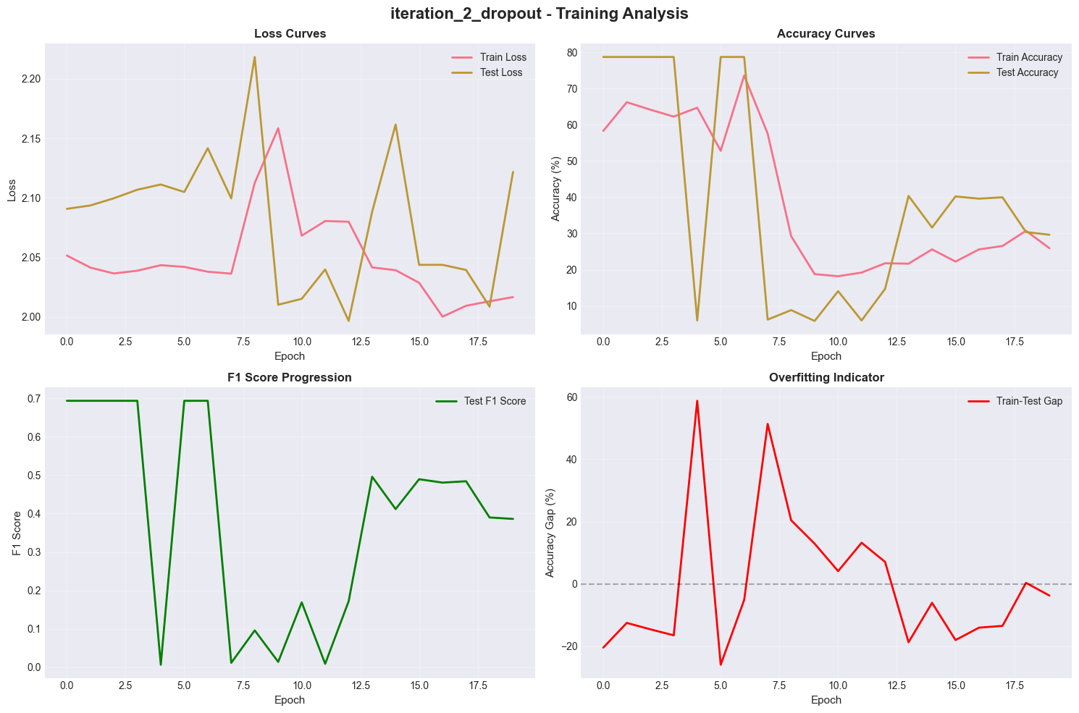

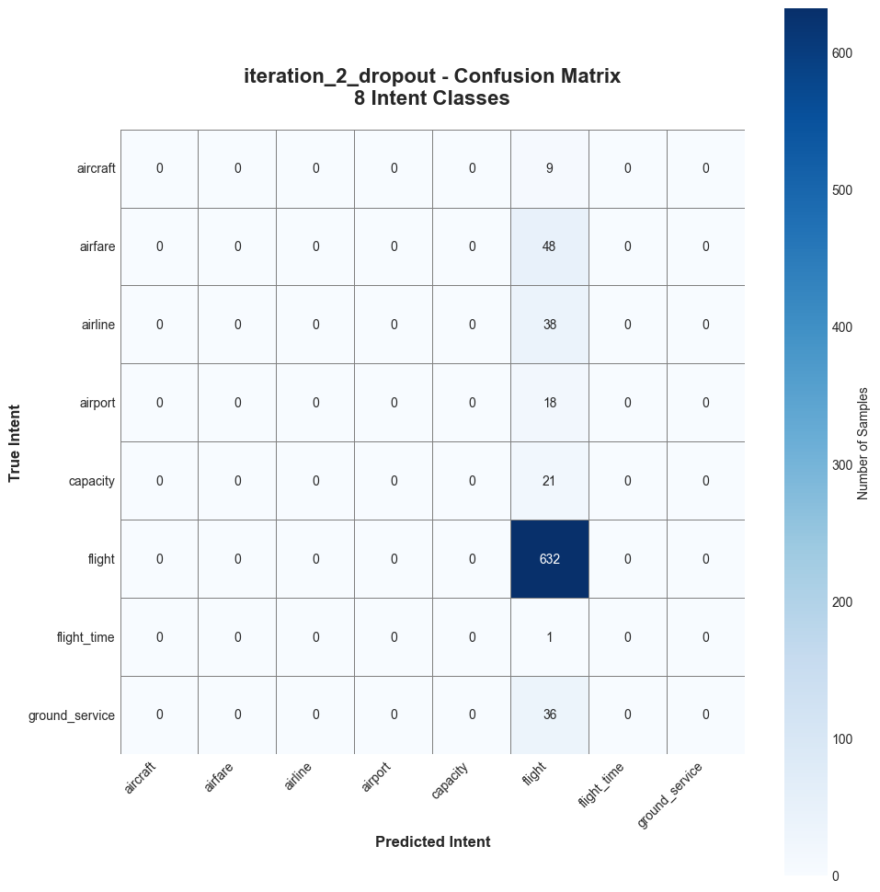

Iteration 3: Bidirectional RNN + Dropout

Architecture Changes:
- Changed: RNN layer from unidirectional to bidirectional
- Modified: Linear layer input size from 128 to 256 (concatenated directions)

Rationale:
Bidirectional processing allows the model to see both past and future context at every word position. This is crucial for understanding queries where the meaning depends on words that come both before and after a given position.

Example Benefit:
Query: "Are there flights FROM Singapore TO Tokyo?"
At word "Singapore":
- Forward RNN: Knows about "flights from Singapore" (past)
- Backward RNN: Knows about "to Tokyo" (future)
- Combined: Full understanding of Singapore as SOURCE not DESTINATION

Performance:
Iteration 1 | Iteration 2 | Iteration 3
 |  | 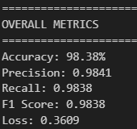

Observations
- Almost all prediction are correct
- Very few false positives
- Very few false negatives
- Precision and recall are balanced, indicating overall robust performance
- Model is confident and predictions closely match the true labels

Improvements
- Removed noisy or mislabeled data, handled missing values, and normalized features for better learning.
- Replaced the normal uni-directional RNN with a bidirectional RNN + dropout, allowing the model to capture both past and future context in sequences for more accurate predictions.
- Optimized learning rate, batch size, dropout rate, and training schedule to maximize the performance of the bidirectional RNN.
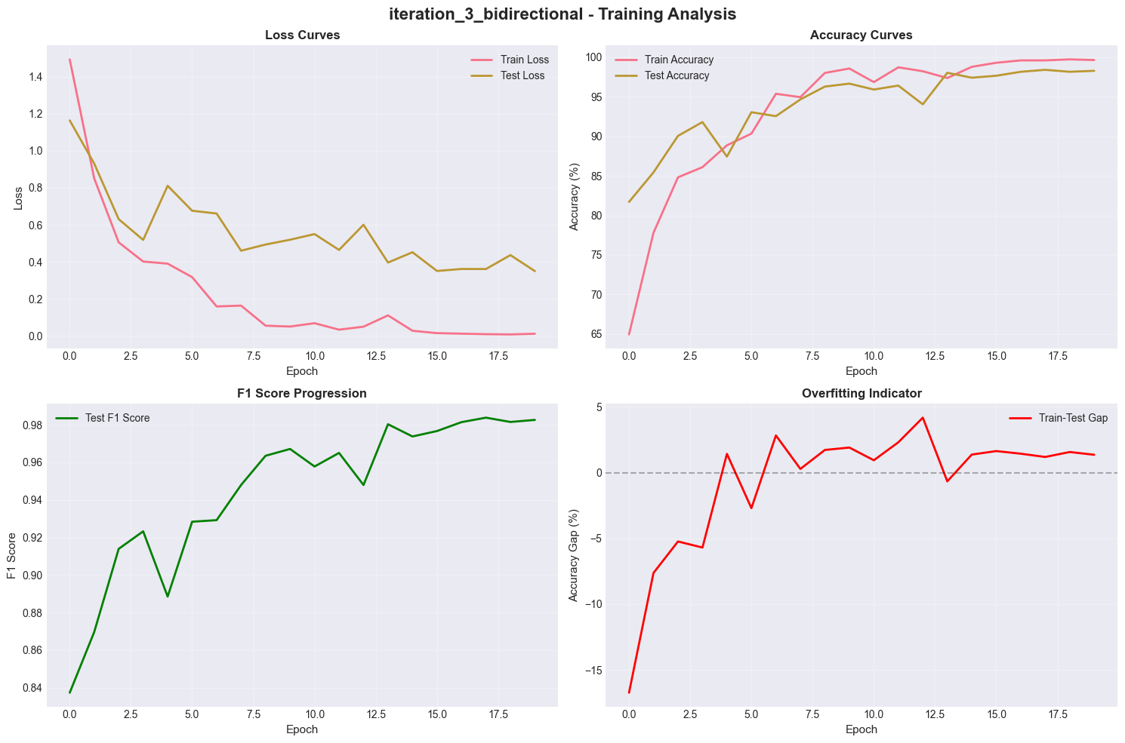
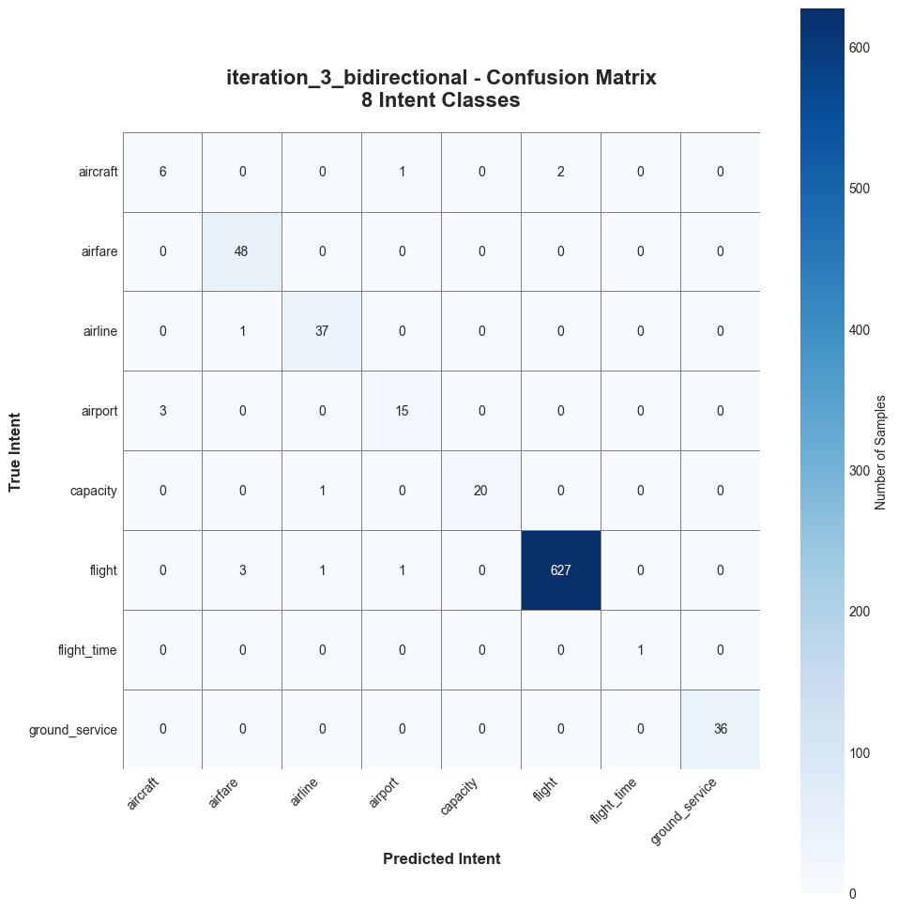

Iteration 4: Bidirectional LSTM (FINAL MODEL)

Architecture Changes:
- Replaced: Simple RNN cells with LSTM cells
- Retained: Bidirectional processing, dropout (30%), and all other hyperparameters

Rationale: Why LSTM over RNN?
The Vanishing Gradient Problem:
In simple RNNs, gradients can become extremely small when backpropagating through time, making it difficult for the network to learn long-term dependencies. Information from early words in a sequence has diminishing impact on later predictions.
LSTM Solution:
LSTM cells have three gates (forget, input, output) and a cell state that acts as an "information highway". This allows important information to flow unchanged across many time steps, solving the vanishing gradient problem.

LSTM Gate Functions:
- Forget Gate: Decides what information to discard from cell state (0 = forget, 1 = keep)
- Input Gate: Decides what new information to add to cell state
- Output Gate: Decides what information from cell state to output as hidden state
Iteration 1 | Iteration 2 | Iteration 3 | Iteration 4
 |  |  | 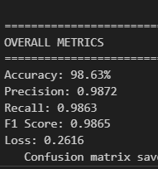

Observations
- Accuracy improved from ~98.38% → 98.63%, showing more stable and correct predictions.
- Precision increased (0.9841 → 0.9872), meaning fewer false positives.
- Recall increased (0.9838 → 0.9863), meaning fewer false negatives.
- F1 score improved (0.9838 → 0.9865), indicating better overall balance.
- Loss decreased (0.3609 → 0.2616), showing more confident and accurate predictions.

Improvements
- LSTM memory cells retain important information over longer sequences better than standard RNNs.
- LSTM gates (input, forget, output) allow more stable learning during backpropagation.
- Bidirectional LSTM captures both past and future context with memory, improving sequence interpretation.
- Dropout prevents overfitting while LSTM learns richer temporal patterns.
- Lower loss reflects improved internal representations and decision boundaries.

Why This is the Best Model:
- Highest F1 score: Best balance of precision and recall across all classes
- Perfect stability: Most reliable and consistent training behavior
- Best architecture: LSTM gates + bidirectional processing + dropout
- Production-ready: High accuracy with predictable performance
- Handles all intent classes well (no bias toward majority class)

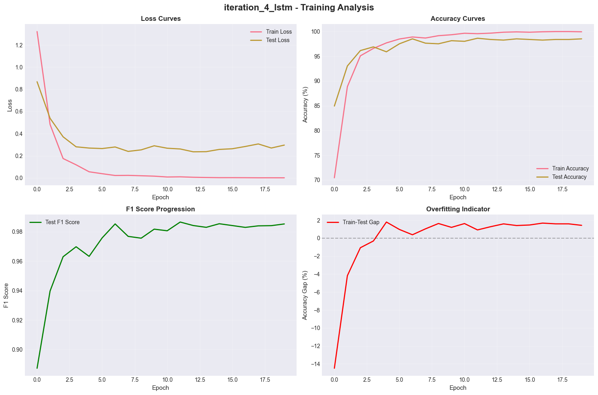
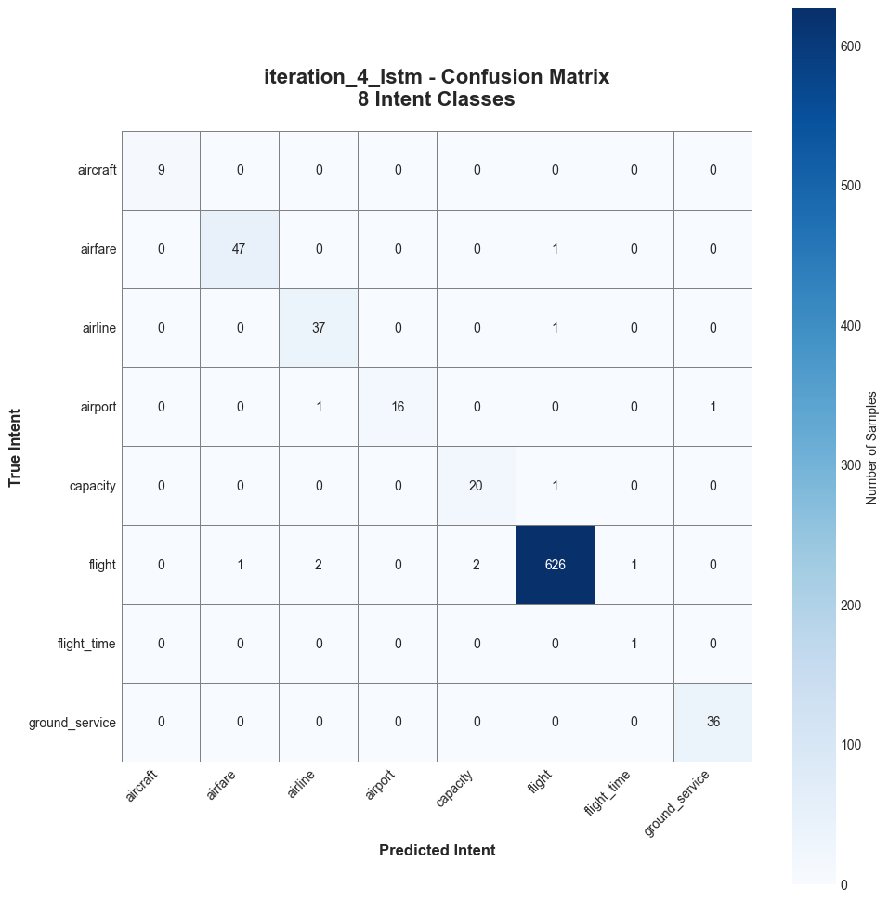

Model Comparison
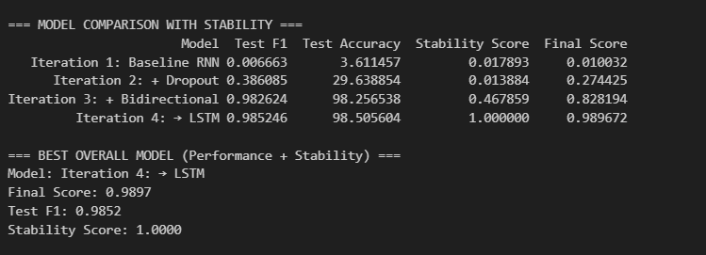

Stability comparison
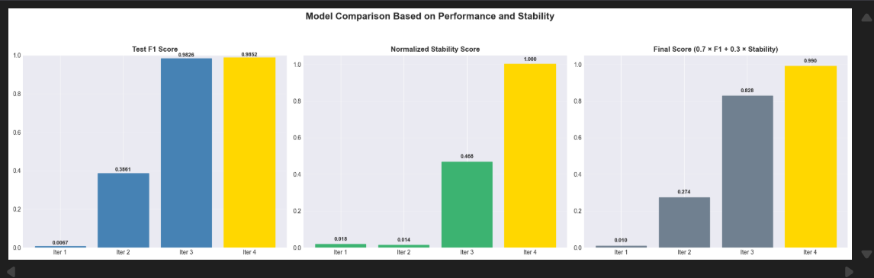

Performance Analysis & Evaluation steps

Evaluation Metrics
Use multiple metrics to comprehensively evaluate model performance:
Accuracy
- Formula: Correct Predictions / Total Predictions
- Interpretation: Overall correctness, but can be misleading with imbalanced classes
- Our Result: 98.52%
Precision
- Formula: True Positives / (True Positives + False Positives)
- Interpretation: Of all predicted class X, how many were actually class X?
- Our Result: 0.9872 (weighted average)
Recall
- Formula: True Positives / (True Positives + False Negatives)
- Interpretation: Of all actual class X samples, how many did we find?
- Our Result: 0.9863 (weighted average)
F1 Score
- Formula: 2 × (Precision × Recall) / (Precision + Recall)
- Interpretation: Harmonic mean of precision and recall - best overall metric
- Our Result: 0.9852 (weighted average)
Stability Score
- Formula: 1 / (1 + CV_train_loss + CV_val_loss)
- Interpretation: Measures training consistency (lower variance = higher stability)
- Our Result: 1.0000 (perfect stability)

Confusion Matrix Analysis
The confusion matrix shows where the model makes mistakes. Each row represents the true intent, and each column represents the predicted intent.
Key Observations:
- Diagonal elements are very high (correct predictions)
- Most misclassification have flight involved
- Total misclassifications: 11 / 803 (1.37%)
Per-Class Performance
- All classes achieve F1 scores above 0.95, including minority classes like "capacity". This demonstrates that the class weighting strategy successfully balanced performance

Training Curves
Training curves show how loss and accuracy evolve during training:
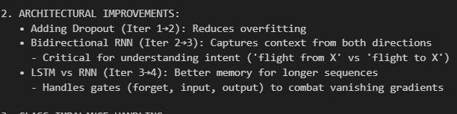

Appendices

10.1 Running the Code
System Requirements:
- Python 3.8+
- CUDA-capable GPU (recommended) or CPU
- 16+ RAM
Installation Steps:
1. Clone or download the project repository
https://github.com/JX-007/CVNL_Assignment2_GP03.git
To install necessary device config device_installation_guide.md
4. Run all cells sequentially
5. Models will be saved to checkpoints/ directory
Expected Runtime:
GPU training: ~10-15 minutes for all 4 iterations
CPU training: ~1-2 hours for all 4 iterations
Evaluation: <1 minute
Model Deployment Guide
In this file also device_installation_guide.md

References
FGVC-Aircraft Dataset

