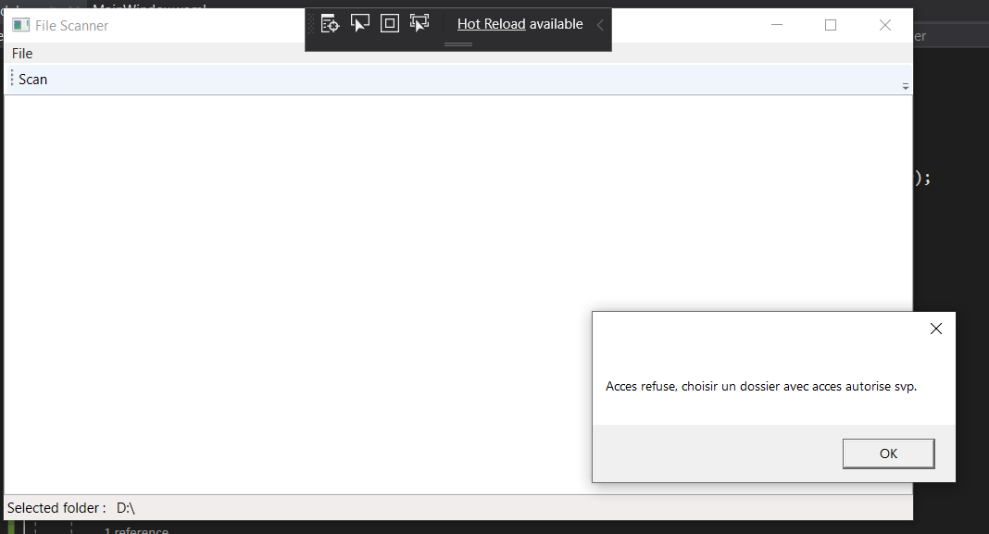

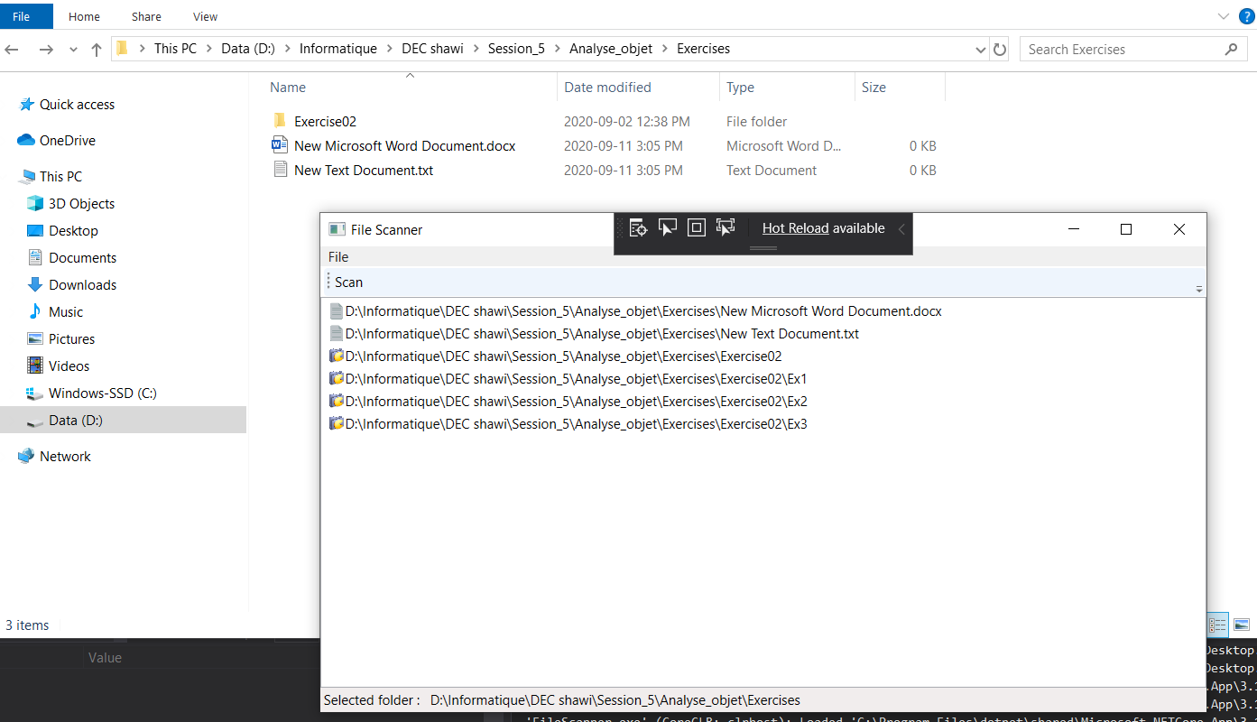

//Source

//https://stackoverflow.com/questions/1395205/better-way-to-check-if-a-path-is-a-file-or-a-directory

//https://github.com/nbourre/0SS_semaine_04

//https://youtu.be/2moh18sh5p4

//https://docs.microsoft.com/fr-fr/dotnet/csharp/programming-guide/concepts/async/