Downloaded trom www.singapore-exam-papers.com

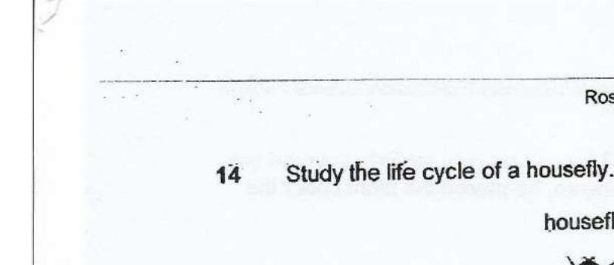



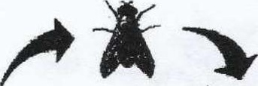

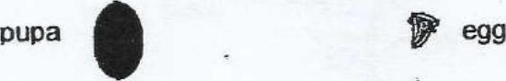

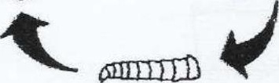

A beaker containing a piece of uncooked meat was left in a room for a week.  
After a week, maggots were observed on the meat as shown below.

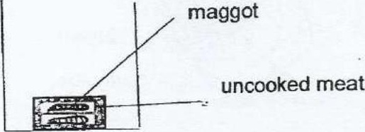

Edina wanted to set up the experiment which would show that the maggots  
did not come from the meat.

